**電通二甲微處理器實驗 實驗結報**

|  |  |  |  |
| --- | --- | --- | --- |
| **實驗名稱** | **Lab 04-四合一七段顯示器** | | |
|  | **06050375** | **組員** | **張博硯** |

1. **實驗目的**

**Checkpoint1 四合一七段顯示器每隔0.3ms加一數字**

**從0000->0059->0100->至2359後歸0**

**Checkpoint2 Pin6按鍵按下後歸0**

**Checkpoint3 合併歸0及倒數計時**

**Pin6按鍵按下後歸0;**

**Pin17按鍵按下倒數計時 放開後恢復正數**

1. **實驗步驟**

**安裝SevSeg.h程式庫**

1. **電路圖**

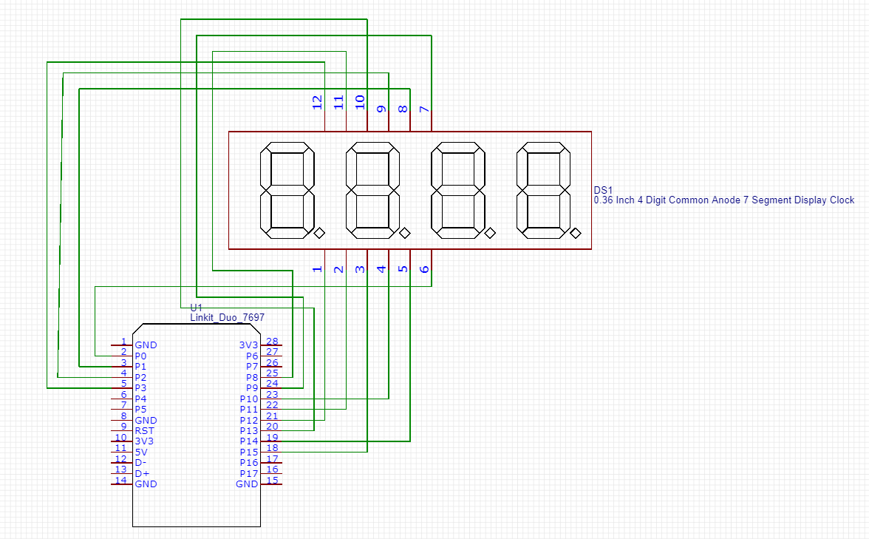

1. **程式碼**

**#include "SevSeg.h"**

**SevSeg sevseg;**

**void setup() {**

**byte numDigits= 4;**

**byte digitPins[] = {2, 3, 4, 5};**

**byte segmentPins[] = {8, 9, 10, 11, 12, 13, 14, 15};**

**sevseg.begin(COMMON_CATHODE , numDigits, digitPins, segmentPins);**

**pinMode(6,INPUT);**

**pinMode(17,INPUT);**

**}**

**int Hour = 0;**

**int Min = 0;**

**unsigned long previousTime = 0;**

**unsigned long interval = 300;**

**void loop() {**

**unsigned long currentTime = millis();**

**if(digitalRead(6) == HIGH)**

**Min = Hour = 0;**

**if(currentTime-previousTime > interval) {**

**previousTime = currentTime ;**

**if(digitalRead(17) == LOW){**

**Min = Min + 1;**

**if (Min == 60) {**

**Min = 0;**

**if (Hour == 23)**

**Hour=0;**

**else**

**Hour++;**

**}**

**}**

**else {**

**if(Min == 0 && Hour == 0) {**

**Min = 59;**

**Hour = 23;**

**}**

**else {**

**Min = Min - 1;**

**if (Min == -1) {**

**Min = 59;**

**if (Hour == -1)**

**Hour=23;**

**else**

**Hour--;**

**}**

**}**

**}**

**}**

**sevseg.setNumber(Hour * 100 + Min, 4);**

**sevseg.refreshDisplay();**

**}**

1. **心得討論**

每周都在補上周的，這次注意參數就好，像我的是共陰性的。