**電通二甲微處理器實驗 實驗結報**

|  |  |  |  |
| --- | --- | --- | --- |
| **實驗名稱** | **Lab 07 LCD顯示器** | | |
|  | **06050375** | **組員** | **張博硯** |

1. **實驗目的**

**Checkpoint1 在LCD上顯示自己的學號、英文名字**

**Checkpoint2 使用PC串列輸入，所有PC輸入皆顯示在LCD上**

1. **實驗步驟**

**安裝LiquidCrystal.h程式庫**

1. **電路圖**

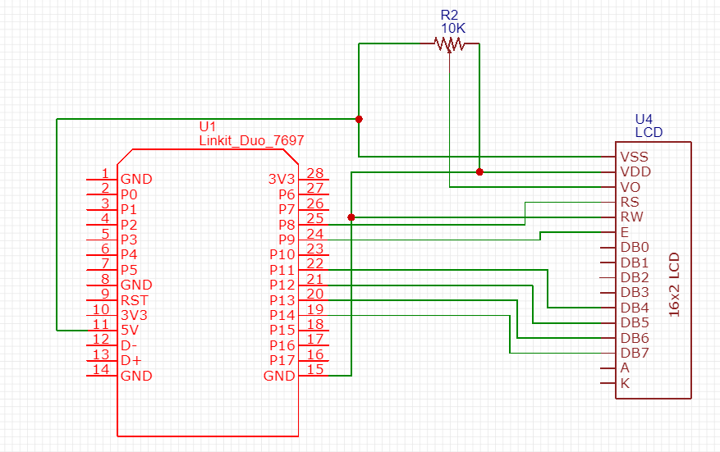

1. **程式碼**

**#include <LiquidCrystal.h>**

**/\***

**LiquidCrystal Library - Hello World**

**The circuit:**

**\* LCD RS pin to digital pin 8**

**\* LCD Enable pin to digital pin 9**

**\* LCD D4 pin to digital pin 11**

**\* LCD D5 pin to digital pin 12**

**\* LCD D6 pin to digital pin 13**

**\* LCD D7 pin to digital pin 14**

**\* LCD R/W pin to ground**

**\* 10K resistor:**

**\* ends to +5V and ground**

**\* wiper to LCD VO pin**

**\*/**

**LiquidCrystal lcd(8, 9, 11, 12, 13, 14);**

**void setup() {**

**lcd.begin(16, 2);**

**lcd.print("06050375");**

**lcd.setCursor(0, 1);**

**lcd.print("Rick");**

**Serial.begin(9600);**

**}**

**int x=0,y=0;**

**void loop() {**

**if(Serial.available()) {**

**lcd.clear();**

**while(Serial.available()>0){**

**char c = Serial.read();**

**Serial.print(c);**

**lcd.print(c);**

**x++;**

**if(x == 16 && y == 0) {**

**x = 0;**

**y = 1;**

**lcd.setCursor(x, y);**

**}**

**else if(x == 16 && y == 1) {**

**x = 0;**

**y = 0;**

**lcd.setCursor(x, y);**

**}**

**}**

**}**

**}**

1. **心得討論**

**LCD要接的地方非常多，最好是要焊，雖然我沒有不過還是順利完成了。**