**電通二甲微處理器實驗 實驗結報**

|  |  |  |  |
| --- | --- | --- | --- |
| **實驗名稱** | **Lab 08 中斷控制與超音波測距** | | |
|  | **06050375** | **組員** | **張博硯** |

1. **實驗目的**

**Checkpoint1 讀取超音波測距之值顯示在LCD上**

**Checkpoint2 將重段方式改為FALLING/RAISING**

**將超音波讀值放入Int0中執行，並顯示在LCD上**

**Checkpoint3 設置Pin6為按鍵**

**P6 -HIGH :接受中斷Interruprs()**

**P6 -LOW :不接受中斷noInterruprs()**

1. **實驗步驟**

**安裝Ultrasonic.h、LiquidCrystal.h程式庫**

1. **電路圖**

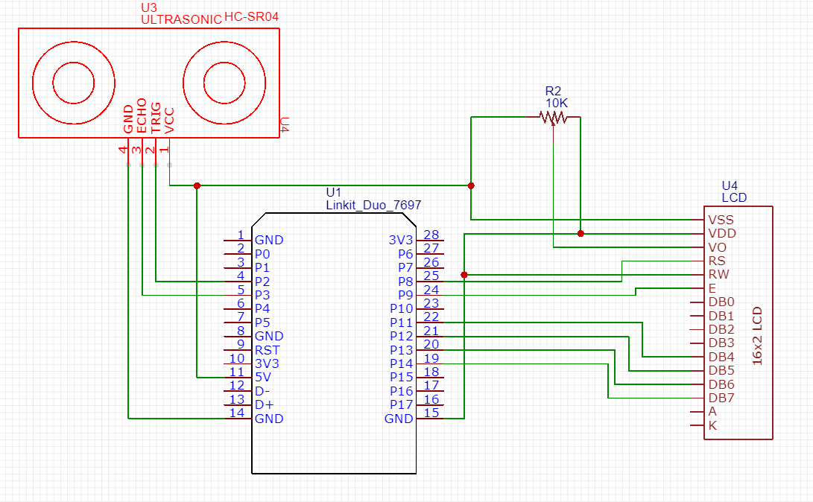

1. **程式碼**

**#include <LiquidCrystal.h>**

**#include <Ultrasonic.h>**

**#define TRIGGER_PIN 4**

**#define ECHO_PIN 5**

**volatile boolean state=LOW;**

**const byte intPin=2;**

**Ultrasonic ultrasonic(TRIGGER_PIN, ECHO_PIN);**

**LiquidCrystal lcd(8, 9, 11, 12, 13, 14);**

**void setup() {**

**pinMode(6,INPUT);**

**lcd.begin(16, 2);**

**Serial.begin(9600);**

**attachInterrupt(intPin, int0, FALLING);**

**}**

**float cmMsec, inMsec;**

**long microsec;**

**void loop() {**

**if(digitalRead(6) == LOW) {**

**noInterrupts();**

**}**

**else {**

**interrupts();**

**}**

**Serial.print("MS: "); Serial.print(microsec);**

**Serial.print(", CM: "); Serial.print(cmMsec);**

**Serial.print(", IN: "); Serial.println(inMsec);**

**lcd.print("MS:"); lcd.print(microsec);**

**lcd.setCursor(0,1);**

**lcd.print("CM:"); lcd.print(cmMsec);**

**lcd.print(", IN:"); lcd.println(inMsec);**

**delay(1000);**

**}**

**void int0() { //interrupt handler**

**microsec = ultrasonic.timing();**

**cmMsec = ultrasonic.convert(microsec, Ultrasonic::CM);**

**inMsec = ultrasonic.convert(microsec, Ultrasonic::IN);**

**lcd.clear();**

**}**

1. **心得討論**

**只要牽扯LCD就覺得麻煩!**

**我用橡皮擦當被測距物體還被學姊問可以測嗎?OWO**