**電通二甲微處理器實驗 實驗結報**

|  |  |  |  |
| --- | --- | --- | --- |
| **實驗名稱** | **Lab 11 MCS Cloud** | | |
|  | **06050375** | **組員** | **張博硯** |

1. **實驗目的**

**Checkpoint1 修改 MCS_GET code, 加入 MCS Remote**

**Checkpoint2 將 A0 電阻值上傳**

1. **實驗步驟**

**於MCS Cloud註冊帳號，並建立Datachannel**

1. **電路圖**

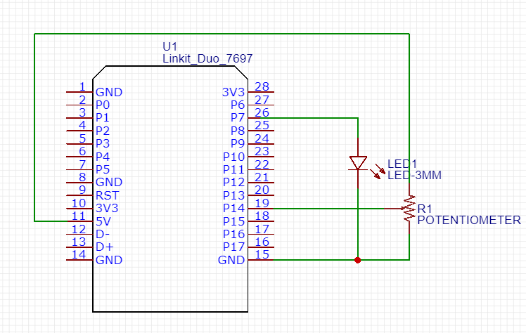

1. **程式碼**

**#include <LWiFi.h>**

**#include <WiFiClient.h>**

**#include "MCS.h"**

**// Assign AP ssid / password here**

**#define _SSID "ASUS23114"**

**#define _KEY "11111166"**

**// Assign device id / key of your test device**

**MCSDevice mcs("Dcw0X1VB", "dItLnDsum0svCcfu");**

**// Assign channel id**

**// The test device should have 2 channel**

**// the first channel should be "Controller" - "On/Off"**

**// the secord channel should be "Display" - "On/Off"**

**MCSControllerOnOff led("led_Controller");**

**MCSDisplayOnOff remote("led_Display");**

**MCSDisplayInteger vr("Temp");**

**#define LED_PIN 7**

**#define R_PIN 14**

**void setup() {**

**// setup Serial output at 9600**

**Serial.begin(9600);**

**// setup LED/Button pin**

**pinMode(LED_PIN, OUTPUT);**

**// setup Wifi connection**

**while(WL_CONNECTED != WiFi.status())**

**{**

**Serial.print("WiFi.begin(");**

**Serial.print(_SSID);**

**Serial.print(",");**

**Serial.print(_KEY);**

**Serial.println(")...");**

**WiFi.begin(_SSID, _KEY);**

**}**

**Serial.println("WiFi connected !!");**

**// setup MCS connection**

**mcs.addChannel(led);**

**mcs.addChannel(remote);**

**mcs.addChannel(vr);**

**while(!mcs.connected())**

**{**

**Serial.println("MCS.connect()...");**

**mcs.connect();**

**}**

**Serial.println("MCS connected !!");**

**// read LED value from MCS server**

**while(!led.valid())**

**{**

**Serial.println("read LED value from MCS...");**

**led.value();**

**}**

**Serial.print("done, LED value = ");**

**Serial.println(led.value());**

**digitalWrite(LED_PIN, led.value() ? HIGH : LOW);**

**}**

**void loop() {**

**// call process() to allow background processing, add timeout to avoid high cpu usage**

**Serial.print("process(");**

**Serial.print(millis());**

**Serial.println(")");**

**mcs.process(100);**

**// updated flag will be cleared in process(), user must check it after process() call.**

**if(led.updated())**

**{**

**Serial.print("LED updated, new value = ");**

**Serial.println(led.value());**

**digitalWrite(LED_PIN, led.value() ? HIGH : LOW);**

**if(!remote.set(led.value()))**

**{**

**Serial.print("Failed to update remote");**

**Serial.println(remote.value());**

**}**

**}**

**if(!vr.set(analogRead(R_PIN)))**

**{**

**Serial.print("Failed to update vr");**

**}**

**// check if need to re-connect**

**while(!mcs.connected())**

**{**

**Serial.println("re-connect to MCS...");**

**mcs.connect();**

**if(mcs.connected())**

**Serial.println("MCS connected !!");**

**}**

**}**

**}**

1. **心得討論**

**幸好有範例，這次乍看很複雜但只要將SSID、KEY、DatachannelID、DatachannelKey設好就可以。**