**電通二甲微處理器實驗 實驗結報**

|  |  |  |  |
| --- | --- | --- | --- |
| **實驗名稱** | **Lab 12溫溼度感測器** | | |
|  | **06050375** | **組員** | **張博硯** |

1. **實驗目的**

**Checkpoint1 使DHT-11可以一直量溫溼度**

**Checkpoint2 整合Timer與DHT11測量溫濕度**

**Checkpoint3 使用Timer每隔10秒將溫溼度上傳至MCS Cloud**

1. **實驗步驟**

**安裝DHT sensor library by Adafruit 、 Adafruit_Sensor library程式庫**

1. **電路圖**

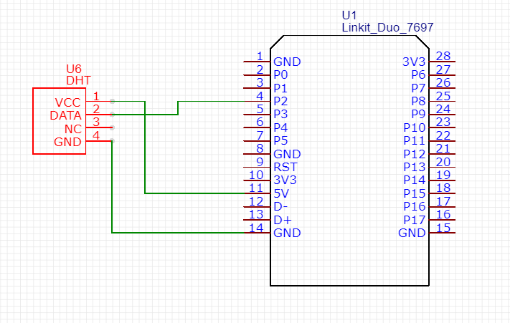

1. **程式碼**

**//Wi-fi**

**#include <LWiFi.h>**

**#include <WiFiClient.h>**

**#include "MCS.h"**

**//DHT**

**#include "DHT.h"**

**// Assign AP ssid / password here**

**#define _SSID "ASUS23114"**

**#define _KEY "11111166"**

**// Assign device id / key of your test device**

**MCSDevice mcs("DW823zSR", "x5VKTgqyUl975aoC");**

**// Assign channel id**

**// The test device should have 2 channel**

**// the first channel should be "Display" - "Temperature"**

**// the secord channel should be "Display" - "Hhumidity"**

**MCSDisplayFloat temperature_1("Temperature_1");**

**MCSDisplayFloat humidity_1("Humidity_1");**

**#define DHTPIN 2 // Digital pin connected to the DHT sensor**

**// Feather HUZZAH ESP8266 note: use pins 3, 4, 5, 12, 13 or 14 --**

**// Pin 15 can work but DHT must be disconnected during program upload.**

**// Uncomment whatever type you're using!**

**#define DHTTYPE DHT11 // DHT 11**

**//#define DHTTYPE DHT22 // DHT 22 (AM2302), AM2321**

**//#define DHTTYPE DHT21 // DHT 21 (AM2301)**

**// Connect pin 1 (on the left) of the sensor to +5V**

**// NOTE: If using a board with 3.3V logic like an Arduino Due connect pin 1**

**// to 3.3V instead of 5V!**

**// Connect pin 2 of the sensor to whatever your DHTPIN is**

**// Connect pin 4 (on the right) of the sensor to GROUND**

**// Connect a 10K resistor from pin 2 (data) to pin 1 (power) of the sensor**

**// Initialize DHT sensor.**

**// Note that older versions of this library took an optional third parameter to**

**// tweak the timings for faster processors. This parameter is no longer needed**

**// as the current DHT reading algorithm adjusts itself to work on faster procs.**

**DHT dht(DHTPIN, DHTTYPE);**

**// Read humidity**

**float h;**

**// Read temperature as Celsius (Fahreheit)**

**float t,f;**

**// Compute heat index in Celsius (Fahreheit)**

**float hic,hif;**

**//timer**

**#include "Arduino.h"**

**#include "LTimer.h"**

**// instantiation**

**LTimer timer0(LTIMER_0);**

**LTimer timer1(LTIMER_1);**

**int flag0 = 0;**

**int flag1 = 0;**

**// callback function for timer0**

**void _callback0(void *usr_data)**

**{**

**flag0=!flag0;**

**}**

**// callback function for timer1**

**void _callback1(void *usr_data)**

**{**

**flag1=!flag1;;**

**}**

**void setup() {**

**Serial.begin(9600);**

**// setup Wifi connection**

**while(WL_CONNECTED != WiFi.status())**

**{**

**Serial.print("WiFi.begin(");**

**Serial.print(_SSID);**

**Serial.print(",");**

**Serial.print(_KEY);**

**Serial.println(")...");**

**WiFi.begin(_SSID, _KEY);**

**}**

**Serial.println("WiFi connected !!");**

**// setup MCS connection**

**mcs.addChannel(temperature_1);**

**mcs.addChannel(humidity_1);**

**while(!mcs.connected())**

**{**

**Serial.println("MCS.connect()...");**

**mcs.connect();**

**}**

**// initialization**

**timer0.begin();**

**timer1.begin();**

**// start the execution**

**timer0.start(1000, LTIMER_REPEAT_MODE, _callback0, NULL);**

**timer1.start(10000, LTIMER_REPEAT_MODE, _callback1, NULL);**

**Serial.println(F("DHT11 test!"));**

**dht.begin();**

**}**

**void loop() {**

**// Wait a few seconds between measurements.**

**delay(1000);**

**// call process() to allow background processing, add timeout to avoid high cpu usage**

**Serial.print("process(");**

**Serial.print(millis());**

**Serial.println(")");**

**mcs.process(100);**

**// Reading temperature or humidity takes about 250 milliseconds!**

**// Sensor readings may also be up to 2 seconds 'old' (its a very slow sensor)**

**h = dht.readHumidity();**

**// Read temperature as Celsius (the default)**

**t = dht.readTemperature();**

**// Read temperature as Fahrenheit (isFahrenheit = true)**

**f = dht.readTemperature(true);**

**// Check if any reads failed and exit early (to try again).**

**if (isnan(h) || isnan(t) || isnan(f)) {**

**Serial.println(F("Failed to read from DHT sensor!"));**

**return;**

**}**

**// Compute heat index in Fahrenheit (the default)**

**hif = dht.computeHeatIndex(f, h);**

**// Compute heat index in Celsius (isFahreheit = false)**

**hic = dht.computeHeatIndex(t, h, false);**

**if(flag0) {**

**delay(300);**

**Serial.print(F("Humidity: "));**

**Serial.print(h);**

**Serial.print(F("% Temperature: "));**

**Serial.print(t);**

**Serial.print(F("°C "));**

**Serial.print(f);**

**Serial.print(F("°F Heat index: "));**

**Serial.print(hic);**

**Serial.print(F("°C "));**

**Serial.print(hif);**

**Serial.println(F("°F"));**

**flag0=!flag0;**

**}**

**if(flag1) {**

**delay(300);**

**if(!temperature_1.set(t))**

**{**

**Serial.print("Failed to update Temperature");**

**}**

**if(!humidity_1.set(h))**

**{**

**Serial.print("Failed to update Hhumidity");**

**}**

**flag1=!flag1;**

**}**

**// check if need to re-connect**

**while(!mcs.connected())**

**{**

**Serial.println("re-connect to MCS...");**

**mcs.connect();**

**if(mcs.connected())**

**Serial.println("MCS connected !!");**

**}**

**}**

1. **心得討論**

**一開始還差反溫度升到50幾度，幸好沒燒壞。**

**DHT跟Timer好像有衝突，不過只要善用旗標，就可完成。**