**Supermarket Management System**



Session: 2022 – 2026

**Submitted by:**

Rida Batool

2022-CS-118

**Supervised by:**

Sir Awais

Department of Computer Science

**University of Engineering and Technology**

**Lahore Pakistan**

**Contents**

**Short Description of Project:** 3

**Users of Application:** 3

**Functional Requirements:** 3

**Wireframes:** 4

**Data Structures** 7

**Function Prototypes** 7

**Functions Working Flow** 8

**Complete code of Business Application** 9

**Weakness in the Business Application** 21

**Future Directions:** 21

# **Short Description of Project:**

The Supermarket Centralized Management System is a software solution designed to automate and streamline the sales and inventory management processes in a supermarket. The system centralizes all information related to products, managers, customers, billing, and other aspects of the business, making it easier for the business owner to keep track of sales on a daily basis.

The manual process of recording sales and maintaining records is time-consuming and prone to errors, but the Supermarket Centralized System Management eliminates these issues by providing fast and accurate calculation and information management. The system ensures that sales activity is completed quickly and efficiently, reducing the workload and freeing up time for other tasks. Overall, the Supermarket Centralized System Management is an efficient and effective solution for managing the day-to-day operations of a supermarket.

## **Users of Application:**

The users of the application will be admin, employees and customers.

**Customers**: Customers who will purchase or use the product. There can be a number of customers being facilitated by the services.

**Admins**: An administrator who oversees the centralized management system for a supermarket, responsible for controlling customer and employee access and actions, and ensuring the delivery of excellent services to customers for their satisfaction.

**Employee:** They are the link between the company and the customer and must deliver the order in a manner that meets the customer's expectations, providing a positive experience and promoting customer satisfaction.

## **Functional Requirements:**

|  |  |  |  |
| --- | --- | --- | --- |
| **User Story Id** | **As** | **I can perform** | **So that I can** |
| 1. | Admin | * LogIn. * Add or Delete Products. * Modification in Rate of Products. * Keep an eye on what Employee and Customers do. * View Orders. * LogOut. | * Manage the System properly. |
| 2. | Customers | * LogIn. * View List of Products. * Make Order * Payment Options. * LogOut. | * Buy Products. * Use Products. |
| 3. | Employee | * LogIn. * Check Orders placed Online. * View Order Details. * LogOut. | * To satisfy customers |

## **Wireframes:**

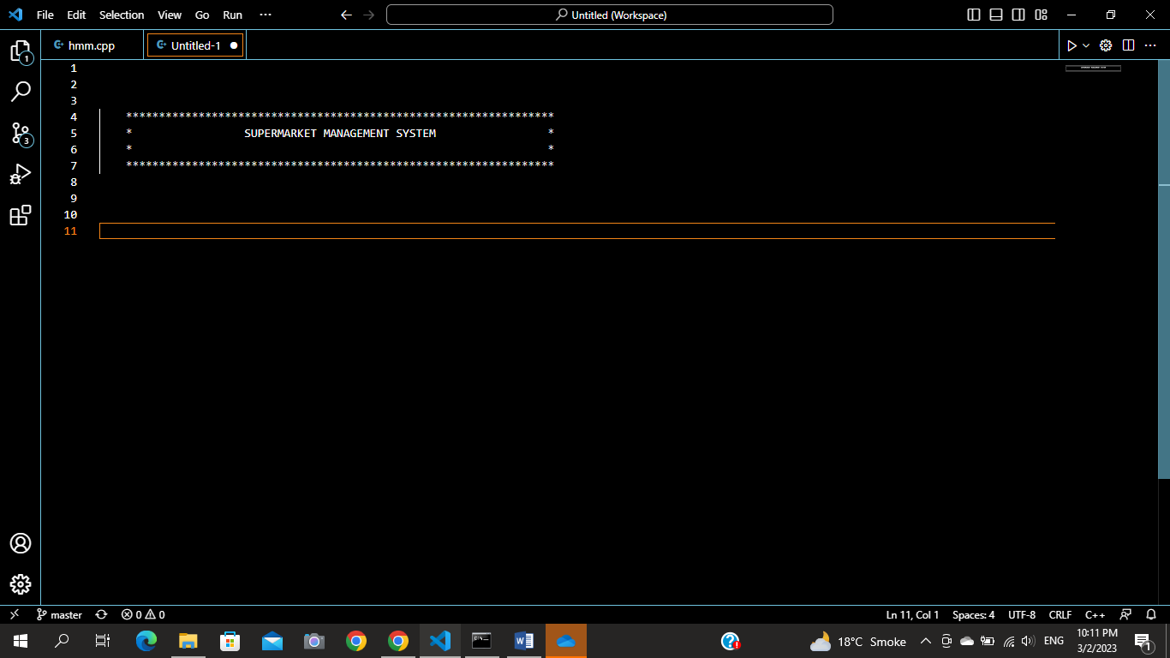

Figure 1: Header

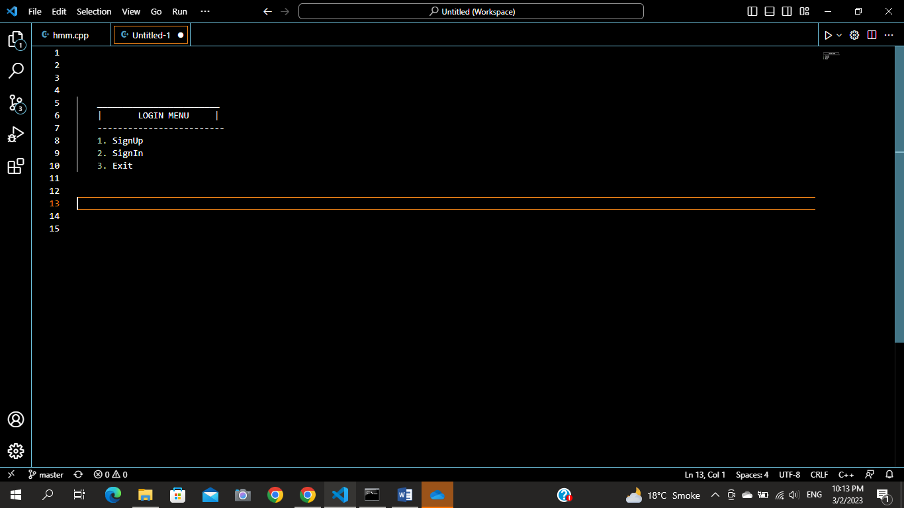

Figure 2: LOGIN MENU

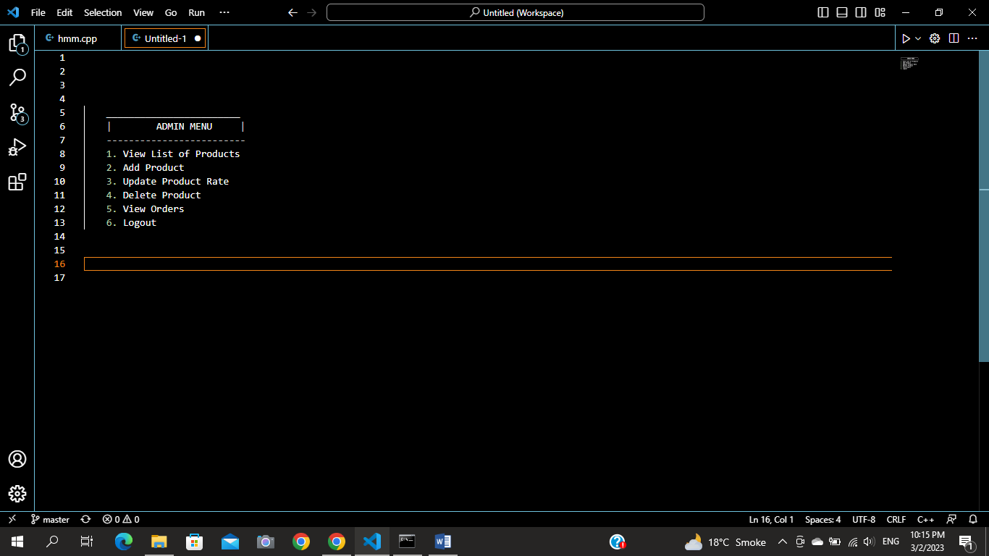

Figure 3: ADMIN MENU

Figure 4: Main Menu

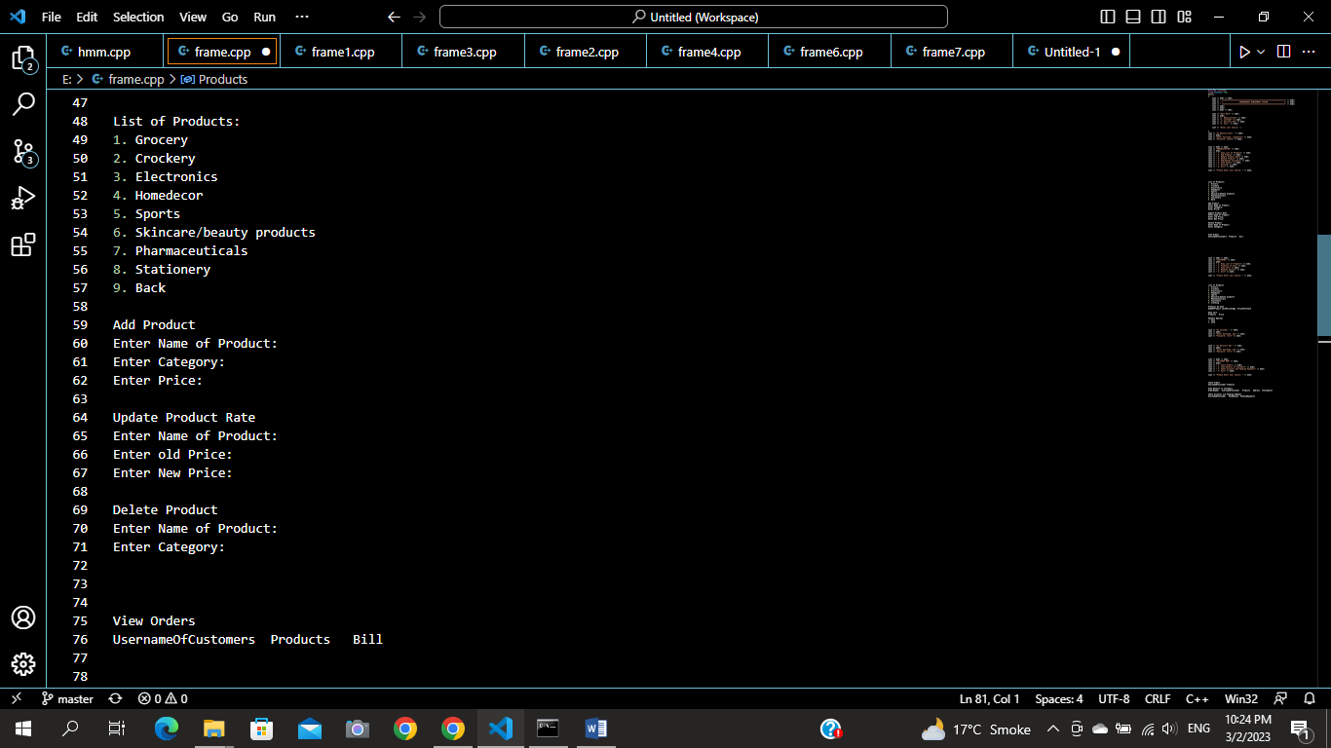

Figure 5: ADMIN OPTIONS

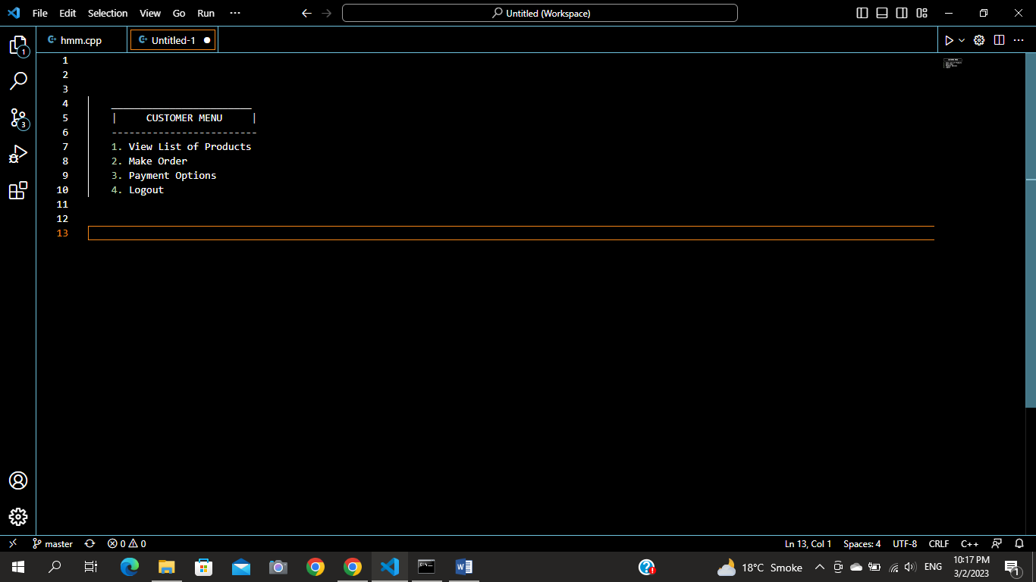

Figure 5: CUSTOMER MENU

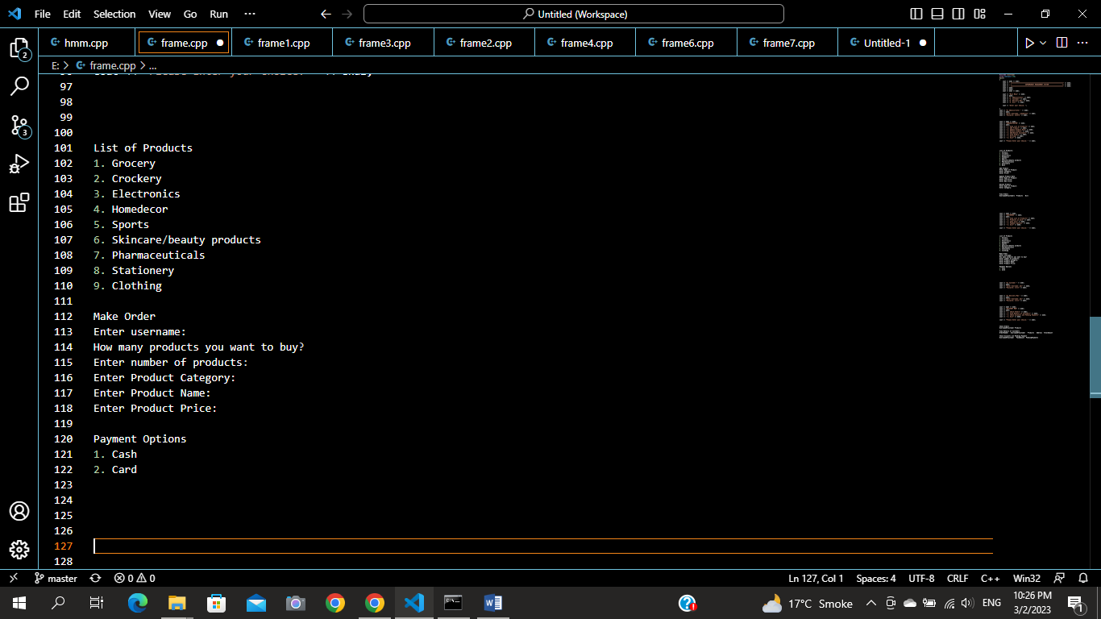

Figure 6: CUSTOMER OPTIONS

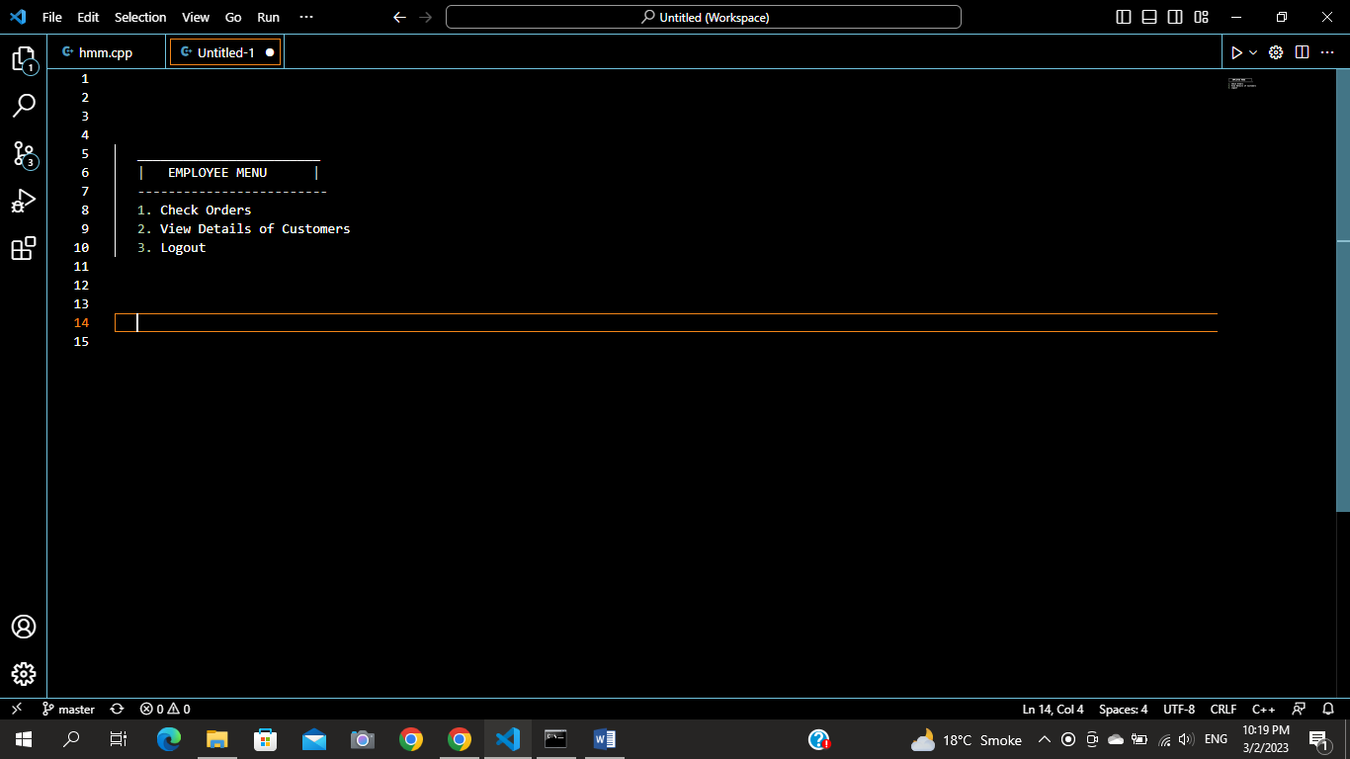

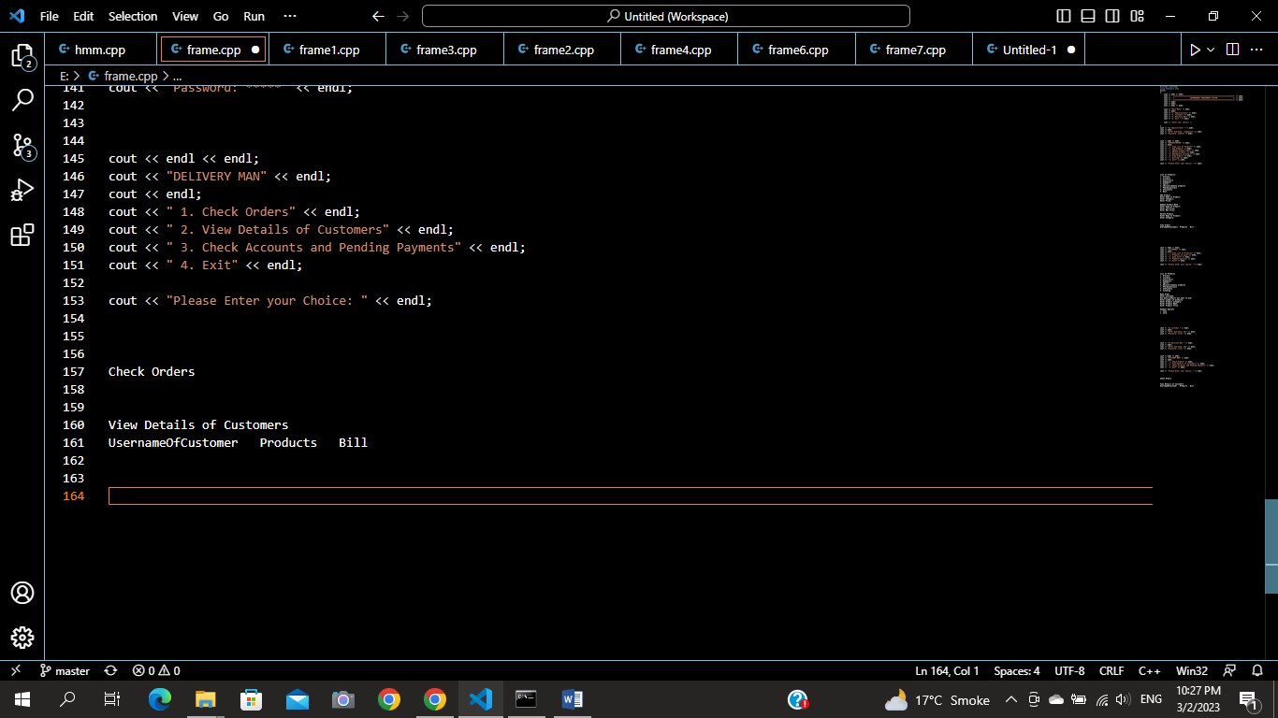

Figure 7: EMPLOYEE MENU

Figure 8: EMPLOYEE OPTIONS

**Data Structures:**

The data structures used in my application are parallel arrays and variables.

* string users[arrSize];
* string passwords[arrSize];
* string roles[arrSize];
* string customerOrders[orderSize];
* string customerUserNAmes[orderSize];
* int customerBills[orderSize];
* string categories[size];
* string productName[size];
* int productPrice[size];
* bool flag = false;
* const int arrSize = 100;
* int productCount = 210;
* int count = 0;
* const int size = 300;
* const int orderSize = 100;
* int orderCount = 0;

**Function Prototypes:**

The functions used in my application are:

* void clearScreen();
* void header();
* int loginMenu();
* bool signIn(string username, string password);
* void signUp(string username, string password, string role);
* void storeLogInData(string username, string password, string role);
* void loadLogInData();
* string getParse(string line, int num);
* bool isValid(string username);
* string getRole(string username);
* void adminInterface();
* void customerInterface();
* void employeeInterface();
* void adminChoice();
* void customerChoice();
* void employeeChoice();
* void category();
* void addProduct();
* bool checkProductUpdate(string pName);
* void updateProductPrice();
* bool checkProductPriceUpdate(string pName, int newPrice);
* void deleteProduct();
* bool checkProductDelete(string pCategory, string pName);
* void storeProducts(string productCategory, string pName, int pPrice);
* void loadProducts();
* void product();
* int customerOrder();
* void addCustomerOrder(string customerName, string order, int bill);
* void storeOrders(string customerName, string order, int bill);
* void loadOrderData();
* void paymentOption();
* void checkOrder();
* void viewOrders();

**Functions Working Flow:**

main()

employeeChoice()

customerChoice()

adminChoice()

viewOrders()

checkOrders()

paymentOption()

makeOrder()

products()

viewOrders()

deleteProduct()

updatePrice()

products()

addProduct()

**Complete code of Business Application:**

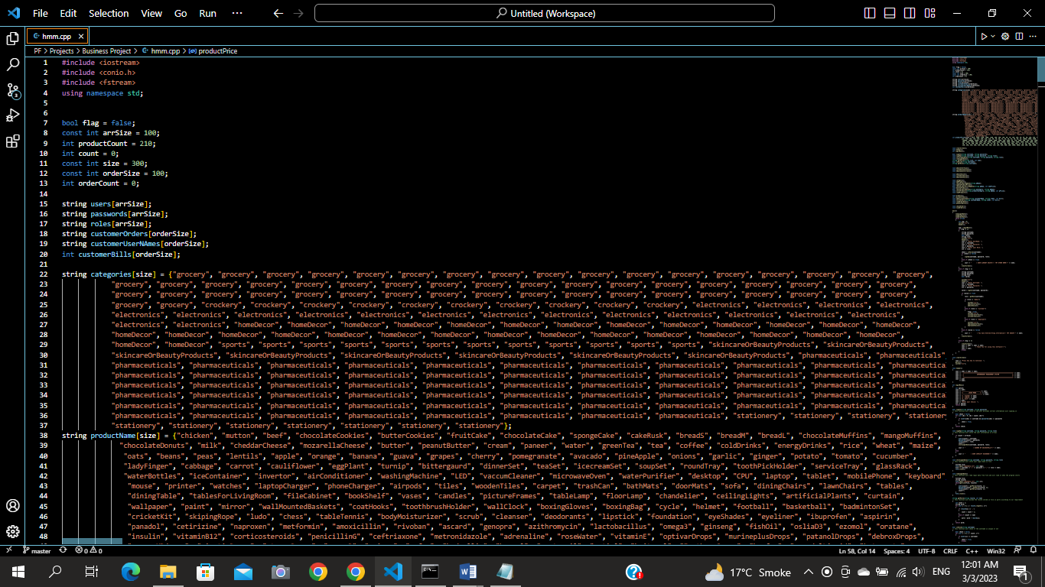

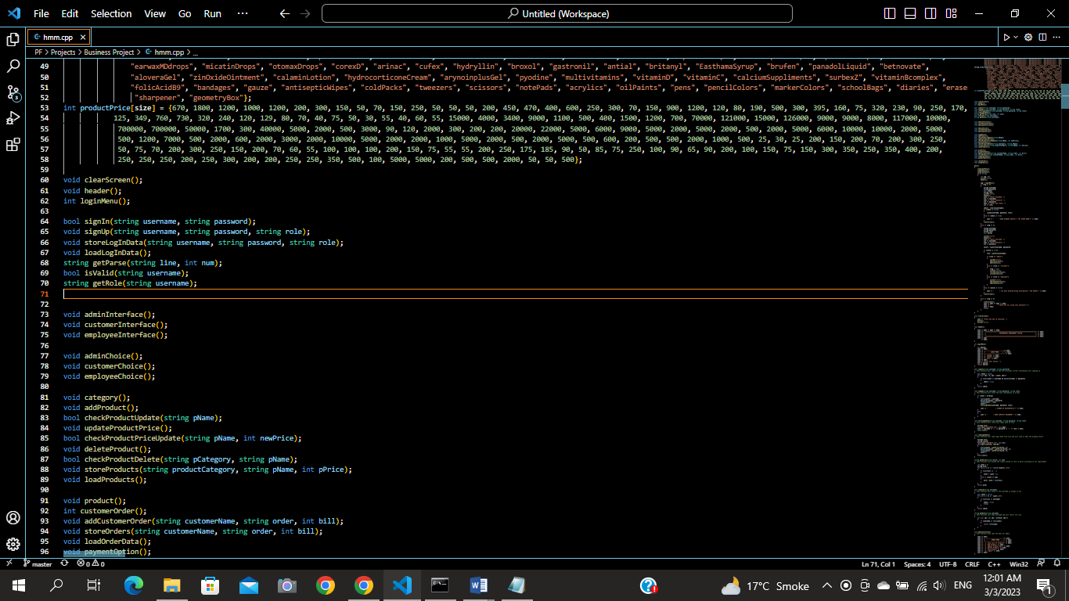

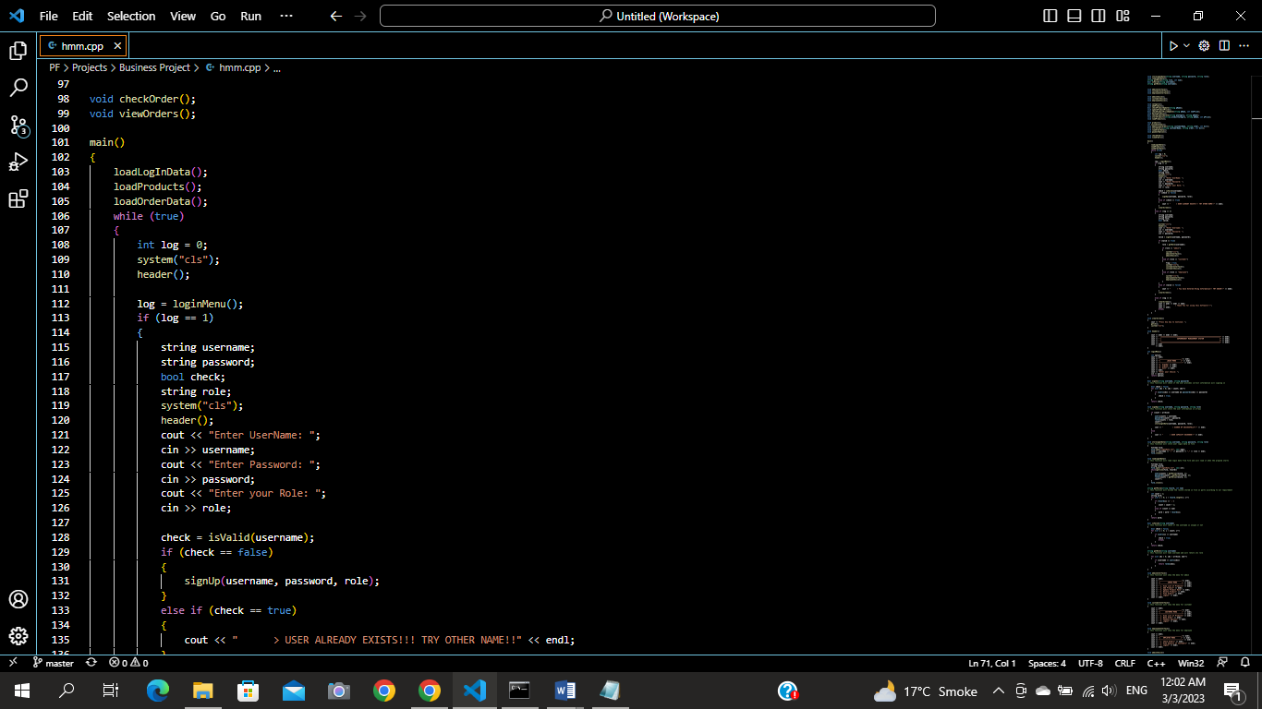

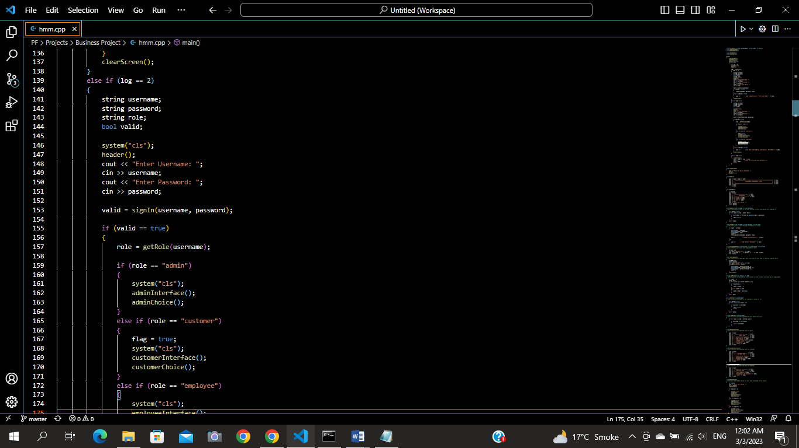

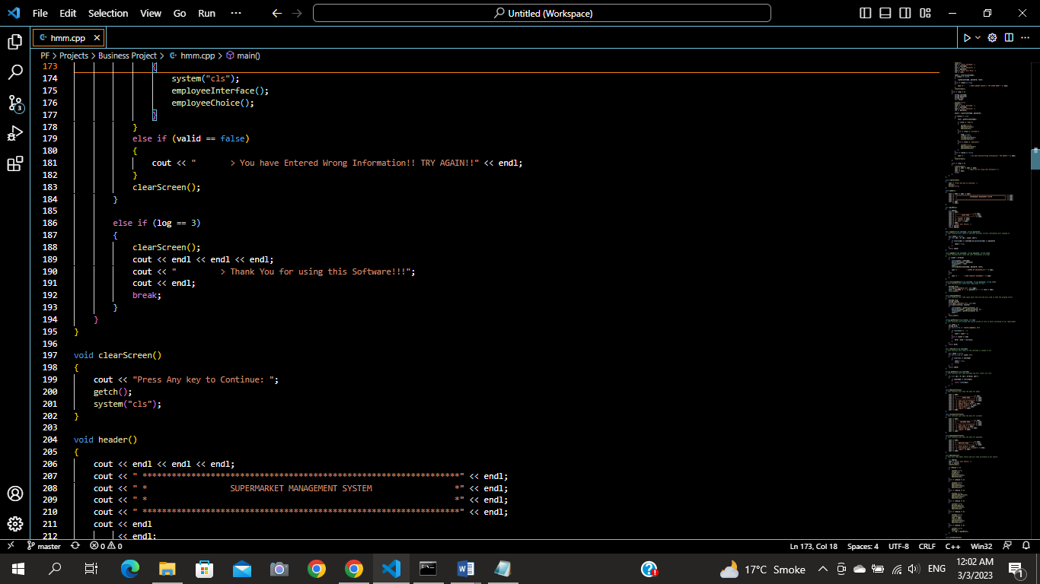

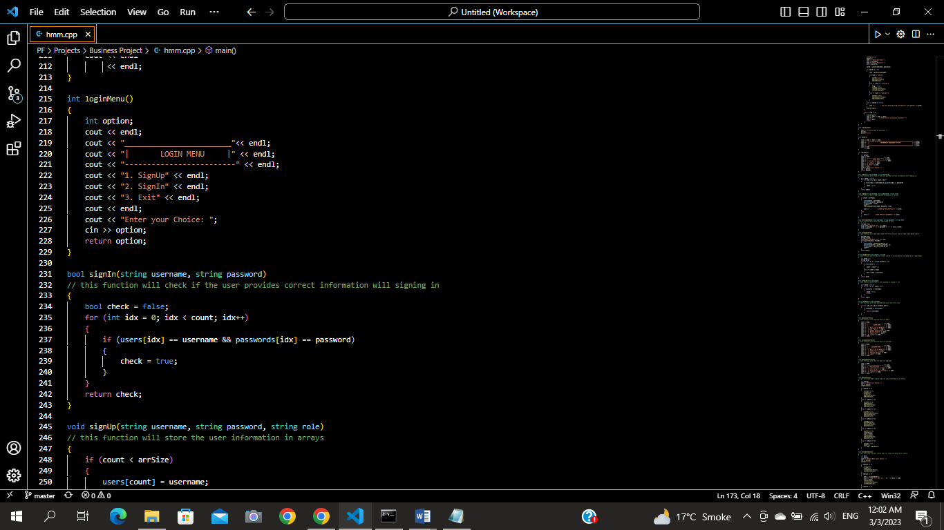

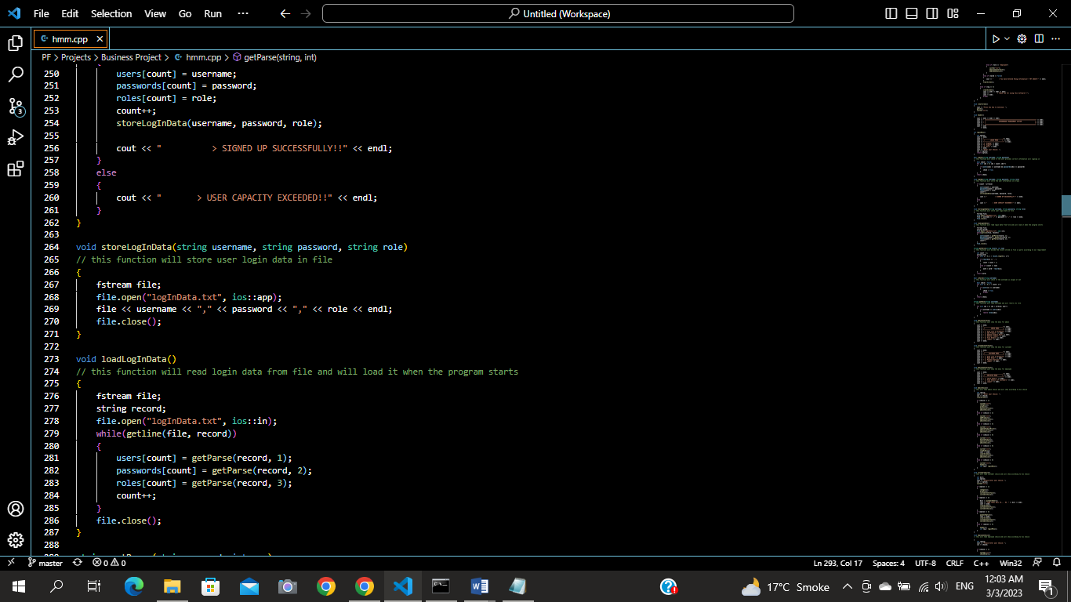

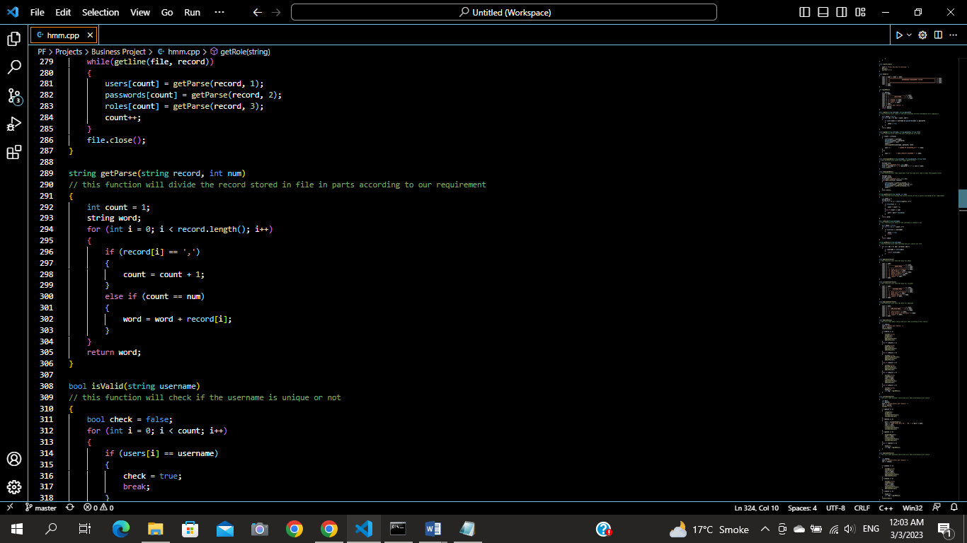

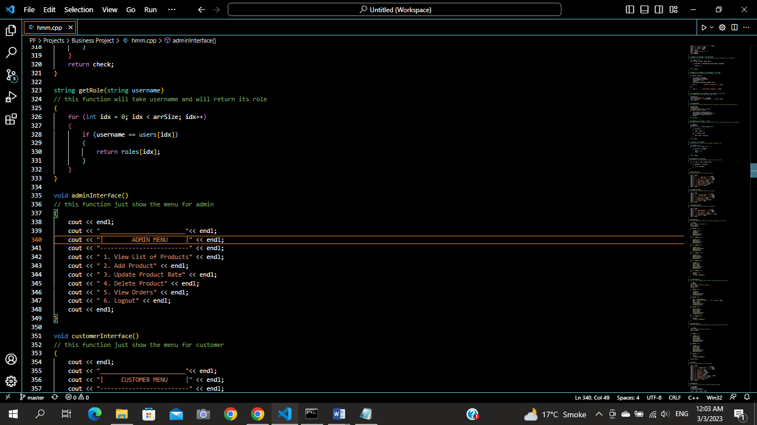

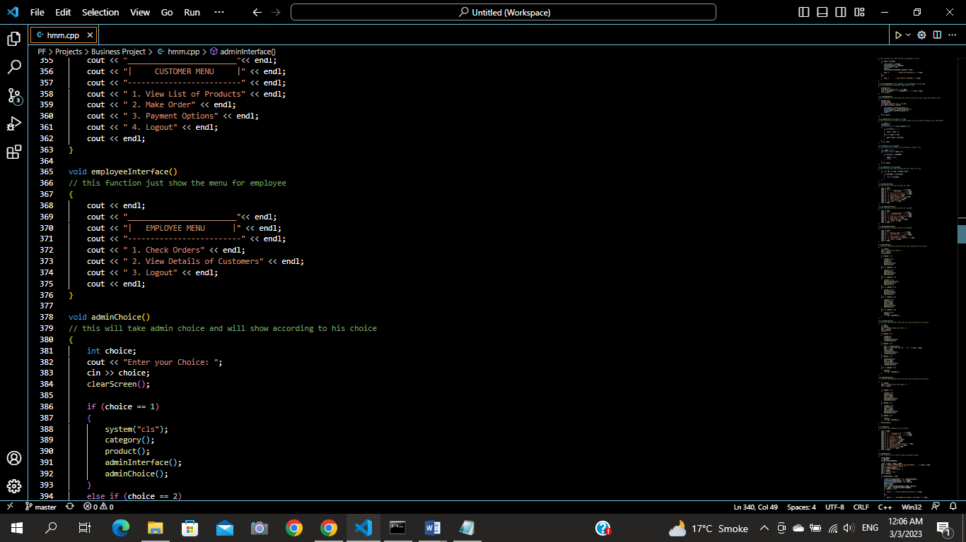

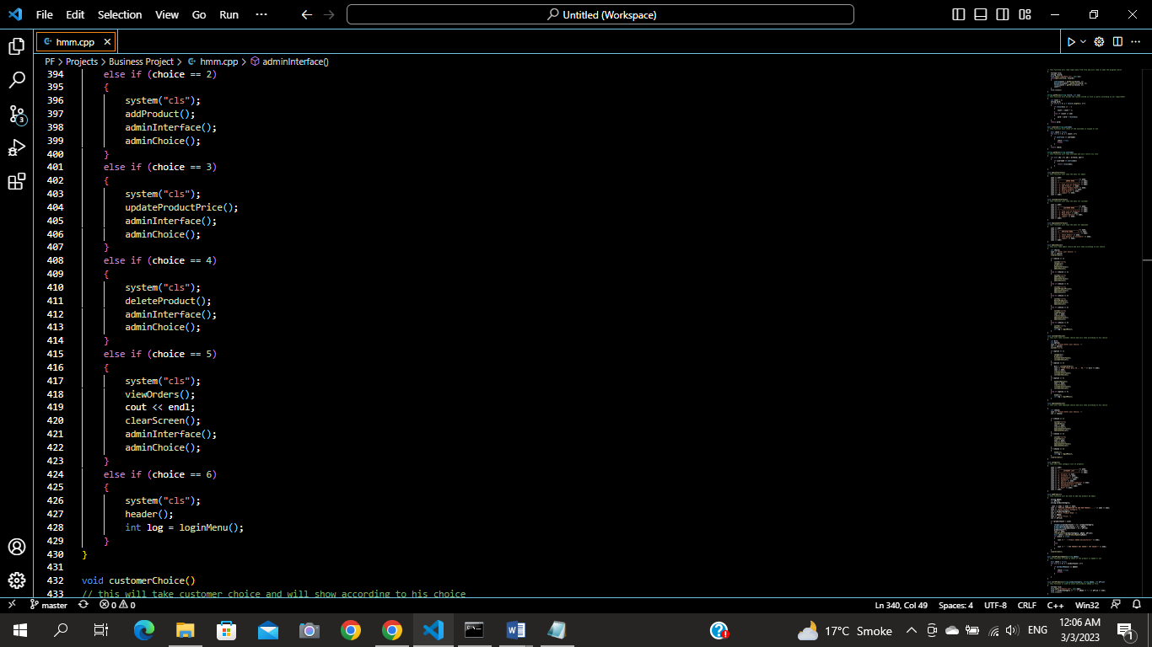

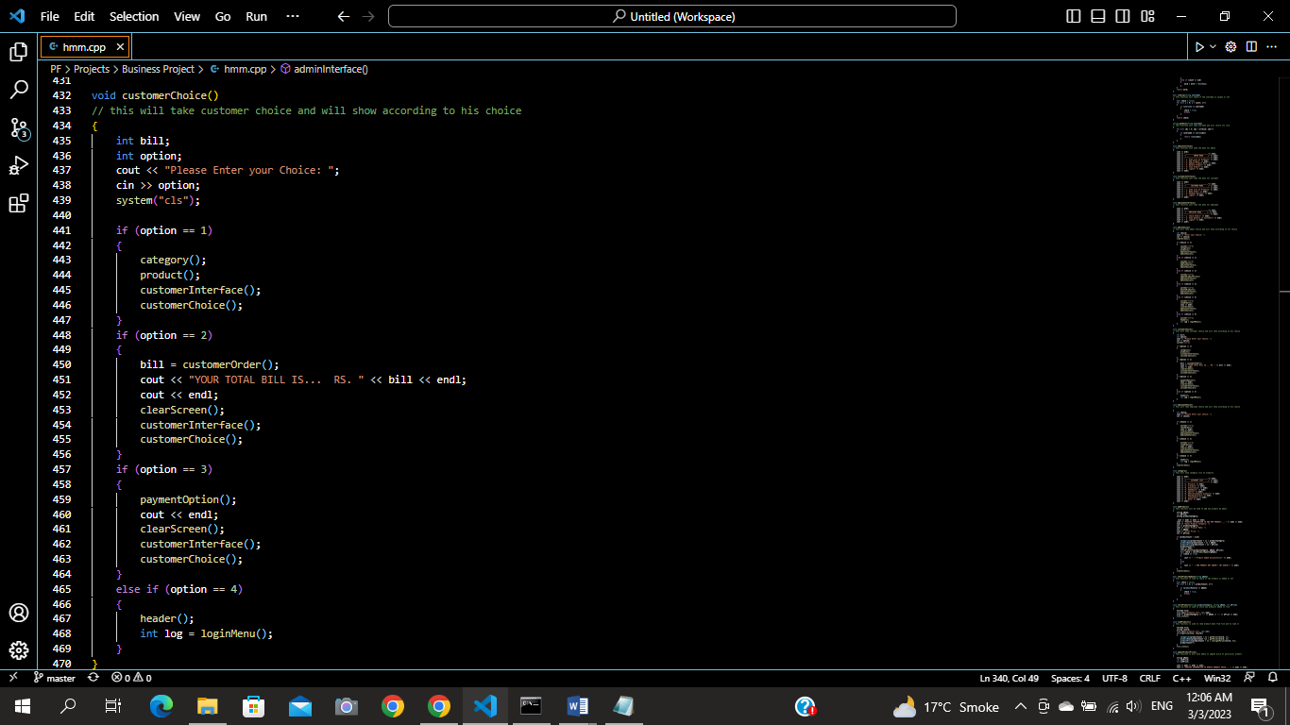

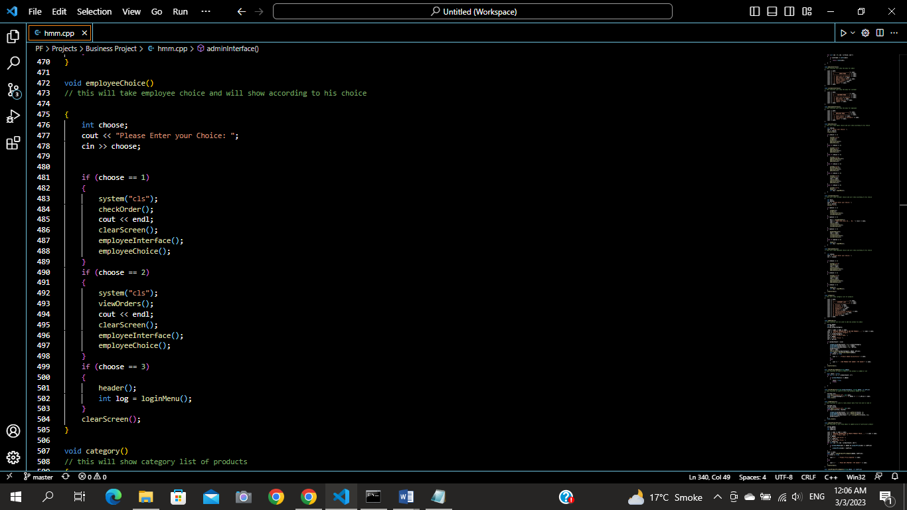

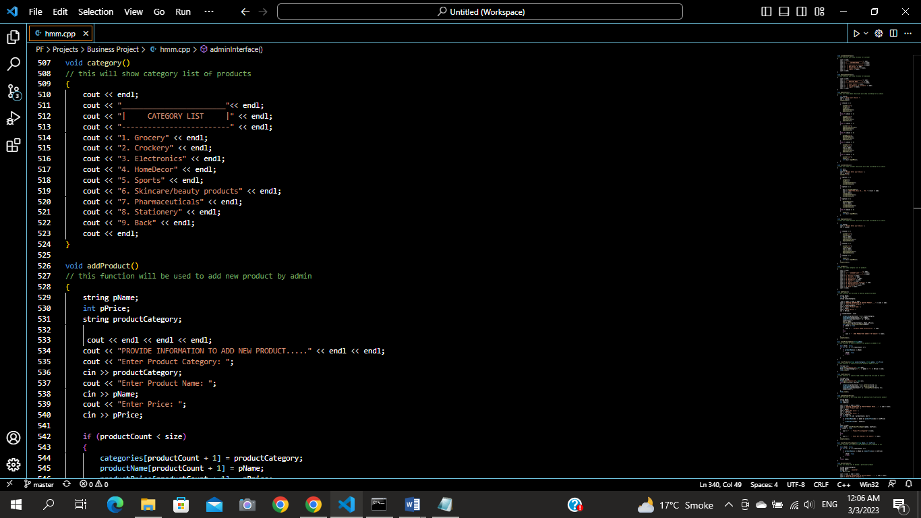

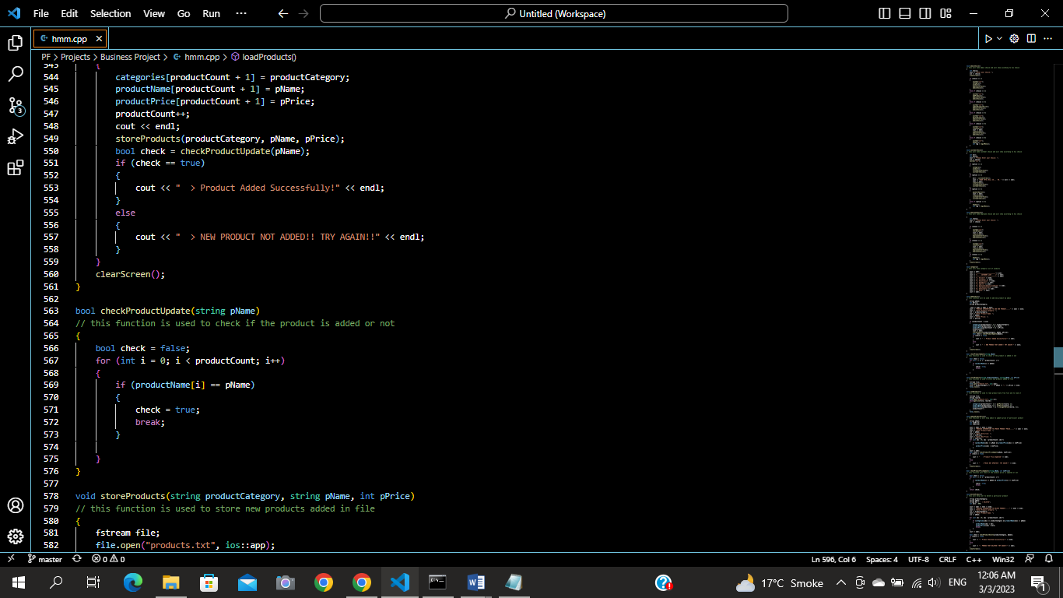

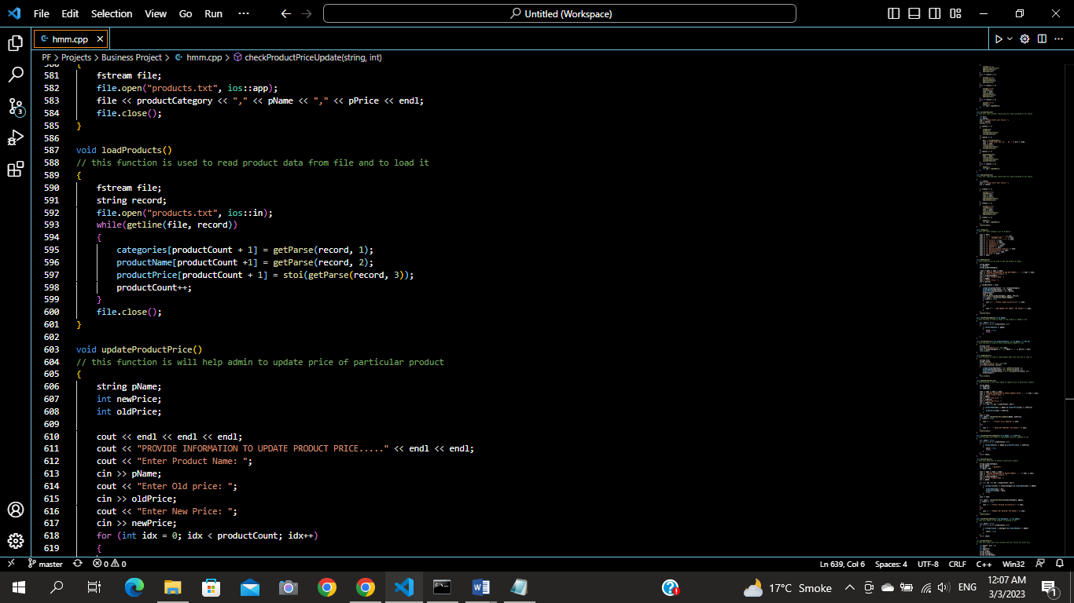

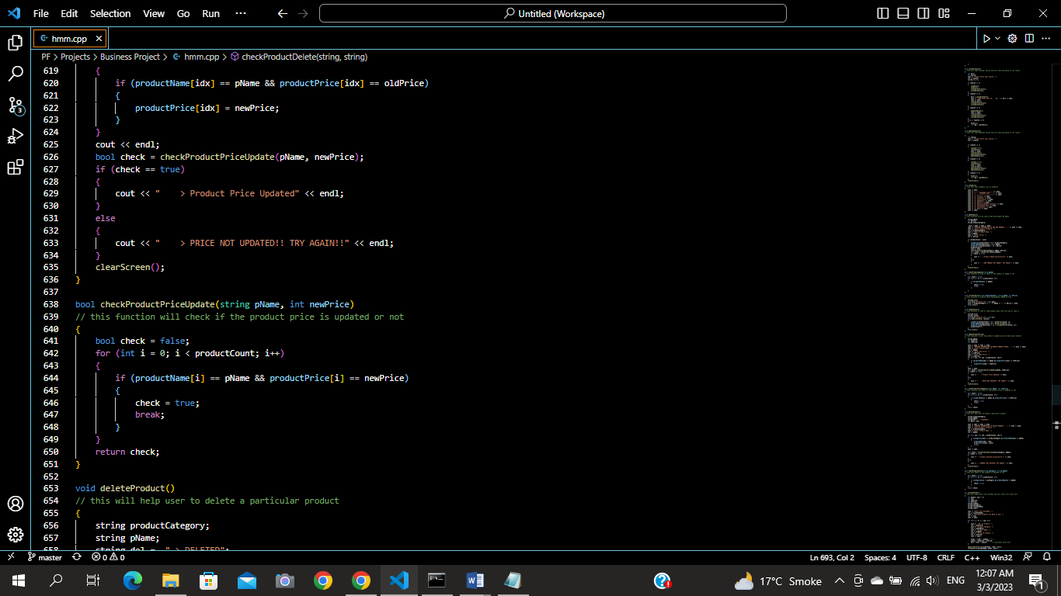

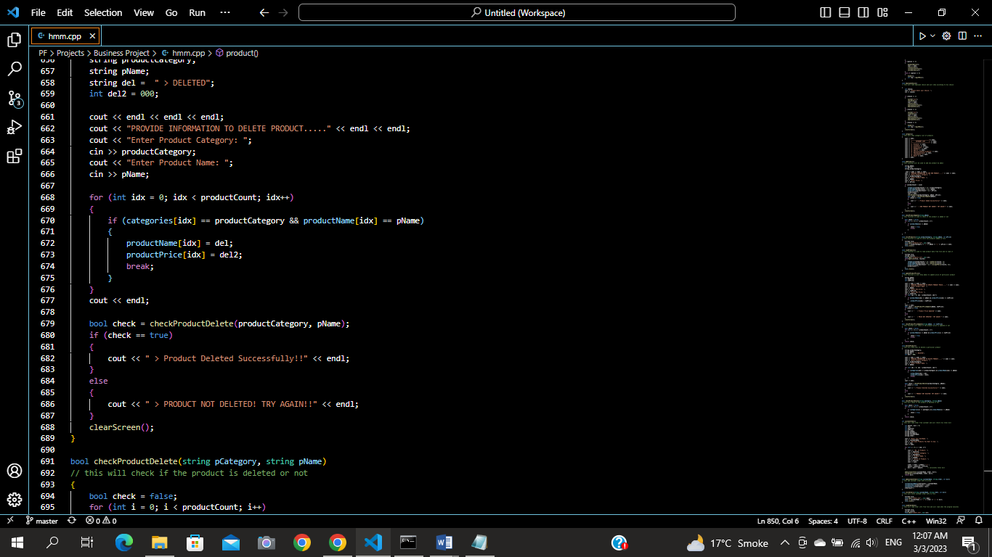

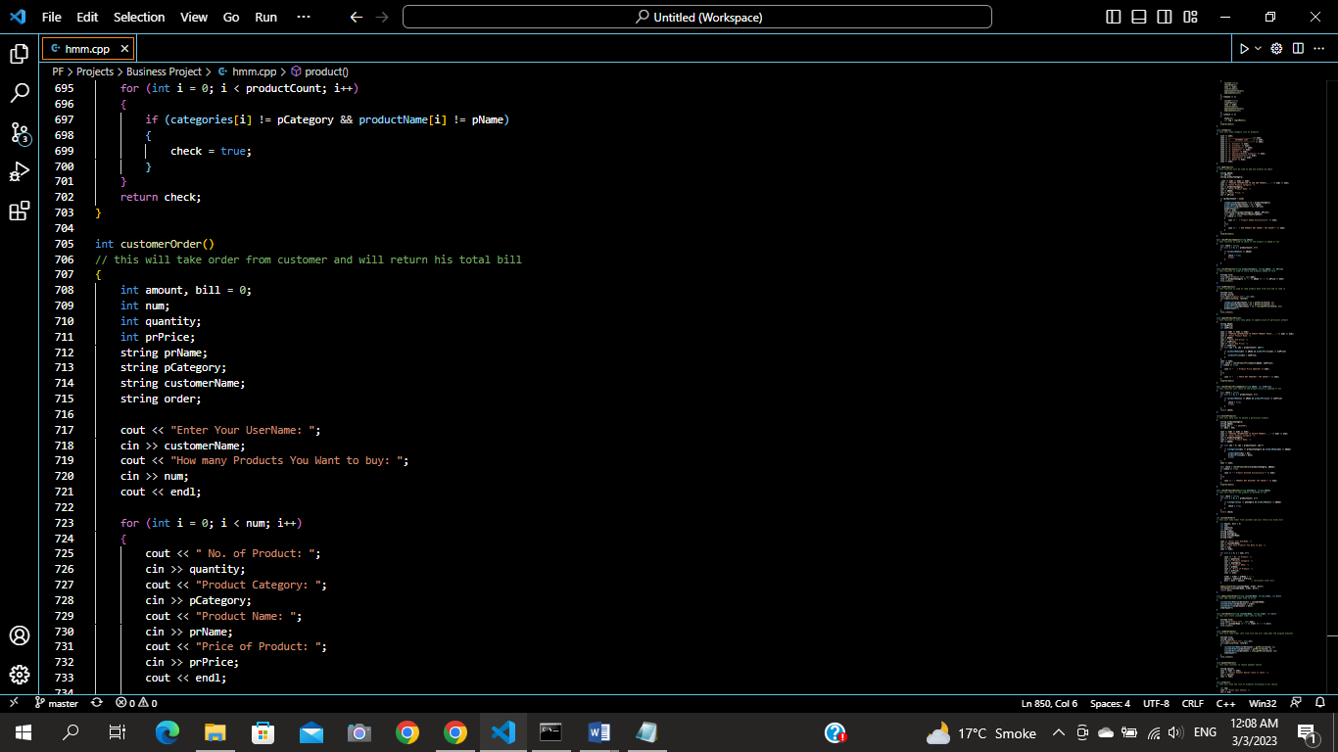

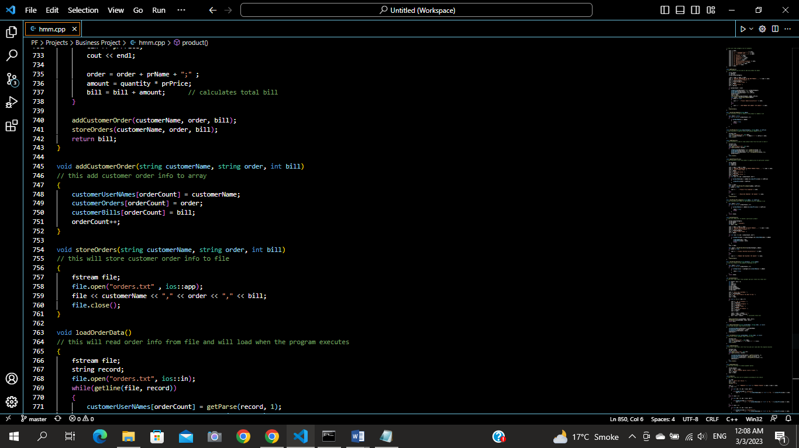

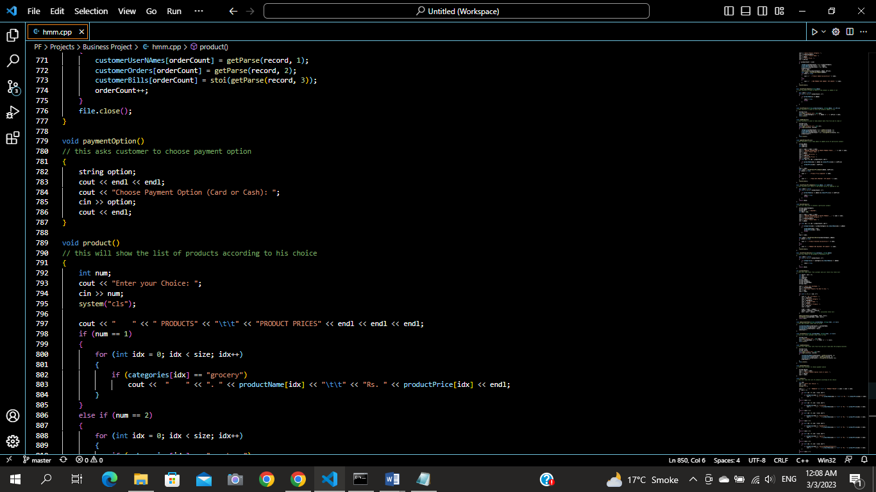

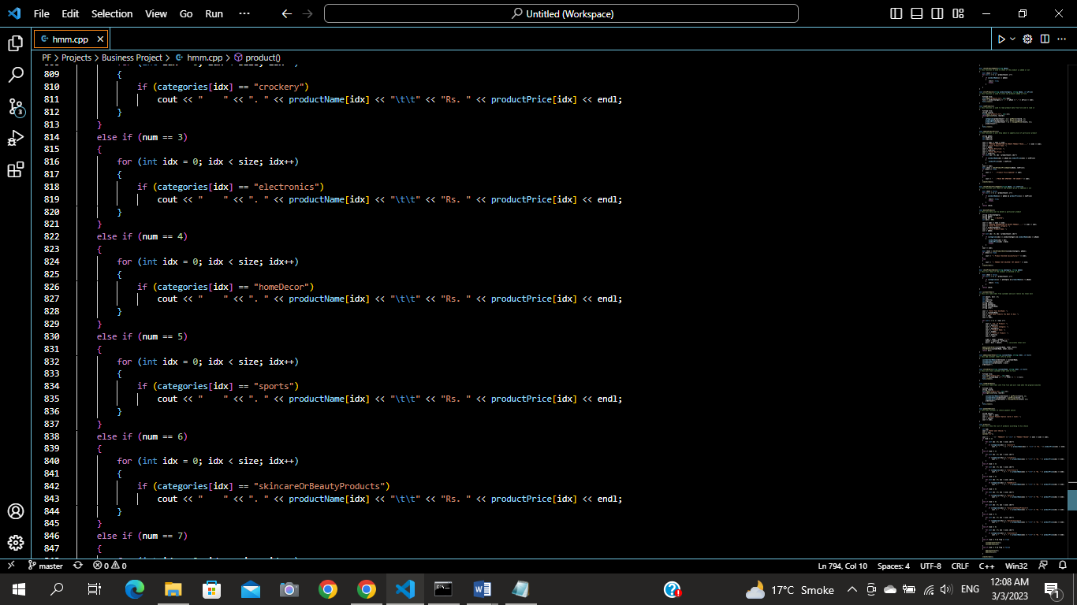

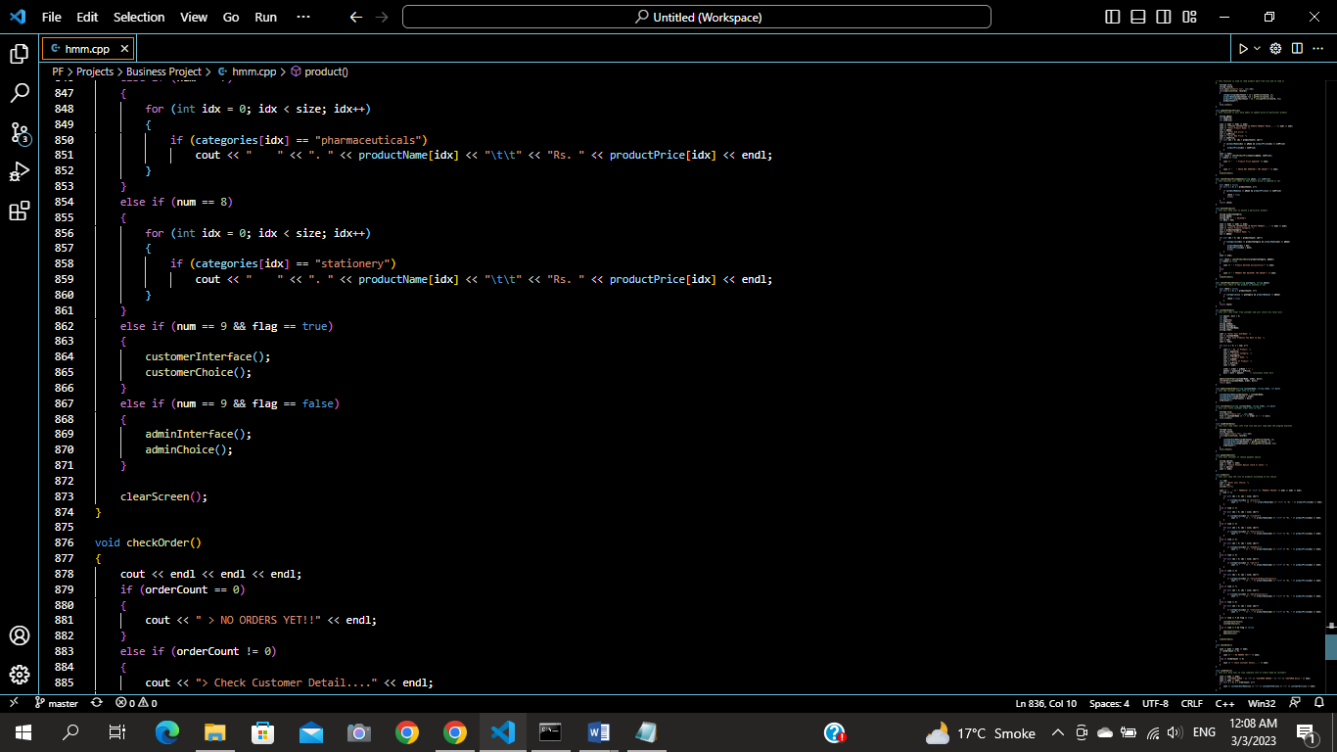

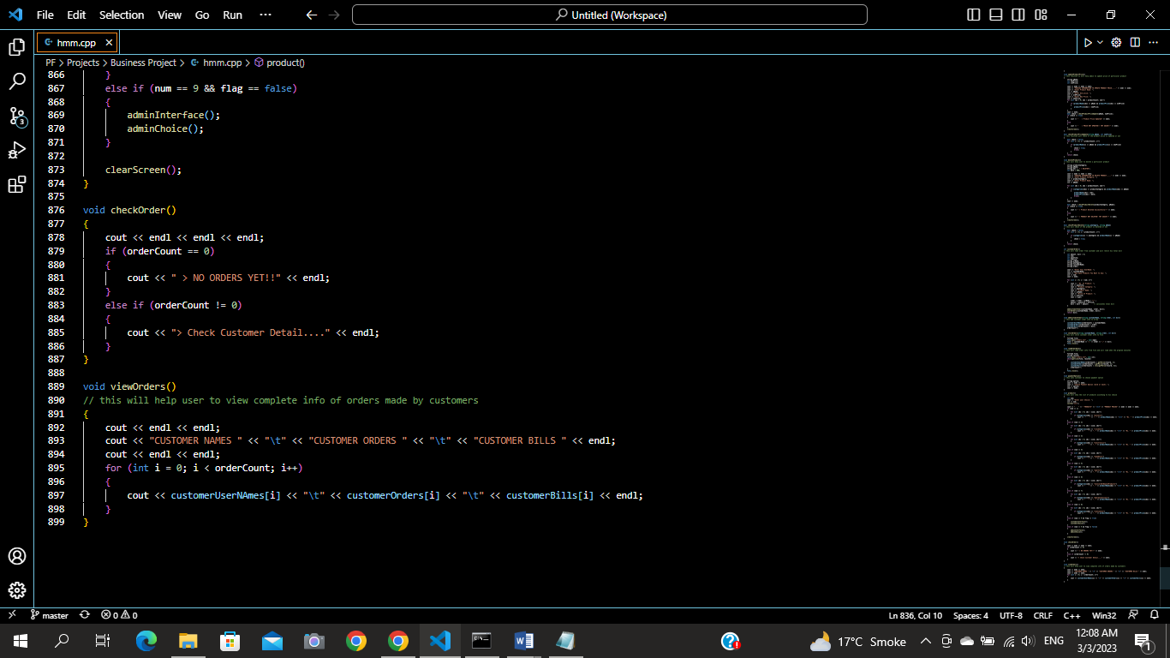

**Weakness in the Business Application:**

I tried my best but still I’m not able to delete or update products permanently though I can delete them temporarily. Sometimes the screen just blinking and the program terminates all by itself; not able to solve this problem.

## **Future Directions:**

I wanted to add much more features but at this level I can only think of different ideas but I’m not able to implement them in my business application. I hope I will add such options in my near future.