**Task # 1:**

**Procedure/Program:**

import Cocoa

var statusCode: Int = 404

var statusMessage: String

switch statusCode

{

case 400:

statusMessage = "Bad request"

case 401: statusMessage = "Unauthorized"

case 403: statusMessage = "Forbidden"

case 404: statusMessage = "Not found"

default: statusMessage = "None" }

**Result/Output:**

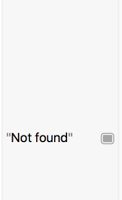

**Task # 2:**

**Procedure/Program:**

let playground = "Hello, playground"

var mutablePlayground = "Hello, mutable playground"

mutablePlayground += "!"

for c: Character in mutablePlayground

{ print("'\(c)'") }

**Result/Output:**

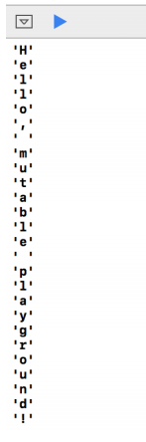

**Task # 3:**

**Procedure/Program:**

var statusCode: Int = 405

var statusMessage: String = "The request failed:"

switch statusCode {

case 400, 401, 403, 404:

statusMessage = "There was something wrong with the request."

fallthrough

default:

statusMessage += " Please review the request and try again."

}print(statusMessage)

**Result/Output:**



**Task # 4:**

**Procedure/Program:**

var statusCode: Int = 405

var statusMessage: String = "The request failed:"

switch statusCode {

case 100, 101:

statusMessage += " Informational, 1xx."

case 204:statusMessage += " Successful but no content, 204."

case 300...307:

statusMessage += " Redirection, 3xx."

case 400...417:

statusMessage += " Client error, 4xx."

case 500...505:

statusMessage += " Server error, 5xx."

default:

statusMessage = "Unknown. Please review the request and try again."

}print(statusMessage)

**Result/Output:**

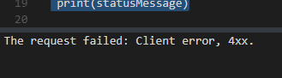

**Task # 5:**

**Procedure/Program:**

var statusCode: Int = 204

var statusMessage: String = "The request failed with the error:"

switch statusCode {

case 100, 101:

statusMessage += " Informational, \(statusCode)."

case 204:

statusMessage += " Successful but no content, 204."

case 300...307:

statusMessage += " Redirection, \(statusCode)."

case 400...417:

statusMessage += " Client error, \(statusCode)."

case 500...505:

statusMessage += " Server error, \(statusCode)."

case let unknownCode where (unknownCode >= 200 && unknownCode < 300)

|| unknownCode > 505:

statusMessage = "\(unknownCode) is not a known error code."

default:

statusMessage = "\(statusCode) is not a known error code."

statusMessage = "Unexpected error encountered."

}print(statusMessage)

**Result/Output:**

