**Task # 1:** Introduction to Swift language syntax:

**Procedure/Program:**

import Foundation

//Variable decleration

var str = "Hello"

var number: Int = 5

let myConstant = 10 //Constant

//Print statement

print("\(str) world!")

number += 1

print("Number: \(number)")

//If-else statement

if number == 6 {

print("Number is equal to 6")

} else {

print("Number is not equal to 6")

}

//For loop

for i in 0 ... 10 {

if i % 2 == 0 {

print("\(i) is even")

} else {

print("\(i) is odd")

}

}

**Result/Output:**

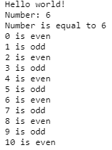

**Task # 2:** Write a program to check which TextField has a greater value:

**Procedure/Program:**

import UIKit

class ViewController: UIViewController {

@IBOutlet weak var t1: UITextField!

@IBOutlet weak var t2: UITextField!

@IBOutlet weak var l1: UILabel!

override func viewDidLoad() {

super.viewDidLoad()

// Do any additional setup after loading the view, typically from a nib.

}

@IBAction func b1(_ sender: Any) {

If Int(t1.text!) ?? 0 > Int(t2.text!) ?? 0 {

l1.text = "Textbox one is greater."

} else {

l1.text = "Textfield two is greater."

}

}

}

**Result/Output:**

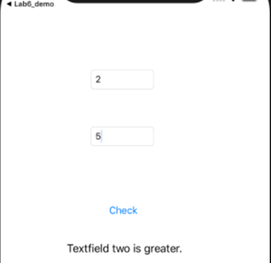

**Task # 3:** Use the properties of TextField:

**Procedure/Program:**

import UIKit

class ViewController: UIViewController {

override func viewDidLoad() {

super.viewDidLoad()

}

@IBOutlet weak var t1: UITextField!

@IBOutlet weak var t2: UITextField!

@IBOutlet weak var t3: UITextField!

@IBOutlet weak var t4: UITextField!

@IBOutlet weak var t5: UITextField!

@IBOutlet weak var t6: UITextField!

@IBAction func b1(_ sender: Any) {

if t1.text == "" || t2.text == "" || t3.text == "" || t4.text == "" || t5.text == "" || t6.text == "" {

let alert = UIAlertController(title: "Alert!", message: "Provide Credentials", preferredStyle: .alert)

alert.addAction(UIAlertAction(title: "OK", style: .default, handler: nil))

present(alert, animated: true, completion: nil)

} else {

let alert = UIAlertController(title: "Alert!", message: "Thank you!", preferredStyle: .alert)

alert.addAction(UIAlertAction(title: "OK", style: .default, handler: nil))

present(alert, animated: true, completion: nil)

}

}

}

**Result/Output:**

