**Task # 1:** Design an interface:

**Result/Output:**

 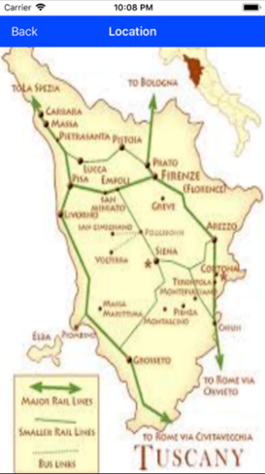

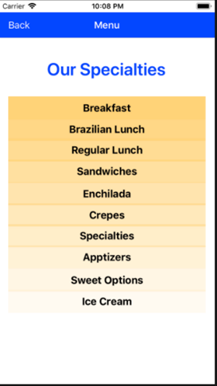 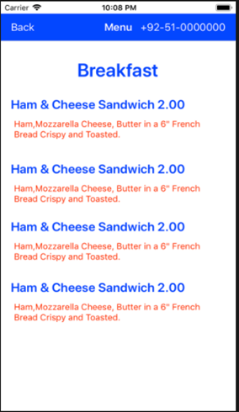

**Task # 2:** Introduction to arrays and functions in Swift:

**Procedure/Program:**

import Foundation

var arr = [Int]() //or var arr: [Int] = []

arr.append(1)

arr.append(2)

arr.append(3)

arr.append(4)

arr.append(5)

print("Count: \(arr.count)")

for i in arr {

if i%2 == 0 {

print("\(i) is even")

} else {

print("\(i) is odd")

}

}

var arr2: [Int] = [23, 4, 3, 5, 66, 7, 80]

arr2.remove(at: 0)

print(arr2)

func getWater(amount: Int, numberOfBottles: Int) -> String {

print("Go to Store.")

print("How many bottles needed: \(numberOfBottles)")

print("Buy and get the change: \(amount - numberOfBottles * 30) ")

return "Thank You!!"

}

print(getWater(amount: 100, numberOfBottles: 2))

**Result/Output:**

