**Task 1:**

*//*

*// ViewController.swift*

*// lab11*

*//*

*// Created by OCLAB1 on 11/29/18.*

*// Copyright © 2018 OCLAB1. All rights reserved.*

*//*

**import** UIKit

**class** ViewController: UIViewController,UIImagePickerControllerDelegate,UINavigationControllerDelegate {

*//*

**let** imagepicker = UIImagePickerController()

**let** imagepicker1 = UIImagePickerController()

**@IBAction** **func** show(**_** sender: **Any**)

{

imagepicker.sourceType = .camera

imagepicker.allowsEditing=**true**

present(imagepicker, animated: **true**, completion: **nil**)

}

**@IBOutlet** **weak** **var** image1: UIImageView!

**override** **func** viewDidLoad()

{

**super**.viewDidLoad()

*//access and power provided to imagepicker*

imagepicker.delegate=**self**

imagepicker1.delegate=**self**

}

*//to take a pic from the media*

**func** imagePickerController(**_** picker: UIImagePickerController, didFinishPickingMediaWithInfo info: [UIImagePickerController.InfoKey : **Any**])

{

*//get pic*

**let** usrimg=info[UIImagePickerController.InfoKey.originalImage] **as**? UIImage

*//save it in imageview*

image1.image=usrimg

*//save imageview*

}

**@IBAction** **func** photo(**_** sender: **Any**) {

imagepicker1.sourceType = .photoLibrary

imagepicker1.allowsEditing=**true**

present(imagepicker1, animated: **true**, completion: **nil**)

}

}

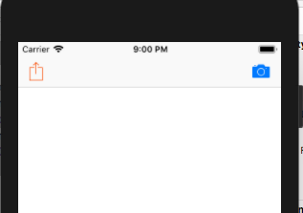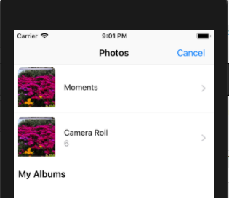

**Task2:**