**Lab # 1: PROGRAMMING FUNDAMENTALS**

**Objectives:**

* **Basics of C++ programming.**
* **Structure of computer programming.**

**Tools Used:**

* **Visual studio.**

**Submission Date:**

**Evaluation: Signatures of Lab Engineer:**

**Task # 1: Give output of some programs.**

**Procedure/Program:**

1. **First we understand that what we want to do in the C++ program.**
2. **According to that we set the mind that we program the C++ program.**
3. **Then we open the compiler and introduce some header files which is the requirement of the program.**
4. **In body of the program we introduce the data according to the requirement of the question.**

**PROGRAM (a) :**

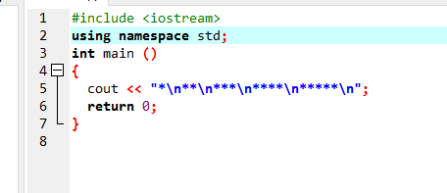

**OUTPUT:**

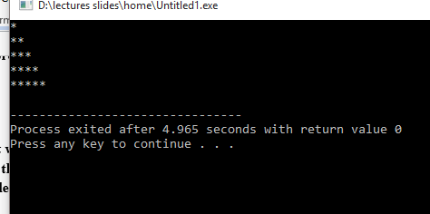

**PROGRAM (b):**

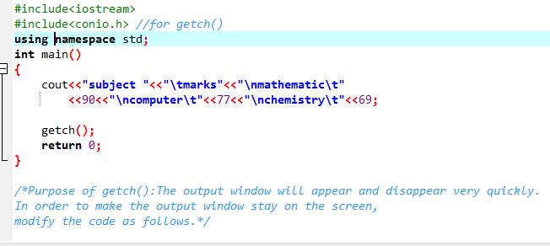

**OUTPUT:**

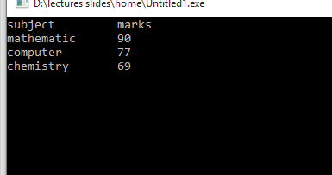

**PROGRAM (c):**

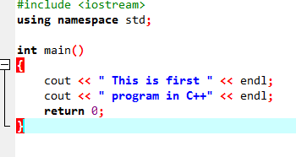

**OUTPUT:**

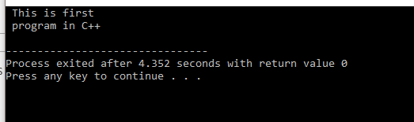

* **In case when we change cout with couts then the program shows error like this.**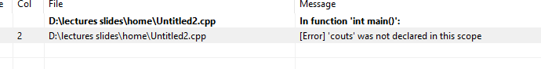
* **If we eliminate the semicolon then it shows errors.**

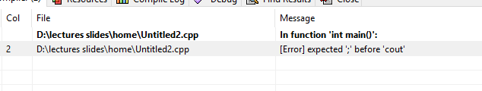

* **If we eliminate the return 0 from the program then it can’t show error.**

|  |  |
| --- | --- |
| **Program:** | **OUTPUT:** |

**Task 2: Write a program which prints your name, your roll no, FSC Marks on screen.**

**Program:**

**Output:**

**Task 3 : Write a program that prints a square as follows :**

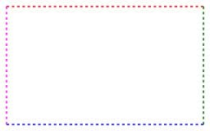

|  |  |
| --- | --- |
| **Program:** | **Output:** |

**Task 4 : Write a program that prints a diamond as follows :**

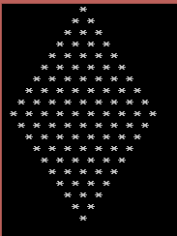

|  |  |
| --- | --- |
| **Program:** | **Output:** |

**Analysis/Conclusion:**

We can understand basics of the programming language in this lab and performed many practicals of the programs.