***COMPUTER PROGRAMMING***

***Course Code:***

***Lab Journal***



**RIDA SAJJAD**

**BSCS(2B)**

**Department of Computer Science**

**BAHRIA UNIVERSITY, ISLAMABAD**

**Lab # 2: BASIC PROGRAMMING**

**Objectives:**

* **To understand the basics of C++ programming.**
* **Learning basic structure of computer programming.**
* **Using some header files.**
* **Using cout statement.**

**Tools Used:**

* **PC with Windows 7 Professional.**
* **Using Dev C++ for programming.**

**Submission Date:**

**Evaluation: Signatures of Lab Engineer:**

**Task # 1.1: MAKE FAMILIER WITH INPUT/OUTPUT**

**Procedure/Program:**

* We write some programs to get familiar with the input and output statements.
* We use cout for getting output.
* We use cin for input the data.
* We can do calculations in these programs to make calculations.

**PROGRAM:**

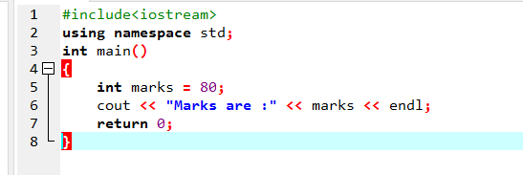

**Result/Output:**

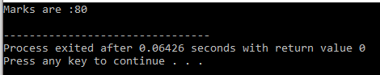

**PROGRAM:**

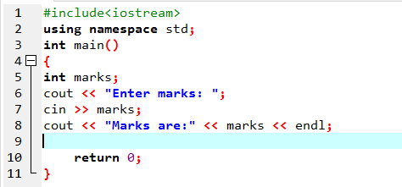

**Result/Output:**

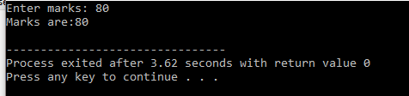

**Program:**

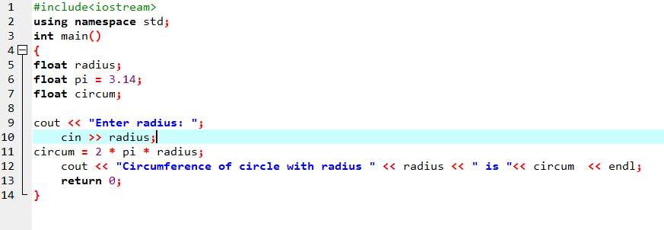

**Output:**

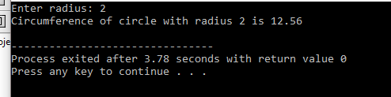

**Program:**

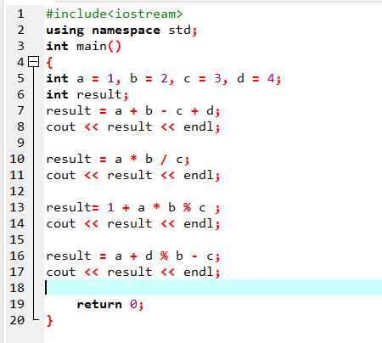

**Output:**

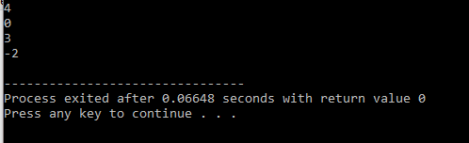

**Program:**

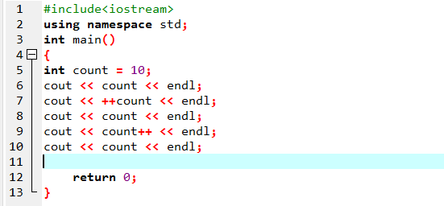

**Output:**

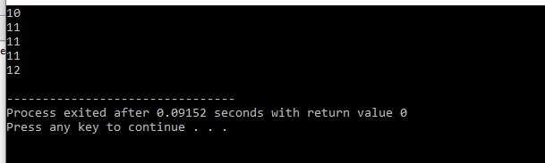

**Program:**

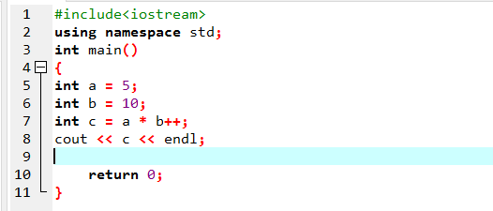

**Output:**

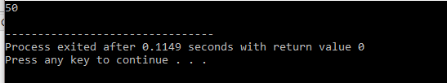

**Program:**

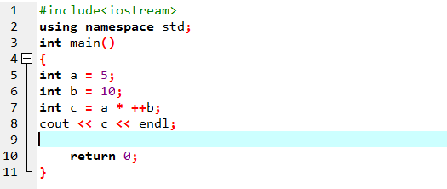

**Output:**

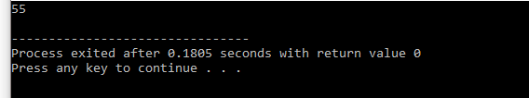

**Program:**

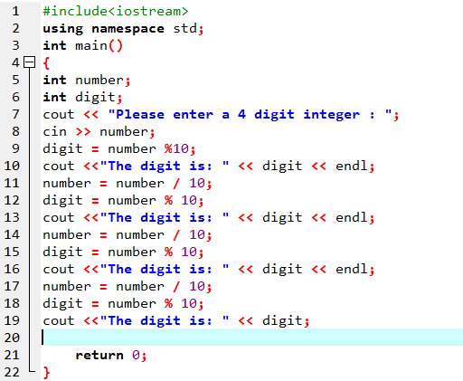

**Output:**

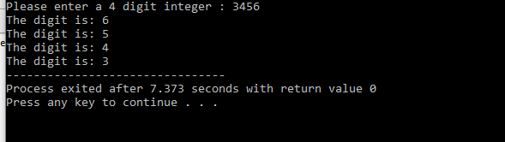

**Program:**

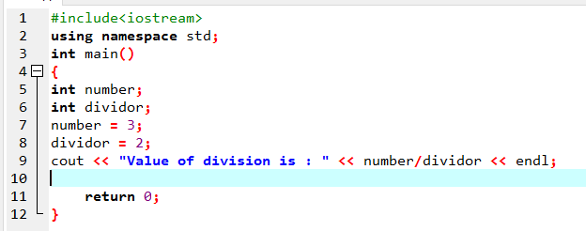

**Output:**

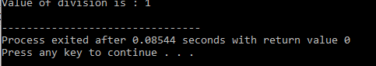

**Program:**

**If we change the data type from int to float it shows different output because float shows the value in points.**

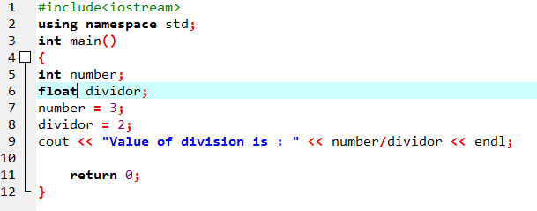

**Output:**

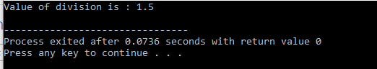

**Analysis/Conclusion:**

In this lab we came to know the use of cout or cin, entering data and also learn the use of increment or decrement operators and sum , average and other mathematical operators etc.