***COMPUTER PROGRAMMING***

***Course Code***

***Lab Journal***



**RIDA SAJJAD**

**BSCS (2B)**

**Department of Computer Science**

**BAHRIA UNIVERSITY, ISLAMABAD**

**Lab # 3:CONDITIONS IN PROGRAMMING**

**Objective:**

1) Understanding of relational and equality operators

2) Understanding Control Structures

3) Using if, if/else, nested if else statements and ternary operator

**Tools Required:**

1. PC with Windows 7 Professional
2. Visual Studio 2010

**Submission Date:**

**Evaluation: Signatures of Lab Engineer:**

**Task # 1.1: Following are the tasks which we perform the programming.**

**Procedure/Program:**

**We write program with use of if, if-else, and switch statement to form the program.**

**We show output at the end of the program.**

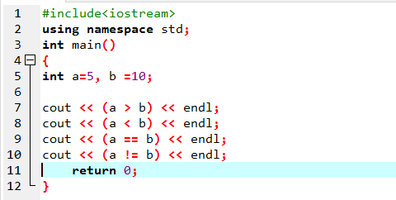

**Result/Output:**

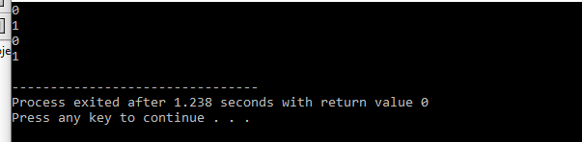

**Procedure/Program:**

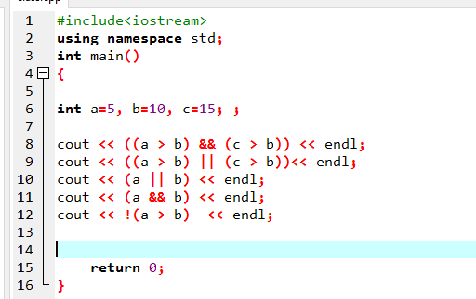

**Result/Output:**

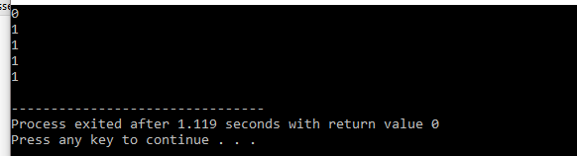

**Procedure/Program:**

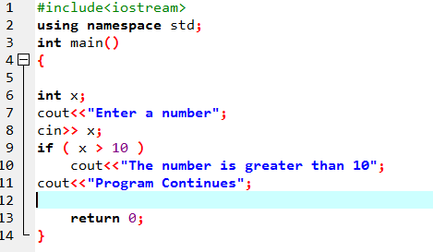

**Result/Output:**

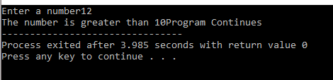

**Procedure/Program:**

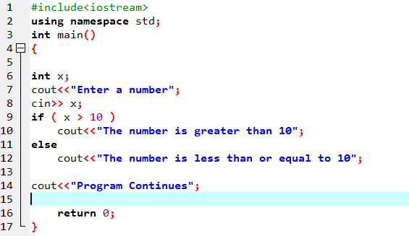

**Result/Output:**

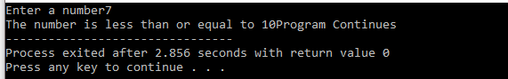

**Procedure/Program:**

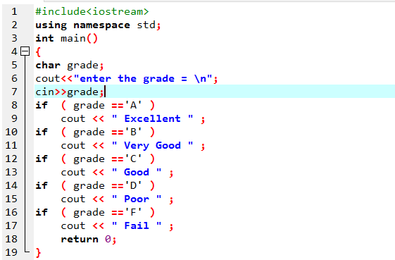

**Result/Output:**

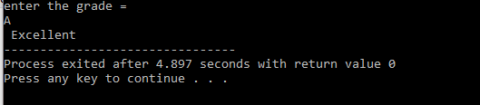

**Procedure/Program:**

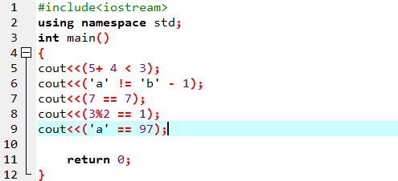

**Result/Output:**

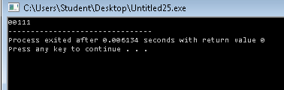

**Procedure/Program:**

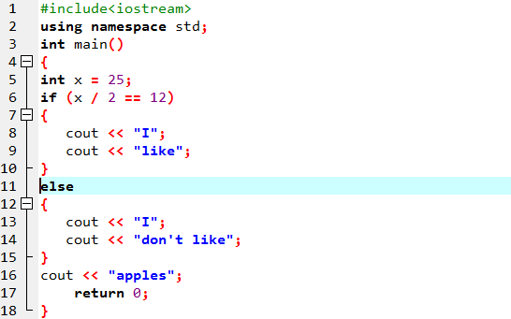

**Result/Output:**

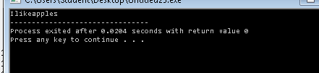

**Procedure/Program:**

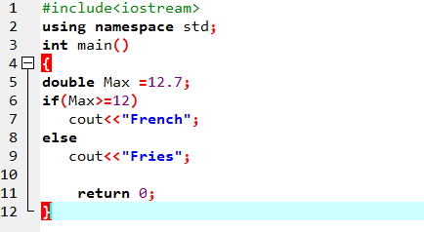

**Result/Output:**

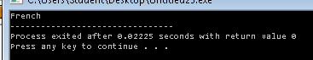

**Procedure/Program:**

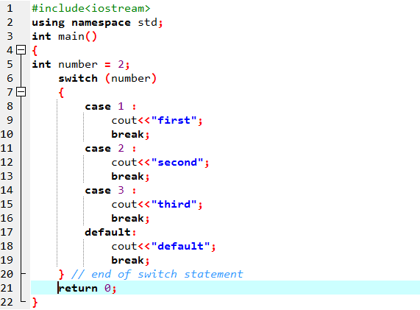

**Result/Output:**

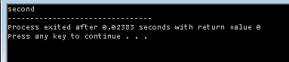

**Program:**

**Using ternary operator:**

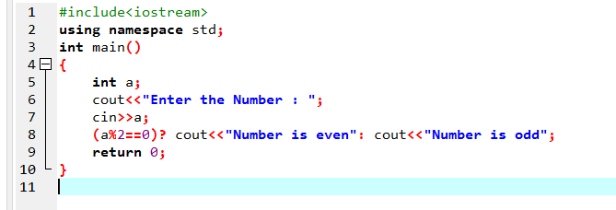

**Result/Output:**

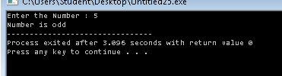

**Task 2:** Write a program in C++ **using if/else and switch statement** which asks the user to enter month number (1-12) and print the respective month such as month number 1 will display “January”**.**

**Procedure/Program:**

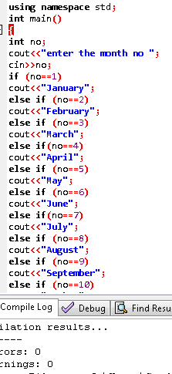

**Procedure/Program:**

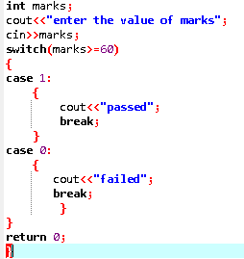

**Result/Output:**

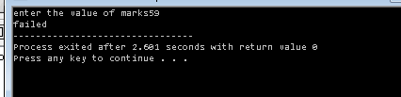

**Procedure/Program:**

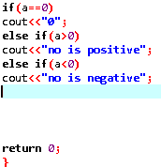

**Result/Output:**

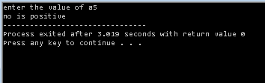

**Procedure/Program:**

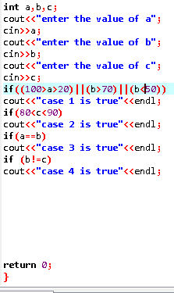

**Result/Output:**

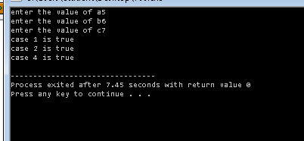

**Analysis/Conclusion:**

In these we become familiar with the if, else if or switch, mainly ternary operators.

We use all these operators when we want to give conditions to the program.