***Course Title***

***Course Code***

***Lab Journal***



**RIDA SAJJAD**

**BSCS(2B)**

**Department of Computer Science**

**BAHRIA UNIVERSITY, ISLAMABAD**

**Tools Used:**

* Visual studio 2010
* PC

**Submission Date:**

**Evaluation: Signatures of Lab Engineer:**

**Lab #4: Lab Title: LOOPS**

**Objective**

This lab will cover the loops in C++. Students will be introduced to for and while loops.

**IMPORTANT: First write the practice programs and do NOT directly jump to exercises.**

**Maintain a word file with source code and screen shots of output.**

**Task 1 :Give output of following :**

**TASK#1:**

**PROGRAM:**

#include<iostream>

#include<conio.h>

using namespace std;

void main()

{

int n=10;

for(int i=n;i>=0;i--)

cout<<"liftoff!"<<endl;

getch ();

}

**Result/output:**

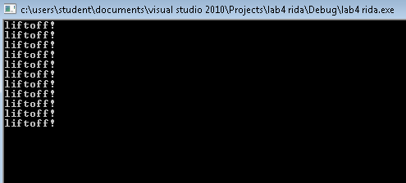

**TASK#2**

#include<iostream>

#include<conio.h>

using namespace std;

void main()

{

int n=10;

for(int i=0;i<=n;i++)

cout<<"liftoff\n";

getch ();

**Result/output:**

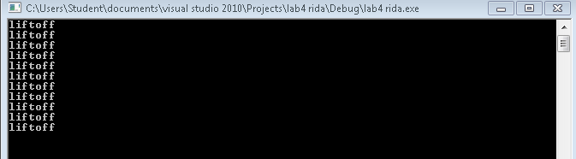

**Task#3**

#include<iostream>

#include<conio.h>

using namespace std;

void main()

{

int n=10;

while(n>0)

{

cout<<n<<",";

--n;

}

cout<<"liftoff"<<endl;

getch ();

}

**Result/output**

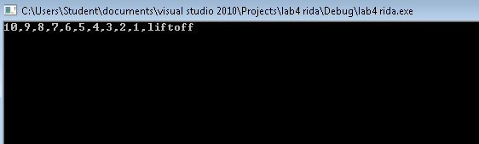

**Task#4**

#include<iostream>

#include<conio.h>

using namespace std;

void main()

{

int j;

for(j=0; j<15;j++)

cout<<"square is:"<<j*j<<endl;

cout<<endl;

getch ();

}

**Result/output:**

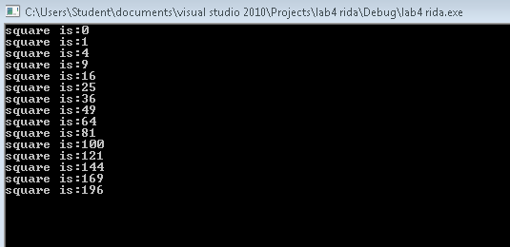

**Task #5:**

#include<iostream>

#include<conio.h>

using namespace std;

void main()

{

int cube=1;

int numb=1;

while(cube<=999)

{

cube=numb*numb*numb;

cout<<"number is:"<<numb<<endl;

cout<<"cube is:"<<cube<<endl;

numb++;

}

getch ();

}

**Result/output:**

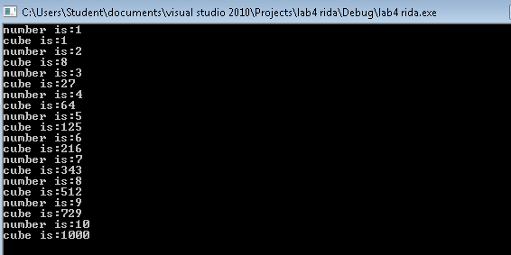

**Task#6**

#include<iostream>

#include<conio.h>

using namespace std;

void main()

{

int divident,divisor,quotient,remainder;

char ch;

do

{

cout<<"enter divident"<<endl;

cin>>divident;

cout<<"enter divisor"<<endl;

cin>>divisor;

quotient=divident/divisor;

remainder=divident%divisor;

cout<<"qoutient is="<<quotient<<endl;

cout<<"remainder is="<<remainder<<endl;

cout<<"\n do another?(y/n ):"<<endl;

cin>>ch;

}

while(ch!='n');

getch ();

}

**Result/output:**

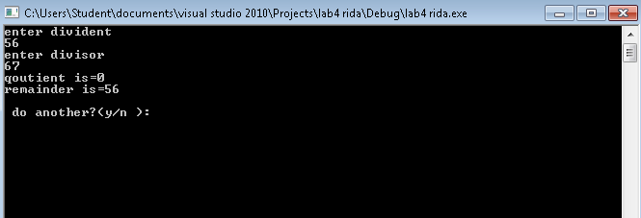

**Task#7:**

Write a program to enter marks for students in a class and compute the class average. The number of students is to be entered by the user. You may use a for loop to compute the average.

#include<iostream>

#include<conio.h>

using namespace std;

void main()

{

int m,sum=0,avg ,j;

cout<<"eneter the limit"<<endl;

cin>>j;

for(int i=1;i<=j;i++)

{

cout<<"enter the marks="<<endl;

cin>>m;

sum=sum+m;

}

avg=m/j;

cout<<"average is="<<avg<<endl;

getch ();

}

**Result/output:**

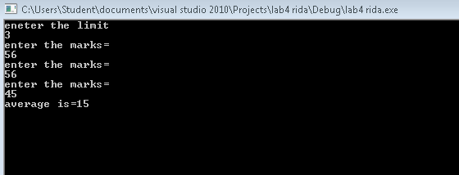

**TASK#8:**

Write a program using for loop to extract even number from the range of integers given from the keyboard and then print them on the screen. Your program output should be like:

Input starting integer: 6

Input ending integer: 12

Even numbers are: 6 8 10 12

**PROGRAM:**

#include<iostream>

#include<conio.h>

using namespace std;

void main ()

{

int n,fact=1;

cout<<"Enter any number : ";

cin>>n;

while(n>=1)

{

fact*=n;

n--;

}

cout<<"Factorial :"<<fact;

**RESULT/OUTPUT:**

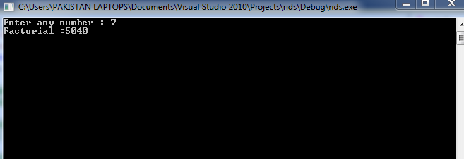

**TASK#9:**

Develop a program in C++ that take integer type values from user & calculate the sum from ‘0’ to number entered, using for loop and while loop.

*Number = 5*

*1+2+3+4+5 = 15*

#include<iostream>

#include<conio.h>

using namespace std;

void main ()

{

int a,b,i;

cin>>a;

cin>>b;

for(int i=a;i<=b;i++)

{

if(i%2==0)

cout<<i<<" ";

}

getch ();

}

**RESULT/OUTPUT:**

