Design, Analysis, and Optimization of Paddock Stand

1Riddhesh Gandre, 1Rohan Kotkar, 1Nishant Dhakne, 1Luv Sharma

2 Dilip Panchal

1Student, 2Assistant Professor

1School of Mechanical and Civil Engineering,

1MIT Academy of Engineering, Alandi (D), Pune, Maharashtra, India-412105

***Abstract:*** Paddock stand is regularly used with the operation of the bike servicing process. Various types of paddock stand models and features are available in the market currently. Lifting each type of supersport alone utilizing the available design of the paddock stand might be impracticable and inconvenient for users. To get over this restriction, a brand-new superbike paddock stand design that could be managed by one person was envisioned.. However, selection of significant product is differed from individual precedence factors similar as price, safety, and also workplace constrain. Improper selection of paddock stand will produce inconvenience for users, especially in handling the movement of two- wheelers while they're being repaired and repositioned. Through the use of Solidworks designing software, it's suitable to give flexible movement and promising safety features. The primary goal of this design research was to create a superbike paddock stand that would be easier for one person to use and more useful.

***Index Terms* - Bike, Paddock stand, Automobile design.**

1. **INTRODUCTION**

## INTRODUCTION

.

Bikes having a dry weight of more than 100 kg, are very difficult for one person to move in a service center. Rarely do they come with a double-stand, like you sometimes see on lighter, with lower CC motorcycles. This double-stand serves as a temporary stand that elevates the motorbike to a vertical standing position, making it easier to do either routine or ad-hoc maintenance. Superbikes' side stands tilt the bike such that just a small portion of the bike may be accessed for servicing. Additionally, superbikes typically need to be elevated off the ground for maintenance work, allowing the front or rear tyres to freely rotate in a vertical position.

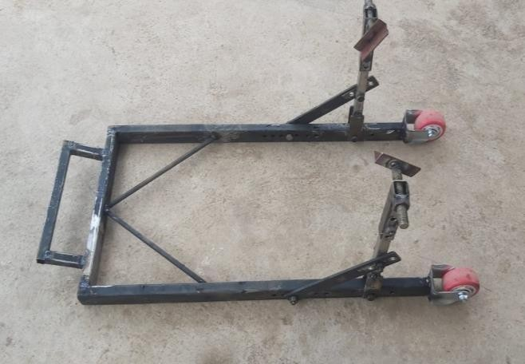

Figure 1: Model

## NEED OF THE STUDY

The purpose of this project is to develop a physical prototype for testing and evaluation as well as to optimise a revolutionary superbike paddock stand design based on finite element analysis (FEA) on various steel tube diameters used. The first step in the research technique is to compile a literature review on the various kinds of superbike paddock stands, practical usage guidelines for paddock stands, and appropriate materials for paddock stand construction. The creation of a CAD model that replicates the newly created paddock stand to be optimised will come next. The findings of this study might influence the development of a brand-new, commercially viable superbike paddock stand design and enhance working practises for riders who must do maintenance tasks by themselves in some capacity.

# LITERATURE REVIEW

Fabrication of Automatic Centre Stand for Motorcycles, the idea proposed in this project is to pull the stand by the use of a linear actuator. This linear actuator will provide enough force to pull the stand and also be able to lift the two-wheeler off the ground. The Actuator will be arranged in a horizontal manner and can be easily bolted to the chassis or the leg guard on the fixed end and to the stand from its moving side i.e., barrel. The actuator will be driven by a DC battery.[1]

Design and Development of a Superbike Paddock Stand, this paper focused on designing a paddock stand with prioritized product features grounded on a case study problem by the operation of 3D CAD tool software. The improved paddock stand was produced and its mobility function was validated with real superbikes and a variety of motorcycles. thus, it satisfied the company’s conditions as it was practical for use by a single user with space constraints. For coming product development, the sharp edges can be cut, and this will bear multiple analyses such as stress analysis, distortion analysis, and transitional displacement test analysis. either, it's recommended to study the operation of lightweight material in the development of the paddock stand.[2]

*Development of RhiNO v2.0 : An Enhanced Single User Paddock Stand,* This paper reports the structural and functional analysis in the development of an enhanced single user paddock stand named RhiNO v2.0. The enhanced and optimized design of the single user superbike paddock stand was fabricated based on the CAD modelling and tested using a real motorcycle, Kawasaki Ninja ZX- 10R 2009. This Product RhiNO v2.0 proved that this product can be operated easily by a single user, hence reducing risk of LBP and MSD.[3]

The "Automatic Side- Stage Retrieval System" was to be created using the same operating system as bikes. As all bikes used to transfer the power from engine to rear wheel by application of chain drive, sprocket rotates and side stand retrieves automatically as the design arrangement is kept between chain drive.[4]

Automatic motor- bike stand slider, By application of mechanical and electronic arrangement automatically retracting side stand was made. Microcontroller, speed sensor, dc motor were used. Speed sensor will detect the gyration of wheel and will send it to the microcontroller and DC motor will get actuated. Which helps to disengage stand from road. A bike stand is used to park the vehicle easily without any effort for a single user. This retracting side stand is constructed to reduce the risk of accidents. The position of this side stand is behind the bottom bracket and can be bolted on anchoring the chain stays.[5]

Design of motorcycle double stand, Currently there are very less methods which can be used for lifting the bikes for maintenance. Very less options are available in terms of single stand which can support a sport bike on its own. For a double stand the strength is most important as bike may feel unstable movement when we apply the center stand. The motive of this project was to design a stand which can support a sports bike, this stand was to be made by doing some modifications in existing stand. The major focus of the project was to take ease of use for the user into consideration as many a times because of very high load of sports bike safety becomes concern.[6]

When computer technologies are used to examine the design, optimising freshly produced items makes the product much better and more dependable*.* The same is true with a recently created superbike paddock platform, which was initially created to help motorcyclists pull up their motorcycles on their own for maintenance purposes*.* The efficiency of this newly created superbike paddock stand has already been proven, but it was discovered to be very heavy and size was bulky, which might result in overdesign and increased production costs. Design optimization is required as a prospective product that may enter the superbike user market in order to fulfil consumer needs, which are what always drive the market for a specific new product..[7]

# METHODOLOGY

It starts with figuring out the needs for a stand that only accommodates one user. Concepts and ideas were produced using the Pugh decision matrix selection procedure before being adopted.

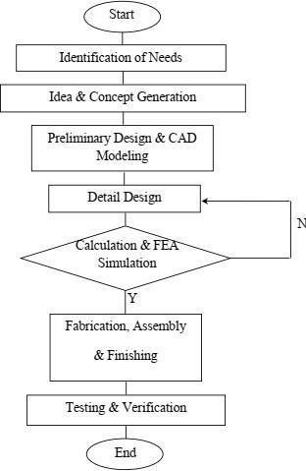

Figure 2: Design Process methodology

Detailed design of the superbike paddock stand was accomplished before it was modelled in a 3D CAD model using Solidworks software; computations and analysis through finite element analysis using CAE software, was also done on the 3D CAD model to analyze the maximum stresses acting on the new design. A prototype was made to test the new design using an actual superbike in order to ensure that it wouldn't malfunction while the load was acting upon it.

1. **CAD DESIGN**

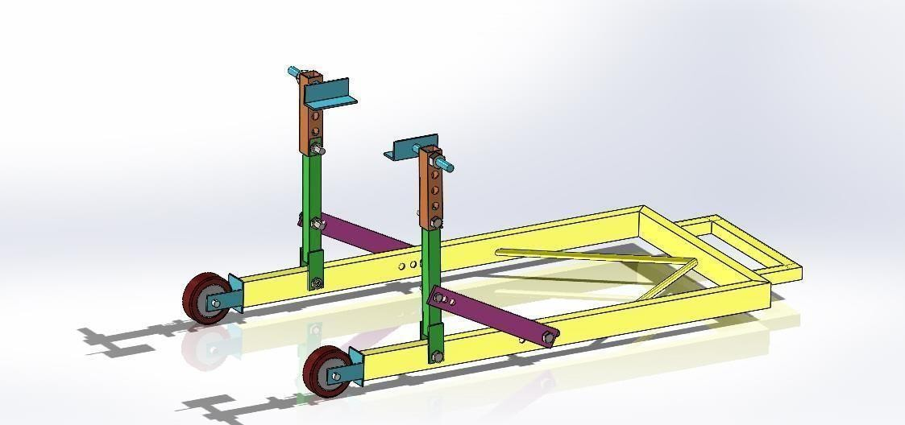

Figure 3: CAD Complete Design

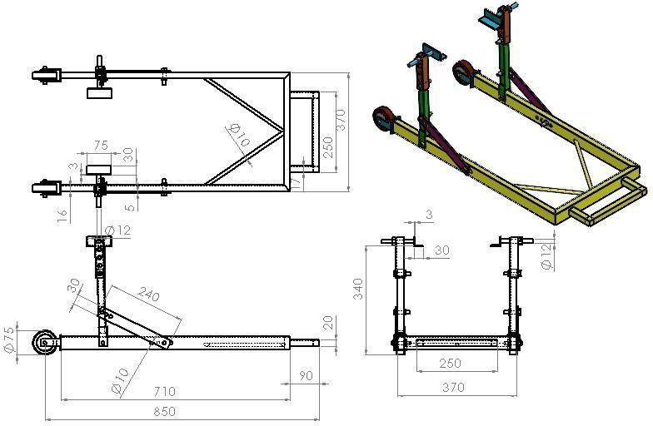

Figure 4: CAD Design Dimensions

1. **CAD ANALYSIS AND EXPLANATION**

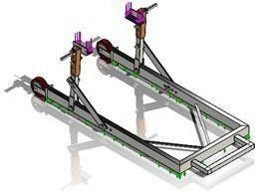 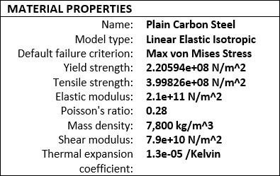

Figure 5: CAD Material Application Table 1: Design Material Selection

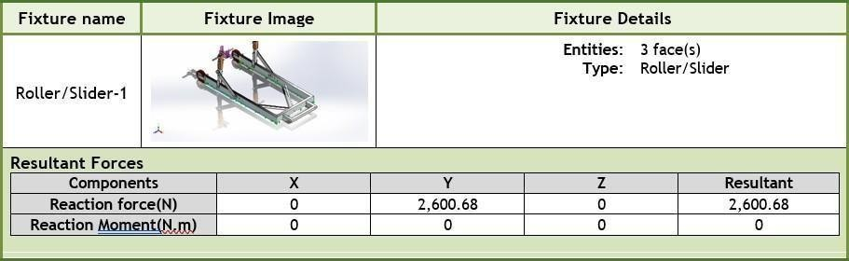

Table 2.1: Force Application

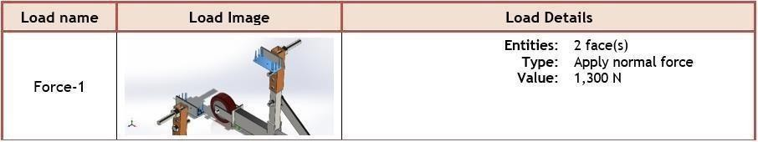

Table 2.2: Force Application

Applicable Load Magnitude Selection- Heaviest Bike as of now weighs 420 Kg, with a general weight distribution of 50-50%, weight on the rear axle sums up to 210 Kg ~ 2060 Newton. Here, the CAD design analysis is performed by taking the total rear weight as 2600 N, equally distributed on both left and right leg (1300 N + 1300 N) of the stand hence giving reaction force = 2600 N.

V (I). ANALYSIS RESULTS

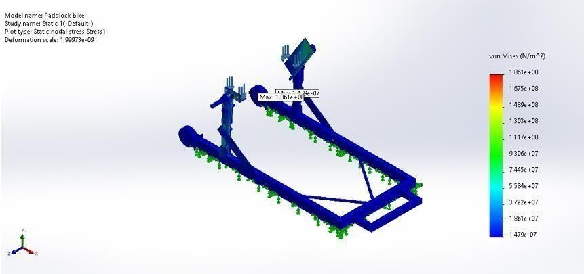

Figure 6: Stress Analysis Result

|  |  |  |  |
| --- | --- | --- | --- |
| Name | Minimum | Maximum | Suffering Part |
| Stress | 1.479e-07 N/m^2 | 1.861e+08 N/m^2 | Leg face |

Table 3: Stress Analysis results

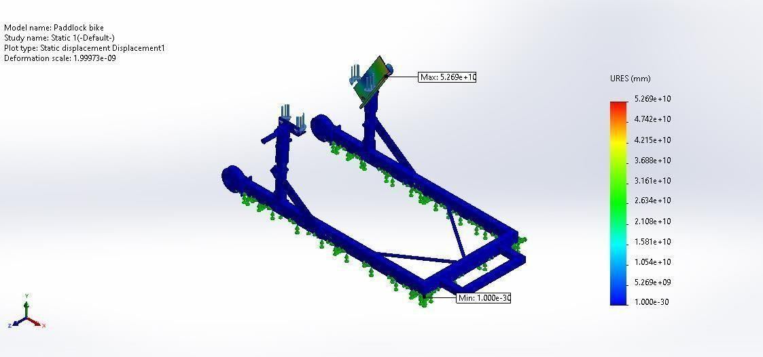

Figure 7: Displacement Result

|  |  |  |  |
| --- | --- | --- | --- |
| Name | Minimum | Maximum | Suffering Part |

|  |  |  |  |
| --- | --- | --- | --- |
| Displacement | 0 | 5.269e+10 mm | Leg face Corners |

Table 4: Displacement Result

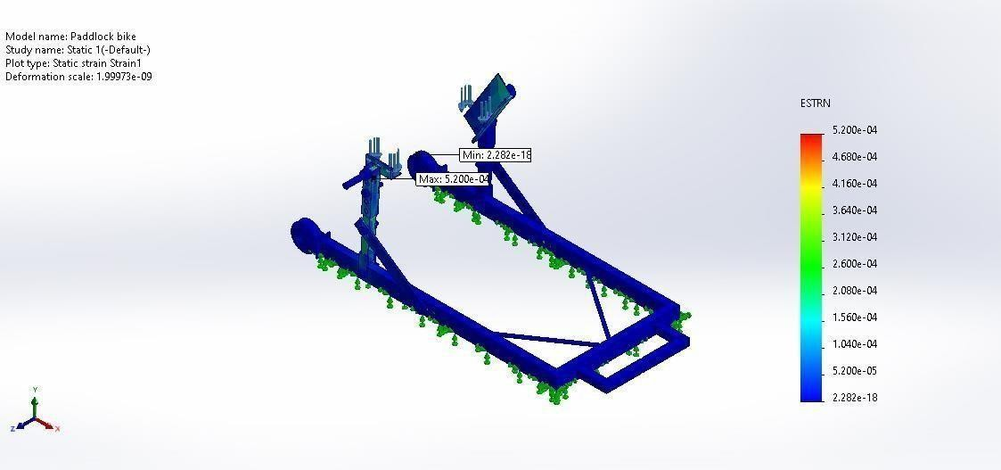

Figure 8: Strain Result

|  |  |  |  |
| --- | --- | --- | --- |
| Name | Minimum | Maximum | Suffering Part |
| Equivalent Strain | 2.282e-18 | 5.200e-04 | Leg face Corners |

Table 5: Strain Result

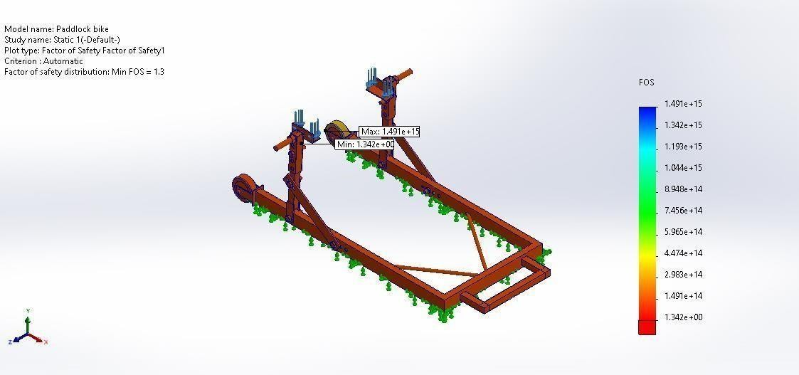

Figure 8: Factor of Safety

|  |  |  |  |
| --- | --- | --- | --- |
| Name | Minimum | Maximum | Suffering Part |
| Factor Of Safety | 1.342e+00 | 1.491e+15 | Leg face Corners |

Table 6: Factor of Safety

## RESULTS AND DISCUSSION

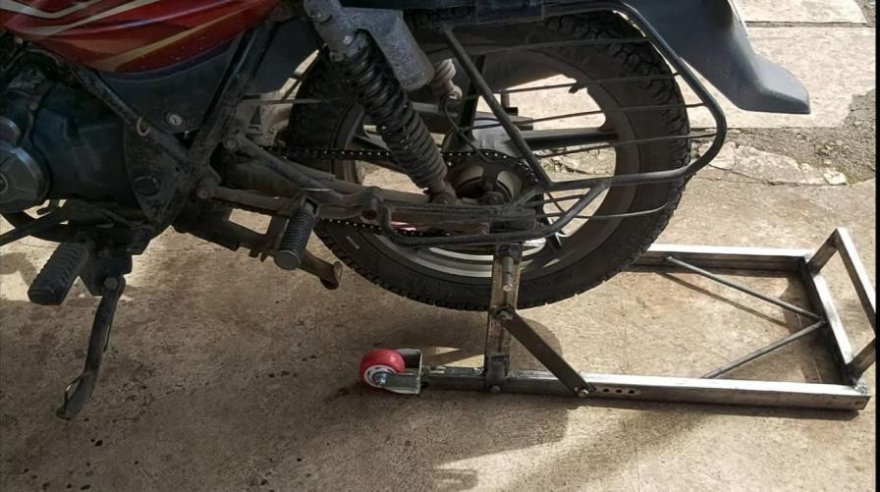

Figure 9: Model Testing

We have successfully designed and fabricate a paddock stand within the timeframe. The paddock stand was tested by using it with actual bikes. Comparing the handling process, the proposed product is satisfied to be operated by one person only similar to the superbike hydraulic jack. Then, both of these types of paddock stand also offer safety element. The proposed paddock stand as shown in Figures is a favorable option among the available options due to the ability of the product’s maneuverability.

**VI. CONCLUSION**

This paper focused on designing a paddock stand with prioritized product features based on market research and literature review. The improved paddock stand was produced and its mobility function was validated with real superbikes and a variety of motorcycles. Therefore, it satisfied the requirements as it was practical for use by a single user with space constraints. For future product development, the sharp edges can be cut, and this will require multiple analyses such as stress analysis, deformation analysis, and transitional displacement test analysis. Besides, it is recommended to study the application of lightweight material in the development of the paddock stand.

**VIII. REFERENCES**

1. **HEMANT M. PATIL, SAURABH S. SIRSIKAR, AND NITIN N. GHOLAP, “PRODUCT DESIGN AND**

**DEVELOPMENT: PHASES AND APPROACH,” INT. J. ENG. RES., VOL. V6, NO. 07, 2017.**

1. **K. T. AND E. ULRICH, “PRODUCT DESIGN AND DEVELOPMENT,” IN 4TH EDITION. NEW YORK: MCGRAWHILL., 2008.**
2. **Z. ZAINAL, “CASE STUDY AS A RESEARCH METHOD TO STUDY,” J. AGING STUD., VOL. 10, NO. 4, PP. 281– 294, 1996.**
3. **S. CROWE, K. CRESSWELL, A. ROBERTSON, G. HUBY, A. AVERY, AND A. SHEIKH, “THE CASE STUDY APPROACH,” BMC MED. RES. METHODOL., VOL. 11, NO. 1, P. 100, 2011.**
4. **W. LIU, J. MOULTRIE, AND S. YE, “THE CUSTOMER-DOMINATED INNOVATION PROCESS: INVOLVING CUSTOMERS AS DESIGNERS AND DECISION-MAKERS IN DEVELOPING NEW PRODUCT,” DES. J., VOL. 22, NO. 3, PP. 299–324, 2019.**
5. **A. BRIÈRE-CÔTÉ, L. RIVEST, AND R. MARANZANA, “COMPARING 3D CAD MODELS: USES, METHODS, TOOLS AND PERSPECTIVES,” COMPUT. AIDED. DES. APPL., VOL. 9, NO. 6, PP. 771–794, 2012.**
6. **H. RASHID, A. H. ABDULLAH, M. H. MOHD NOH, A. H. ABDUL HAMID, AND N. M. ZAINAL ABIDIN, “DESIGN OF A SUPERBIKE PADDOCK STAND USING CAD AND CAE TOOLS,” INT. J. AUTOMOT. MECH. ENG., VOL. 5, NO. 1, PP. 670–679, 2012.**
7. **H. PAN, “DEVELOPMENT AND APPLICATION OF LIGHTWEIGHT HIGH-STRENGTH METAL MATERIALS,” MATEC WEB CONF., VOL. 207, PP. 1–4, 2018.**