CLIENT SIDE MODULE

CONTENTS

This module has the following files:
- MODULE_CLIENT_SIDE.doc
- MODULE_CLIENT_SIDE_MEDIA.zip

INTRODUCTION
You are asked to develop a game called BOMBSKUY using HTML and CSS and develop client-side programming using JavaScript. Some media files are available to you in a zip file. You can create more media and modify anything in the media if you want. Your game needs to be developed in a tablet resolution (1000 x 600 pixels). In bigger resolution, the game must be centred in the screen both horizontally and vertically.

DESCRIPTION OF PROJECTS AND TASKS
You can create the layout using HTML/CSS and create the functionality of the game using JavaScript that allows the game to work correctly in different web browsers. EcmaScript 6 / Javascript Modules not allowed for this module. This module will be marked with directly opening the index.html page using Google Chrome.
BOMBSKUY game screen should have meet these requirements below:
- Player Name
- Gameboard
- Character
- Player Lives
- Total Items
- Timer

Game functionalities
- Game should be on a single page application (index.html). No refresh / reload page and additional html page for any action.
- Display a welcome screen in the centre of the page when the game loads.
- Players can Start the game after filling the username field and click the “Play Game” button at the bottom of the welcome page.
- The “Play Game” button should remain disabled until a username is entered..
- After entering a username and clicking "Play Game", the player should choose one of three difficulty levels: Easy, Medium, or Hard.
- After selecting a difficulty level, show a countdown in the centre of the screen for 3 seconds before the game starts.
- Provide an "Instruction" button that, when clicked, displays the game instructions.
- Users can close instructions after clicking the “X” button.
- Players will get 3 hearts when the game starts.
- The number of dogs (computer-controlled opponents) is determined by the difficulty level:
  - 1 Dog for Easy
  - 2 Dogs for Medium
  - 3 Dogs for Hard
- the dog's position will be random
- The player’s character starts in the top-left corner of the game map when the game begins.
- Place brick walls randomly around the game map to act as obstacles that players cannot pass through.
- Place stone walls according to the given game maps as follow:
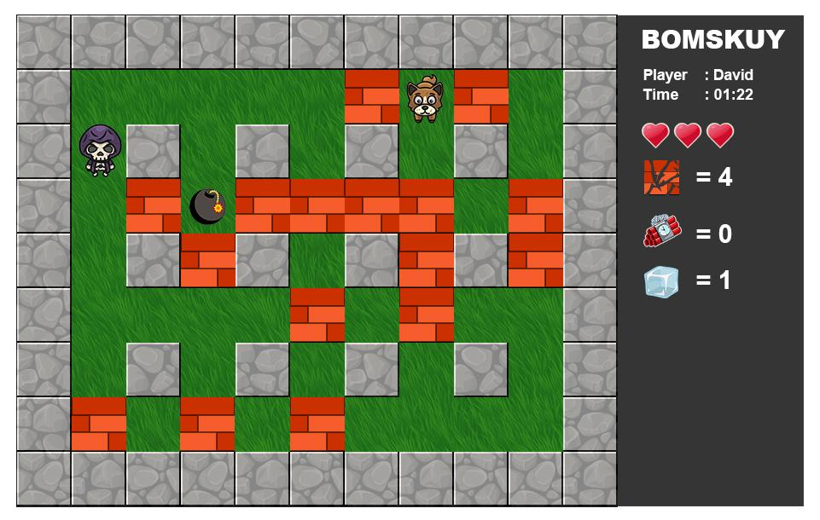
Image 1. Stone walls placement.
- The player can move their character using the following keys:
  - “A” or “Left arrow” to move left
  - “W” or “Up arrow ” to move up
  - “D” or “Right arrow” to move right
  - “S” or “Down arrow” to move down
- Pressing the Space key allows the player to place a bomb.
- The bomb will explode 5 seconds after being placed.
- Bomb explosions affect one box in each direction: up, down, left, and right..
- The wall will destroyed after hit by a bomb explosion
- Items are hidden inside walls and appear when walls are destroyed.
- The items that will be there are as follows:
  - Broken Heart: Decreases the player’s hearts.
  - TNT: Doubles the bomb’s explosion range
  - Ice cube: Freezes the player for 5 seconds.
- The item disappears after being touched by the player.
- When a player gets an item, the player's character will have a mark of that item.
- Each items that player gets will be increase are as follows:
  - Destroyed walls
  - TnT earned
  - Ice box obtained
- Walking animation when the character is moving must be shown.
- The dog (computer) can move as needed and
- The dog (computer) must search for players.
- Hearts decrease if the player is hit by a bomb explosion or touches a dog.
- Show animation on the character when the player touches the bomb explosion and dog.
- Players can pause the game by pressing the Esc key.
- When paused, display a popup, and the game should stop until Esc is pressed again or the Continue button is clicked.
- Game Over when the heart reaches 0.
- Show popup after game over to display the player username, time elapsed, total score, Save score button and Leaderboards button.
- Match history should be saved in local storage after the player clicks the Save Score button.
- Players can see the leaderboards after clicking the Leaderboards Button.
- Clicking the Leaderboard button displays a leaderboard sorted by:
  - Total walls destroyed
  - TNTs collected
  - Ice cubes obtained
- The game needs to work correctly on Google Chrome.

INSTRUCTION FOR COMPETITORS
- Create a root folder called XX_CLIENT_MODULE in your local computer, where XX is your computer number.
- Place your works inside the root folder. Make sure your works are working well when directly opening the index.html file.
- Zip your root folder XX_CLIENT_MODULE and submit to the submission page
Example
These following images are for example purposes only. You may design your own game layout.