DAY2
Q3: Write a program to calculate the area and perimeter of a rectangle given its length and breadth.

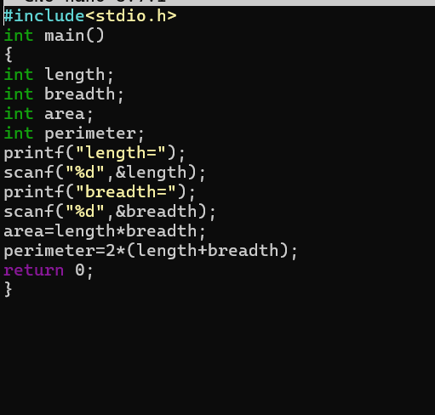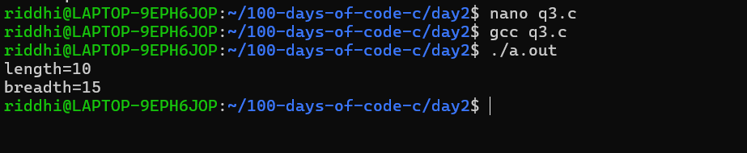
Q4: Write a program to calculate the area and circumference of a circle given its radius.
