DAY6
Q11: Write a program to input an integer and check whether it is even or odd using if–else.
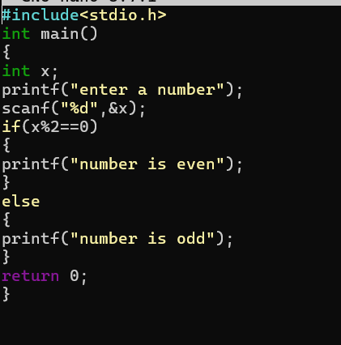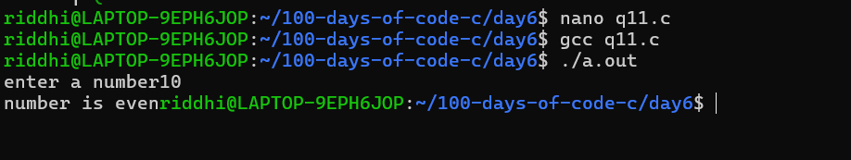

Q12: Write a program to input an integer and check whether it is positive, negative or zero using nested if–else.
