DAY7
Q13: Write a program to input a year and check whether it is a leap year or not using conditional statements.
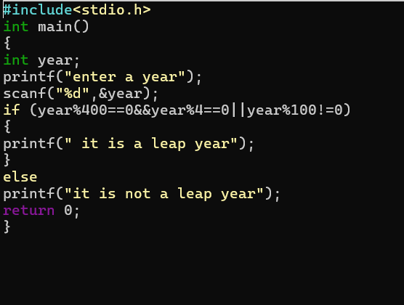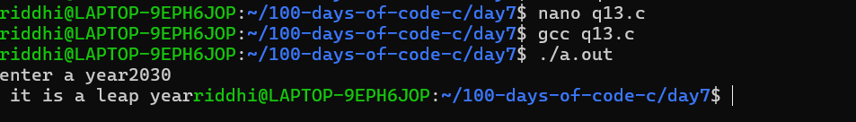
Q14: Write a program to input a character and check whether it is a vowel or consonant using if–else.

