Alliance School of Advanced Computing
Course Name: Graph Analytics
Course Code:
Assignment No: 2

Name of the Student: Riddhima Jha
Registration Number: 2411021060036
A. Title of The Problem:
Find the nearest clone
B. Problem Statement in detail:
Complete the findShortest function in the editor below. It should return an integer representing the length of the shortest path between two nodes of the same colour, or if it is not possible.
findShortest has the following parameter(s):
- g_nodes: an integer, the number of nodes
- g_from: an array of integers, the start nodes for each edge
- g_to: an array of integers, the end nodes for each edge
- ids: an array of integers, the color id per node
- val: an integer, the id of the color to match
C. HackerRank/Leetcode Link of the problem (If applicable):
https://www.hackerrank.com/challenges/find-the-nearest-clone/problem?utm_source=chatgpt.com
D. Student’s Github link of report and code upload, along with the readme file: https://github.com/Riddhi-coder-oss/Assignment-2

E. Solution Steps/Algorithm:
- Start
- Read the number of nodes and edges of the graph.
- Create an adjacency list to represent the undirected graph.
- Read all edges and add both connections:
  - Add v to the list of u.
  - Add u to the list of v.
- Read the color (ids) of every node.
- Read the target color val.
- Find all nodes whose color is equal to val.
- If fewer than 2 nodes have the target color, return -1.
- Initialize:
  - A queue for BFS.
  - A distance array to store the distance of each node.
  - A source array to identify which target-colored node each visited node came from.
- Add all nodes having the target color to the queue with distance 0.
- Perform BFS:
  - Remove a node from the queue.
  - Visit each of its neighbouring nodes.
- If a neighbour has not been visited:
  - Assign its distance.
  - Assign its source.
  - Add it to the queue.
- If a neighbour has already been visited but came from a different target-colored source, two BFS searches have met.
- Calculate the path length as:
distance[current] + distance[neighbour] + 1
- Return this value as the minimum distance between two nodes having the target color.

- If no two target-colored nodes can be connected, return -1.
- Stop.
F. Code developed:
def findShortest(graph_nodes, graph_from, graph_to, ids, val):
from collections import deque

graph = [[] for _ in range(graph_nodes + 1)]

for i in range(len(graph_from)):
u = graph_from[i]
v = graph_to[i]
graph[u].append(v)
graph[v].append(u)

queue = deque()
distance = [-1] * (graph_nodes + 1)
source = [-1] * (graph_nodes + 1)

for i in range(1, graph_nodes + 1):
if ids[i - 1] == val:
queue.append(i)
distance[i] = 0
source[i] = i

if len(queue) < 2:
return -1

while queue:

current = queue.popleft()

for neighbour in graph[current]:

if distance[neighbour] == -1:
distance[neighbour] = distance[current] + 1
source[neighbour] = source[current]
queue.append(neighbour)

elif source[neighbour] != source[current]:
return distance[current] + distance[neighbour] + 1

return -1
G. HackerRank test case passed Screenshot or Output screenshot (Mandatory):
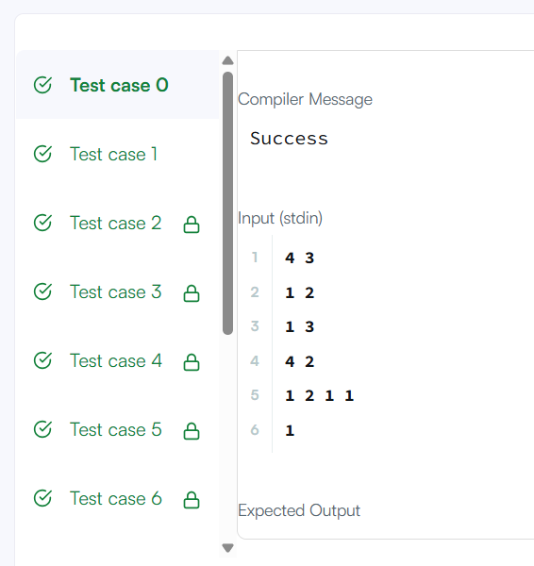
H. Observation: Observation
The graph is represented using an adjacency list, and Breadth-First Search (BFS) is used to find the shortest distance between two vertices having the given colour. BFS starts from all vertices of the target colour simultaneously, and when two searches meet, the shortest path between those vertices is obtained. If fewer than two vertices have the required colour or no connection exists, the program returns -1.

