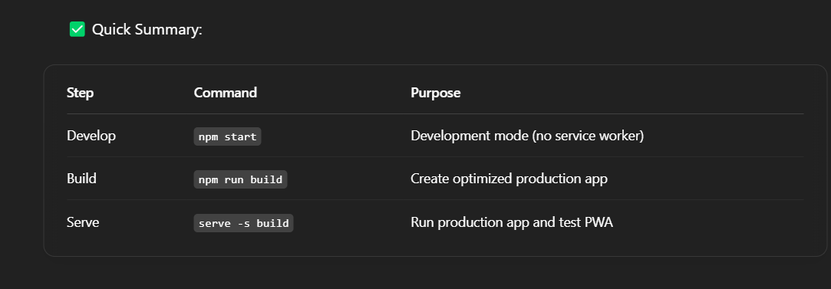

Overview:

**Supplier Features:**

1. **Account Creation**: Suppliers should be able to create an account using email, phone number, or social logins.
2. **Profile Management**: Suppliers should add their business details (name, location, contact info) and logo.
3. **Service Listings**: Suppliers can list the services they provide (oil change, tire repair, etc.), set prices, and add descriptions and images.
4. **Availability**: Suppliers can set their working hours and available slots for bookings.
5. **Booking Management**: Suppliers should be able to view and manage bookings (approve, reschedule, or cancel).
6. **Payment Integration**: Option for suppliers to receive payments through the app for services rendered.

**Customer Features:**

1. **Account Creation**: Customers can create accounts to track their booking history.
2. **Service Search & Filters**: Customers can search by service type, location, price, ratings, etc.
3. **Booking System**: Customers can book a service by selecting a supplier, time, and payment method.
4. **Rating & Reviews**: After a service, customers can rate their experience and leave reviews for suppliers.
5. **Notifications**: Notifications about booking confirmations, reminders, or promotions.

**Additional Features:**

1. **Admin Panel**: Admins can manage users, approve or reject service listings, and monitor transactions.
2. **Geo-Location**: Use location tracking to show nearby suppliers for customers.
3. **Payment Gateway**: Integrate a payment system for seamless transactions (e.g., Stripe, PayPal).

Features :

**For Suppliers:**

* **Create Account**: Ability to sign up, verify, and log in.
* **Create and Manage Service Listings**: Add service descriptions, prices, images, and set availability.
* **Booking Management**: Approve, cancel, or reschedule bookings.
* **Payment Integration**: Receive payments via a gateway.

**For Customers:**

* **Account Creation**: Sign up, login, and manage profile.
* **Search and Filter**: Find suppliers based on services, location, ratings, etc.
* **Book Service**: Choose a supplier, select service, and book a time slot.
* **Reviews and Ratings**: Rate suppliers after service completion.