**Riddhi Roy Choudhury (Cognizant)**

This document gives an overview of how to set up the application in local machine for development. It also says how to run and test the same IIS Hosted app from IIHT VM.

PROJECT MANAGER

Contents

Software Requirements and Technology details 2

Required Software 2

Technology Details 2

Setting up the application 2

Taking checkout 2

Client 3

Server 3

Database 3

Running the application 4

Hosted App in IIHT VM: 4

# Software Requirements and Technology details

## Required Software

These are the list of the software installed in the system to debug/develop and run the application:

1. Visual Studio 2017
2. Visual Studio Code (preferable latest version)
3. SQL Server Management Studio 2017
4. Google Chrome
5. Node JS latest version.
6. Angular CLI installed , if not install it using npm.
7. GIT BASH and GIT UI (for connecting to the repository)

## Technology Details

These are the list of the technologies used in the application:

1. Angular 9.x (UI)
2. HTML (UI)
3. CSS3 and BOOTSTRAP (UI)
4. .NET Framework 4.6.1 (C# API)
5. Web API 2.0 (C# API)
6. Entity Framework 6.0 (C# API)
7. SQL (C# API)
8. SQL Server DB.

# Setting up the application

## Taking checkout

1. Visit the URL <https://github.com/Riddhi1607/FSE_SBA_Final_353587> where the code is checked in.
2. Click on the “**Clone or download**” button.

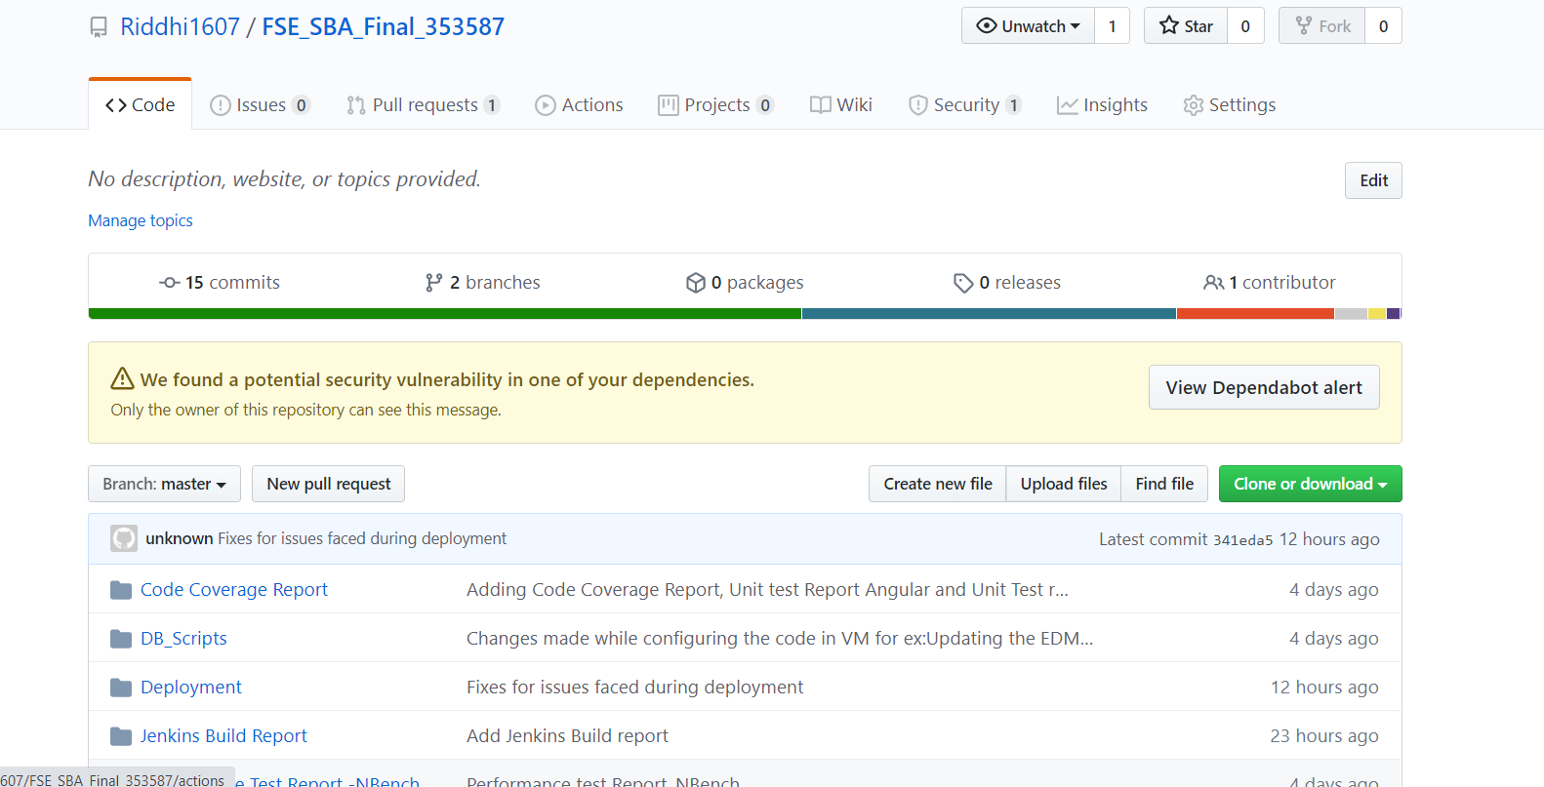

1. Once a small pop-up opens, click on the “**Download ZIP**” button. Or copy the SSH or HTTPS url to clone the code using GIT CLI. Command: git clone <url> . To use the SSH url , you will need to set up the public / private key pair using sshkeygen command in windows.   
   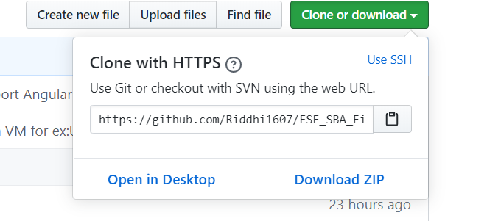
2. Open the downloaded file/cloned folder. The Name would be : FSE_SBA_Final_353587-master

Now In the main folder there are two main folders where the client and server side code is maintained.

1. Client: (“ProjectManager-Client”)  
   This folder contains the angular client side code.
2. Server: (“ProjectManager-ServerSideCode”)  
   This folder contains the web api c# server side code.

**Please Note:** The entire project is currently checkout at location: D:\FSE_SBA_353587\FSE_SBA_Final_353587 in IIHT VM (DnetCTS06) assign to Riddhi Roy Choudhury

### Client

1. Go to the folder ProjectManager-Client where you can see the file ***package.json***
2. Open command prompt
3. Copy the folder path of Step No. 1
4. Traverse to the path of Step 1 in the command prompt
5. Once you are in this path, run this command “npm install –g -f @angular/cli” if Angular-CLI is not installed in your system.
6. After this installation is done, run this command “npm install -f”
7. Let all the npm packages install in the project
8. Once the installation is done you will be able to see a folder “*node_modules*” in your system
9. Don’t close the command window yet

### Server

1. Open the folder **ProjectManager-ServerSideCode**
2. Open the file “**ProjectManager.sln**” in Visual Studio 2017
3. Download the dependencies from NUget .
4. Build the application
5. Don’t close the Visual Studio 2017 yet

### Database

1. Open the SQL Server Management Studio
2. Run the following scripts from **DB_Scripts** folder

* DB_ProjectManager_Script_Local (To create the DB. You may face face some errors here depending on which version of SQL Server and SSMS is installed in your system. You need to resolve those and make sure the database is created.)
* Table_ParentTask_Script (to create ParentTask Table)
* Table_Projects_Script (to create Projects Table)
* Table_Tasks_Script (to create Tasks Table)
* Table_Users_Script (to create Users Table)

# Running the application

The entire project is currently checkout at location: D:\FSE_SBA_353587\FSE_SBA_Final_353587

Once the build is succeeded:

1. Open the command prompt and run the command “ng serve”
2. Open the visual studio 2017 and select the “**ProjectManager**” project as startup project and press “**Start**” to run the application which should host the app in IISExpress at port number 50830.
3. Once the node modules are built after the step 1, open Google Chrome and enter the URL [**http://localhost:4200**](http://localhost:4200)

# Hosted App in IIHT VM:

The app is already hosted in IIHT VM DnetCTS06 in Local IIS. To test it out:

* **Server side Web Api code** is hosted at IIS port 8001. Login to the VM and hit localhost:8001/ from the browser to see the Web API running. To test it out, you can hit couple of get methods for ex: localhost:8001/api/project, localhost:8001/api/user etc. It should return you the data in JSON format.
* Client side code is hosted in IIS port 4000. Open chrome and hit url <http://localhost/ProjectManagerClient/> which should open the Angular App hosted in IIS at port 4000.