CURRICULUM VITAE
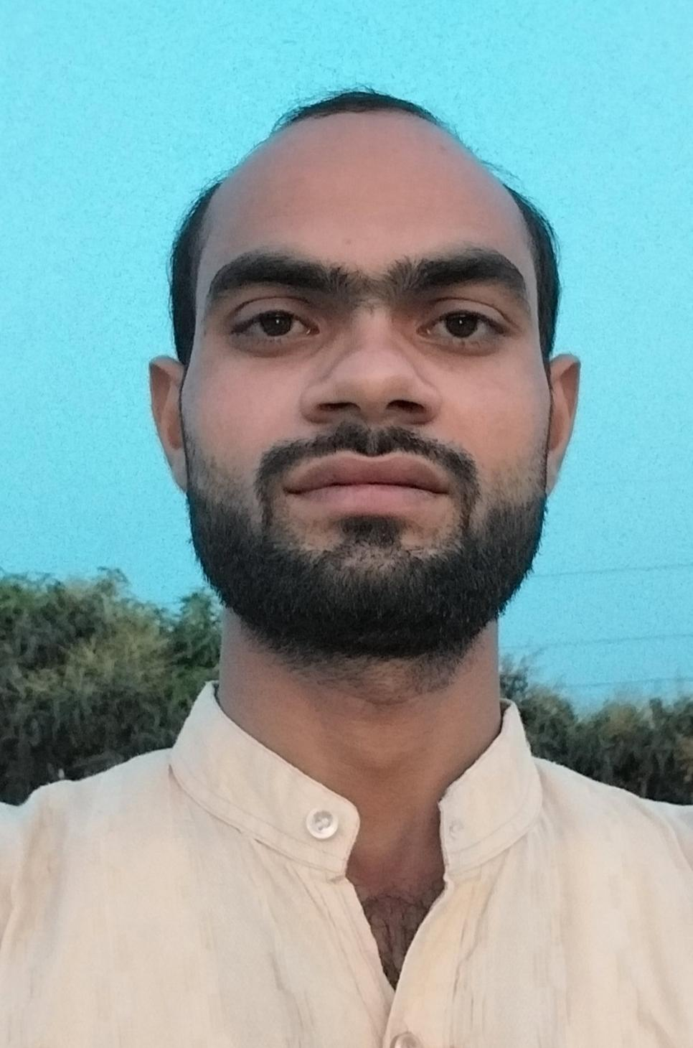
Mohd Nadeem
Address: Vill-Mohanpur Gada, PO.-Jandhera Samaspur
Dist. Saharanpur (UP), India
Pin Code: 247451
Contact No: +91-9536395060
E-mail ID: mohd.nadeem600@gmail.com

Career Objective:
To succeed in an environment of growth and excellence and earn a job which provides me job satisfaction and self-development and help me achieve personal as well as organizational goals.
Educational Qualification:
Examination | Board | Year | Aggregate (%)
High School | U.P Board | 2010 | (62.83)
Intermediate | U.P Board | 2013 | (71.60)
Graduation | CCS University Meerut | 2016 | (57.23)

Technical Skill / IT Skill
- MS Word, Excel, Paint & Power Point
- Basic knowledge of Computer & Internet & Email
- C Programming Language & Data Entry
- AutoCAD
- SAP (training)

Extra-Curricular Activities
• Store Department in Unitech Machines Limited, Saharanpur, Uttar Pradesh, India as a Supervisor from 2016 to 2020
• Production Department in Karbro Agro Tech Nabha, Patiala, Punjab, India as a supervisor from 2021 to 2022 in Fabrication
• Quality Department in GSA Industries, Patiala, Punjab, India as a Supervisor from 2023 to 2025 in Fabrication
• Production Department in Kartar Agro Industries (P) Ltd. Bhadson, Patiala, India as a Supervisor From April 2025 to Oct 2025 in Fabrication
• Now Production Department in AIML (Alliance Integrated Metaliks Limited) Rajpura, Patiala, India as a Supervisor From Oct 2025 to continue in Heavy Fabrication (Bullet Train Project)
Hobbies:
- Reading Books | - Playing with small children & Watching Movies
Strength:
- Hard Working | - Positive Attitude
- Punctual | - Self-Motivated
Personal Detail:
Name : Mohd Nadeem
Father’s Name : Saleem Ahamad
Date of Birth : 5 July, 1994
Nationality : Indian
Gender : Male
Marital Status : married
Language Known : English, Hindi & Urdu
Declaration:
- I hereby declare that all the information provided here is correct to the best of my knowledge and belief and I promise to abide all the norms laid down by your esteemed organization.
Reference:
Date: 01 April, 2026 Signature
(Mohd Nadeem)

