23BKT0038
Riddhi Vatsala
Database Systems :BCSE302L
Project Report
Topic: Job Portal

SKILLSYNC
1. Problem Definition & Requirements Analysis
1.1 Problem Definition
In the modern recruitment ecosystem, job seekers often struggle to find suitable opportunities that match their skills, while employers face challenges identifying qualified candidates efficiently. There is a lack of centralized, skill-oriented platforms that simplify the recruitment process.
SkillSync aims to bridge this gap by creating an intelligent job portal system where candidates can register, upload their resumes, and apply for jobs, while recruiters can post openings, filter candidates by skills, and manage hiring seamlessly.
1.2 Objectives
- To design and implement a relational database that supports all key operations of a job portal.
- To ensure efficient storage, retrieval, and management of users, job listings, applications, and skills data.
- To provide query functionalities for both admin and users for insight generation.
- To maintain data integrity through normalization and constraints.
1.3 Functional Requirements
- Job Seeker Module: Register, login, create profile, update skills, apply for jobs.
- Employer Module: Register company, post jobs, view applicants, shortlist candidates.
- Admin Module: Manage users, monitor job postings, generate reports.
- System Requirements: MySQL or PostgreSQL as DBMS, SQL-based data manipulation, and secure data handling.
1.4 Non-functional Requirements
- High availability and consistency.
- Secure data storage and user authentication.
- Scalability for multiple users and job postings.
- Optimized queries for performance.

2. Conceptual Design
2.1 ER Diagram Description
Entities:
- JobSeeker (SeekerID, Name, Email, Password, ResumeLink, ExperienceLevel)
- Employer (EmployerID, CompanyName, Email, Password, Industry)
- Job (JobID, Title, Description, Salary, Location, PostedDate, EmployerID)
- Application (ApplicationID, JobID, SeekerID, Status, AppliedDate)
- Skill (SkillID, SkillName)
- JobSeekerSkill (SeekerID, SkillID)
- JobSkill (JobID, SkillID)
- Admin (AdminID, Name, Email, Password)
Relationships:
- JobSeeker – Application – Job (Many-to-Many through Application)
- Employer – Job (One-to-Many)
- JobSeeker – Skill (Many-to-Many through JobSeekerSkill)
- Job – Skill (Many-to-Many through JobSkill)
- Admin manages both JobSeeker and Employer
2.2 ER Diagram (Description in Words)
Each employer can post multiple jobs.
Each job can require multiple skills.
Each job seeker can have multiple skills.
A job seeker can apply for multiple jobs, and each application belongs to one job and one seeker.
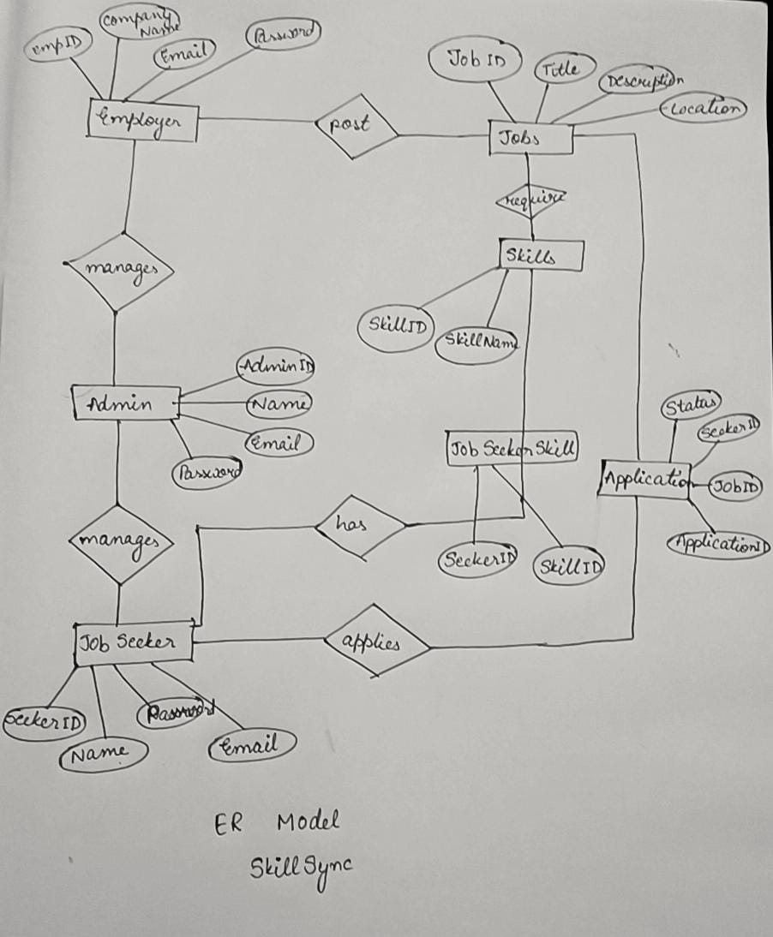
2.3 Normalization
All relations are normalized up to BCNF (Boyce-Codd Normal Form):
- No partial, transitive, or multivalued dependencies exist.
- Every determinant is a candidate key.
Example:
- Job(JobID, Title, Salary, Location, EmployerID) → JobID is primary key, EmployerID is foreign key.
- Application(ApplicationID, JobID, SeekerID, Status) → composite dependency removed by ensuring separate tables for skills and applications.

3. Logical & Physical Database Design
3.1 Relational Schema
JobSeeker(SeekerID [PK], Name, Email [Unique], Password, ResumeLink, ExperienceLevel)
Employer(EmployerID [PK], CompanyName, Email [Unique], Password, Industry)
Job(JobID [PK], Title, Description, Salary, Location, PostedDate, EmployerID [FK])
Application(ApplicationID [PK], JobID [FK], SeekerID [FK], Status, AppliedDate)
Skill(SkillID [PK], SkillName)
JobSeekerSkill(SeekerID [FK], SkillID [FK], PRIMARY KEY(SeekerID, SkillID))
JobSkill(JobID [FK], SkillID [FK], PRIMARY KEY(JobID, SkillID))
Admin(AdminID [PK], Name, Email [Unique], Password)
3.2 Data Types and Constraints
Field | Data Type | Constraints
SeekerID, EmployerID, JobID, SkillID, ApplicationID | INT | PRIMARY KEY, AUTO_INCREMENT
Name, Title, CompanyName, SkillName | VARCHAR(100) | NOT NULL
Email | VARCHAR(100) | UNIQUE, NOT NULL
Password | VARCHAR(255) | NOT NULL
Salary | DECIMAL(10,2) | CHECK (Salary > 0)
PostedDate, AppliedDate | DATE | DEFAULT CURRENT_DATE
Status | ENUM('Pending', 'Accepted', 'Rejected') | DEFAULT 'Pending'
3.3 Indexing
- Indexes created on Email fields for fast authentication.
- Index on SkillName for faster skill-based filtering.
- Foreign keys indexed automatically for join efficiency.

4. Implementation (SQL / DBMS Use)
4.1 Table Creation Example
CREATE TABLE JobSeeker (
SeekerID INT PRIMARY KEY AUTO_INCREMENT,
Name VARCHAR(100) NOT NULL,
Email VARCHAR(100) UNIQUE NOT NULL,
Password VARCHAR(255) NOT NULL,
ResumeLink VARCHAR(255),
ExperienceLevel VARCHAR(50)
);

CREATE TABLE Employer (
EmployerID INT PRIMARY KEY AUTO_INCREMENT,
CompanyName VARCHAR(100) NOT NULL,
Email VARCHAR(100) UNIQUE NOT NULL,
Password VARCHAR(255) NOT NULL,
Industry VARCHAR(100)
);
4.2 Trigger Example
CREATE TRIGGER UpdateApplicationStatus
AFTER INSERT ON Application
FOR EACH ROW
UPDATE Job
SET PostedDate = CURRENT_DATE
WHERE JobID = NEW.JobID;
4.3 Stored Procedure Example
CREATE PROCEDURE GetJobsBySkill(IN skill_name VARCHAR(100))
BEGIN
SELECT j.Title, e.CompanyName, j.Location
FROM Job j
JOIN JobSkill js ON j.JobID = js.JobID
JOIN Skill s ON js.SkillID = s.SkillID
JOIN Employer e ON j.EmployerID = e.EmployerID
WHERE s.SkillName = skill_name;
END;
4.4 Views Example
CREATE VIEW JobApplications AS
SELECT j.Title, js.Name AS SeekerName, a.Status
FROM Application a
JOIN Job j ON a.JobID = j.JobID
JOIN JobSeeker js ON a.SeekerID = js.SeekerID;

5. Query Demonstration & Reporting
Sample Queries
- List all available jobs:
SELECT Title, Location, Salary FROM Job;
- Find jobs matching a seeker’s skills:
SELECT DISTINCT j.Title, e.CompanyName
FROM Job j
JOIN JobSkill js ON j.JobID = js.JobID
JOIN Skill s ON js.SkillID = s.SkillID
JOIN JobSeekerSkill jss ON jss.SkillID = s.SkillID
WHERE jss.SeekerID = 1;
- Count total applications per job:
SELECT j.Title, COUNT(a.ApplicationID) AS TotalApplications
FROM Job j
LEFT JOIN Application a ON j.JobID = a.JobID
GROUP BY j.Title;
- Generate employer activity report:
SELECT e.CompanyName, COUNT(j.JobID) AS JobsPosted
FROM Employer e
LEFT JOIN Job j ON e.EmployerID = j.EmployerID
GROUP BY e.CompanyName;

