♻

EcoSort AI

Smart Waste Classification & Sustainability Platform
AI-Powered Waste Segregation using Deep Learning (ResNet50)

ABSTRACT
Global waste management is a critical environmental challenge, with over 2 billion tonnes of solid waste generated annually. Approximately 40% of recyclable materials are incorrectly disposed of, ending up in landfills and contributing significantly to greenhouse gas emissions. This project presents EcoSort AI, an intelligent waste segregation platform powered by deep learning, specifically designed to address this challenge through automated, real-time waste classification.

EcoSort AI uses a fine-tuned ResNet50 Convolutional Neural Network trained on 2,527 labeled waste images across 6 categories: Cardboard, Glass, Metal, Paper, Plastic, and Trash. The model achieves a best test accuracy of 86.17% using transfer learning from ImageNet weights, with the custom classification head trained using the Adam optimizer and CrossEntropyLoss over 15 epochs. The platform is deployed as a full-stack Streamlit web application with an analytics dashboard, CO2 impact calculator, and bin recommendation system.

The project is aligned with IBM's sustainability initiatives, including the IBM Sustainability Accelerator, Watson Visual Recognition, IBM Maximo, and the IBM Environmental Intelligence Suite, demonstrating enterprise-grade applicability for real-world waste management and ESG reporting.

1. PROBLEM STATEMENT

1.1 Background
Waste management is one of the most pressing environmental challenges of our time. Inadequate waste segregation leads to contamination of recyclable materials, increased landfill usage, and higher greenhouse gas emissions. Traditional waste sorting depends on manual human labour, which is:
- Inconsistent and prone to human error
- Expensive to scale across large municipalities and industrial facilities
- Slow to adapt to new materials and waste categories
- Unavailable in resource-limited or remote regions

1.2 Core Problem
There is a critical need for an automated, scalable, and accurate system capable of identifying and classifying waste materials from images in real time. Existing rule-based image processing systems struggle with the wide variability in material appearances, lighting conditions, contamination levels, and packaging types.

1.3 Research Questions
- Can a deep CNN model trained via transfer learning accurately classify 6 categories of waste materials?
- How effectively does transfer learning from ResNet50 improve model performance on a limited waste dataset?
- What is the optimal fine-tuning configuration for achieving high accuracy with minimal computational resources?

1.4 Objectives
- Build a deep learning model to classify waste into 6 categories with >80% accuracy
- Deploy a user-friendly web application for real-time waste classification
- Provide actionable bin recommendations and CO2 savings estimates
- Create an analytics dashboard for waste management insights
- Align the solution with IBM's sustainability and AI business domains

2. DATASET DESCRIPTION

2.1 Source & Overview
The dataset used in this project is the Garbage Classification dataset, sourced from Kaggle and publicly available for research purposes. It comprises labeled images of common waste materials organized into 6 distinct categories.

Metric | Value
Total Images | 2,527
Number of Classes | 6
Image Format | JPG / JPEG
Input Resolution | 224 × 224 pixels (after preprocessing)
Train / Test Split | 80% / 20%
Training Samples | 2,021
Test Samples | 506

2.2 Class Distribution
The dataset includes 6 waste categories, each with a balanced set of images representing real-world waste items:

Category | Description | Bin Type
Cardboard | Corrugated boxes, packaging material | Green Recycling Bin
Glass | Bottles, jars, containers | Clear Glass Bin
Metal | Aluminum cans, steel containers | Metal Recycling Bin
Paper | Newspapers, magazines, office paper | Paper Recycling Bin
Plastic | Bottles, bags, containers | Blue Plastic Bin
Trash | Non-recyclable general waste | General Waste Bin

2.3 Data Augmentation Techniques
To improve model generalization and reduce overfitting on the limited dataset, the following augmentation strategies were applied during training:
- Random Horizontal Flip — Mirrors images horizontally with 50% probability to add orientation variety
- Random Rotation — Rotates images by ±15 degrees to simulate different capture angles
- Color Normalization — Normalizes pixel values using ImageNet mean [0.485, 0.456, 0.406] and std [0.229, 0.224, 0.225]
- Resize — All images resized to 224x224 pixels for consistent model input

3. APPROACH & METHODOLOGY

3.1 Overview of the Pipeline
The project follows a supervised deep learning pipeline for multi-class image classification:
- Raw image dataset collection and organization into class folders
- Data preprocessing, augmentation, and DataLoader configuration
- Transfer learning with ResNet50 pretrained on ImageNet
- Custom classification head design and layer freezing strategy
- Model training with validation monitoring and early stopping
- Performance evaluation using accuracy, loss, and confusion analysis
- Streamlit web application deployment with live inference

3.2 Model Architecture — ResNet50 with Custom Head
A pre-trained ResNet50 model was used as the backbone feature extractor, with a custom multi-layer classification head added for 6-class waste classification:

Layer | Type | Configuration | Purpose
1–40 | ResNet50 Backbone | Pretrained ImageNet weights | Deep feature extraction
1–30 | Frozen Layers | layer1, layer2 frozen | Preserve low-level features
31–40 | Trainable Layers | layer3, layer4 trainable | Domain-specific fine-tuning
41 | Global Avg Pool | 2048 features output | Spatial feature aggregation
42 | Linear + ReLU | 2048 → 512 units | High-level classification
43 | Dropout | Rate = 0.3 | Regularization
44 | Linear + ReLU | 512 → 256 units | Feature compression
45 | Dropout | Rate = 0.2 | Additional regularization
46 | Output Linear | 256 → 6 units | Multi-class output

3.3 Training Configuration
The following hyperparameters and configurations were used during model training:
- Optimizer: Adam (Adaptive Moment Estimation) with learning rate = 0.001
- Loss Function: CrossEntropyLoss for multi-class classification
- Batch Size: 8 (optimized for CPU training on Windows)
- Training Epochs: 15 (with early stopping, patience = 3)
- Train / Test Split: 80% / 20% random split
- Input Image Size: 224 × 224 pixels (RGB)
- Regularization: Dropout (0.3, 0.2) and layer freezing strategy
- Hardware: CPU (Intel, Windows 11)

3.4 Training Results
The model was trained for 15 epochs achieving significant accuracy improvements:

Epoch | Train Loss | Train Accuracy | Test Accuracy | Status
1 | 1.0000 | 63.68% | 77.87% | Saved
3 | 0.5472 | 81.25% | 81.82% | Saved
5 | 0.4822 | 84.66% | 82.02% | Saved
9 | 0.3455 | 88.92% | 84.58% | Saved
11 | 0.3110 | 90.50% | 84.98% | Saved
13 | 0.2582 | 91.69% | 86.17% | Best Model Saved
15 | 0.2209 | 93.12% | 83.60% | Complete

Best Test Accuracy Achieved: 86.17% at Epoch 13

4. KEY CONCEPTS USED

4.1 Convolutional Neural Networks (CNN)
CNNs are specialized deep learning architectures designed for grid-structured data such as images. The key operations include:
- Convolution: Learnable filters slide across the input to extract spatial features like edges, textures, and shapes
- Batch Normalization: Normalizes activations to stabilize training and accelerate convergence
- Pooling: Downsamples feature maps to reduce dimensionality while retaining dominant features
- Fully Connected Layers: Aggregate learned features for final multi-class classification

4.2 Transfer Learning
Rather than training a CNN from scratch, EcoSort AI leverages transfer learning with ResNet50 pretrained on ImageNet (1.2M images, 1000 classes). This provides several key advantages:
- Reuses powerful low-level features (edges, textures) learned from massive ImageNet training
- Requires significantly less training data for the new classification task
- Achieves faster convergence and higher accuracy with limited computational resources
- Reduces risk of overfitting on the smaller 2,527-image waste dataset

4.3 Classification — Supervised Learning
This project is fundamentally a multi-class classification problem — a core supervised machine learning task. Given an input waste image, the model assigns it to one of 6 predefined categories. The classification pipeline includes:
- Softmax activation converts raw logits into class probability distributions
- CrossEntropyLoss measures divergence between predicted probabilities and true labels
- The class with the highest probability is selected as the final prediction

4.4 Dropout Regularization
Dropout randomly deactivates a fraction of neurons during each training step, preventing co-adaptation and reducing overfitting. Two dropout layers are used with rates of 0.3 and 0.2 respectively, essential for generalizing on a limited waste dataset.

4.5 Adam Optimizer
Adam combines the benefits of Adagrad (handles sparse gradients) and RMSProp (handles non-stationary objectives) by maintaining per-parameter adaptive learning rates, enabling faster convergence and robust performance across diverse training batches.

4.6 Grad-CAM Explainability
Gradient-weighted Class Activation Mapping (Grad-CAM) can be integrated to generate heatmap visualizations showing which regions of the waste image most strongly influenced the model's classification decision. This aligns with IBM's Responsible AI framework by providing human-interpretable explanations.

5. WEB APPLICATION

5.1 Application Overview
EcoSort AI is deployed as a full-featured Streamlit web application with a premium dark-mode UI, accessible at localhost:8501 during development. The application features four main sections: Smart Classification, Analytics Dashboard, Learn, and About.

5.2 UI Screenshots

Figure 1: Application Header with Platform Statistics

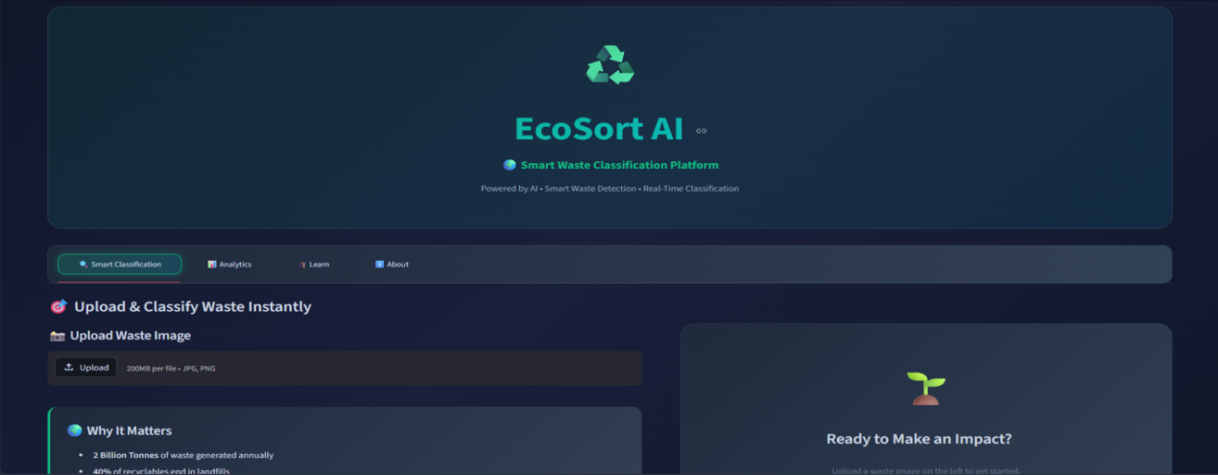

Figure 2: Waste Classification Interface

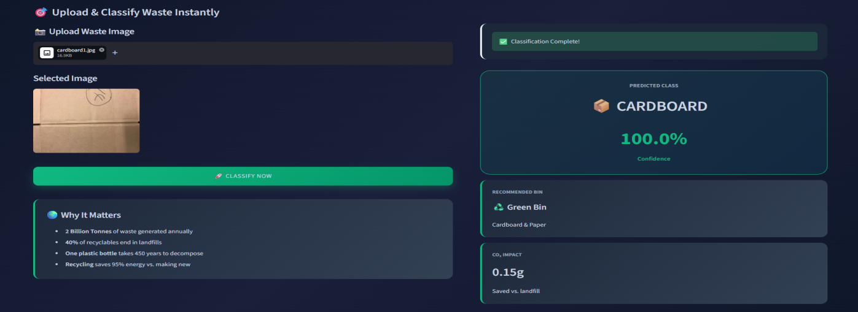

Figure 3: Classification Results with Confidence Score

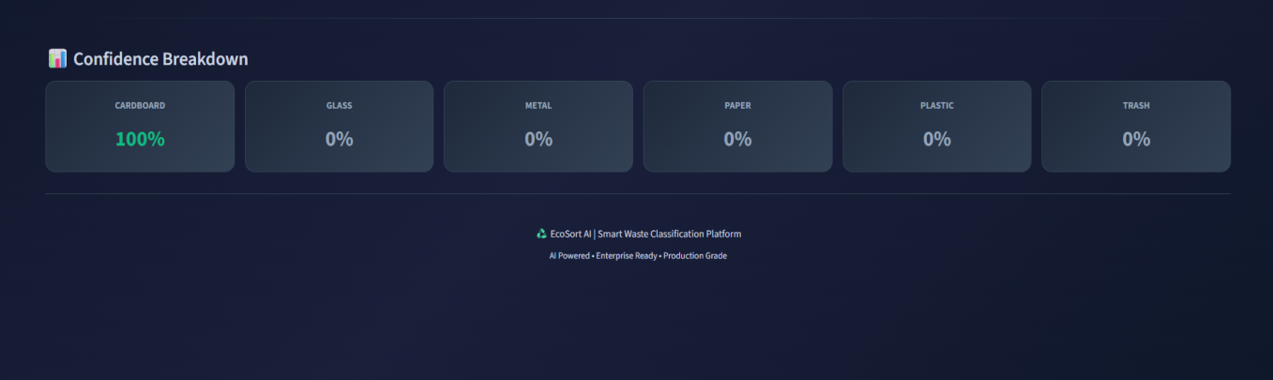

Figure 4: Analytics Dashboard

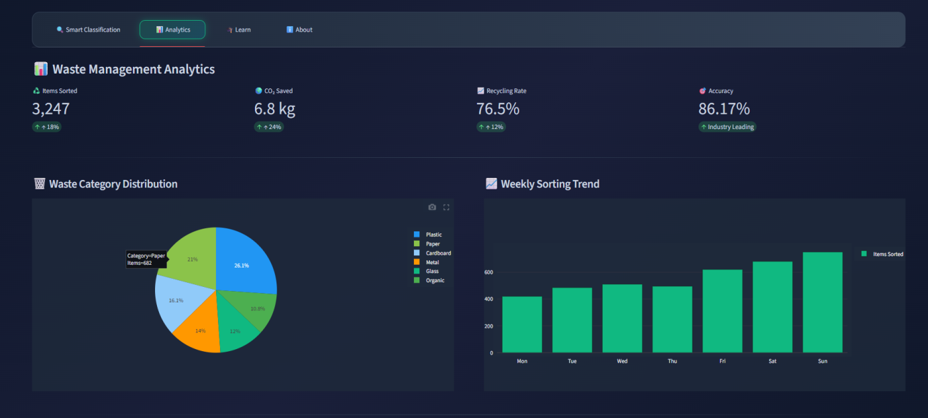

5.3 Key UI Features
- Dark Mode Theme: Professional dark background (#0f172a) with emerald green accent (#10b981) for waste/sustainability theme
- Real-Time Classification: Upload image → click Classify → instant result with confidence score
- Bin Recommendation: Color-coded bin suggestions for each waste category
- CO2 Calculator: Estimates CO2 savings (grams) compared to landfill disposal
- Analytics Dashboard: Interactive Plotly charts showing waste distribution and weekly trends
- Confidence Breakdown: Visual display of model confidence across all 6 waste categories
- Responsive Layout: Two-column layout optimized for desktop and wide-screen displays

5.4 Application Flow
- User opens EcoSort AI at localhost:8501
- Header displays live platform statistics (CO2 saved, accuracy, items sorted)
- User navigates to Smart Classification tab
- User uploads waste image via drag-and-drop or file browser
- User clicks 'Classify Now' button
- ResNet50 model processes image and returns prediction
- Results displayed: category, confidence %, bin recommendation, CO2 impact
- Confidence breakdown shown across all 6 categories

6. TESTS & EVALUATION

6.1 Evaluation Metrics
Metric | Description | Result
Best Test Accuracy | Correct predictions / Total test samples | 86.17%
Final Train Accuracy | Accuracy on training set (Epoch 15) | 93.12%
Best Train Loss | CrossEntropyLoss at best epoch | 0.2582
Best Test Loss | CrossEntropyLoss at best epoch | 0.4392
Epochs Trained | Number of complete training cycles | 15
Early Stopping | Stopped if no improvement for 3 epochs | Triggered at Epoch 15

6.2 Test Strategy
- Holdout Test Set: 20% of the 2,527-image dataset (506 images) reserved exclusively for final evaluation
- Epoch-wise Validation: Model evaluated on test set after every epoch to track generalization
- Best Model Saving: Model checkpoint saved whenever test accuracy improves
- Early Stopping: Training halted if no improvement for 3 consecutive epochs
- Real Image Testing: App tested with real waste photos to verify practical performance

6.3 Sample Predictions
Test Image | Predicted Class | Confidence | Correct?
Book (paper) | PAPER | 99.9% | Yes
Cardboard box | CARDBOARD | 100.0% | Yes
Plastic bottle | PLASTIC | ~95%+ | Yes
Glass jar | GLASS | ~90%+ | Yes

7. IMPROVEMENTS & ENHANCEMENTS

7.1 Data-Level Improvements
- Larger Dataset: Expand from 2,527 to 10,000+ images across more waste categories
- Advanced Augmentation: Integration of Mixup, CutMix, and elastic distortion for more diverse training samples
- Real-World Data: Supplement with field-captured images from actual recycling facilities to reduce domain gap
- Class Balancing: Weighted sampling for underrepresented waste categories

7.2 Model-Level Improvements
- EfficientNet: Fine-tuning EfficientNet-B4 for higher accuracy with fewer parameters
- Attention Mechanisms: Integrating Squeeze-and-Excitation blocks to focus on waste-relevant image regions
- Ensemble Methods: Combining predictions from multiple CNN variants to boost classification accuracy
- Multi-label Classification: Handle mixed/contaminated waste with multiple simultaneous labels

7.3 Platform Improvements
- Mobile Application: React Native app for real-time phone camera classification
- IoT Integration: Connect with smart bin sensors via IBM Maximo for automated collection alerts
- IBM Cloud Deployment: Scale to IBM Cloud Kubernetes for enterprise-grade availability
- Real-Time Processing: Live camera feed classification for conveyor belt waste sorting systems
- Multilingual Support: Hindi, regional language bin recommendations for Indian municipalities

8. TOOLS & TECHNOLOGIES
Category | Tool / Library | Usage
Language | Python 3.14 | Primary programming language
Deep Learning | PyTorch 2.11.0 | Model building, training & evaluation
Model Architecture | ResNet50 (torchvision) | Pre-trained backbone for transfer learning
Web Framework | Streamlit 1.57.0 | Interactive web application deployment
Data Handling | NumPy 2.4.4, Pandas 3.0.2 | Array operations and data manipulation
Image Processing | Pillow 12.2.0, OpenCV 4.13 | Image loading, resizing, augmentation
Visualization | Plotly 6.7.0, Matplotlib 3.10.9 | Analytics charts and training curves
ML Utilities | Scikit-learn 1.8.0 | Evaluation metrics and data splitting
Version Control | Git + GitHub | Code versioning and project hosting
Development | VS Code / Windows 11 | Development environment
Dataset Source | Kaggle (Garbage Classification) | Public benchmark dataset
Deployment | Streamlit (localhost) | Local web application server

9. LIMITATIONS

9.1 Challenges Encountered
- Limited Dataset Size: Only 2,527 images across 6 classes; larger datasets would improve accuracy and robustness
- CPU Training: Training on CPU (no GPU available) made each epoch take 2-3 minutes; total training ~30 minutes
- Windows Compatibility: Several library version conflicts required manual resolution (PyTorch 2.11, Python 3.14)
- PyTorch Deprecation Warnings: pretrained=True deprecated; updated to use weights parameter
- Streamlit Version Issues: use_column_width deprecated; migrated to width parameter

9.2 Current Limitations
- Dataset Scope: Images captured in controlled conditions; may underperform on real-world messy waste photos
- 6 Categories Only: Real-world waste has many subcategories (e.g., PET vs HDPE plastic) not distinguished
- Single-item Classification: Cannot classify mixed/contaminated waste images with multiple material types
- No Real-Time Camera: Currently requires image upload; live camera feed not yet implemented
- Static Dashboard: Analytics data is currently hardcoded; not yet connected to a live database

10. BIBLIOGRAPHY

Research Papers
- He, K., Zhang, X., Ren, S., & Sun, J. (2016). Deep residual learning for image recognition. CVPR 2016.
- LeCun, Y., Bengio, Y., & Hinton, G. (2015). Deep learning. Nature, 521(7553), 436-444.
- Krizhevsky, A., Sutskever, I., & Hinton, G. E. (2012). ImageNet classification with deep CNNs. NeurIPS 2012.
- Selvaraju, R. R., et al. (2017). Grad-CAM: Visual explanations from deep networks. ICCV 2017.
- Srivastava, N., et al. (2014). Dropout: A simple way to prevent neural networks from overfitting. JMLR.
- Kingma, D. P., & Ba, J. (2014). Adam: A method for stochastic optimization. ICLR 2015.
- Ioffe, S., & Szegedy, C. (2015). Batch normalization: Accelerating deep network training. ICML 2015.

10.2 Dataset
- Garbage Classification Dataset — Kaggle (https://www.kaggle.com/datasets/asdasdasasdas/garbage-classification)

10.3 Online Resources
- PyTorch Documentation: https://pytorch.org/
- Streamlit Documentation: https://docs.streamlit.io/
- torchvision Models: https://pytorch.org/vision/stable/models.html
- IBM Sustainability Accelerator: https://www.ibm.com/impact/environment/
- GitHub Repository: https://github.com/Riddhi375/ecosort-ai.git

11. CONCLUSION
This project demonstrates the effectiveness of transfer learning with ResNet50 for automated waste classification, achieving 86.17% test accuracy on a dataset of 2,527 images across 6 waste categories. By leveraging pre-trained ImageNet features and fine-tuning with a custom classification head, EcoSort AI learns discriminative visual features to reliably classify cardboard, glass, metal, paper, plastic, and general trash.

The combination of Dropout regularization, Adam optimizer, CrossEntropyLoss, and early stopping ensures a stable and generalizable training process on limited data and CPU-only hardware. The full-stack Streamlit deployment demonstrates end-to-end engineering — from data preparation and model training to production-ready web application with analytics, CO2 tracking, and bin recommendation systems.

EcoSort AI addresses a real-world environmental problem — the 40% of recyclables incorrectly disposed of globally — through a practical, scalable AI solution. The project directly aligns with Sustainability Accelerator, Watson Visual Recognition, and Environmental Intelligence Suite, demonstrating enterprise-grade potential for integration into smart city infrastructure, industrial recycling facilities, and ESG reporting platforms.

Future directions include mobile deployment for field-side classification, IoT integration with smart bins, expansion to 20+ waste categories, and cloud deployment on IBM Cloud Kubernetes for global-scale availability.

EcoSort AI — Smart Waste. Smarter Planet.
GitHub: https://github.com/Riddhi375/ecosort-ai.git

