RETAIL ANALYTICS DASHBOARD USING POWER BI
PROJECT DOCUMENTATION
Riddhi Chatterjee
MBA (Business Analytics & Data Science)
Bengal Institute of Business Studies (BIBS)
2025 - 2026

TABLE OF CONTENTS
1. Project Overview
2. Dataset Documentation
3. Assumptions Made
4. Data Cleaning Strategy
5. Transformation Logic
6. Data Model
7. Revenue Analytics Dashboard
8. Customer Insights Dashboard
9. Category Trends Dashboard
10. Azure Cloud Mapping
11. Conclusion

Project Overview
This project focuses on developing a comprehensive Retail Analytics Dashboard using Power BI. The purpose of the project is to transform raw retail transaction data into meaningful business insights that can support strategic and operational decision-making. Modern retail organizations generate a large volume of data through sales transactions, customer purchases, payment systems and inventory movement. However, without proper analysis, the value hidden inside this data cannot be fully utilized. The project addresses this challenge by creating an interactive business intelligence solution.
The dashboard provides visibility into revenue generation, customer behaviour, product performance and category-level trends. Business users can monitor key performance indicators, identify growth opportunities and evaluate performance across different locations and product groups. The solution uses data preparation, transformation, modelling and visualization techniques to ensure that the final output is accurate, reliable and actionable.
The project demonstrates practical application of analytics concepts including KPI generation, trend analysis, segmentation, aggregation and visual reporting. The final dashboard allows users to interact with the data through slicers and filters, making it easier to explore business performance from multiple perspectives.

Dataset Documentation
The dataset used in this project consists of curated retail transaction records. It includes customer information, product details, category information, city details, transaction values, quantity purchased and payment information. The dataset serves as the foundation for all analyses and dashboard visualizations.
Key columns include transaction_id, customer_id, customer_name, product_id, category, city, transaction_date, purchase_location, quantity, revenue, discount and discount_loss. Additional calculated columns such as Month, Month Number and Quarter were generated to support time-series reporting. The dataset was structured to support revenue analysis, customer analysis, category analysis and regional performance evaluation.
The availability of multiple dimensions and measures enabled the creation of interactive dashboards capable of answering important business questions. The dataset was also prepared with data governance considerations, including masking of sensitive customer information.
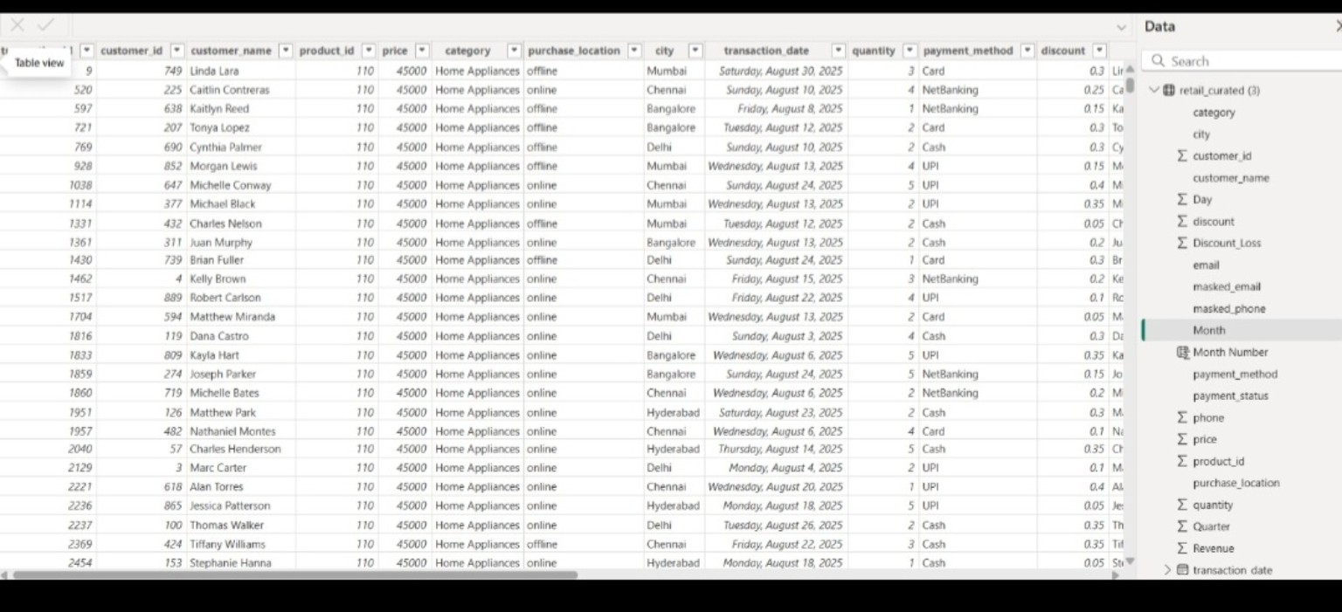

Assumptions Made
All transaction records were assumed to be valid business transactions. Customer identifiers were considered unique and reliable. Revenue values were assumed to be complete and accurate for reporting purposes. Category names and city names were treated as standardized after the cleaning process. Discount percentages were considered suitable for discount-loss calculations. The curated dataset was assumed to represent the final reporting layer and therefore was considered ready for business intelligence reporting. These assumptions helped maintain consistency throughout the analytical workflow and ensured that KPI calculations produced meaningful results.All transaction records were assumed to be valid business transactions. Customer identifiers were considered unique and reliable. Revenue values were assumed to be complete and accurate for reporting purposes. Category names and city names were treated as standardized after the cleaning process. Discount percentages were considered suitable for discount-loss calculations. The curated dataset was assumed to represent the final reporting layer and therefore was considered ready for business intelligence reporting. These assumptions helped maintain consistency throughout the analytical workflow and ensured that KPI calculations produced meaningful results.

Data Cleaning Strategy
Data cleaning was performed using Power Query. The objective of the cleaning process was to improve data quality, remove inconsistencies and prepare the dataset for reporting. Several transformation steps were applied including data type correction, column renaming, validation of field values, removal of unnecessary attributes and standardization of formats. Sensitive customer information was protected through masking techniques. The cleaning process reduced the risk of inaccurate reporting and ensured that business decisions would be based on reliable information. Data quality is a critical component of business intelligence projects, and therefore extensive validation was performed before dashboard development.Data cleaning was performed using Power Query. The objective of the cleaning process was to improve data quality, remove inconsistencies and prepare the dataset for reporting. Several transformation steps were applied including data type correction, column renaming, validation of field values, removal of unnecessary attributes and standardization of formats. Sensitive customer information was protected through masking techniques. The cleaning process reduced the risk of inaccurate reporting and ensured that business decisions would be based on reliable information. Data quality is a critical component of business intelligence projects, and therefore extensive validation was performed before dashboard development.
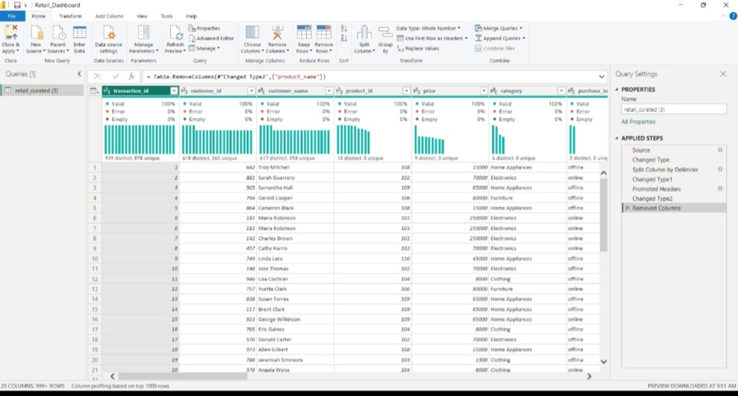

Transformation Logic
Transformation logic was implemented to convert raw transactional data into analysis-ready information. Month and Month Number fields were derived from transaction dates to support monthly trend analysis. Quarter values were generated to enable quarterly performance reporting. Revenue and Discount Loss metrics were used to create KPIs and support category-level analysis. Aggregation techniques were applied to generate customer-level, city-level and category-level insights. These transformations improved reporting flexibility and enhanced the analytical value of the dataset. Transformation logic was implemented to convert raw transactional data into analysis-ready information. Month and Month Number fields were derived from transaction dates to support monthly trend analysis. Quarter values were generated to enable quarterly performance reporting. Revenue and Discount Loss metrics were used to create KPIs and support category-level analysis. Aggregation techniques were applied to generate customer-level, city-level and category-level insights. These transformations improved reporting flexibility and enhanced the analytical value of the dataset. Transformation logic was implemented to convert raw transactional data into analysis-ready information. Month and Month Number fields were derived from transaction dates to support monthly trend analysis. Quarter values were generated to enable quarterly performance reporting. Revenue and Discount Loss metrics were used to create KPIs and support category-level analysis. Aggregation techniques were applied to generate customer-level, city-level and category-level insights. These transformations improved reporting flexibility and enhanced the analytical value of the dataset.

Data Model
A simplified single-table model was used in this project. The retail_curated table contained all necessary dimensions and measures required for reporting. Because all attributes were available within a single curated dataset, additional relationships were not required. This design improved performance, simplified maintenance and reduced model complexity. The model supports filtering, slicing, KPI calculations and visual interactions efficiently. A simplified single-table model was used in this project. The retail_curated table contained all necessary dimensions and measures required for reporting. Because all attributes were available within a single curated dataset, additional relationships were not required. This design improved performance, simplified maintenance and reduced model complexity. The model supports filtering, slicing, KPI calculations and visual interactions efficiently. A simplified single-table model was used in this project. The retail_curated table contained all necessary dimensions and measures required for reporting. Because all attributes were available within a single curated dataset, additional relationships were not required. This design improved performance, simplified maintenance and reduced model complexity. The model supports filtering, slicing, KPI calculations and visual interactions efficiently.
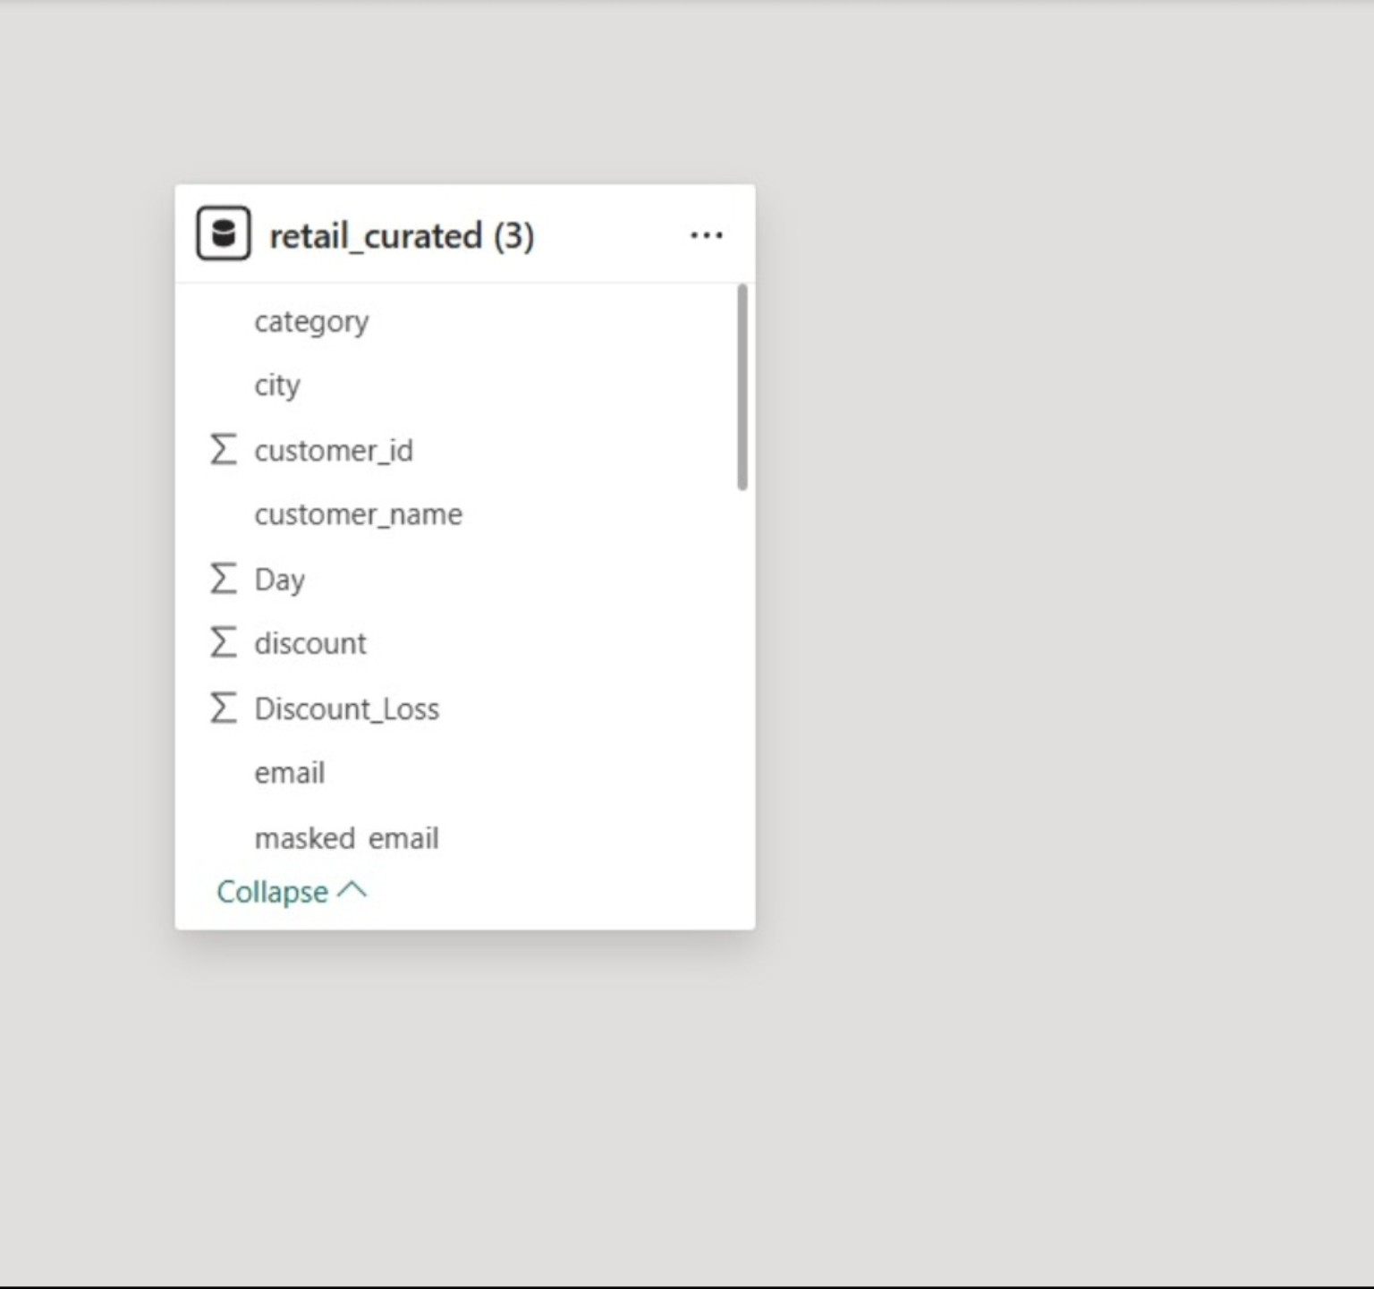

Revenue Analytics Dashboard
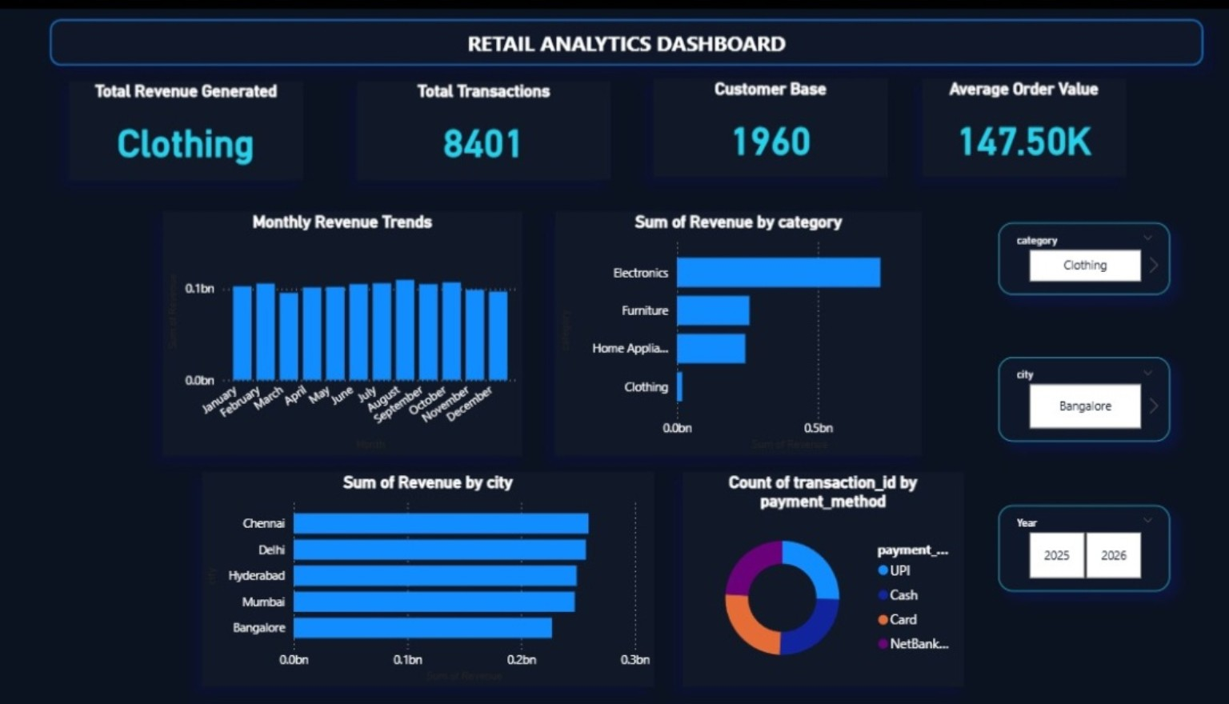
The Revenue Analytics Dashboard provides a high-level overview of business performance. KPIs such as Total Revenue, Total Transactions, Customer Base and Average Order Value allow management to evaluate overall business health. Monthly revenue trends reveal performance patterns across time. Revenue by category identifies the strongest product groups, while revenue by city highlights important regional markets. Payment method analysis provides insights into customer transaction preferences and supports strategic planning. The Revenue Analytics Dashboard provides a high-level overview of business performance. KPIs such as Total Revenue, Total Transactions, Customer Base and Average Order Value allow management to evaluate overall business health. Monthly revenue trends reveal performance patterns across time. Revenue by category identifies the strongest product groups, while revenue by city highlights important regional markets. Payment method analysis provides insights into customer transaction preferences and supports strategic planning. The Revenue Analytics Dashboard provides a high-level overview of business performance. KPIs such as Total Revenue, Total Transactions, Customer Base and Average Order Value allow management to evaluate overall business health. Monthly revenue trends reveal performance patterns across time. Revenue by category identifies the strongest product groups, while revenue by city highlights important regional markets. Payment method analysis provides insights into customer transaction preferences and supports strategic planning. The Revenue Analytics Dashboard provides a high-level overview of business performance. KPIs such as Total Revenue, Total Transactions, Customer Base and Average Order Value allow management to evaluate overall business health. Monthly revenue trends reveal performance patterns across time. Revenue by category identifies the strongest product groups, while revenue by city highlights important regional markets. Payment method analysis provides insights into customer transaction preferences and supports strategic planning. The Revenue Analytics Dashboard provides a high-level overview of business performance. KPIs such as Total Revenue, Total Transactions, Customer Base and Average Order Value allow management to evaluate overall business health. Monthly revenue trends reveal performance patterns across time. Revenue by category identifies the strongest product groups, while revenue by city highlights important regional markets. Payment method analysis provides insights into customer transaction preferences and supports strategic planning. The Revenue Analytics Dashboard provides a high-level overview of business performance. KPIs such as Total Revenue, Total Transactions, Customer Base and Average Order Value allow management to evaluate overall business health. Monthly revenue trends reveal performance patterns across time. Revenue by category identifies the strongest product groups, while revenue by city highlights important regional markets. Payment method analysis provides insights into customer transaction preferences and supports strategic planning. The Revenue Analytics Dashboard provides a high-level overview of business performance. KPIs such as Total Revenue, Total Transactions, Customer Base and Average Order Value allow management to evaluate overall business health. Monthly revenue trends reveal performance patterns across time. Revenue by category identifies the strongest product groups, while revenue by city highlights important regional markets. Payment method analysis provides insights into customer transaction preferences and supports strategic planning. The Revenue Analytics Dashboard provides a high-level overview of business performance. KPIs such as Total Revenue, Total Transactions, Customer Base and Average Order Value allow management to evaluate overall business health. Monthly revenue trends reveal performance patterns across time. Revenue by category identifies the strongest product groups, while revenue by city highlights important regional markets. Payment method analysis provides insights into customer transaction preferences and supports strategic planning.

Customer Insights Dashboard
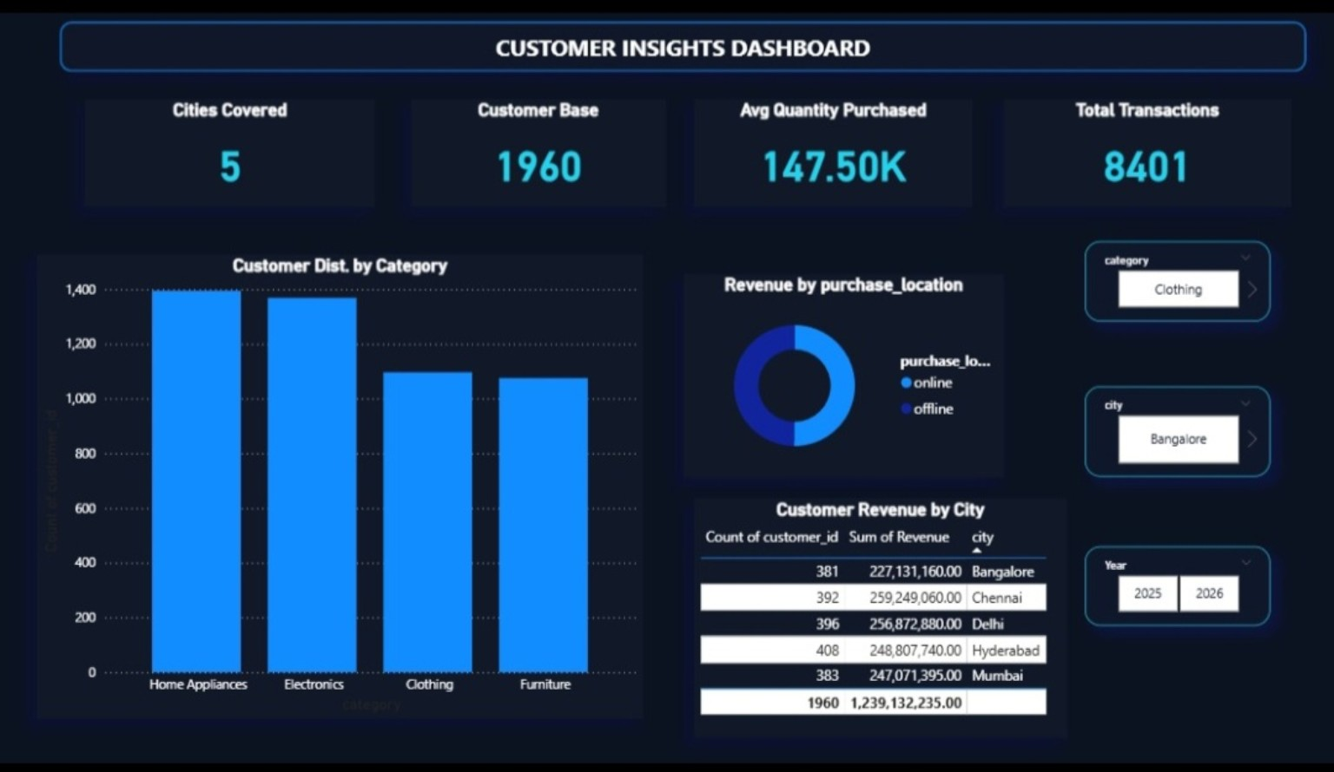
The Customer Insights Dashboard focuses on understanding customer behaviour. Customer distribution by category reveals purchasing preferences, while revenue by purchase location compares online and offline business performance. City-wise customer revenue analysis helps identify the most valuable markets. These insights can support customer acquisition strategies, retention initiatives and targeted marketing campaigns. The Customer Insights Dashboard focuses on understanding customer behaviour. Customer distribution by category reveals purchasing preferences, while revenue by purchase location compares online and offline business performance. City-wise customer revenue analysis helps identify the most valuable markets. These insights can support customer acquisition strategies, retention initiatives and targeted marketing campaigns. The Customer Insights Dashboard focuses on understanding customer behaviour. Customer distribution by category reveals purchasing preferences, while revenue by purchase location compares online and offline business performance. City-wise customer revenue analysis helps identify the most valuable markets. These insights can support customer acquisition strategies, retention initiatives and targeted marketing campaigns. The Customer Insights Dashboard focuses on understanding customer behaviour. Customer distribution by category reveals purchasing preferences, while revenue by purchase location compares online and offline business performance. City-wise customer revenue analysis helps identify the most valuable markets. These insights can support customer acquisition strategies, retention initiatives and targeted marketing campaigns. The Customer Insights Dashboard focuses on understanding customer behaviour. Customer distribution by category reveals purchasing preferences, while revenue by purchase location compares online and offline business performance. City-wise customer revenue analysis helps identify the most valuable markets. These insights can support customer acquisition strategies, retention initiatives and targeted marketing campaigns. The Customer Insights Dashboard focuses on understanding customer behaviour. Customer distribution by category reveals purchasing preferences, while revenue by purchase location compares online and offline business performance. City-wise customer revenue analysis helps identify the most valuable markets. These insights can support customer acquisition strategies, retention initiatives and targeted marketing campaigns. The Customer Insights Dashboard focuses on understanding customer behaviour. Customer distribution by category reveals purchasing preferences, while revenue by purchase location compares online and offline business performance. City-wise customer revenue analysis helps identify the most valuable markets. These insights can support customer acquisition strategies, retention initiatives and targeted marketing campaigns. The Customer Insights Dashboard focuses on understanding customer behaviour. Customer distribution by category reveals purchasing preferences, while revenue by purchase location compares online and offline business performance. City-wise customer revenue analysis helps identify the most valuable markets. These insights can support customer acquisition strategies, retention initiatives and targeted marketing campaigns.

Category Trends Dashboard
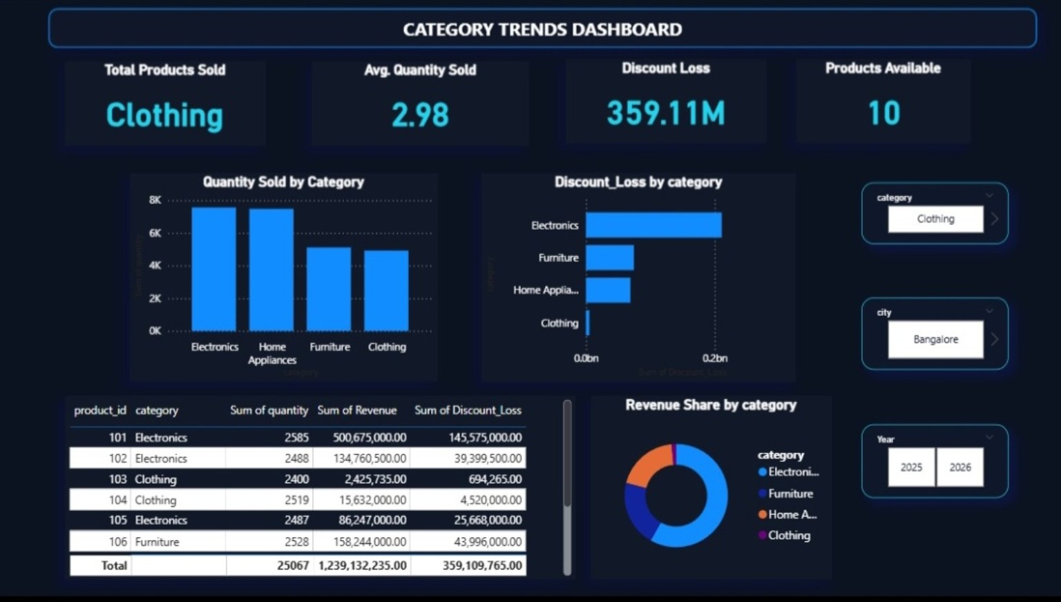
The Category Trends Dashboard evaluates category-level performance using metrics such as quantity sold, products available and discount loss. Revenue share analysis identifies categories that contribute most to business performance. The dashboard supports inventory planning, pricing decisions and category management. Managers can use these insights to optimize product portfolios and improve profitability. The Category Trends Dashboard evaluates category-level performance using metrics such as quantity sold, products available and discount loss. Revenue share analysis identifies categories that contribute most to business performance. The dashboard supports inventory planning, pricing decisions and category management. Managers can use these insights to optimize product portfolios and improve profitability. The Category Trends Dashboard evaluates category-level performance using metrics such as quantity sold, products available and discount loss. Revenue share analysis identifies categories that contribute most to business performance. The dashboard supports inventory planning, pricing decisions and category management. Managers can use these insights to optimize product portfolios and improve profitability. The Category Trends Dashboard evaluates category-level performance using metrics such as quantity sold, products available and discount loss. Revenue share analysis identifies categories that contribute most to business performance. The dashboard supports inventory planning, pricing decisions and category management. Managers can use these insights to optimize product portfolios and improve profitability. The Category Trends Dashboard evaluates category-level performance using metrics such as quantity sold, products available and discount loss. Revenue share analysis identifies categories that contribute most to business performance. The dashboard supports inventory planning, pricing decisions and category management. Managers can use these insights to optimize product portfolios and improve profitability. The Category Trends Dashboard evaluates category-level performance using metrics such as quantity sold, products available and discount loss. Revenue share analysis identifies categories that contribute most to business performance. The dashboard supports inventory planning, pricing decisions and category management. Managers can use these insights to optimize product portfolios and improve profitability. The Category Trends Dashboard evaluates category-level performance using metrics such as quantity sold, products available and discount loss. Revenue share analysis identifies categories that contribute most to business performance. The dashboard supports inventory planning, pricing decisions and category management. Managers can use these insights to optimize product portfolios and improve profitability. The Category Trends Dashboard evaluates category-level performance using metrics such as quantity sold, products available and discount loss. Revenue share analysis identifies categories that contribute most to business performance. The dashboard supports inventory planning, pricing decisions and category management. Managers can use these insights to optimize product portfolios and improve profitability.

Azure Cloud Mapping
Although the project was implemented locally, the architecture aligns with cloud-based analytics principles. Azure Data Factory can be used for ingestion, Azure Data Lake Storage for storage, Azure Databricks for processing and Power BI Service for reporting. The workflow is cloud-ready and can be scaled for enterprise-level deployment. This demonstrates alignment with modern analytics architecture while satisfying project requirements. Although the project was implemented locally, the architecture aligns with cloud-based analytics principles. Azure Data Factory can be used for ingestion, Azure Data Lake Storage for storage, Azure Databricks for processing and Power BI Service for reporting. The workflow is cloud-ready and can be scaled for enterprise-level deployment. This demonstrates alignment with modern analytics architecture while satisfying project requirements. Although the project was implemented locally, the architecture aligns with cloud-based analytics principles. Azure Data Factory can be used for ingestion, Azure Data Lake Storage for storage, Azure Databricks for processing and Power BI Service for reporting. The workflow is cloud-ready and can be scaled for enterprise-level deployment. This demonstrates alignment with modern analytics architecture while satisfying project requirements. Although the project was implemented locally, the architecture aligns with cloud-based analytics principles. Azure Data Factory can be used for ingestion, Azure Data Lake Storage for storage, Azure Databricks for processing and Power BI Service for reporting. The workflow is cloud-ready and can be scaled for enterprise-level deployment. This demonstrates alignment with modern analytics architecture while satisfying project requirements.

Conclusion
The Retail Analytics Dashboard successfully transformed raw data into actionable business intelligence. Through data cleaning, transformation, modelling and visualization, the project generated meaningful insights related to revenue, customers and categories. The dashboard provides a practical decision-support tool and demonstrates strong understanding of business analytics concepts, Power BI reporting and KPI-driven analysis. The Retail Analytics Dashboard successfully transformed raw data into actionable business intelligence. Through data cleaning, transformation, modelling and visualization, the project generated meaningful insights related to revenue, customers and categories. The dashboard provides a practical decision-support tool and demonstrates strong understanding of business analytics concepts, Power BI reporting and KPI-driven analysis. The Retail Analytics Dashboard successfully transformed raw data into actionable business intelligence. Through data cleaning, transformation, modelling and visualization, the project generated meaningful insights related to revenue, customers and categories. The dashboard provides a practical decision-support tool and demonstrates strong understanding of business analytics concepts, Power BI reporting and KPI-driven analysis. The Retail Analytics Dashboard successfully transformed raw data into actionable business intelligence. Through data cleaning, transformation, modelling and visualization, the project generated meaningful insights related to revenue, customers and categories. The dashboard provides a practical decision-support tool and demonstrates strong understanding of business analytics concepts, Power BI reporting and KPI-driven analysis.

