S24CSEU0322-RIDDHIGANDHI

TASK1-Github link- https://github.com/Riddhi743/MLOps_bennett/blob/main/P02_S24CSEU0322.ipynb
TASK 2-
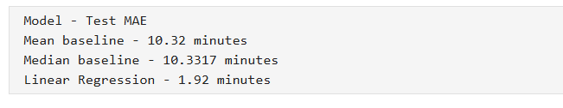
TASK 3-