DevOps Practical
Activity 9
Containerized REST API for Student Records
Project Report
Submitted by
Sr. No. | Name | Roll No.
1 | Riddhi Gopalani | 34124
2 | Om Mahajan | 34140
3 | Sudhan Dabhade | 34118
4 | Pratik Kalburgi | 34130

GitHub Repository:
https://github.com/RiddhiGopalani/Containerized-REST-API-for-Student-Records

1. Problem Statement
Build a simple REST API that supports adding, viewing, and updating student records. Package the application into a Docker container and demonstrate that it can be started, stopped, and recreated without manually configuring the host environment.

2. Aim
To develop a REST API for managing student records using Python and FastAPI, containerize it using Docker, and demonstrate the container lifecycle with persistent data storage.

3. Objectives
- Implement a basic REST API to add, view and update student records.
- Store the records in a SQLite database so that data is not lost when the server stops.
- Write a Dockerfile and configure the required ports.
- Run the API inside a Docker container without installing Python packages on the host.
- Demonstrate API functionality and container lifecycle commands (stop, start, restart, rm, run).
- Use a Docker volume so that student records survive container removal and recreation.
- Test the API with automated and manual tests and record the results.

4. Theory

4.1 REST API
REST (Representational State Transfer) is a simple way of designing web services. Each resource, like a student, has a URL (for example /students/4) and the client uses HTTP methods to work with it. The data is sent and received in JSON format. The server does not remember anything about the client between requests.
HTTP Method | Use in this project
GET | Read data - view all students or one student
POST | Create data - add a new student
PUT | Update data - change an existing student's details

HTTP status codes tell the client what happened:
Code | Meaning | When our API returns it
200 OK | Request successful | View or update succeeded
201 Created | New resource created | Student added
404 Not Found | Resource does not exist | Student ID not in database
409 Conflict | Clashes with existing data | Roll number already used
422 Unprocessable Entity | Input is invalid | Missing field, bad email, non-numeric ID

4.2 FastAPI and Uvicorn
FastAPI is a Python web framework for building APIs. We define the request data as Pydantic models, and FastAPI checks the input automatically and returns a 422 error if it is wrong. It also creates interactive Swagger documentation at /docs, which we used to test the API from the browser. Uvicorn is the ASGI server that actually runs the FastAPI application and listens for HTTP requests.

4.3 SQLite
SQLite is a small database that stores everything in one file (students.db). It is built into Python, so no separate database server is needed. This makes it a good fit for a simple project like ours.

4.4 Docker
Docker packages an application together with everything it needs (Python, libraries, code) so that it runs the same way on any machine. Important terms:
Term | Meaning
Dockerfile | A text file with step-by-step instructions to build an image.
Image | A read-only template built from the Dockerfile (student-records-api:1.0).
Container | A running instance of an image (student-api).
Port mapping (-p) | Connects a port on the host to a port inside the container (8000:8000).
Volume (-v) | Storage managed by Docker that lives outside the container, so data survives when the container is removed (student-data).
Docker Desktop | The application that runs the Docker engine on Windows.

4.5 Container Lifecycle
A container goes through the states Created → Running → Stopped (Exited) → Removed. docker run creates and starts a container, docker stop and docker start move it between running and stopped, docker restart does both, and docker rm deletes it. Anything stored only inside the container is lost after docker rm, which is why we keep the database in a volume.

5. Software and Hardware Requirements
Software | Version / Details
Operating System | Windows 11
Python | 3.13.7 (only needed to run locally; the container has its own Python)
FastAPI | 0.115.12
Uvicorn | 0.34.2
Pytest / HTTPX | 8.3.5 / 0.28.1
SQLite | Built into Python
Docker Desktop | Docker Engine 29.3.1
Base image | python:3.13-slim
Git and GitHub | Version control and code hosting
Browser / VS Code | Swagger UI testing and code editing

Hardware | Minimum
Processor | 64-bit processor with virtualization enabled (for Docker)
RAM | 4 GB (8 GB recommended for Docker Desktop)
Disk space | About 2 GB free for Docker Desktop and images

6. System Architecture
The client (browser, Swagger UI or curl) sends HTTP requests to localhost:8000. Docker forwards host port 8000 to port 8000 inside the student-api container, where Uvicorn runs the FastAPI app. The app reads and writes the SQLite file /app/data/students.db. The /app/data folder is a Docker volume (student-data), so the data is stored outside the container. The bottom part of the diagram shows the build and run workflow.
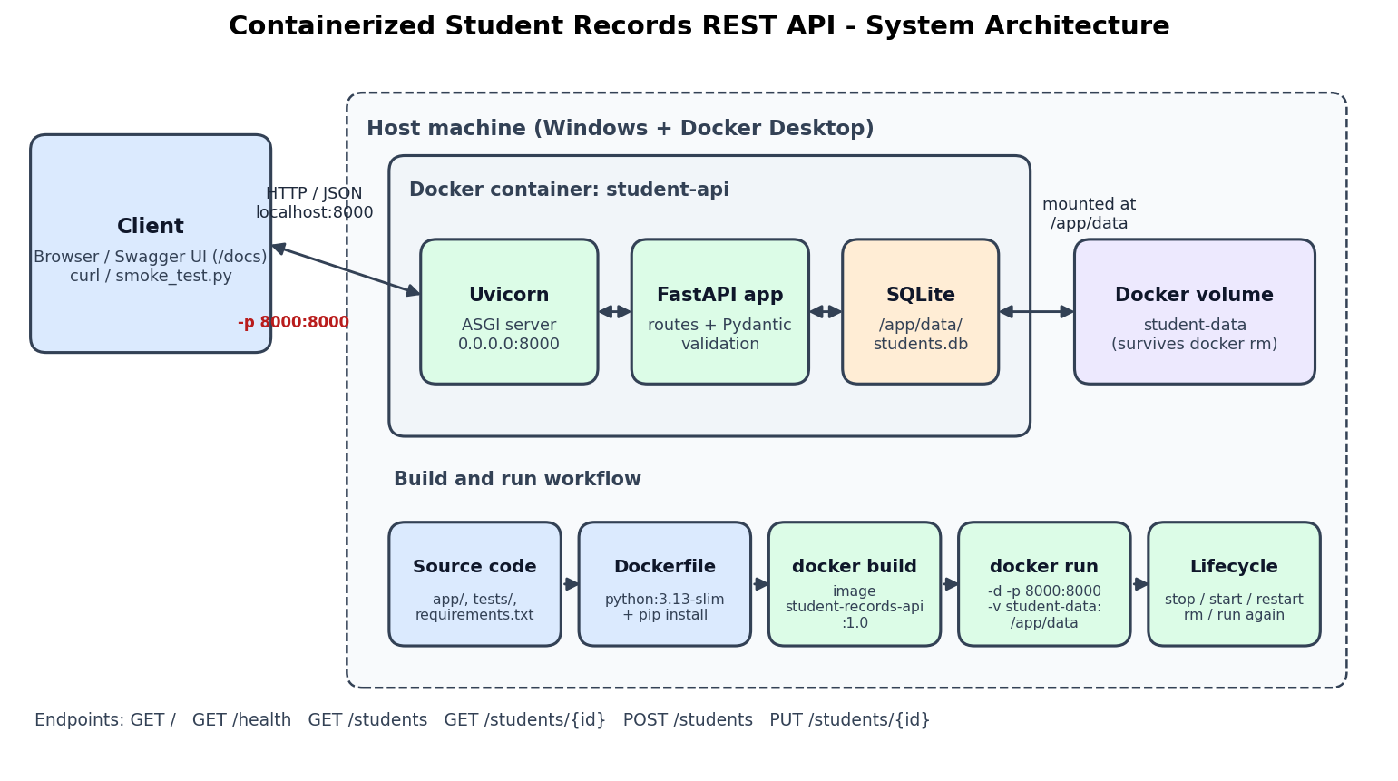
Fig. 1: System architecture and Docker workflow

Project Structure
Containerized-REST-API-for-Student-Records/
├── app/
│ ├── main.py FastAPI app and endpoints
│ ├── database.py SQLite functions
│ └── schemas.py Pydantic models (input validation)
├── tests/test_api.py 11 pytest test cases
├── scripts/smoke_test.py Live test against the container
├── docs/ Diagram, report, presentation
├── screenshots/ Output screenshots
├── Dockerfile
├── .dockerignore
├── requirements.txt
├── pytest.ini
└── README.md

7. Implementation Procedure
1. Checked the environment: Python 3.13.7 and Docker 29.3.1 were installed. Docker Desktop had to be started.
2. Created a Python virtual environment and installed FastAPI, Uvicorn, Pytest and HTTPX from requirements.txt.
3. Wrote database.py: creates the students table (id, name, roll_no, department, email) and adds three sample students the first time. The database path is read from the DB_PATH environment variable.
4. Wrote schemas.py: Pydantic model StudentIn with length checks and an email pattern.
5. Wrote main.py: the six endpoints, with 404 for a missing student and 409 for a duplicate roll number.
6. Ran the API locally with Uvicorn and tested every endpoint through Swagger UI (Figs. 2-9).
7. Wrote 11 pytest test cases. Each test uses its own temporary database so real data is not touched.
8. Wrote the Dockerfile and .dockerignore, built the image student-records-api:1.0 and ran the container student-api with port 8000 and the student-data volume (Figs. 10-14).
9. Demonstrated the lifecycle commands: stop, start, restart, rm and run, and checked that data was still there after recreation (Fig. 15).
10. Wrote a live smoke test script and ran it against the container, including automatic recreation (Fig. 16).
11. Pushed the code, configuration files and documentation to GitHub.

Key code - adding a student (app/main.py)
@app.post("/students", response_model=Student, status_code=status.HTTP_201_CREATED)
def add_student(student: StudentIn):
try:
return database.insert_student(student.model_dump())
except sqlite3.IntegrityError:
raise HTTPException(status_code=409, detail=f"Roll number {student.roll_no} already exists")

Key code - input validation (app/schemas.py)
class StudentIn(BaseModel):
name: str = Field(..., min_length=2, max_length=100)
roll_no: str = Field(..., min_length=1, max_length=20)
department: str = Field(..., min_length=2, max_length=100)
email: str = Field(..., pattern=EMAIL_PATTERN, max_length=100)

8. API Endpoints
Method | Endpoint | Purpose | Status codes
GET | / | Welcome message and list of endpoints | 200
GET | /health | Health check (also used by Docker HEALTHCHECK) | 200
GET | /students | View all students | 200
GET | /students/{student_id} | View one student by ID | 200 / 404
POST | /students | Add a new student | 201 / 409 / 422
PUT | /students/{student_id} | Update an existing student | 200 / 404 / 409 / 422

Example request body for POST and PUT:
{
"name": "Riddhi Gopalani",
"roll_no": "101",
"department": "Computer Engineering",
"email": "riddhi@example.com"
}

9. Docker Configuration

9.1 Dockerfile
# Base image with Python already installed
FROM python:3.13-slim
# Do not create .pyc files and show logs immediately
ENV PYTHONDONTWRITEBYTECODE=1 \
PYTHONUNBUFFERED=1 \
DB_PATH=/app/data/students.db
WORKDIR /app
# Install dependencies first so Docker can cache this layer
COPY requirements.txt .
RUN pip install --no-cache-dir -r requirements.txt
# Copy the application code and tests
COPY app/ ./app/
COPY tests/ ./tests/
COPY pytest.ini .
# Folder for the SQLite database (a Docker volume is mounted here)
RUN mkdir -p /app/data
VOLUME ["/app/data"]
# The API listens on port 8000 inside the container
EXPOSE 8000
# Docker marks the container healthy when /health responds
HEALTHCHECK --interval=30s --timeout=5s --start-period=10s --retries=3 \
CMD python -c "import urllib.request; urllib.request.urlopen('http://localhost:8000/health')" || exit 1
# 0.0.0.0 makes the server reachable from outside the container
CMD ["uvicorn", "app.main:app", "--host", "0.0.0.0", "--port", "8000"]

Instruction | Why it is used
FROM python:3.13-slim | Small official image that already has Python.
ENV DB_PATH=... | Tells the app to store the database in /app/data.
COPY requirements.txt + RUN pip install | Installs libraries first so this layer is cached.
COPY app/ tests/ | Copies our source code into the image.
VOLUME /app/data | Marks the data folder for persistent storage.
EXPOSE 8000 | Documents the port the API uses.
HEALTHCHECK | Docker calls /health every 30 s and shows (healthy) in docker ps.
CMD uvicorn ... --host 0.0.0.0 | Starts the server; 0.0.0.0 makes it reachable from outside the container.

9.2 .dockerignore
Keeps unnecessary files out of the image: .git, .venv, __pycache__, .pytest_cache, the local data folder, docs, screenshots and markdown files. This makes the build faster and the image smaller.

9.3 Docker and Lifecycle Commands
Command | Purpose
docker build -t student-records-api:1.0 . | Builds the image from the Dockerfile and tags it.
docker run -d --name student-api -p 8000:8000 -v student-data:/app/data student-records-api:1.0 | Creates and starts a container in the background, maps port 8000 and mounts the volume.
docker ps / docker ps -a | Lists running containers / all containers including stopped ones.
docker logs student-api | Shows the Uvicorn server logs from the container.
docker stop student-api | Stops the running container (status becomes Exited).
docker start student-api | Starts the same stopped container again.
docker restart student-api | Stops and starts the container in one step.
docker rm student-api | Deletes the stopped container. The volume is not deleted.
docker volume ls | Lists volumes - student-data is still present after docker rm.

Removing the container does not delete the student-data volume. When a new container is created with the same -v student-data:/app/data option, it uses the same database file, so all records are still available.

10. Output Screenshots

10.1 API Running Locally
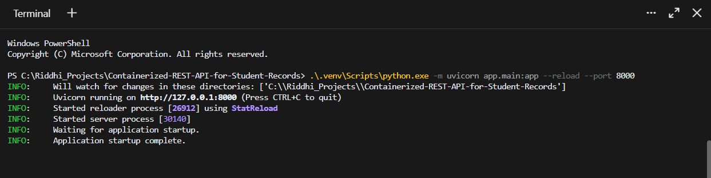
Fig. 2: Uvicorn server running locally on http://127.0.0.1:8000
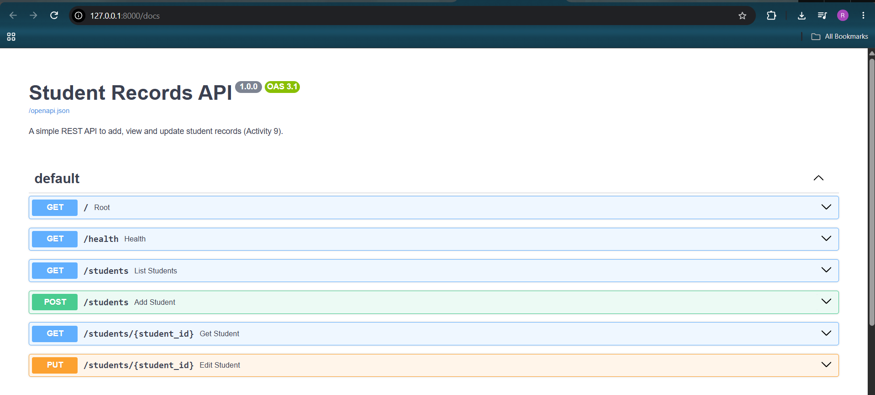
Fig. 3: FastAPI Swagger documentation (/docs) showing all six endpoints
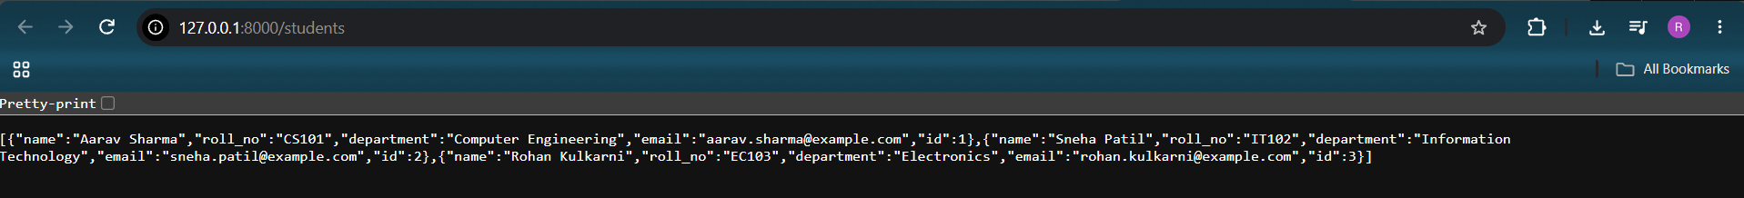
Fig. 4: GET /students returning the three sample student records
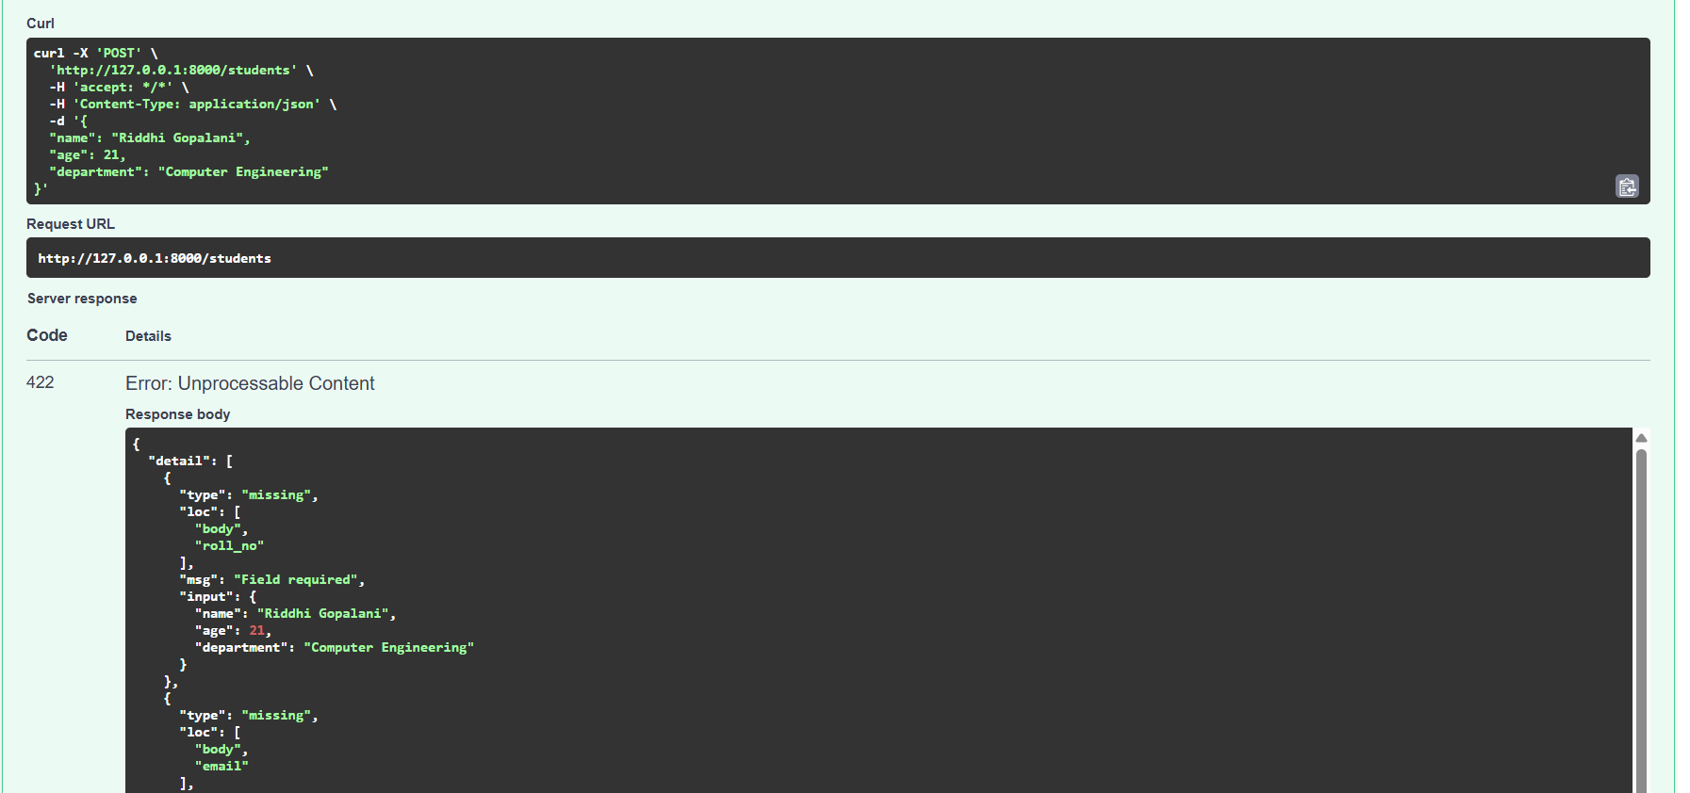
Fig. 5: Input validation - POST with missing roll_no and email returns 422 Unprocessable Entity
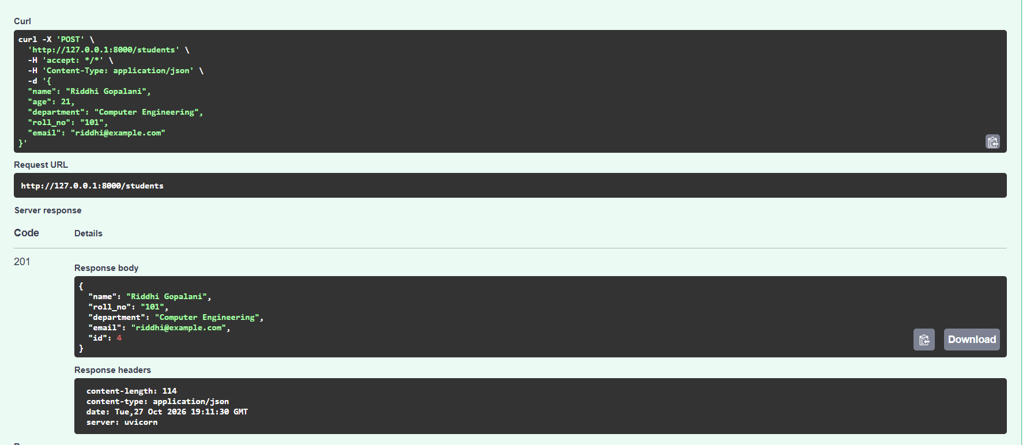
Fig. 6: POST /students - new student added successfully (201 Created, id 4)
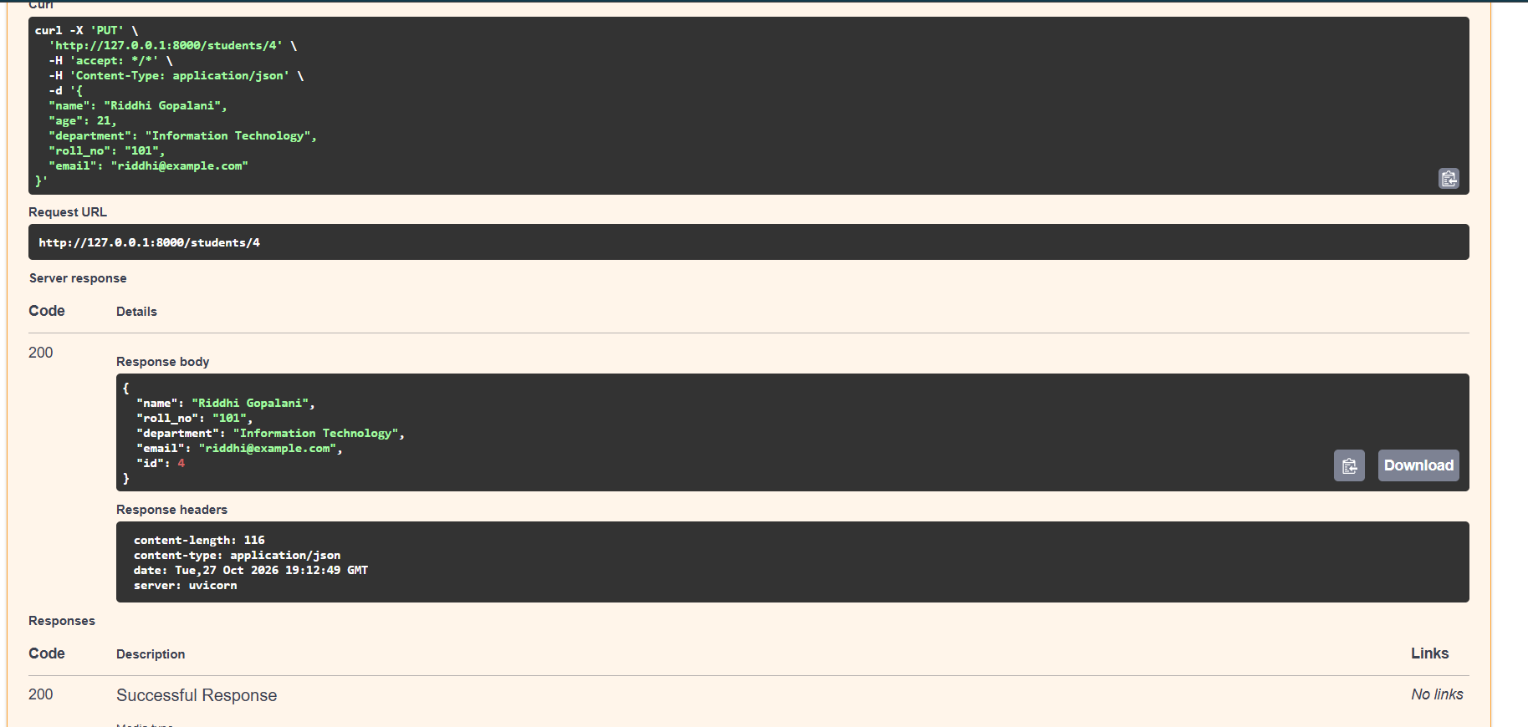
Fig. 7: PUT /students/4 - department updated to Information Technology (200 OK)
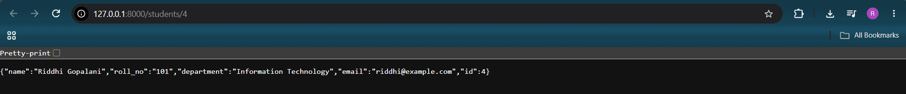
Fig. 8: GET /students/4 - viewing the updated student by ID
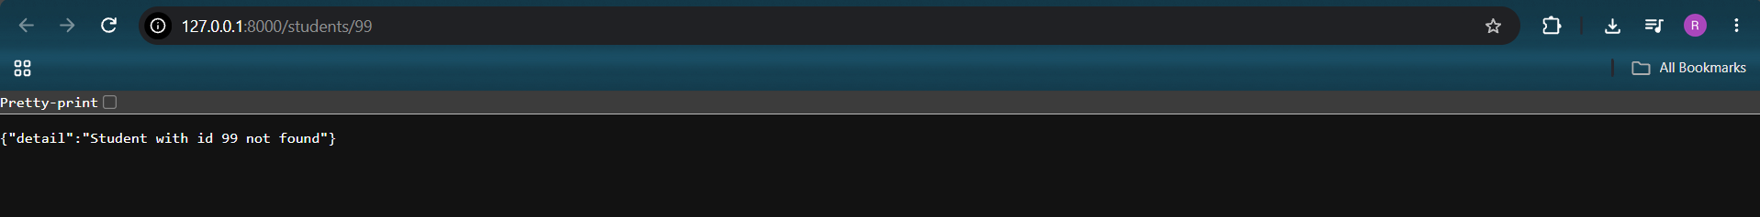
Fig. 9: GET /students/99 - non-existent student returns "not found" (404)

10.2 Docker Image and Running Container
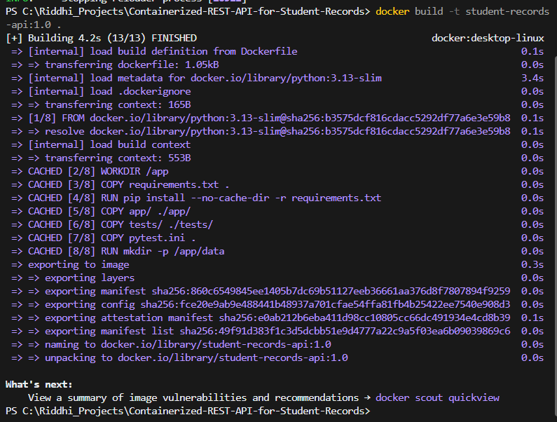
Fig. 10: docker build - Docker image student-records-api:1.0 built successfully
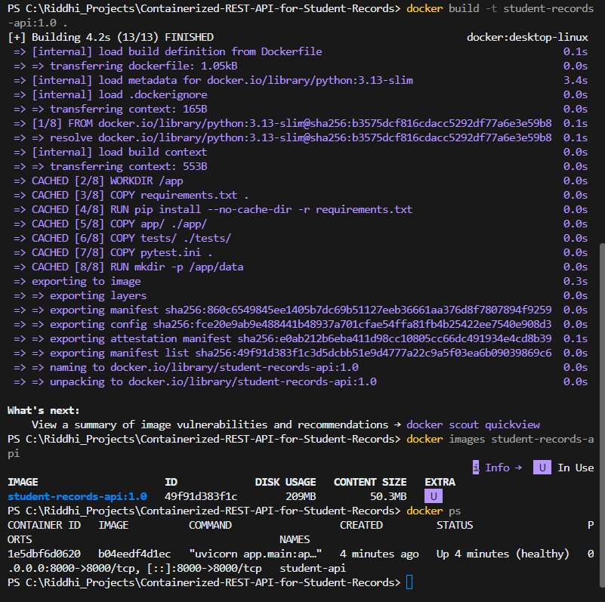
Fig. 11: docker images and docker ps - image listed and container running (healthy) on port 8000
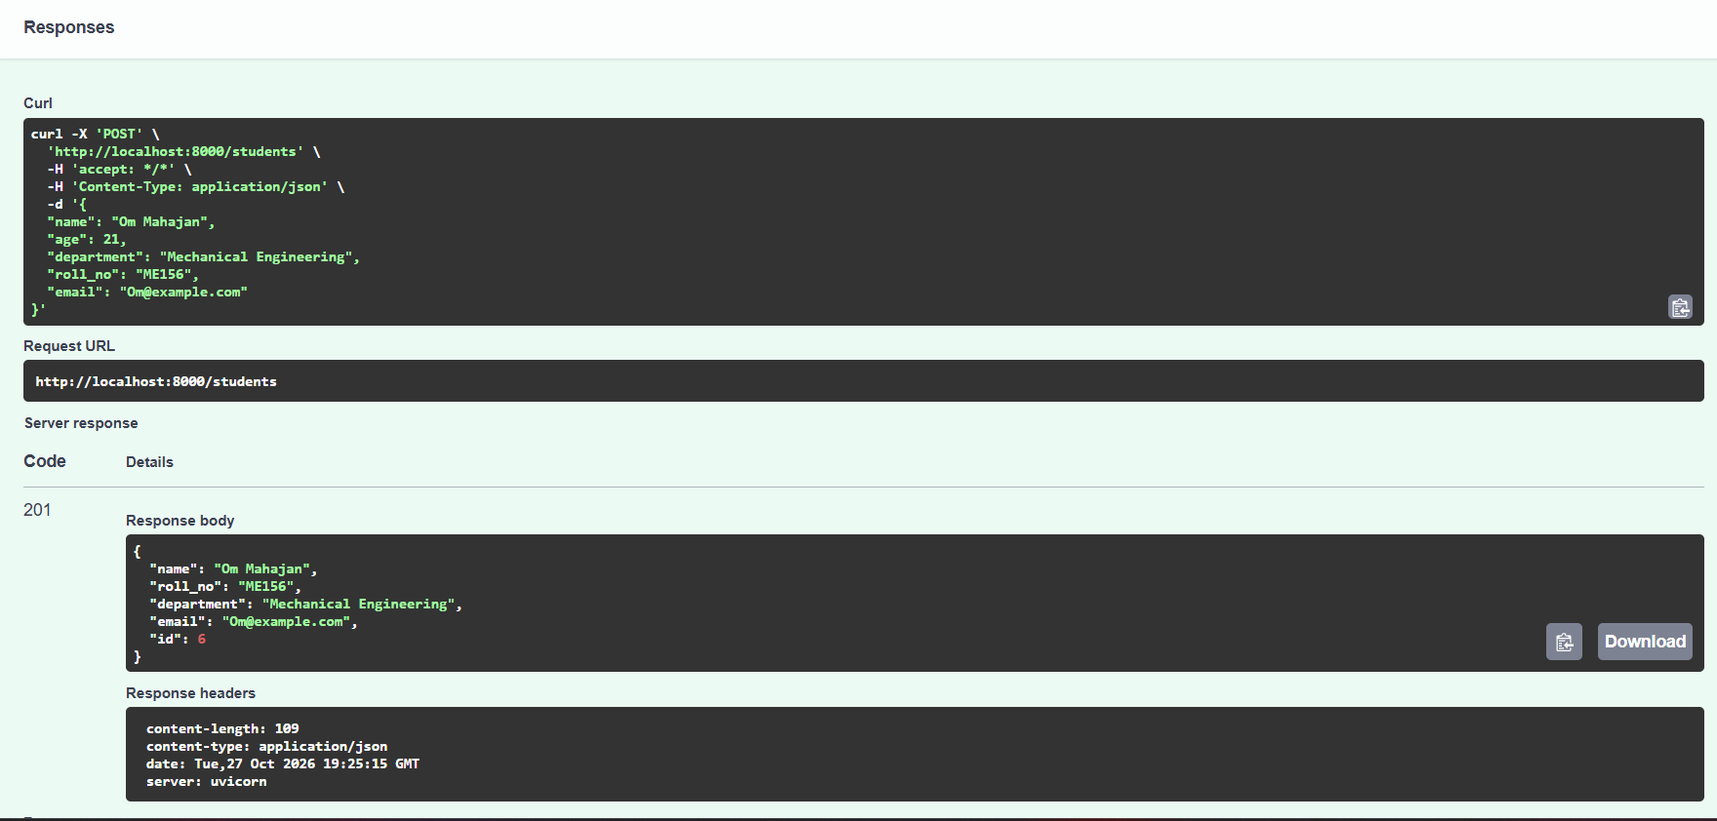
Fig. 12: POST /students through the Docker-published port (localhost:8000) - 201 Created
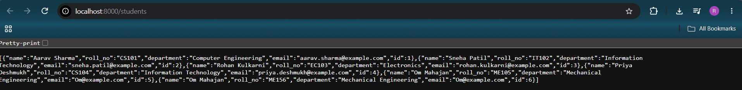
Fig. 13: GET /students through the Docker container - all records returned
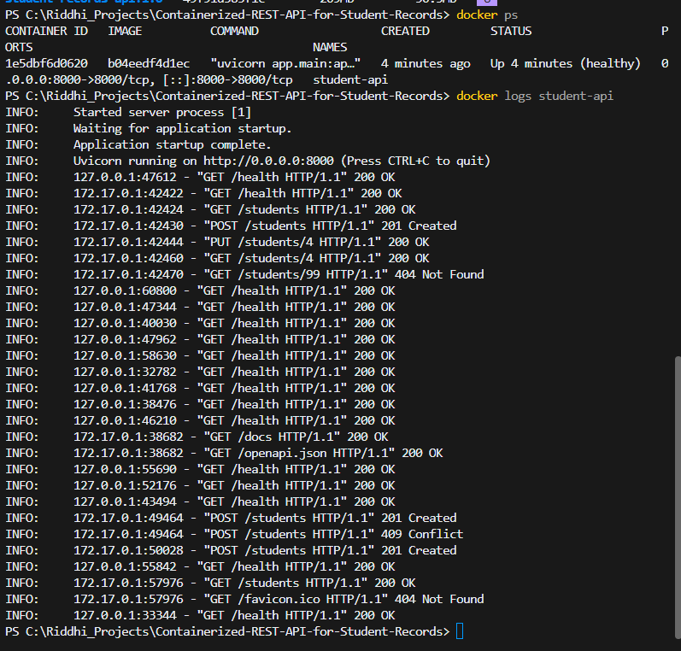
Fig. 14: docker logs student-api - server logs including 201 Created, 404 and 409 Conflict responses

10.3 Container Lifecycle and Data Persistence
The container was stopped (status Exited), started, restarted, then stopped and removed. docker ps -a showed no container, but docker volume ls still listed student-data. docker run created a new container with a different ID (30f12535efbf), and it came up healthy.
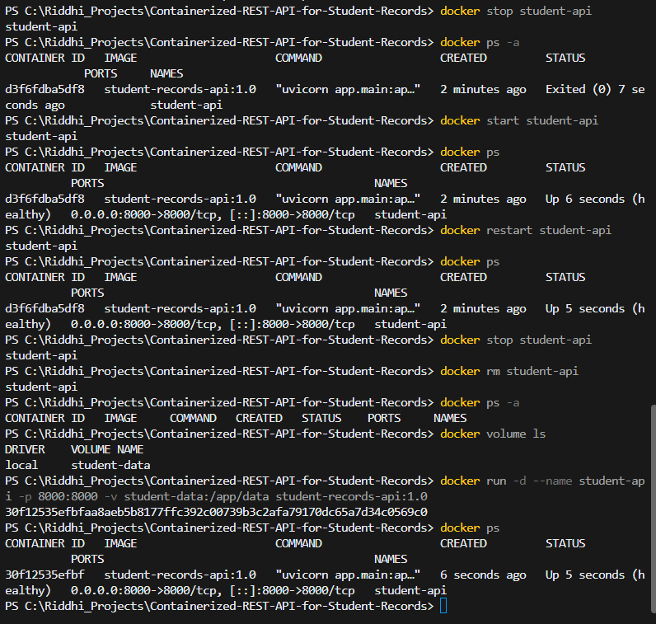
Fig. 15: Container lifecycle - docker stop, start, restart, rm, volume ls and run (new container ID)

10.4 Testing
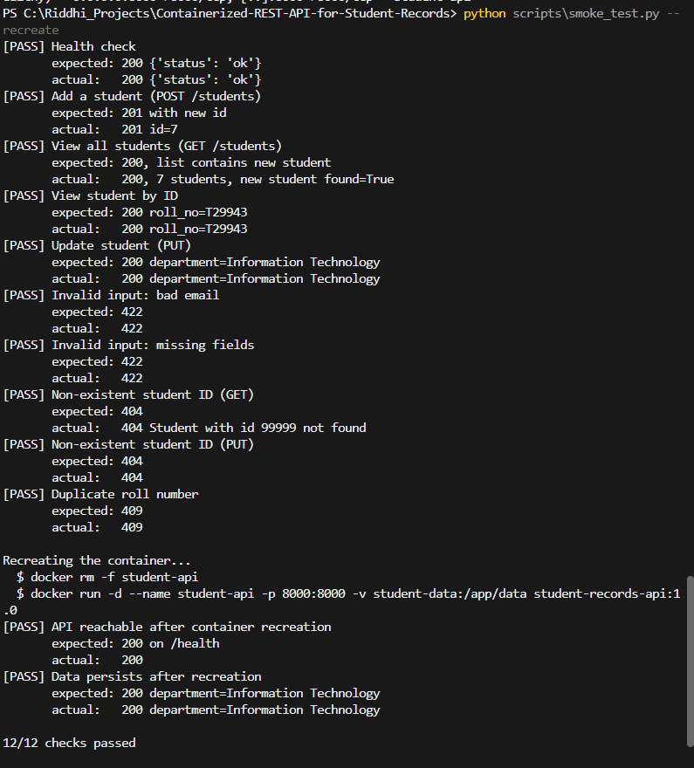
Fig. 16: Live smoke test - 12/12 checks passed, including container recreation and data persistence

11. Testing Results
Testing was done in three ways: 11 automated pytest test cases (run both on the host and inside the container with docker exec), manual testing through Swagger UI, and a live smoke test script (scripts/smoke_test.py) that sends real HTTP requests to the container and also recreates it.
# | Test case | Expected | Actual | Result
1 | Health check GET /health | 200, status ok | 200, {"status": "ok"} | Pass
2 | Add a student (POST /students) | 201 with new ID | 201, new ID returned | Pass
3 | View all students (GET /students) | 200, list includes new student | 200, new student found | Pass
4 | View student by ID | 200 with correct record | 200, correct roll number | Pass
5 | Update student (PUT /students/{id}) | 200, department changed | 200, department = Information Technology | Pass
6 | Invalid input - bad email | 422 | 422 | Pass
7 | Invalid input - missing fields | 422 | 422 (Field required) | Pass
8 | Invalid input - non-numeric ID | 422 | 422 | Pass
9 | Non-existent ID (GET /students/99999) | 404 | 404, Student with id 99999 not found | Pass
10 | Non-existent ID (PUT /students/99999) | 404 | 404 | Pass
11 | Duplicate roll number | 409 | 409 Conflict | Pass
12 | API after docker rm + docker run | 200 on /health | 200 | Pass
13 | Data persists after container recreation | Updated record still present | Record present with updated department | Pass
14 | Pytest suite on host | All tests pass | 11 passed | Pass
15 | Pytest suite inside container | All tests pass | 11 passed | Pass

Result: all 15 test cases passed.

12. Troubleshooting Notes
Problem | What happened | Solution
Docker engine not running | docker info failed with "failed to connect to the docker API at npipe:////./pipe/dockerDesktopLinuxEngine". The Docker CLI was installed but Docker Desktop was not started. | Started Docker Desktop and waited until the engine was running.
Wrong fields in the POST request | Our first POST request from Swagger sent an "age" field and did not send roll_no and email, so the API returned 422 Unprocessable Entity with "Field required" (Fig. 5). | Sent all required fields (name, roll_no, department, email). The request then returned 201 Created. Extra fields like age are simply ignored.
Slow first image build | The first docker build took about 3 minutes because pip downloaded packages slowly. | requirements.txt is copied and installed before the app code, so Docker caches that layer. Later builds took about 4 seconds (Fig. 10 shows the CACHED steps).
Git Bash changes container paths | docker exec student-api ls /app/data failed in Git Bash with "cannot access 'C:/Program Files/Git/app/data'". | Ran the command in PowerShell instead, or used MSYS_NO_PATHCONV=1 in Git Bash.
PowerShell removes nested quotes | A docker exec ... python -c "...'...'..." command gave a Python SyntaxError because PowerShell stripped the inner quotes. | Avoided nested quotes in PowerShell and used Git Bash or a script file for such commands.
Port 8000 already in use (precaution) | The local Uvicorn server and the container both use port 8000. | Stopped the local server with Ctrl+C before starting the container.

13. Conclusion
We built a REST API for student records using FastAPI with SQLite storage. It supports adding, viewing all, viewing by ID and updating students, and it returns proper status codes for invalid input (422), missing students (404) and duplicate roll numbers (409). The application was packaged into a Docker image and run as a container with port 8000 published, so no Python packages had to be installed on the host to run it.
We demonstrated the container lifecycle commands docker stop, start, restart, rm and run. Because the database is stored in the student-data Docker volume, all records were still available after the container was removed and recreated. All 15 test cases passed. Through this practical we learned how to build a REST API, write a Dockerfile, map ports, use volumes for persistent data and manage containers.

14. Individual Contributions
Name | Roll No. | Contribution
Riddhi Gopalani | 34124 | Set up the GitHub repository and project structure. Designed and wrote the FastAPI application (all six endpoints), the SQLite database functions and the Pydantic input validation. Connected the database to a Docker volume for persistence, ran the final demonstration, captured the screenshots and managed the commits on GitHub.
Om Mahajan | 34140 | Wrote the Dockerfile and .dockerignore, configured the port mapping (8000:8000) and the health check, built the Docker image and performed the container lifecycle demonstration (stop, start, restart, rm, run).
Sudhan Dabhade | 34118 | Wrote the pytest test cases and the live smoke test script, ran the tests on the host and inside the container, recorded the test results and collected the troubleshooting notes.
Pratik Kalburgi | 34130 | Prepared the project report and the presentation, drew the system architecture diagram and wrote the README documentation for the GitHub repository.

15. References
- FastAPI documentation - https://fastapi.tiangolo.com
- Docker documentation - https://docs.docker.com
- Python sqlite3 module - https://docs.python.org/3/library/sqlite3.html
- Pytest documentation - https://docs.pytest.org
- Project repository - https://github.com/RiddhiGopalani/Containerized-REST-API-for-Student-Records

