
Mini Project Research Paper

TOPIC-ROCK PAPER SCISSOR LIZARD SPOCK
By TEAM MEMBERS:
NAME | PRN
ANIBHA KUMARI | 1262254133
ANSHIKA YADAV | 1262254075
RIDDHI GUPTA | 1262250823
RIDDHIMA SHRIVASTAVA | 1262253507

Under the guidance of
Dr. Renuka Mane

Dr. Vishwanath Karad MIT-World Peace University
Department of Computer Engineering & Technology School of
Computer Science & Engineering
SUBMISSION DATE - 26-03-2026

INDEX

SR No. | TITLES | PAGE NO.
1 | ABSTRACT | 2
2 | INTRODUCTION | 3
3 | BACKGROUND,  RELATED WORK, RULES  AND OBJECTIVE | 4
4 | SYSTEM REQUIREMENT | 5
5 | METHODOLOGY | 6
6 | ALGORITHM | 7
7 | FLOWCHART | 8
8 | RESULT | 17
9 | FUTURE SCOPE | 18
10 | CONCLUSION | 19
11 | REFERENCE | 20
Introduction
Rock-paper-scissors-lizard-Spock is a five-gesture expansion of the classic selection method game rock-paper-scissors. It operates on the same basic principle, but includes two additional weapons: the lizard (formed by the hand as a sock-puppet-like mouth) and Spock (formed by the Star Trek Vulcan salute). This reduces the chances of a round ending in a tie. The game was invented by Sam Kass with Karen Bryla, as "Rock Paper Scissors Spock Lizard". The game was mentioned in three episodes of The Big Bang Theory. According to an interview with Kass, the series producers did not ask for permission to use the game, but he was later referenced in an episode in the fifth season. It has been used to understand the transitivity of climate change policy choice.
In this project, the extended version of the game is implemented using the C programming language as a command-line application. The focus is on applying fundamental programming concepts such as conditional statements, loops, functions, and random number generation to simulate gameplay between a user and the computer. The computer generates its moves randomly, ensuring unpredictability and fairness in the game.
In the modern era, advancements in computer vision and artificial intelligence have enabled systems to recognize hand gestures in real time, allowing machines and even robotic systems to play gesture-based games like Rock-Paper-Scissors. Although this project does not directly implement gesture recognition, it draws inspiration from such technologies and focuses on building the logical foundation of the game.
Overall, this project provides hands-on experience in designing and developing an interactive application, covering the complete workflow from logic building and implementation to testing and execution. It serves as a practical example of how programming concepts can be used to create engaging and meaningful applications.

Background, Related Work, Rules and Objectives

- Background:
Rock-Paper-Scissors is a popular traditional game used for decision-making and entertainment. It involves three choices, but due to limited options, it often results in frequent draws and predictable outcomes.
To improve this, an extended version called Rock-Paper-Scissors-Lizard-Spock was introduced, adding two more choices. This increases the possible outcomes from three to five, reducing ties and making the game more balanced and interesting.
With advancements in technology, such games are also used in programming and artificial intelligence. This project focuses on implementing the game in C programming, helping to understand basic logic, decision-making, and user interaction in a simple command-line environment.

- Related work
- Several versions of the Rock-Paper-Scissors game have been developed in different programming languages as beginner-level projects to demonstrate basic programming concepts. The traditional version with three choices is commonly implemented using simple conditional logic and random number generation.

- The extended version, Rock-Paper-Scissors-Lizard-Spock, has also gained popularity due to its increased complexity and reduced probability of ties. It has been implemented in various forms, including command-line applications, graphical user interfaces, and web-based games

- In recent years, advancements in technology have led to the development of gesture-based systems using computer vision, where machines can recognize hand signs and play the game in real time. Some projects also involve artificial intelligence to predict user moves and improve gameplay.
- However, most beginner-level implementations focus on basic logic building and user interaction. This project follows a similar approach by implementing the extended version of the game using C programming, emphasizing simplicity, correctness, and understanding of core programming concepts.

- Rules

The rules of Rock-paper-scissors-lizard-Spock are

: • Scissors cut paper
• Paper covers rock
• Rock crushes lizard
• Lizard poisons Spock
• Spock smashes (or melts) scissors
• Scissors decapitate lizard
• Lizard eats paper
• Paper disproves Spock
• Spock vaporizes rock
• Rock breaks scissors

There are ten possible pairings of the five gestures; each gesture beats two of the other gestures and is beaten by the remaining two.

One way to remember the rules is to remember the standard "rock-paper-scissors" ordering, where each gesture defeats the one before it, and is defeated by the one after. But then add the two novel gestures near the word they approximately rhyme with:
1. Rock
2. Spock
3. Paper
4. Lizard
5. Scissors

In this expanded list, each gesture is defeated by the following two options, and defeats the preceding two. Since the Spock gesture is known to be notoriously difficult for some people to perform, some players may be disadvantaged while playing this variant. The fingers must be moved quickly into the final position from a closed fist, which means that many people will not be able to use Spock, thus cutting down their options.[ fig(i)- Ohio States University]
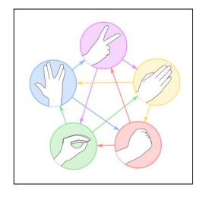
Choice | Wins Against | Loses To
Rock (0) | Scissors (2), Lizard (3) | Paper (1), Spock (4)
Paper (1) | Rock (0), Spock (4) | Scissors (2), Lizard (3)
Scissors (2) | Paper (1), Lizard (3) | Rock (0), Spock (4)
Lizard (3) | Paper (1), Spock (4) | Rock (0), Scissors (2)
Spock (4) | Rock (0), Scissors (2) | Paper (1), Lizard (3)

4. Objective:
The main objectives of this project are as follows:
- To develop an interactive game using C programming
The primary objective is to design and implement a command-line based Rock-Paper-Scissors-Lizard-Spock game that allows users to play against the computer in an engaging way.
- To understand fundamental programming concepts
This project helps in applying core concepts of C programming such as conditional statements (if-else), loops, functions, and switch-case statements in a practical scenario.
- To implement random number generation
The project aims to use random functions to generate unpredictable computer choices, ensuring fairness and realism in gameplay.
- To design efficient game logic
A key objective is to correctly implement the rules of the game and develop logic that determines the winner among five possible choices.
- To enhance problem-solving and logical thinking skills
By building the game logic and handling different conditions, the project improves analytical thinking and coding skills.
- To ensure proper user interaction
The program is designed to accept user input, validate it, and display clear outputs, making the game user-friendly.
- To test and verify program accuracy
Another objective is to test the program with different inputs and scenarios to ensure correctness and reliability.
- To create a foundation for advanced projects
This project serves as a base for future enhancements such as graphical interfaces, multiplayer functionality, or integration with advanced technologies like AI and gesture recognition.

System Requirements
The system requirements specify the hardware and software needed to develop and run the Rock-Paper-Scissors-Lizard-Spock game efficiently.

1. Hardware Requirements
These are the minimum physical components required:
- Computer/Laptop: Any basic system capable of running a C compiler
- Processor: Intel Core i3 or equivalent (or higher recommended)
- RAM: Minimum 2 GB (4 GB recommended for smooth performance)
- Storage: At least 100 MB free disk space
- Input Devices: Keyboard (for user input)
- Output Devices: Monitor (for displaying game results)

2. Software Requirements
These include the tools and environment required for development and execution:
- Operating System: Windows, Linux, or macOS
- Programming Language: C
- Compiler: GCC / Turbo C / Clang
- IDE/Editor (optional): VS Code, Code::Blocks, Dev C++
- Libraries Used:
  - stdio.h (for input/output functions)
  - stdlib.h (for random number generation)
  - time.h (for seeding random function)

3. Functional Requirements
These describe what the system should do:
- Accept user input for game choice
- Generate random choice for computer
- Compare user and computer choices
- Display the result (win/lose/draw)
- Validate user input
- Allow repeated gameplay (optional feature)

4. Non-Functional Requirements
These define system performance and quality:
- Usability: Easy to understand and use
- Performance: Fast execution with minimal delay
- Reliability: Accurate results for all valid inputs
- Portability: Can run on different operating systems
- Maintainability: Simple code structure for easy modification

Methodology
The methodology describes the step-by-step process followed to design and develop the Rock-Paper-Scissors-Lizard-Spock game using C programming.

1. Problem Understanding
The first step was to understand the rules of the extended game. Unlike the traditional version, this game includes five choices—rock, paper, scissors, lizard, and Spock. Each choice wins against two options and loses to two, making the logic slightly more complex.

2. Program Design
A structured design approach was followed:
- The game was planned as a command-line application
- Inputs and outputs were clearly defined
- Game rules were converted into logical conditions
- Flow of the program was outlined using an algorithm

3. User Input Handling
- The user is asked to enter a number corresponding to their choice
- Input is taken using standard input functions
- Validation is applied to ensure the input is within the valid range (0–4)

4. Random Number Generation
- The computer’s move is generated using the rand() function
- The srand (time(0)) function is used to ensure different outputs each time the program runs
- The random value is limited to 0–4 to match the five choices

5. Game Logic Implementation
- Conditional statements (if-else) are used to compare user and computer choices
- Rules of the game are applied to determine the winner
- Cases handled:
  - Draw (same choices)
  - User wins
  - Computer wins

6. Output Display
- The program displays:
  - User choice
  - Computer choice
  - Result (Win/Lose/Draw)
- Clear and readable messages are shown for better user experience

7. Testing and Validation
- The program was tested with multiple inputs
- All possible combinations were checked
- Errors and incorrect outputs were corrected

8. Execution Flow
- Start program
- Display choices
- Accept user input
- Generate computer choice
- Apply game logic
- Display result
- End program

Algorithm
- Start
- Display choices (Rock, Paper, Scissors, Lizard, Spock)
- Input user choice
- Generate random computer choice
- If both choices are same → Draw
- Else check conditions:
  - Rock crushes Scissors & Lizard
  - Paper covers Rock & disproves Spock
  - Scissors cuts Paper & decapitates Lizard
  - Lizard eats Paper & poisons Spock
  - Spock smashes Scissors & vaporizes Rock
- Display winner
- Ask user to continue or exit
- Stop

FLOWCHART
Fig(ii)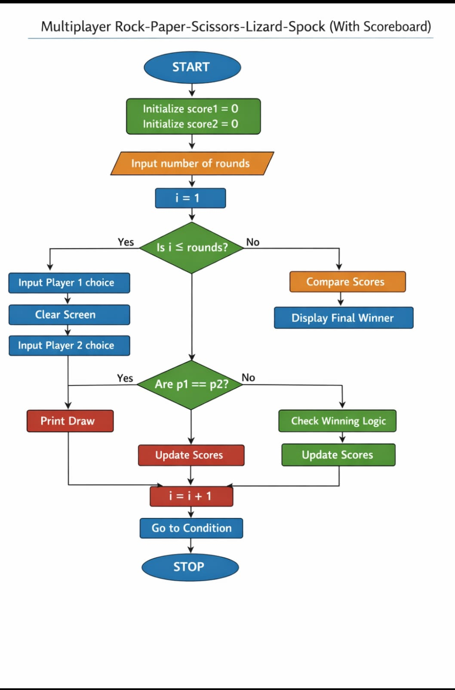
OUTPUT
  - Player choice to select game mode.
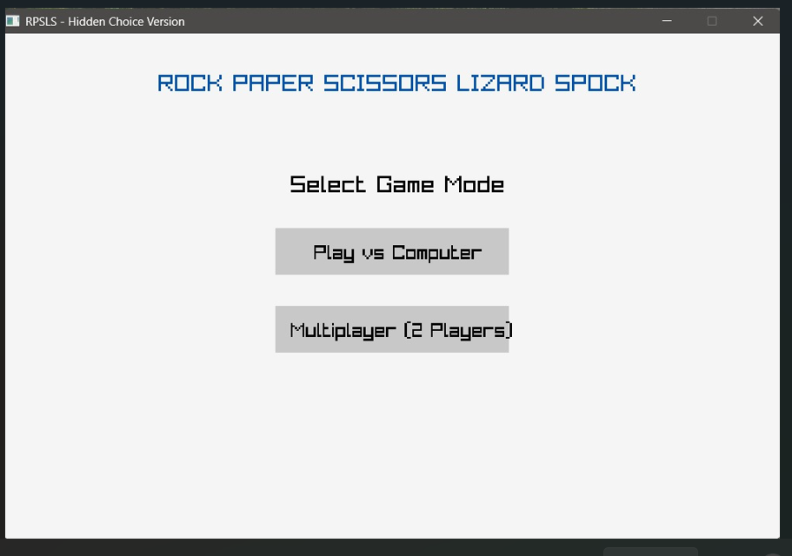
  - Choice for player 1 to choose [ROCK, PAPER, SCISSOR, LIZARD, SPOCK]

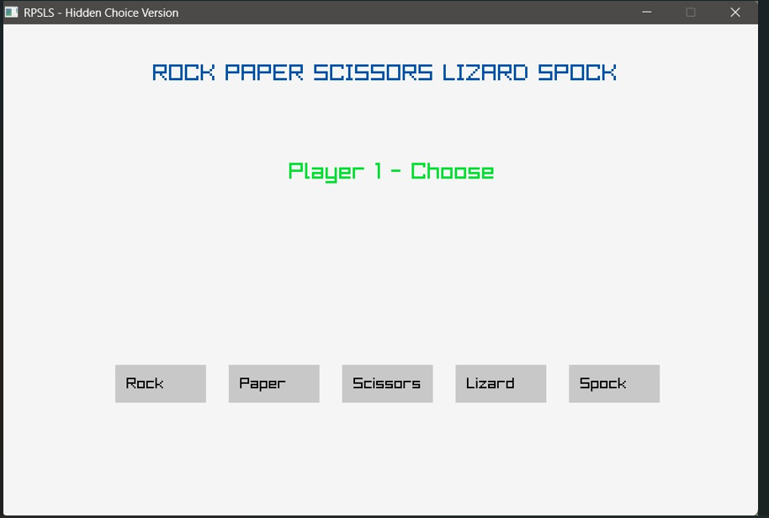

  - First-round result of Player
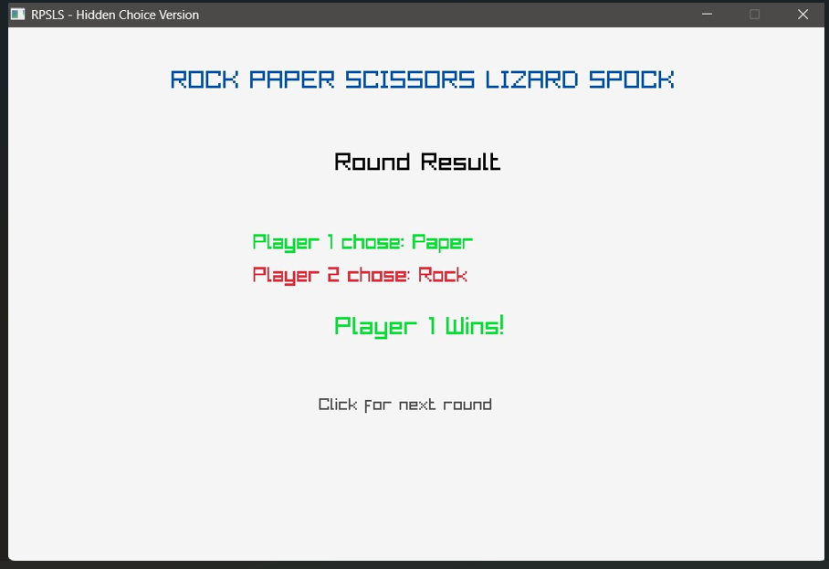

4. Player choice in 2-nd round with game result.

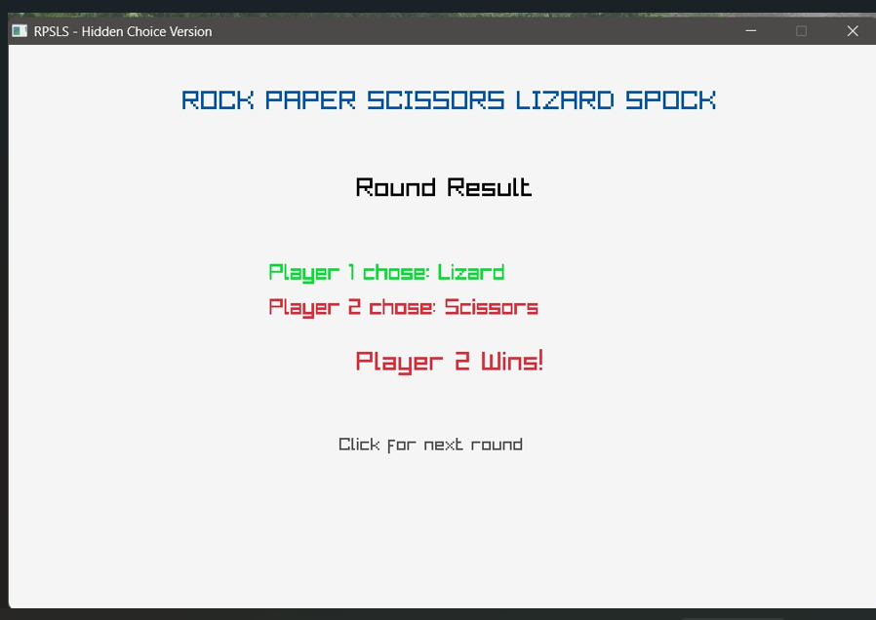

  - After Player-1 and Player-2 plays all round with their choices
Overall result is seen with winner Player.

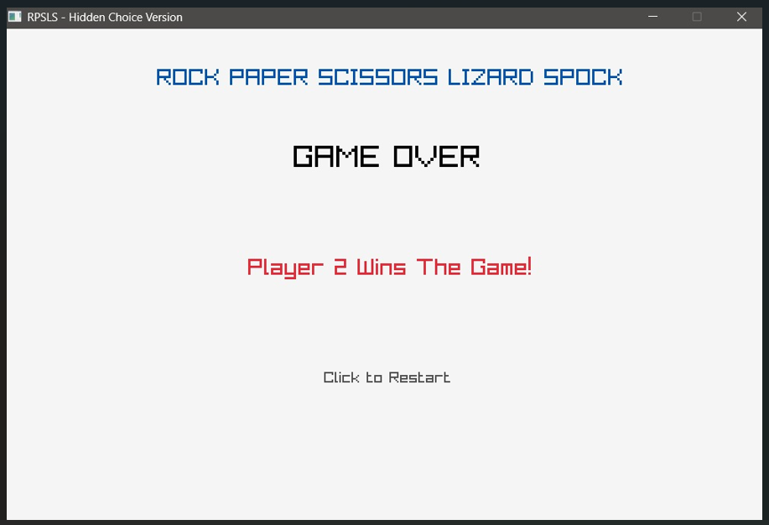

Future Scope
Although the current project successfully implements the Rock-Paper-Scissors-Lizard-Spock game using C programming, there are several opportunities to enhance and expand its functionality in the future.

1. Graphical User Interface (GUI)
The current version is command-line based. In the future, a graphical interface can be developed using tools like graphics libraries or frameworks to make the game more attractive, interactive, and user-friendly.

2. Multiplayer Mode
The game can be extended to support multiplayer functionality, allowing two or more users to play together either on the same system or over a network.

3. Score Tracking System
A scoring system can be added to keep track of wins, losses, and draws over multiple rounds, providing a more competitive gaming experience.

4. Artificial Intelligence Integration
Advanced versions of the game can include AI-based decision-making, where the computer analyzes user patterns and predicts moves instead of relying only on random generation.

5. Gesture-Based Gameplay (Computer Vision)
The game can be integrated with computer vision technology to recognize hand gestures using a camera. This would allow real-time gameplay without keyboard input.

6. Mobile or Web Application Development
The game can be converted into a mobile app or web-based application, making it accessible on smartphones and browsers.

7. Sound Effects and Animations
Adding sound effects, animations, and visual feedback can make the game more engaging and entertaining.

8. Difficulty Levels
Different difficulty levels (easy, medium, hard) can be introduced to control the behavior of the computer player.

9. Data Storage and Analytics
User data and gameplay statistics can be stored and analyzed to improve user experience and understand playing patterns.

10. Integration with Robotics
The game can be connected with robotic systems to physically demonstrate moves, combining programming with hardware applications.

Conclusion of Future Scope:
These enhancements can transform the simple command-line program into a more advanced, intelligent, and user-friendly application.
Conclusion
The Rock-Paper-Scissors-Lizard-Spock game developed in C programming successfully demonstrates the practical application of fundamental programming concepts. The project was designed as a command-line based interactive game, allowing a user to play against the computer in a simple and engaging manner.
Through this project, key concepts such as conditional statements, loops, functions, and random number generation were effectively implemented. The game logic was carefully designed to handle all possible combinations of the five choices—rock, paper, scissors, lizard, and Spock—ensuring accurate and reliable results. The use of random number generation provided unpredictability, making the gameplay fair and interesting.
The program was tested with various inputs to verify its correctness and performance. The results confirm that the system works efficiently and produces correct outcomes for all valid inputs. Additionally, input validation and clear output messages enhance the overall user experience.
Overall, this project serves as a strong foundation for understanding problem-solving and logical thinking in programming. It also highlights how simple concepts can be used to build interactive applications. The project can be further improved by adding advanced features such as graphical interfaces, multiplayer functionality, and artificial intelligence, making it more sophisticated and user-friendly in the future.

References
The following sources were referred to during the development of this project:
- Books:
  - Yashavant Kanetkar, Let Us C, BPB Publications
  - Brian W. Kernighan and Dennis M. Ritchie, The C Programming Language, Prentice Hall
- Websites:
  - GeeksforGeeks – Tutorials on C programming concepts and examples
  - TutorialsPoint – Reference for C syntax and functions
  - W3Schools – Basic programming concepts and examples
- Online Documentation:
  - Official GCC Compiler Documentation
  - Standard C Library Documentation (stdio.h, stdlib.h, time.h)
- Educational Resources:
  - Lecture notes and classroom materials provided by faculty
  - Online video tutorials and coding practice platforms
- Project Development Tools:
  - VS Code / Code::Blocks IDE
  - GCC Compiler for program execution
- Images Sources:
- Fig 1: Diagram( Ohio States University)
- Fig 2: Flowchart (Source: GeeksforGeeks)

Abstract

This project focuses on the development of an interactive command-line game based on the extended version of Rock-Paper-Scissors, known as Rock-Paper-Scissors-Lizard-Spock, using the C programming language. The primary objective of the project is to design a simple yet engaging game that demonstrates fundamental programming concepts such as conditional statements, loops, functions, and random number generation.
The system allows a user to play against the computer, where the computer’s choices are generated randomly to ensure unpredictability. The game logic is implemented based on predefined rules that determine the winner among the five possible choices: rock, paper, scissors, lizard, and Spock. User input is validated to ensure correct gameplay, and the results are displayed after each round.
The program was tested for multiple scenarios to ensure accuracy and reliability. The results show that the game runs efficiently and provides a smooth user experience. In conclusion, this project effectively demonstrates the application of core C programming concepts while creating an entertaining and user-friendly game.

Keyword:C Programming, Command-Line Game, Rock-Paper-Scissors-Lizard-Spock, Conditional Statements, Loops, Functions, Random Number Generation, Game Logic, User Interaction

