AADHAAR ENROLMENT AND UPDATE TRENDS:
A COMPARATIVE ANALYSIS OF MAHARASHTRA AND MUMBAI SUBURBAN

Name: RIDDHI MORE
Tool Used: EXCEL & POWER BI
Dataset Source: UIDAI OPEN DATA
Analysis Period: JULY 2025 & SEPTEMBER 2025

PROBLEM STATEMENT & OBJECTIVE:

Problem Statement:
Aadhaar serves as a foundational identity system for residents of India, supporting access to government services, welfare schemes, and financial inclusion. Understanding patterns of Aadhaar enrolment and update activities is essential for assessing administrative demand and service accessibility across regions.

Objective:
This study aims to analyse Aadhaar enrolment, demographic update, and biometric update trends across Maharashtra and Mumbai Suburban. The objective is to compare service demand across regions and age groups, and to evaluate update pressure relative to enrolment activity during a high administrative activity period.

DATASET DESCRIPTION:
Datasets Used:
- Aadhaar Enrolment Data
- Aadhaar Demographic Update Data
- Aadhaar Biometric Update Data
Geographical Coverage:
- Maharashtra (State-level)
- Mumbai Suburban (Urban district)
Time Granularity:
- Daily (raw)
- Monthly (post aggregation)
Age Groups:
- 0–5 years
- 5–17 years
- 17+/18+ years
Data sourced from UIDAI Open Data Portal in CSV format.

METHODOLOGY:

Data Preparation
- Raw CSV files were cleaned and standardized
- Dates were converted to monthly format
- Data aggregated at region level

Time Window Selection
- Analysis period: July 2025 and September 2025
- The period was selected to ensure temporal consistency across all Aadhaar services, enabling accurate comparison of enrollment and update trends while avoiding analytical bias caused by non-overlapping service activity.

Derived Metrics
- Total enrolment
- Total demographic updates
- Total biometric updates
- Update Pressure Ratio

Formula
Update Pressure Ratio = (Demographic Updates + Biometric Updates) / Enrolment

DATA ANALYSIS & VISUALISATION:
5.1 Aadhaar Enrolment Trends

Chart: Line chart
- X-axis: Month (July 2025, September 2025)
- Y-axis: Total Enrolment
- Legend: Maharashtra vs Mumbai Suburban
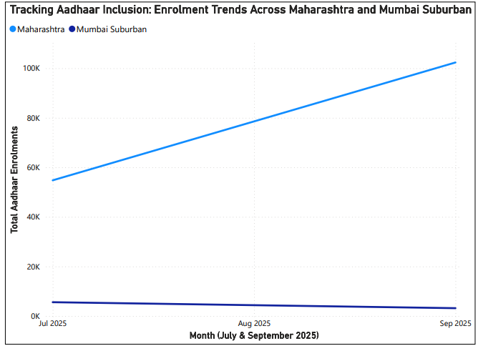
This chart compares total Aadhaar enrolment across Maharashtra and Mumbai Suburban during July and September 2025.

Insight:
Maharashtra shows higher absolute enrolment volumes due to its larger population base, while Mumbai Suburban reflects concentrated urban enrolment activity.
  - Demographic Update Activity

Chart: Line chart
- Metric: Total Demographic Updates
- Region comparison
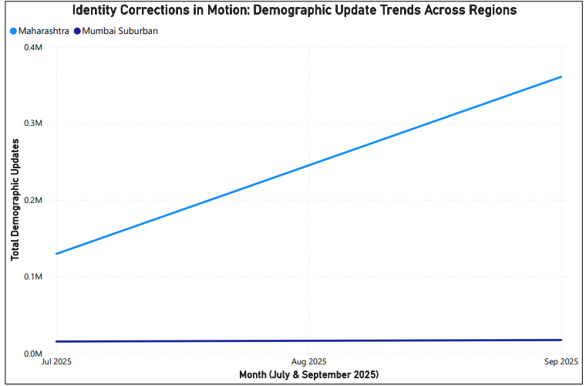
The chart illustrates demographic update activity across regions during the selected analysis period.

Insight:
Mumbai Suburban demonstrates relatively higher demographic update intensity, indicating frequent changes in personal information in urban populations.

5.3 Biometric Update Activity

Chart: Line chart
- Metric: Total Biometric Updates
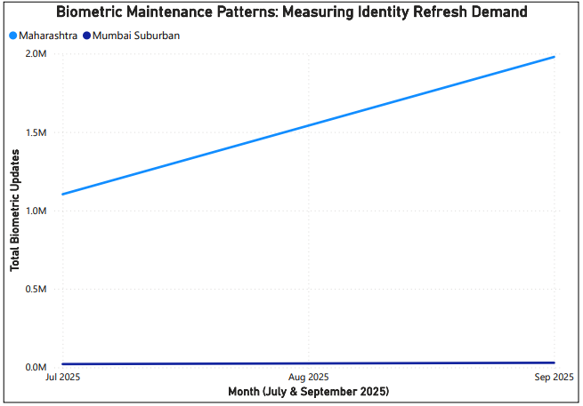
This visualization represents biometric update volumes across Maharashtra and Mumbai Suburban.

Insight:
Biometric updates are proportionally higher in Mumbai Suburban, suggesting greater system interaction and identity maintenance in urban regions.

5.4 Comparative Update Activity Across Regions

Chart: Clustered Bar Chart
- X-axis: Region
- Y-axis: Combined Updates
- total_demo_updates + total_bio_updates
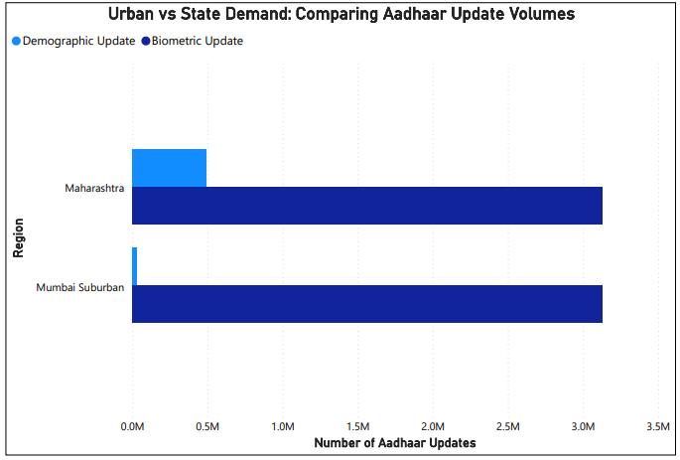
This clustered bar chart compares the combined volume of demographic and biometric update activities across Maharashtra and Mumbai Suburban.

Insight:
While Maharashtra records higher absolute update volumes due to scale, Mumbai Suburban demonstrates comparatively higher update intensity relative to its enrolment base.

  - Update Pressure Ratio Analysis

Chart: Line Chart
- Metric: Update Pressure Ratio
- Region comparison
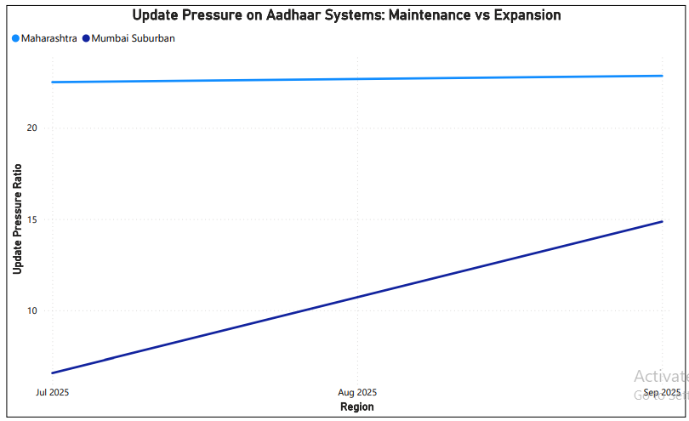
Update pressure ratio represents the proportion of update activity relative to new enrolments.

Insight:
Mumbai Suburban exhibits a higher update pressure ratio compared to Maharashtra, indicating greater administrative load from identity maintenance rather than new enrolments.

  - Enrolment Volume vs Update Pressure Ratio

Chart: Combo chart
- Column: Total Enrolment
- Line: Update Pressure Ratio
- X-axis: Region
- Dual axis enabled
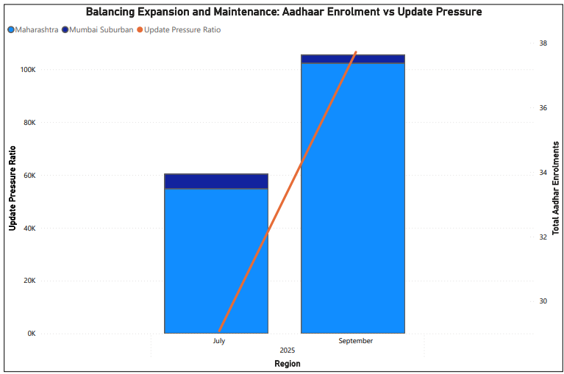
The combo chart contrasts enrolment volume with update pressure ratio to highlight differences between expansion and maintenance of Aadhaar services.

Insight:
Despite lower enrolment volumes, Mumbai Suburban exhibits a higher update pressure ratio, reflecting greater operational demand for Aadhaar updates in dense urban settings

5.7 Service Load Composition: Enrolment vs Updates

Chart: Stacked column chart
- X-axis: Region (Maharashtra, Mumbai Suburban)
- Stacks:
  - Total Demographic Updates
  - Total Biometric Updates
- Reference: Total Enrolment
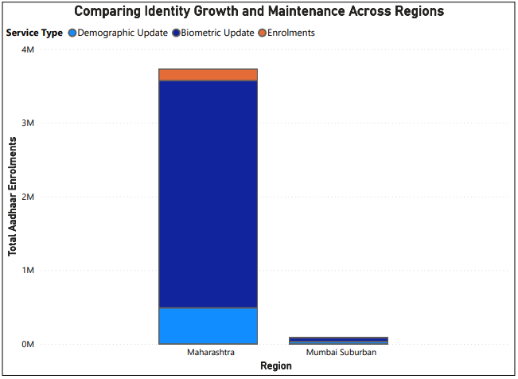
This chart illustrates the composition of Aadhaar service demand by comparing enrolment volumes with demographic and biometric update activities across regions.

Insight:
Mumbai Suburban shows a higher proportion of update activity relative to enrolment compared to Maharashtra, indicating that Aadhaar service demand in urban regions is driven more by identity maintenance than new registrations.

KEY INSIGHTS:
- Maharashtra records higher absolute Aadhaar enrolment volumes, reflecting its larger and more diverse population base.
- Mumbai Suburban exhibits comparatively higher demographic and biometric update activity relative to enrolment, indicating frequent identity maintenance in urban settings.
- The update pressure ratio is consistently higher in Mumbai Suburban, highlighting increased administrative load despite lower enrolment volumes.
- The contrast between enrolment volume and update intensity suggests a mature Aadhaar ecosystem in urban regions versus expansion-focused activity at the state level.
- Excluding partial-period data ensured methodological consistency and improved reliability of comparative insights.

CONCLUSION AND RECOMMENDATIONS:

Conclusion:
This project primarily falls under descriptive and diagnostic analytics, as it analyzes historical Aadhaar service data to understand patterns, trends, and update pressure across regions and time. This analysis highlights distinct patterns in Aadhaar service utilization across Maharashtra and Mumbai Suburban. While Maharashtra demonstrates higher enrolment volumes, Mumbai Suburban shows greater relative demand for demographic and biometric updates. These trends indicate differing administrative requirements between expansion-driven regions and maintenance-intensive urban areas. The findings emphasize the importance of region-specific planning for Aadhaar service delivery.

Recommendations:
- Urban regions may require enhanced infrastructure and staffing to manage higher update-related service pressure.
- State-level regions should continue focusing on enrolment outreach while gradually strengthening update service capacity.
- Periodic monitoring of update pressure ratios can help identify emerging administrative stress points.
- Similar analyses across additional districts can support data-driven policy decisions at a national level.

