Software Requirements Specification (SRS)
Project: Software Change Management System (SCMS)
Version: 1.0
Authors:
Manchikanti Sharvani(PES1UG23AM165)
N Riddhi Samitha(PES1UG23AM175)
K S Niharika(PES1UG23AM132)
Date: 03-09-2025
Status: Draft / To be Approved

Revision History
Version | Date | Author | Change Summary | Approval
1.0 | 02-09-2025 | 1.Manchikanti Sharvani  2.N Riddhi Samitha  3.K S Niharika | Initial SRS with complete requirements and diagrams | Pending

Approvals
Role | Name | Signature/Email | Date
Course Coordinator | Prof. Anand M S | anandms@pes.edu | 03-09-2025
Project Guide

Table of Contents
- Introduction
- Overall description
- External interfaces
- System features (detailed)
- Non-functional requirements (detailed)
- Quality attributes & Acceptance tests
- UML Use-Case Diagram
- Requirements Traceability Matrix (RTM)

1. Introduction

1.1 Purpose
This document specifies the requirements for a Software Change Management System (SCMS). The SCMS manages the complete lifecycle of software changes from request submission through implementation, testing, and deployment, ensuring controlled and traceable software evolution.

1.2 Scope
The SCMS covers change request lifecycle management, automated impact analysis, integration with development tools (Git, Jira, CI/CD pipelines), approval workflows, deployment coordination, rollback capabilities, and comprehensive audit trails. Excludes actual code development and testing execution.

1.3 Audience
Software Developers, DevOps Engineers, Release Managers, QA Engineers, Project Managers, Compliance Officers, and System Administrators.

1.4 Definitions
- SCM: Software Change Management
- CR: Change Request
- CAB: Change Advisory Board
- CI/CD: Continuous Integration/Continuous Deployment
- RFC: Request for Change
- RBAC: Role-Based Access Control
- API: Application Programming Interface
- VCS: Version Control System

2. Overall Description

2.1 Product Perspective
The SCMS is a centralized web-based platform that orchestrates software change management across development, staging, and production environments. It integrates with existing development toolchains including Git repositories, CI/CD pipelines, issue tracking systems, and deployment tools.

2.2 Major Product Functions

- Submit and categorize change requests with technical impact assessment
- Automated dependency analysis and conflict detection
- Multi-stage approval workflows with CAB integration
- Integration with Git repositories for commit tracking
- CI/CD pipeline integration for automated testing and deployment
- Real-time change status monitoring, implementation tracking, and notifications
- Rollback planning, rollback execution with defined criteria, and emergency change procedures
- Comprehensive audit trails and compliance reporting
- Risk assessment and change impact prediction
- Release coordination and deployment scheduling
- Validation of test coverage through CI results mapped to change requests
- Coordination of CAB meetings (agenda, attendees, decisions linked to change requests)
- Auditor review of immutable logs filtered by CR, user, or date
- Configuration of CI/CD integration settings per project (endpoints, credentials, jobs, environments)
- Setup and management of Git webhooks for commit/merge event tracking
- Management of infrastructure configuration metadata (environments, change freeze windows)
- Customizable notification configuration (channels, recipients, rules) for deployments and rollbacks
- Validation of deployment health using automated probes and pipeline checks
- Generation of deployment reports (success/failure, duration, approvers, artifacts, environment)
- Triggering of pipeline builds and deployments directly from a change request or release page
- Synchronization of change request status with external issue tracking systems (e.g., Jira, Azure Boards)
- Real-time dashboards for monitoring deployments and system health

2.3 User Roles and Characteristics

- Developer: Creates change requests, links code commits, and focuses on technical implementation.
- Technical Lead: Reviews technical feasibility, resolves conflicts, and approves low-risk changes.
- Change Manager: Oversees the change process, coordinates CAB meetings, and manages approval workflows.
- Release Manager: Plans and coordinates deployments, manages release schedules, and oversees release windows.
- QA Engineer: Validates test coverage, ensures quality assurance through CI/CD results, and approves testing strategies.
- DevOps Engineer: Handles deployment automation, sets up CI/CD integrations and Git webhooks, manages infrastructure configurations.
- Auditor: Reviews compliance, accesses immutable audit logs, and generates compliance-related reports.
- System Administrator: Manages environment configurations, monitors deployment health, enforces change freeze windows, and oversees rollback execution.

2.4 Operating Environment
- Web-based application supporting Chrome 90+, Firefox 88+, Safari 14+
- Server: Linux/Windows Server with Docker containerization
- Database: PostgreSQL 13+ or MySQL 8+
- Integration APIs: REST/GraphQL with OAuth 2.0
- Cloud deployment ready (AWS, Azure, GCP)

2.5 Constraints
- Must integrate with existing Git infrastructure
- Compliance with ITIL v4 change management processes
- ISO/IEC 27001 security requirements
- SOX compliance for financial sector deployments
- Limited to Git-based version control systems
- Requires network connectivity for real-time integrations

3. External Interface Requirements

3.1 User Interfaces
- Primary Dashboard: Real-time change status overview with filtering and search
- Change Request Form: Multi-step wizard with technical details, impact assessment
- Approval Interface: CAB dashboard with voting, comments, and risk visualization
- Integration Status: Real-time view of Git/CI/CD pipeline status
- Reporting Interface: Customizable reports with export capabilities
- Mobile Interface: Responsive design for approval notifications and status checks

3.2 Hardware Interfaces
- Standard web browsers on desktop/laptop/mobile devices
- No specialized hardware requirements
- Network infrastructure for API integrations

3.3 Software Interfaces
- Git Integration: GitHub/GitLab/Bitbucket APIs for commit tracking
- CI/CD Integration: Jenkins, GitLab CI, Azure DevOps pipeline APIs
- Issue Tracking: Jira, Azure Boards API integration
- Notification Services: SMTP, Slack, Microsoft Teams APIs
- Identity Management: LDAP, Active Directory, SAML 2.0

3.4 Communications
- HTTPS with TLS 1.3 minimum for all external communications
- OAuth 2.0 for API authentication
- Webhook support for real-time integrations
- Message queuing for asynchronous processing (RabbitMQ/Apache Kafka)

4. System Features

4.1 Change Request Submission
Req ID | Requirement | Type | Priority | Source/Stakeholder | Acceptance Criteria | Comments/Dependencies
SCMS-F-001 | The system shall allow users to submit change requests with technical details, impact scope, and file attachments | Functional | High | Development Team | AC-SCMS-F-001: CR form accepts all required fields, validates technical impact assessment, allows multiple file uploads. Test: TC-CR-01 | Requires file storage and validation
SCMS-F-002 | The system shall automatically generate unique CR identifiers following format CR-YYYY-NNNN | Functional | High | Compliance | AC-SCMS-F-002: Each CR receives unique ID, no duplicates possible, format validated. Test: TC-CR-02 | Database sequence integrity required
SCMS-F-003 | The system shall categorize changes as Emergency, Standard, or Normal with different approval paths | Functional | High | ITIL Process | AC-SCMS-F-003: Category selection affects workflow routing, emergency changes bypass standard approval. Test: TC-CR-03 | Workflow engine dependency

4.2 Impact Analysis and Dependencies
Req ID | Requirement | Type | Priority | Source/Stakeholder | Acceptance Criteria | Comments/Dependencies
SCMS-F-004 | The system shall perform automated dependency analysis by scanning code repositories and architectural documentation | Functional | High | Architecture Team | AC-SCMS-F-004: System identifies affected modules, services, and dependencies automatically. Test: TC-IA-01 | Requires code parsing capabilities
SCMS-F-005 | The system shall detect potential conflicts with other pending change requests | Functional | High | Development Team | AC-SCMS-F-005: Conflict detection shows overlapping file changes, dependency conflicts. Test: TC-IA-02 | Real-time Git integration required
SCMS-F-006 | The system shall provide risk scoring based on change complexity, affected systems, and historical data | Functional | Medium | Risk Management | AC-SCMS-F-006: Risk score calculated using defined algorithm, displayed in approval interface. Test: TC-IA-03 | Historical data analysis required
SCMS-F-018 | The system shall allow tracking implementation status of each change request through defined states (In Progress, In Review, Verified, Ready for Deploy) | Functional | High | Change Manager | AC-SCMS-F-018: CR dashboard shows current state; state transitions are logged in audit trail. Test: TC-CR-04 | Workflow and audit trail integration

4.3 Approval Workflow Management
Req ID | Requirement | Type | Priority | Source/Stakeholder | Acceptance Criteria | Comments/Dependencies
SCMS-F-007 | The system shall route change requests through configurable approval workflows based on risk level and change type | Functional | High | Change Advisory Board | AC-SCMS-F-007: Workflow routes correctly based on rules, parallel/sequential approvals supported. Test: TC-WF-01 | Workflow engine required
SCMS-F-008 | The system shall allow approvers to approve, reject, or request modifications with mandatory comments | Functional | High | Management | AC-SCMS-F-008: All approval actions require comments, decisions are recorded with timestamps. Test: TC-WF-02 | Audit trail integration
SCMS-F-009 | The system shall support emergency change procedures with post-implementation approval | Functional | High | Operations | AC-SCMS-F-009: Emergency changes can be implemented immediately with required post-approval process. Test: TC-WF-03 | Emergency workflow paths
SCMS-F-021* | The system shall coordinate CAB meetings with agenda, attendees, and decisions linked to CRs | Functional | Medium | Change Manager | AC-SCMS-F-021: CAB events stored; decisions auto-attach to CRs; notifications sent. Test: TC-WF-04 | Calendar/notification integration

4.4 Version Control Integration
Req ID | Requirement | Type | Priority | Source/Stakeholder | Acceptance Criteria | Comments/Dependencies
SCMS-F-010 | The system shall integrate with Git repositories to link commits with change requests using commit messages or tags | Functional | High | Development Team | AC-SCMS-F-010: Commits automatically linked to CRs via CR ID in commit message. Test: TC-GIT-01 | Git webhook integration
SCMS-F-011 | The system shall automatically update CR status when associated commits are merged to target branches | Functional | High | DevOps Team | AC-SCMS-F-011: CR status changes to "Implemented" when commits merged to specified branches. Test: TC-GIT-02 | Branch monitoring required
SCMS-F-012 | The system shall maintain traceability between change requests, commits, and deployed versions | Functional | High | Compliance | AC-SCMS-F-012: Complete audit trail from CR to deployment version maintained. Test: TC-GIT-03 | Deployment pipeline integration
SCMS-F-024* | The system shall setup and manage Git webhooks to receive commit/merge events | Functional | High | DevOps Engineer | AC-SCMS-F-024: Webhook registration and secret verification succeed. Test: TC-GIT-04 | Git hosting platform

4.5 Deployment and Release Management
Req ID | Requirement | Type | Priority | Source/Stakeholder | Acceptance Criteria | Comments/Dependencies
SCMS-F-013 | The system shall integrate with CI/CD pipelines to track deployment status and success/failure | Functional | High | DevOps Team | AC-SCMS-F-013: Pipeline status reflected in CR, deployment failures trigger notifications. Test: TC-DEP-01 | CI/CD webhook integration
SCMS-F-014 | The system shall support rollback procedures with automated rollback triggers based on defined criteria | Functional | High | Operations | AC-SCMS-F-014: Rollback procedures defined per CR, automatic triggers configurable. Test: TC-DEP-02 | Deployment tooling integration
SCMS-F-015 | The system shall coordinate release windows with calendar integration and resource scheduling | Functional | Medium | Release Management | AC-SCMS-F-015: Release calendar shows conflicts, resource availability checked. Test: TC-DEP-03 | Calendar API integration
SCMS-F-023 | The system shall configure CI/CD integrations per project (endpoints, credentials, jobs, environments) | Functional | High | DevOps Engineer | AC-SCMS-F-023: Setup screen validates credentials and endpoints. Test: TC-DEP-05 | Pipeline configuration
SCMS-F-025 | The system shall manage infrastructure configuration metadata (environments, freeze windows) | Functional | Medium | System Administrator | AC-SCMS-F-025: Environment registry editable with RBAC; freeze windows enforced. Test: TC-ADM-01 | Infra configuration DB
SCMS-F-026 | The system shall configure notification channels (Email, Slack, Teams) for deployments and rollbacks | Functional | Medium | Release Manager | AC-SCMS-F-026: Notifications sent on trigger events; test message function works. Test: TC-NOTIF-01 | Notification API
SCMS-F-027 | The system shall validate deployment health using pipeline/job checks and service probes | Functional | High | System Administrator | AC-SCMS-F-027: Health status displayed; failures escalate per rules. Test: TC-DEP-06 | Health monitoring tools
SCMS-F-028 | The system shall generate deployment reports (success/failure, duration, approvers, artifacts) | Functional | Medium | Release Manager | AC-SCMS-F-028: Reports available per release; exportable. Test: TC-DEP-07 | Report generator
SCMS-F-029 | The system shall trigger pipeline builds and deployments directly from a CR or release page | Functional | High | DevOps Engineer | AC-SCMS-F-029: Authorized users trigger jobs; job results linked back to CR. Test: TC-DEP-08 | CI/CD permissions

4.6 Reporting and Analytics
Req ID | Requirement | Type | Priority | Source/Stakeholder | Acceptance Criteria | Comments/Dependencies
SCMS-F-016 | The system shall generate real-time dashboards showing change request metrics, approval bottlenecks, and deployment success rates | Functional | Medium | Management | AC-SCMS-F-016: Dashboard updates in real-time, shows key metrics and trends. Test: TC-REP-01 | Analytics engine required
SCMS-F-017 | The system shall export compliance reports in PDF/Excel formats with customizable date ranges and filters | Functional | Medium | Compliance | AC-SCMS-F-017: Reports generated with specified formats, filters applied correctly. Test: TC-REP-02 | Report generation engine
SCMS-F-022 | The system shall allow auditors to review immutable audit logs filtered by CR, user, and date | Functional | High | Auditor | AC-SCMS-F-022: Read-only log viewer; export to CSV/PDF. Test: TC-AUD-01 | Immutable audit log storage
SCMS-F-019 | The system shall validate test coverage for each change request by integrating CI results and mapping them to the CR | Functional | High | QA Engineer | AC-SCMS-F-019: Coverage percentage and pass/fail status displayed per CR; blocking rules configurable. Test: TC-CR-05 | Requires CI/CD integration and test result parsing

5. Non-Functional Requirements
Req ID | Requirement | Category | Priority | Acceptance Criteria/Measurement
SCMS-NF-001 | System shall maintain 99.5% uptime per month excluding scheduled maintenance windows | Availability | High | Monthly uptime reports show ≥99.5%. Test: TC-Perf-01
SCMS-NF-002 | System shall respond within 2 seconds for 95% of change request submission and approval actions under normal load | Performance | High | Load testing shows 95th percentile ≤2s response time. Test: TC-Perf-02
SCMS-NF-003 | System shall support 1000 concurrent users with degraded performance acceptable up to 1500 users | Scalability | High | Concurrent user testing validates performance thresholds. Test: TC-Perf-03
SCMS-NF-004 | System shall encrypt all sensitive data at rest using AES-256 and in transit using TLS 1.3 | Security | High | Security audit confirms encryption standards compliance. Test: TC-Sec-01
SCMS-NF-005 | System shall provide responsive web interface compatible with desktop and mobile devices meeting WCAG 2.1 AA standards | Usability | Medium | Accessibility audit and cross-device testing pass. Test: TC-UX-01
SCMS-NF-006 | System shall archive all change management logs and records for at least 7 years to support compliance audits | Compliance | Medium | Archived data retrievable on request; storage verified. Test: TC-Comp-01
SCMS-NF-007 | System shall ensure Recovery Time Objective (RTO) of 1 hour and Recovery Point Objective (RPO) of 15 minutes | Reliability | High | DR drill validates ≤1h recovery and ≤15m data loss. Test: TC-DR-01
SCMS-NF-008 | System shall support zero-downtime upgrades using blue-green or rolling deployment strategies | Maintainability | Medium | Deployment test shows uninterrupted service during upgrades. Test: TC-DEP-09
SCMS-NF-009 | System shall allow export of audit logs in CSV and PDF formats for regulatory review | Auditability | Medium | Logs exported successfully in CSV/PDF with filters. Test: TC-AUD-02

5.1 Security

5.1.1 Security Objectives
- Ensure confidentiality, integrity, and availability of change request data, source code references, and audit trails to prevent unauthorized access and data tampering.
- Implement defense-in-depth security controls including multi-factor authentication, role-based access control, and comprehensive audit logging to prevent unauthorized system access and maintain compliance with security standards.

5.1.2 Security Requirements
Req ID | Requirement | Type | Priority | Acceptance Criteria/Test Case Ref
SCMS-SR-001 | TLS 1.3 mandatory for all network communications with certificate validation | Security | High | AC-SCMS-SR-001: All connections use TLS 1.3, certificate validation enforced. Test: TC-SEC-01
SCMS-SR-002 | Multi-factor authentication required for Change Managers, Release Managers, and Auditors | Security | High | AC-SCMS-SR-002: MFA enforced for specified roles, multiple auth methods supported. Test: TC-SEC-02
SCMS-SR-003 | Account lockout after 5 failed login attempts with progressive delay and admin unlock capability | Security | High | AC-SCMS-SR-003: Account locks after 5 failures, progressive delays implemented. Test: TC-SEC-03
SCMS-SR-004 | Comprehensive audit logging of all critical change management actions with immutable storage | Security | High | AC-SCMS-SR-004: All actions logged with user/timestamp, logs tamper-evident. Test: TC-SEC-04
SCMS-SR-005 | Regular security vulnerability scanning with automated dependency checking for integrated systems | Security | Medium | AC-SCMS-SR-005: Weekly vulnerability scans, dependency checks integrated in CI/CD. Test: TC-SEC-05
SCMS-SR-006 | System shall authenticate all webhook and CI/CD pipeline integrations using secure tokens or keys | Security | High | AC-SCMS-SR-006: Penetration testing validates secure authentication. Test: TC-SEC-06
SCMS-SR-007 | System shall maintain immutable, tamper-proof audit logs accessible only to authorized auditors | Security | High | AC-SCMS-SR-007: Audit review verifies immutability and RBAC enforcement. Test: TC-SEC-07

6. Quality Attributes & Acceptance Tests
Exit Criteria for Acceptance:
- All high-priority functional requirements implemented and verified through automated and manual testing
- No critical non-functional requirement failures
- Security requirements validated through penetration testing
- Integration testing with Git, CI/CD, and notification systems completed
- Performance benchmarks met under specified load conditions
- Complete Requirements Traceability Matrix with all test cases passed
Acceptance Test Suites:
- Change Request Management: Submission, categorization, lifecycle management
- Integration Testing: Git, CI/CD, Jira, notification systems
- Approval Workflow: Multi-stage approvals, emergency procedures, CAB integration
- Deployment Coordination: Pipeline integration, rollback procedures
- Performance Testing: Load testing, concurrent user scenarios
- Security Testing: Authentication, authorization, data protection
- Compliance Testing: Audit trail validation, regulatory compliance

7. System Models and Diagrams

7.1 UML Use-Case Diagrams
Diagram 1: Change Request Lifecycle Management
Actors: Developer, Technical Lead, Change Manager, QA Engineer
Use Cases:
- Submit Change Request
- Review Technical Impact
- Perform Impact Analysis
- Approve/Reject Change
- Link to Source Code
- Track Implementation Status
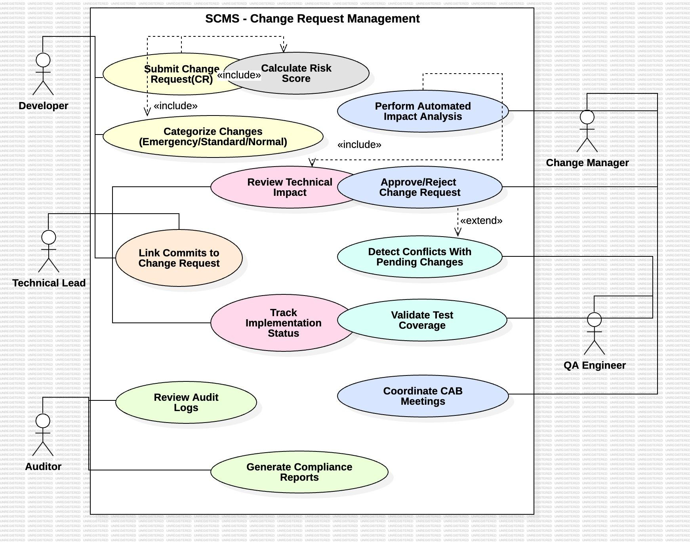
Diagram 2: Integration and Deployment Workflow
Actors: DevOps Engineer, Release Manager, System Administrator
Use Cases:
- Configure CI/CD Integration
- Monitor Deployment Status
- Execute Rollback Procedure
- Generate Compliance Reports
- Manage Emergency Changes
- Schedule Release Windows
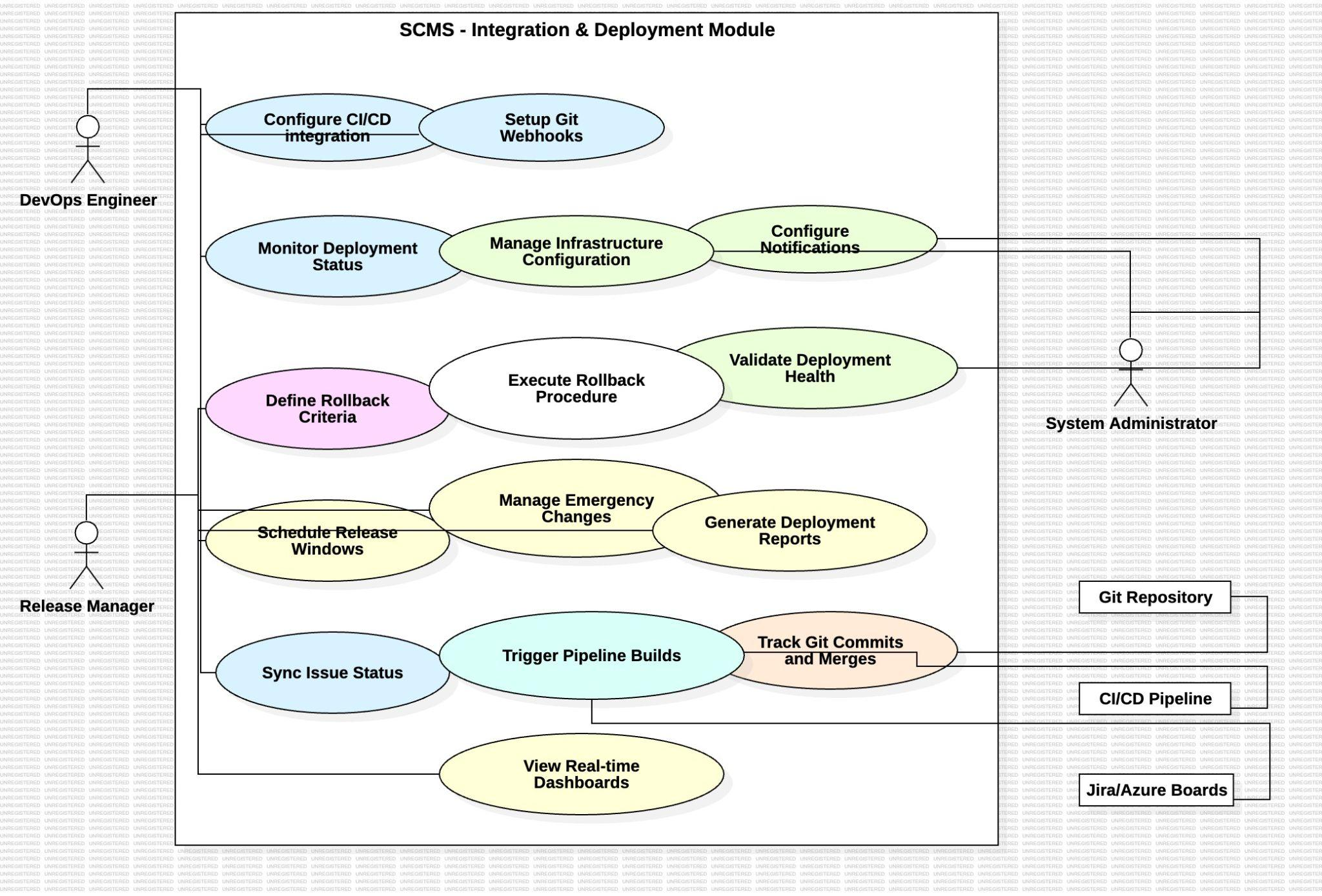

8. Requirements Traceability Matrix (RTM)
Req ID | Requirement Short | Section Ref | Module | Test Case(s) | Status | Comments
SCMS-F-001 | Submit CR with attachments | 4.1 | CR Management Module | TC-CR-01 | N | File upload validation required
SCMS-F-002 | Generate unique CR ID | 4.1 | CR Management Module | TC-CR-02 | N | Database sequence implementation
SCMS-F-003 | Categorize changes by type | 4.1 | Workflow Module | TC-CR-03 | N | Workflow engine dependency
SCMS-F-004 | Automated dependency analysis | 4.2 | Analysis Module | TC-IA-01 | N | Code parsing integration
SCMS-F-005 | Conflict detection | 4.2 | Analysis Module | TC-IA-02 | N | Git integration required
SCMS-F-006 | Risk scoring algorithm | 4.2 | Analysis Module | TC-IA-03 | N | Historical data analysis
SCMS-F-007 | Configurable approval workflows | 4.3 | Workflow Module | TC-WF-01 | N | Workflow engine configuration
SCMS-F-008 | Approval actions with comments | 4.3 | Approval Module | TC-WF-02 | N | Audit trail integration
SCMS-F-009 | Emergency change procedures | 4.3 | Workflow Module | TC-WF-03 | N | Emergency workflow paths
SCMS-F-010 | Git commit linking | 4.4 | Integration Module | TC-GIT-01 | N | Git webhook integration
SCMS-F-011 | Auto-update from Git merges | 4.4 | Integration Module | TC-GIT-02 | N | Branch monitoring service
SCMS-F-012 | Change-to-deployment traceability | 4.4 | Integration Module | TC-GIT-03 | N | Deployment pipeline hooks
SCMS-F-013 | CI/CD pipeline integration | 4.5 | Deployment Module | TC-DEP-01 | N | Pipeline API integration
SCMS-F-014 | Automated rollback procedures | 4.5 | Deployment Module | TC-DEP-02 | N | Deployment tooling required
SCMS-F-015 | Release window coordination | 4.5 | Scheduling Module | TC-DEP-03 | N | Calendar API integration
SCMS-F-016 | Real-time dashboards | 4.6 | Reporting Module | TC-REP-01 | N | Analytics engine required
SCMS-F-017 | Export compliance reports | 4.6 | Reporting Module | TC-REP-02 | N | Report generation engine
SCMS-NF-001 | 99.5% monthly uptime | 5 | Infrastructure | TC-Perf-01 | N | Monitoring integration
SCMS-NF-002 | 2-second response time | 5 | Performance Module | TC-Perf-02 | N | Load testing required
SCMS-NF-003 | 1000 concurrent users | 5 | Scalability Module | TC-Perf-03 | N | Load balancing required
SCMS-NF-004 | Data encryption standards | 5 | Security Module | TC-Sec-01 | N | Encryption library integration
SCMS-NF-005 | Cross-device compatibility | 5 | UI Module | TC-UX-01 | N | Responsive design testing
SCMS-SR-001 | TLS 1.3 enforcement | 5.1.2 | Security Module | TC-SEC-01 | N | SSL configuration
SCMS-SR-002 | MFA for privileged users | 5.1.2 | Authentication Module | TC-SEC-02 | N | MFA provider integration
SCMS-SR-003 | Account lockout policy | 5.1.2 | Authentication Module | TC-SEC-03 | N | Login attempt tracking
SCMS-SR-004 | Comprehensive audit logging | 5.1.2 | Audit Module | TC-SEC-04 | N | Immutable log storage
SCMS-SR-005 | Vulnerability scanning | 5.1.2 | Security Module | TC-SEC-05 | N | Security scanning tools
SCMS-F-018 | Track CR implementation status | 4.2 | CR Management Module | TC-CR-04 | N | Workflow and audit trail required
SCMS-F-019 | Validate CI test coverage per CR | 4.6 | QA Module | TC-CR-05 | N | Requires CI/CD integration
SCMS-F-021 | Coordinate CAB meetings | 4.3 | Workflow Module | TC-WF-04 | N | Calendar/notification integration
SCMS-F-023 | Configure CI/CD integration settings | 4.5 | Deployment Module | TC-DEP-05 | N | Pipeline configuration
SCMS-F-024 | Manage Git webhooks for commit/merge events | 4.4 | Integration Module | TC-GIT-04 | N | Git hosting platform
SCMS-F-025 | Manage infra configuration & freeze windows | 4.5 | Admin Module | TC-ADM-01 | N | Infra config DB
SCMS-F-026 | Configure notification channels | 4.5 | Notification Module | TC-NOTIF-01 | N | Notification API
SCMS-F-027 | Validate deployment health | 4.5 | System Monitoring | TC-DEP-06 | N | Health monitoring tools
SCMS-F-028 | Generate deployment reports | 4.5 | Reporting Module | TC-DEP-07 | N | Report generator
SCMS-F-029 | Trigger pipeline builds from CR/release page | 4.5 | Deployment Module | TC-DEP-08 | N | CI/CD permissions
SCMS-NF-006 | System shall archive change logs ≥7 years | 5 | Compliance Module | TC-Comp-01 | N | Long-term storage
SCMS-NF-007 | RTO ≤ 1 hour, RPO ≤ 15 minutes | 5 | Disaster Recovery | TC-DR-01 | N | Backup/replication testing
SCMS-NF-008 | System updates with zero downtime via blue-green deployment | 5 | Deployment Module | TC-DEP-09 | N | Blue/green strategy
SCMS-NF-009 | Audit logs exportable in CSV/PDF formats | 5 | Audit Module | TC-AUD-02 | N | Export tool required
SCMS-SR-006 | Secure token authentication for webhooks/CI | 5.1.2 | Integration Module | TC-SEC-06 | N | Pen-test validation
SCMS-SR-007 | Immutable audit logs with RBAC access | 5.1.2 | Audit Module | TC-SEC-07 | N | RBAC enforcement required

