Software Architecture and Design Specification
Project: Software Change Management System (SCMS)
Version: 1.0
Authors: Manchikanti Sharvani (PES1UG23AM165), N Riddhi Samitha (PES1UG23AM175), K S Niharika (PES1UG23AM132)
Date: October 02, 2025
Status: Draft

Revision History

Version | Date | Author | Change Summary
1.0 | 02-10-2025 | Manchikanti Sharvani, N Riddhi Samitha, K S Niharika | Initial architecture document for academic implementation

Approvals
Role | Name | Signature/Date
Project Guide | Prof. Anand M S

1. Introduction

1.1 Purpose
This document specifies the architecture and design of the Software Change Management System (SCMS) as an academic project. It provides a practical, implementable view of the system's structure suitable for a 2-month development timeline.

1.2 Scope
This document covers:
- Simplified architecture suitable for rapid prototyping
- Core functional components for demonstration
- Essential integrations (Git webhook simulation, basic CI/CD)
- Security fundamentals
- Technology stack appropriate for student implementation
Out of Scope for Initial Implementation:
- Enterprise-scale features (full Kubernetes orchestration, multi-region)
- Complex ML-based analytics
- Production-grade high availability
- Multiple CI/CD platform integrations (focus on one)

1.3 Audience
Project team members, course instructors, and evaluators.

1.4 Definitions
- SCMS: Software Change Management System
- CR: Change Request
- API: Application Programming Interface
- MVC: Model-View-Controller
- REST: Representational State Transfer
- JWT: JSON Web Token

2. Document Overview

2.1 How to Use This Document
- Section 3 describes the practical architecture for 2-month implementation
- Section 4 provides design details with focus on implementable features
- Use technology stack recommendations to set up development environment quickly
- Reference the simplified component descriptions for development task allocation

2.2 Related Documents
- SCMS Software Requirements Specification (SRS) v1.0
- SCMS Software Test Plan (STP) v1.0
- Requirements Traceability Matrix (RTM)

3. Architecture
3.1 Goals & Constraints
Goals for 2-Month Timeline
- Core Functionality: CR submission, basic approval workflow, status tracking
- Essential Integration: Git webhook simulation, basic deployment tracking
- Basic Security: User authentication, role-based access, audit logging
- Demonstration Ready: Working prototype with 5-10 key features
- Learning Focus: Understanding change management concepts practically

Practical Constraints
- Time: 2 months with limited daily hours due to coursework
- Team Size: 3 undergraduate students
- Resources: Free-tier cloud services or local development
- Complexity: Avoid over-engineering; focus on core features
- Learning Curve: Team learning technologies while building
3.2 Stakeholders & Concerns
Stakeholder | Primary Concerns
Project Team | Feasible implementation, learning outcomes, clear task division
Course Instructor | Understanding of concepts, working prototype, documentation quality
Developers (simulated) | Submit CRs, link to Git commits
Approvers (simulated) | Review and approve/reject CRs

3.3 Component (UML) Diagram
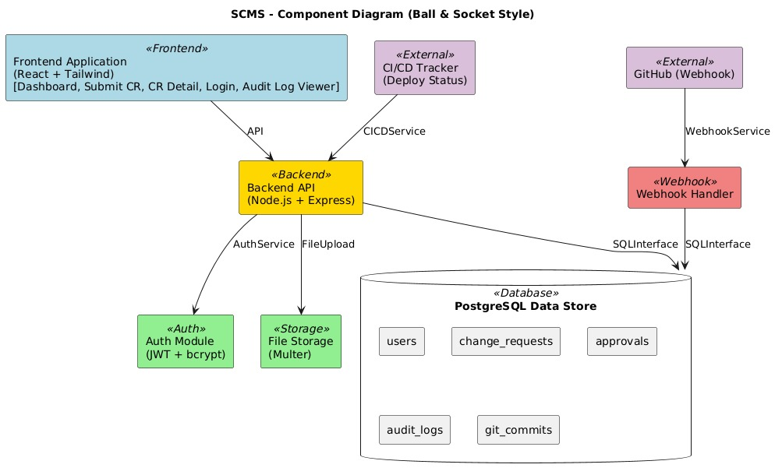

3.4 Component Descriptions

3.4.1 Frontend Application
- Technology: React with React Router
- Purpose: User interface for all interactions
- Key Pages:
  - Dashboard (CR list with status)
  - Submit CR Form
  - CR Detail View with approval actions
  - Simple reports page
- State Management: React Context API or Redux (simple setup)
- Styling: Tailwind CSS or Material-UI for rapid development

3.4.2 Backend API Server
- Technology: Node.js + Express
- Purpose: Business logic, API endpoints, data management
- Key Responsibilities:
  - CR CRUD operations
  - User authentication (JWT-based)
  - Workflow state management
  - Basic Git webhook receiver
  - Simple audit logging

3.4.3 Database
- Technology: PostgreSQL
- Purpose: Persist all application data
- Key Tables:
  - users (id, email, password_hash, role)
  - change_requests (id, cr_number, title, description, status, category, created_by, created_at)
  - approvals (id, cr_id, approver_id, decision, comment, approved_at)
  - audit_logs (id, action, user_id, cr_id, timestamp, details)
  - git_commits (id, cr_id, commit_sha, message, repository, committed_at)

3.4.4 Authentication Module
- Technology: JWT tokens with bcrypt for password hashing
- Purpose: User login and session management
- Implementation:
  - Login endpoint returns JWT token
  - Protected routes verify token
  - Basic RBAC (Developer, Approver, Admin roles)

3.4.5 Git Integration (Simplified)
- Technology: Mock webhook receiver or simple GitHub webhook
- Purpose: Demonstrate commit linking
- Implementation:
  - Webhook endpoint receives commit data
  - Extracts CR ID from commit message
  - Links commit to CR in database
  - Updates CR status if configured

3.5 Chosen Architecture Pattern and Rationale

Selected Pattern: Monolithic MVC with Modular Services
Rationale for Academic Project:
- Simplicity: Single codebase, easier to understand and debug
- Rapid Development: No distributed system complexity
- Resource Efficient: Runs on single server/laptop for demo
- Team Coordination: Easier for 3-person team to collaborate
- Learning Focus: Concentrate on domain logic, not infrastructure
Architecture Decision:
ADR-001: Monolithic Architecture for Academic Prototype
- Context: 2-month timeline, 3 undergraduate students, learning project
- Decision: Build monolithic application with clear module separation
- Consequences:
  - Faster development and debugging
  - Simpler deployment (single application)
  - Lower infrastructure complexity
  - Not production-ready for large scale
  - Limited independent service scaling
ADR-002: Node.js + Express for Backend
- Context: Need rapid development with simple async I/O
- Decision: Use Node.js with Express framework
- Consequences:
  - JavaScript full-stack (same language as frontend)
  - Large ecosystem (npm packages)
  - Easy webhook handling
  - Fast prototyping
  - Less strict typing (can use TypeScript to mitigate)

3.6 Technology Stack & Data Stores

Simplified Technology Stack
Layer | Technology | Justification
Frontend | React 18 + React Router + Axios | Standard modern web framework, large community support
UI Framework | Tailwind CSS or Material-UI | Rapid UI development with pre-built components
Backend | Node.js 18+ with Express.js | JavaScript full-stack, easy async operations, fast setup
Database | PostgreSQL 13+ | Free, robust, JSON support, good for learning SQL
Authentication | jsonwebtoken + bcrypt | Industry-standard JWT auth, secure password hashing
Git Integration | Simple webhook endpoint | Simulated or real GitHub webhook for demo
File Upload | Multer (Node.js middleware) | Simple file handling for CR attachments
Testing | Jest (backend) + React Testing Library | Built-in with Node/React projects
API Documentation | Postman Collection | Easy to share and test APIs
Deployment | Heroku, Render, or Railway (free tier) | Simple deployment for demos
Version Control | Git + GitHub | Source code management, collaboration

3.7 Risks & Mitigations

Risk | Impact | Mitigation
Insufficient time | High | Focus on core features only; use MVP approach
Technology learning curve | Medium | Start with tutorials; use familiar technologies where possible
Scope creep | High | Strict feature prioritization; defer non-essential features
Integration complexity | Medium | Simulate external systems if real integration too complex
Team coordination | Medium | Daily standups, clear task division, Git workflow
Database design errors | Medium | Design schema early, get feedback, use migrations

3.8 Traceability to Requirements
Core Features for 2-Month Implementation:
Requirement ID | Priority | Component | Implementation Notes
SCMS-F-001 | HIGH | Backend + Frontend | CR submission with basic file upload
SCMS-F-002 | HIGH | Backend | Auto-generate CR-YYYY-NNNN format
SCMS-F-003 | HIGH | Backend | Category selection (Emergency/Standard/Normal)
SCMS-F-007 | HIGH | Backend | Basic approval workflow (1-step for simplicity)
SCMS-F-008 | HIGH | Backend + Frontend | Approve/reject with comments
SCMS-F-010 | MEDIUM | Backend | Simulated Git webhook or manual commit linking
SCMS-F-018 | HIGH | Backend + Frontend | Status tracking display
SCMS-SR-001 | MEDIUM | Backend | HTTPS in deployment (handled by hosting platform)
SCMS-SR-002 | LOW | Defer | MFA not essential for academic demo
SCMS-SR-004 | HIGH | Backend | Basic audit logging to database

3.9 Security Architecture

Realistic Security for Academic Project
Essential Security Controls:
- Authentication:
  - Password hashing with bcrypt (12 rounds)
  - JWT tokens with 24-hour expiry
  - Login endpoint with basic rate limiting
  - Secure password requirements (min 8 characters, at least one number)
- Authorization (RBAC):
  - Three distinct roles: Developer, Approver, Admin
  - Role-based middleware for protected routes
  - Resource ownership verification for edit/delete operations
  - Admin-only access to audit logs and user management
- Data Protection:
  - HTTPS in production (free with Heroku/Render)
  - Parameterized SQL queries (prevent SQL injection)
  - Input validation with joi or express-validator
  - Output sanitization to prevent XSS
- Audit Trail:
  - Log all CR create/update/approve actions with user ID
  - Log authentication attempts (success and failures)
  - Log authorization failures (access denied scenarios)
  - Store user ID and timestamp for all actions
  - Admin-only audit log viewer
Simplified Threat Mitigation:
Threat | Basic Mitigation | Implementation
SQL Injection | Parameterized queries | Use pg library with $1, $2 placeholders
XSS | Input validation + React escaping | React escapes by default; validate all inputs
CSRF | SameSite cookies | Set cookie options: sameSite: 'strict'
Password Attacks | Bcrypt + password requirements | Min 8 chars, complexity rules, bcrypt 12 rounds
Unauthorized Access | JWT + RBAC middleware | Verify token and role on all protected routes
Privilege Escalation | Role verification + audit logging | Check role in JWT, log all access attempts
Session Hijacking | Short token expiry | 24-hour JWT expiry, secure token storage

4. Design

4.1 Design Overview
Layered Architecture:
- Presentation Layer: React components
- API Layer: Express.js routes
- Business Logic Layer: Service functions
- Data Access Layer: Database queries
- Database Layer: PostgreSQL
Folder Structure (Backend):

scms-backend/
├── src/
│ ├── routes/ # Express route handlers
│ │ ├── auth.js
│ │ ├── changeRequests.js
│ │ └── approvals.js
│ ├── controllers/ # Request/response logic
│ ├── services/ # Business logic
│ ├── models/ # Database queries
│ ├── middleware/ # Auth, validation
│ ├── utils/ # Helper functions
│ └── server.js # App entry point
├── tests/
├── package.json
└── .env # Environment variables

Folder Structure (Frontend):

scms-frontend/
├── src/
│ ├── components/ # Reusable UI components
│ ├── pages/ # Page components
│ │ ├── Dashboard.jsx
│ │ ├── SubmitCR.jsx
│ │ ├── CRDetail.jsx
│ │ └── Login.jsx
│ ├── services/ # API calls
│ ├── context/ # Auth context
│ ├── App.jsx
│ └── index.jsx
├── public/
└── package.json

4.2 UML Sequence Diagrams
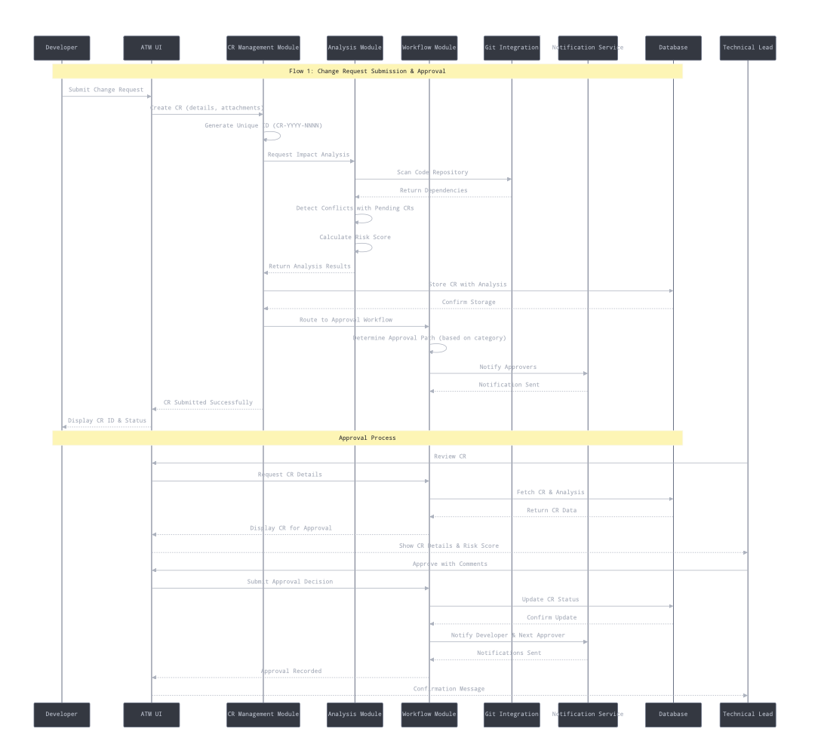
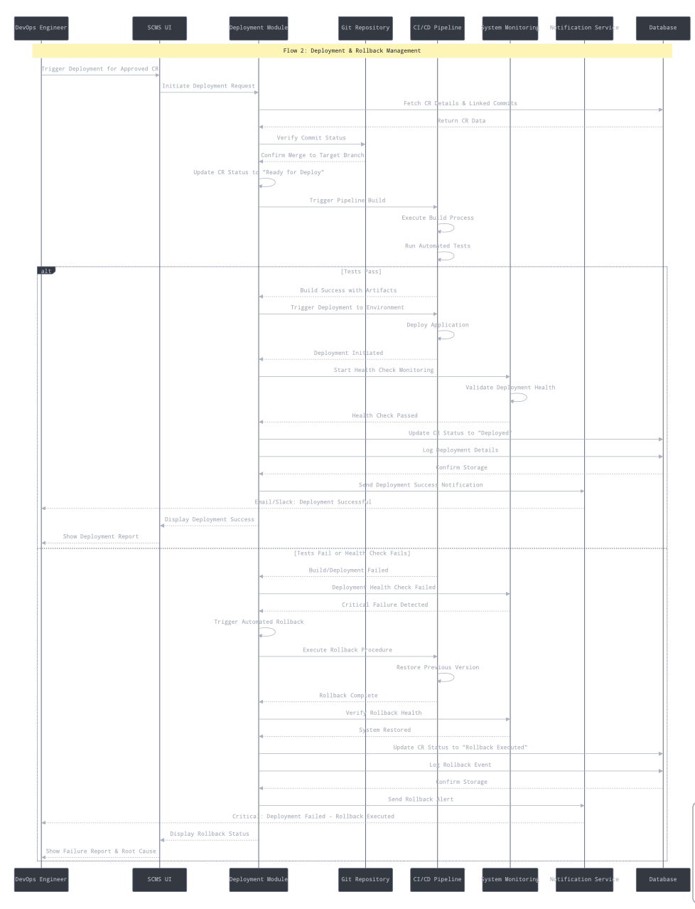

4.3 API Design

Core API Endpoints (RESTful)
Authentication:
POST /api/auth/register
POST /api/auth/login
GET /api/auth/me (requires JWT)
Change Requests:
GET /api/change-requests (list all, with filters)
GET /api/change-requests/:id (get single CR)
POST /api/change-requests (create new)
PUT /api/change-requests/:id (update - owner only)
DELETE /api/change-requests/:id (delete draft - owner only)
Approvals:
POST /api/change-requests/:id/approve
POST /api/change-requests/:id/reject
GET /api/change-requests/:id/approvals
Audit Logs:
GET /api/audit-logs (admin only)
GET /api/audit-logs?cr_id=:id
Git Integration (Webhook):
POST /api/webhooks/git (receives commit data)

4.4 Error Handling, Logging & Monitoring

Error Handling (Simplified)
Standard Error Response:
json
{
"error": "Validation Error",
"message": "Title is required and must be between 10-500 characters",
"statusCode": 400
}
Common HTTP Status Codes:
- 200 OK - Success
- 201 Created - Resource created
- 400 Bad Request - Validation error
- 401 Unauthorized - Invalid or missing token
- 403 Forbidden - Insufficient permissions
- 404 Not Found - Resource doesn't exist
- 500 Internal Server Error - Unexpected error
Backend Error Handling Pattern:
javascript
try {
// Business logic
} catch (error) {
console.error('Error creating CR:', error);
res.status(500).json({
error: 'Internal Server Error',
message: 'Failed to create change request'
});
}

Logging (Simplified)
Console Logging (adequate for academic project):
javascript
console.log('[INFO]', 'CR created:', crNumber);
console.error('[ERROR]', 'Database error:', error.message);

Monitoring (Basic)
- Console logs during development
- Heroku/Render logs viewer in production
- Manual testing and debugging
- Optional: Simple health check endpoint

4.5 UX Design

Simplified User Interface
1. Login Page
- Email and password fields
- Login button
- Link to register (if implementing registration)
- Basic validation messages
2. Dashboard
- Table showing all CRs with columns:
  - CR Number
  - Title
  - Category
  - Status
  - Created By
  - Created Date
  - Actions (View button)
- Filter by status (Draft, Pending, Approved, Rejected)
- "Submit New CR" button prominently placed
3. Submit CR Form
- Simple form with fields:
  - Title (required)
  - Description (textarea)
  - Category (dropdown: Emergency, Standard, Normal)
  - Priority (dropdown: High, Medium, Low)
  - Impact Scope (text input or multi-select)
- Submit and Cancel buttons
- Client-side validation with error messages
4. CR Detail View
- Display all CR information
- Approval section (if user is Approver and CR is Pending):
  - Comment textarea
  - Approve and Reject buttons
- Approval history (list of past approvals)
- Linked commits section (if any)
- Edit button (if owner and status is Draft)
5. Audit Log Viewer (Admin)
- Simple table with:
  - Timestamp
  - Action
  - User
  - CR Number
  - Details
- Basic date filter

Accessibility Basics
- Semantic HTML (proper headings, labels)
- Form labels for screen readers
- Keyboard navigation (tab order)
- Sufficient color contrast
- Responsive design (mobile-friendly)

4.6 Open Issues & Next Steps

Implementation Plan (2 Months)
Week 1-2: Setup & Core Backend
- Set up project repositories (frontend & backend)
- Initialize Node.js + Express backend
- Set up PostgreSQL database
- Implement user authentication (register, login, JWT)
- Create database schema and migrations
- Deliverable: Working auth system
Week 3-4: CR Management
- Implement CR CRUD APIs
- Build React frontend structure
- Create Dashboard and Submit CR pages
- Implement CR listing and creation
- Deliverable: Can create and view CRs
Week 5-6: Approval Workflow
- Implement approval endpoints
- Build CR Detail page with approve/reject
- Add audit logging
- Implement role-based access control
- Deliverable: Complete approval workflow
Week 7: Integration & Polish
- Implement simulated Git webhook
- Add basic commit linking
- Improve UI/UX
- Bug fixes and testing
- Deliverable: Functional prototype
Week 8: Testing & Documentation
- Write test cases (at least 20 key tests)
- Prepare demo scenarios
- Complete documentation
- Prepare presentation
- Deploy to free hosting platform
- Deliverable: Demo-ready application

Success Criteria
Minimum Viable Demo:
- User can register and login
- User can create a CR with all required fields
- CR gets unique number (CR-2025-NNNN)
- Approver can view CR and approve/reject with comment
- CR status updates based on approval
- Dashboard shows all CRs with current status
- Basic audit log shows key actions
- Simulated Git commit can be linked to CR
Bonus Features (if time permits): 9. File upload for CR attachments 10. Email notifications (using nodemailer) 11. Advanced dashboard with statistics 12. Export CR data to CSV 13. Password reset functionality

5. Appendices

5.1 Glossary
Term | Definition
CR | Change Request - formal request to modify software
JWT | JSON Web Token - authentication token format
REST | Representational State Transfer - API architecture style
CRUD | Create, Read, Update, Delete - basic data operations
MVP | Minimum Viable Product - simplest version with core features

5.2 References
- Express.js Documentation: https://expressjs.com/
- React Documentation: https://react.dev/
- PostgreSQL Tutorial: https://www.postgresqltutorial.com/
- JWT.io: https://jwt.io/
- REST API Best Practices
- SCMS SRS v1.0
- SCMS STP v1.0

5.3 Tools & Setup

Development Tools
Tool | Purpose | Setup Time | Link
VS Code | Code editor | 30 min | https://code.visualstudio.com/
Node.js 18+ | Runtime | 30 min | https://nodejs.org/
PostgreSQL | Database | 1 hour | https://www.postgresql.org/
Postman | API testing | 30 min | https://www.postman.com/
Git + GitHub | Version control | 1 hour | https://github.com/
React DevTools | Debugging | 15 min | Browser extension

UML & Diagram Tools
Tool | Purpose | Recommended For | Learning Curve
Draw.io (diagrams.net) | Component diagrams, sequence diagrams | All diagram types | Easy (30 min)
PlantUML | Text-based UML diagrams | Sequence diagrams | Medium (2 hours)
StarUML | Professional UML tool | Complete UML suite | Medium (2-3 hours)

