Git Version Control System – Coding Assignment

- 1

Student Details
Name: Riddhi Shete
Roll No: 95631
Batch / Course: Mern
Date of Submission: 13/01/2025

Instructions
Perform all tasks using Git Bash / Command Prompt
Attach screenshots for each question as proof of execution Push the final project to GitHub
Convert this document to Word (.docx) after completion Submit Word file

Question 1
Verify that Git is correctly installed on your system and record the version displayed.

Answer:

git --version

git version 2.52.0.windows.1

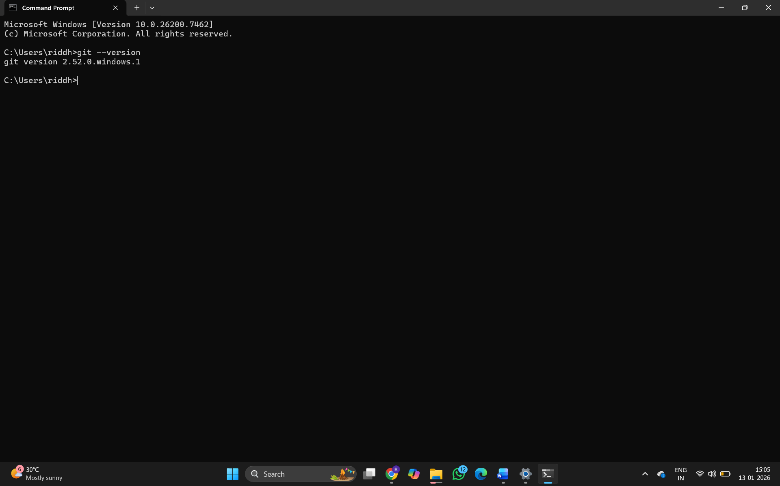

Question 2
Configure Git with your global username and email ID, and verify that the configuration has been applied successfully.

Answer:
Configured username: RiddhiShete
Configured email ID: riddhishete169@gmail.com

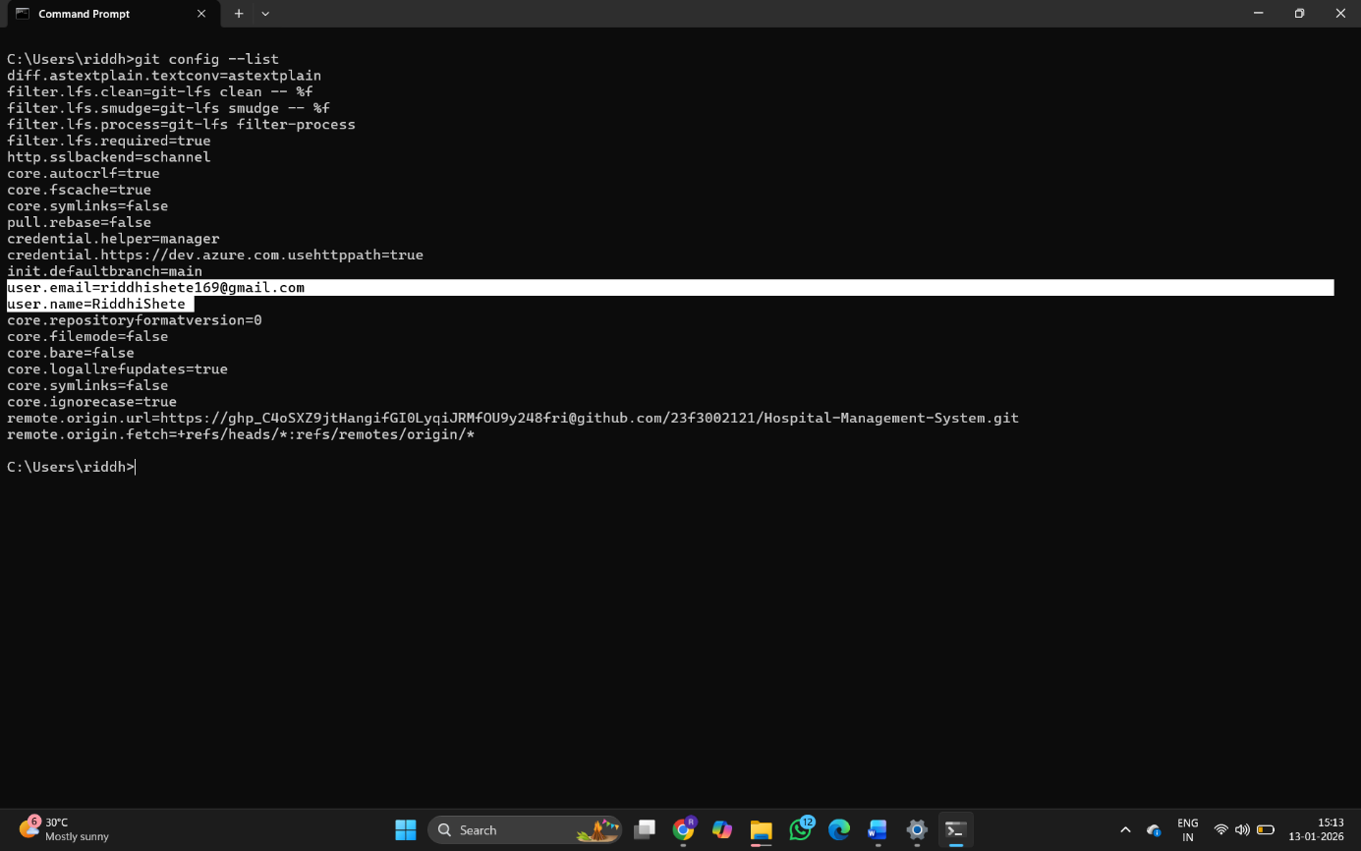

Question 3
Create a new local Git repository named git-assignment and initialize version control in it.

Answer:
Create a folder named git-assignment and inside that folder, open git bash by right clicking and then give “git init” command on git bash.

Screenshot Evidence: 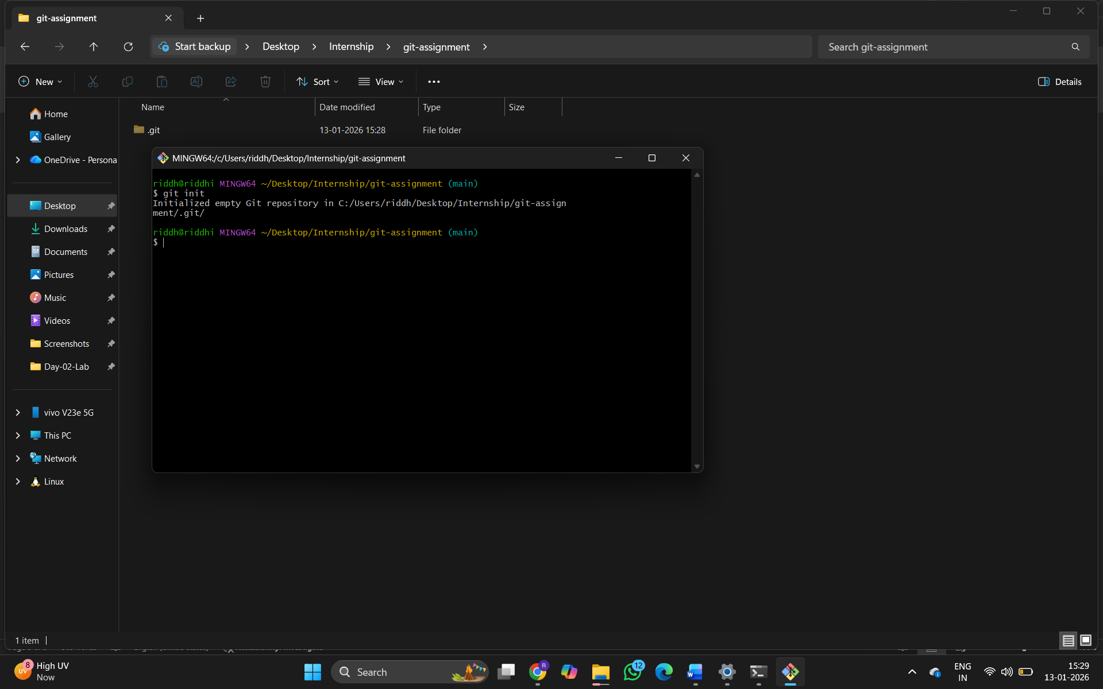

Question 4
Create a README.md file inside the repository, add relevant project information, and commit the file to the repository.

Answer:
File created: README.md
Commit message used:

Screenshot Evidence:
(Paste screenshot showing commit details)

Question 5
Modify the existing README.md file and create a new file named index.html. Track the changes and commit them with an appropriate commit message.

Answer:
Modified file: README.md
New file created: index.html
Commit message used:

Screenshot Evidence:
(Paste screenshot showing file changes and commit)

Question 6
SUNBEAM
Display the commit history of the repository and identify the commit hash, author, and commit message.

Answer:

Commit Hash Author Commit Message

Screenshot Evidence:
(Paste screenshot showing commit history)

Question 7
Create a new branch named feature-branch, switch to it, add a new file named
feature.txt, and commit the changes.

Answer:
Branch created: feature-branch
File added: feature.txt
Commit message used:

Screenshot Evidence:
(Paste screenshot showing branch creation and commit)

Question 8
Switch back to the main branch and merge the feature-branch into it. Ensure the merge is completed successfully.

Answer:
(Mention successful merge status)

Screenshot Evidence:
(Paste screenshot showing successful merge)

Question 9

Create a new remote repository on GitHub named git-assignment and push the complete local repository to GitHub.
SUNBEAM

Answer:
GitHub repository URL:

Screenshot Evidence:
(Paste screenshot of GitHub repository with uploaded files)

Screenshot Evidence:
(Paste screenshots demonstrating undo operations)

