What is SDLC?

* SDLC means software development life cycle.
* A Software development life cycle is essentially a series of step, or phases. That provide a model for the developments and life cycle management of an application or piece of software.

What is software testing?

* Testing is the process of evaluating a system or its component(s) with the intent to find that whether it satisfies the specified requirements or not.
* Software testing is a process used to identify the correctness, completeness, and quality of developed computer software.
* testing is executing a system in order to identify any gaps, errors or missing requirements in contrary to the actual desire or requirements.

What is Agile methodology?

* It is a combination iterative and increment model.
* It divides the software into small incremental builds, this build is provided in iterations, that means the big projects are divided into small chunks(iteration).
* Each iteration last about one to three weeks.
* Each iteration involves all the team members working simultaneously on areas

Like planning, requirement, analysis, design, coding, unit testing and acceptance testing.

What is SRS?

* A software requirements specification (SRS) is a complete description of the behavior of the system to be developed.
* It includes a set of use cases that describe all of the interactions that the users will have with the software.
* Use cases are also known as functional requirements. In addition to use cases, the SRS also contains nonfunctional (or supplementary) requirements.
* Non-functional requirements are requirements which impose constraints on the design or implementation (such as performance requirements, quality standards, or design constraints).

What is oops?

* Object oriented programming is way of writing the programs in organized

Way object are like a black box where data are hidden.

Write Basic concepts of oops?

* 1.class
* 2.object
* 3.inheritance
* 4.polymorphism

1.Over ridding

2.Over loading

* 5.Encapsulaction
* 6.Abstraction.

What is object?

* Object gives the permission to access functionality of class.

What is class?

* Class is a collection of data member and member function.

What is encapsulation?

* The process wrapping the data in a single unit. To secure the data from

Outside world.

What is inheritance?

* Making a class from an existing class. Deriving the attribute of some

Other class.

What is polymorphism?

* One name multiple form.

TYPE: over riding

Same name of function with same parameter but definition will be different.

Over loading

1.Function overloading: same function name but different parameter.

2.constructor overloading: same constructor name but different parameter.

3.operator overloading: Using the operator to add the object instead of

Variable operands.

Draw Use case on Online book Shopping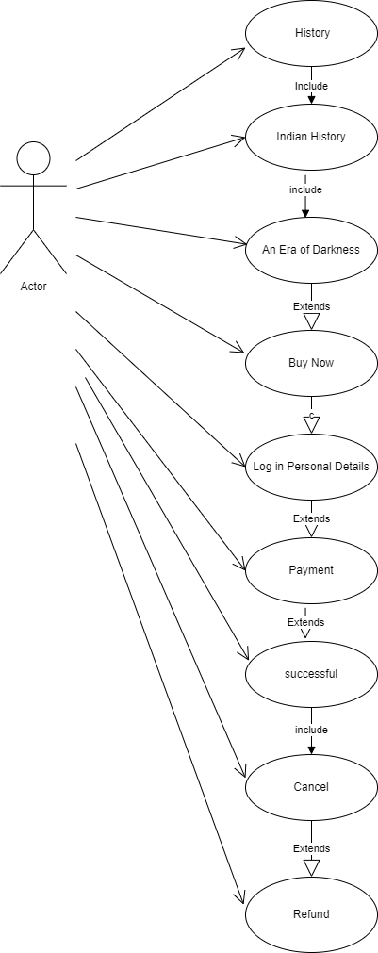

Draw Use case on online bill payment System [paytm]

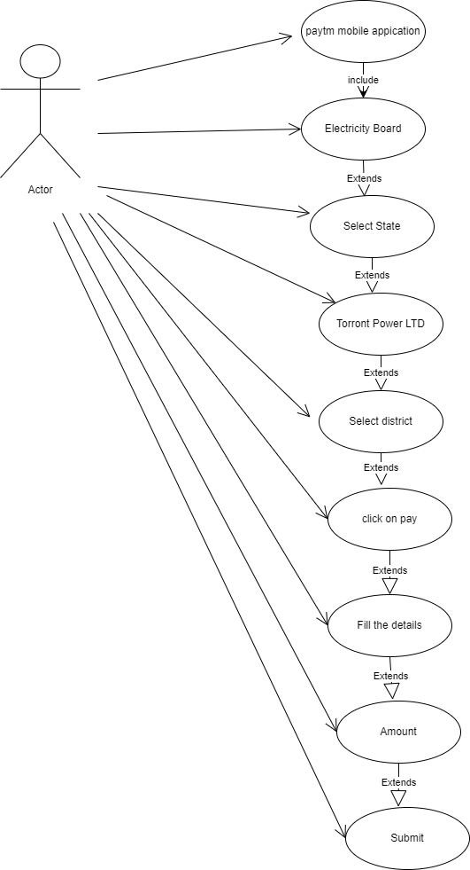

Write SDLC phases with basic introduction?

* **Requirement Gathering**:
* Although requirements may be documented in written form, they may be incomplete, or even incorrect.
* Requirements will Change!
* Types of Requirements:
* 1.Function Requirement:
* 2.Non-Function Requirement:
* **Analysis phase:**
* Ideally, this document states in a clear and precise fashion what is to be built.
* This phase starts with the requirement document delivered by the requirement phase and maps the requirements into architecture.
* The architecture defines the components, their interfaces and behaviors.
* **Design phase:**
* Design Architecture Document
* Implementation Plan
* Critical Priority Analysis
* Performance Analysis
* The design team can now expand upon the information established in the requirement document.
* Test Plan
* **Implementation phase:**
* In the implementation phase, the team builds the components either from scratch or by composition.
* The implementation phase deals with issues of quality, performance, baselines, libraries, and debugging.
* **Testing phase:**
* Simply stated, quality is very important. Many companies have not learned that quality is important and deliver more claimed functionality but at a lower quality level.
* A customer satisfied with the quality of a product will remain loyal and wait for new functionality in the next version.
* Quality is a distinguishing attribute of a system indicating the degree of excellence.
* **Type of testing**
* Regression Testing
* Internal Testing
* Unit testing
* Application testing
* Stress testing
* The testing phase is a separate phase which is performed by a different team after the implementation is completed.
* There is merit in this approach; it is hard to see one’s own mistakes, and a fresh eye can discover obvious errors much faster than the person who has read and re-read the material many times.
* **Maintenance phase:**
* Maintenance is the process of changing a system after it has been deployed.
* Corrective maintenance:

Identifying and repairing defects.

* Adaptive maintenance:

Adapting the existing solution to the new platforms.

* Perfective maintenance:

implementing the new requirements. In a spiral lifecycle, everything after the delivery and deployment of the first prototype can be considered “maintenance”!

Explain phases of the waterfall model?

* Requirements collection
* Analysis
* Design
* Implementation
* Testing
* Maintenance

Write phases of spiral model?

* Planning
* Risk Analysis
* Engineering
* Customer Evaluation

Explain working methodology of agile model and also write pros and cons?

* Agile model divides the software into small incremental builds, this build are provided in iterations, that means the big projects are divided in to small chunks.
* Working on planning requirement analysis, design, coding, unit testing and acceptance testing. And after the working product is displayed to the customer or the important take holder and it is released in the market.
* After the release we check for the feedback of the deployed software.
* If any enhancement is needed in the project, then it’s done and it’s re-released.
* **Pros**
* Frequent delivery
* Face to face communication with the customer
* Less time
* Adaptability
* **Cons**
* Less documentation
* Maintenance problem

Draw use case on online shopping product using COD

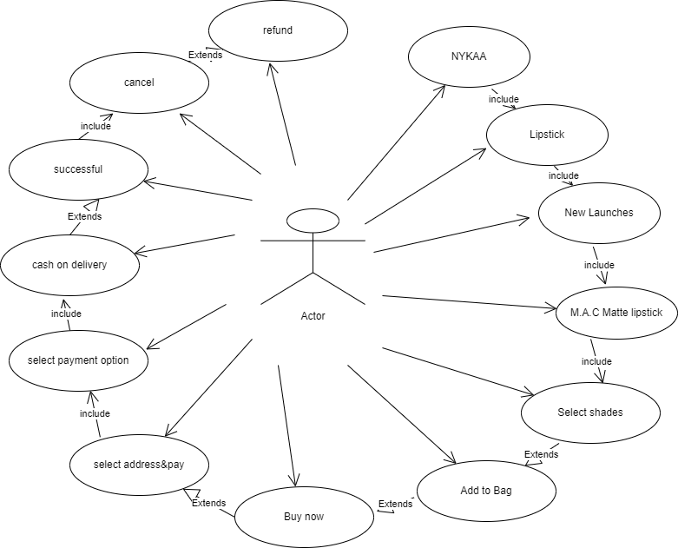

Draw use case on Online shopping product using payment gateway

