Subject: Design and Analysis of Algorithms (DAA) Lab Project

Member 1. Name: Avni Shukla
Section-Batch: A1-B2
Roll No.: 19

Member 2. Name: Riddhi Bante
Section-Batch: A1-B2
Roll No.: 31

Member 3. Name: Priyanka Bala
Section-Batch: A1-B4
Roll No.: 55

TITLE: Automatic Resume Matcher

- Objectives:

- To automate the process of resume and job description matching using string-matching algorithms.
- To analyze and compare the degree of textual similarity using more than one or more algorithmic approach.
- To generate a ranking of candidates based on textual relevance to the job description.
- To learn about and implement algorithm concepts related to Dynamic Programming and Pattern Matching..

- Introduction:
Recruiters frequently need to sift through hundreds of resumes for a single job position. This is a tedious, inconsistent, and time-consuming process. To mitigate these weaknesses, this project will present an Automatic Resume Matcher that utilizes classical string-matching algorithms to determine how similar the resumes and job descriptions are in text form.
The proposed system will tokenize and pre-process the text, before applying three primary algorithms:
Fuzzy LCS (Longest Common Subsequence): Identifies the longest ordered sequence of words that match, and can also account for synonyms (e.g. "developer" = "programmer").
KMP (Knuth-Morris-Pratt): Searches efficiently for job keywords within resumes.
Edit Distance (Levenshtein Distance): Measures how many edits are needed in order to change one string into another.
The system will create a weighted score that combines the three similarity results in order to rank the resumes by relevance to the job description.

3. Algorithms/Technique used:
1. Fuzzy LCS (Longest Common Subsequence)
- Concept:
Finds the longest sequence of words appearing in both texts (in the same order but not necessarily contiguous).
- Enhancement:
Adds synonym mapping (e.g., developer = programmer) for semantic matching.
- Approach:
Dynamic Programming is used to fill an m × n table comparing each word from both sequences.
- Formula:
if match(seq1[i], seq2[j]):
dp[i+1][j+1] = dp[i][j] + 1
else:
dp[i+1][j+1] = max(dp[i][j+1], dp[i+1][j])
Algorithm:
def fuzzy_lcs(seq1, seq2):
synonyms = {
"developer": ["programmer", "coder"],
"data": ["dataset", "information"],
"machine": ["ml", "ai"],
"analysis": ["analytics", "analyst"],
"model": ["framework", "architecture"]
}
m, n = len(seq1), len(seq2)
dp = [[0]*(n+1) for _ in range(m+1)]

def match(x, y):
return x == y or y in synonyms.get(x, [])

for i in range(m):
for j in range(n):
if match(seq1[i], seq2[j]):
dp[i+1][j+1] = dp[i][j] + 1
else:
dp[i+1][j+1] = max(dp[i][j+1], dp[i+1][j])
return dp[m][n] / max(m, 1)
Explanation:
A dictionary of synonyms is established to deal with semantic similarity. For example, "developer" can be matched with "programmer" or "coder." The algorithm takes two lists of words, seq1 and seq2, both of which are tokenized job text and resume text, respectively. The algorithm creates a 2D DP (Dynamic Programming) table of size (m + 1) × (n + 1), where m and n are the lengths of the two sequences. Each cell dp[i][j] contains information about the length of the longest common subsequence, where i indicates we are up to words from seq1 until i, and j indicates we are up to words in seq2 until j. The function match(x, y) checks to see if the words are exactly equal or if the words are synonyms based on the dictionary we created.
The algorithm goes through all pairs of words using a nested loop, to check for matches:
- If the two strings are similar and match for the i-th and j-th words, we update the value at dp[i + 1][j + 1] to dp[i][j] + 1, which would mean this sequence has been extended by one word.
- If we don’t find a match, we take the max value of the previous row and column (dp[i][j + 1], dp[i + 1][j]), which represents the best subsequence we have found up to that point.
At the end of our algorithm, we normalize our result by dividing dp[m][n] (the longest common subsequence) by the total number of words within the job description for a simplicity score that will range between 0 and 1. Thus, Fuzzy LCS captures both word order and synonym meaning, making it robust for natural language text like resumes.

2. KMP (Knuth–Morris–Pratt) String Matching
- Concept: Efficiently searches for a word (pattern) inside text using precomputed LPS (Longest Prefix Suffix) array.
- Use here: Finds how often job description keywords appear in resumes.
- Pseudo code:
computeLPS(pattern)
i, j = 0
while i < len(text):
if text[i] == pattern[j]:
i++, j++
if j == len(pattern):
count++
j = lps[j-1]
else:
j = lps[j-1] if j > 0 else 0
if j == 0:
i++

Algorithm:
def compute_lps(pattern):
lps = [0]*len(pattern)
j = 0
for i in range(1, len(pattern)):
while j > 0 and pattern[i] != pattern[j]:
j = lps[j-1]
if pattern[i] == pattern[j]:
j += 1
lps[i] = j
return lps

def kmp_search(text, pattern):
if not pattern:
return 0
lps = compute_lps(pattern)
i = j = count = 0
while i < len(text):
if text[i] == pattern[j]:
i += 1
j += 1
if j == len(pattern):
count += 1
j = lps[j-1]
else:
j = lps[j-1] if j else 0
if j == 0:
i += 1
return count

def kmp_similarity(job_words, resume_words):
text = ' '.join(resume_words)
hits = sum(kmp_search(text, word) for word in job_words)
return hits / len(job_words) if job_words else 0

Explanation:
The function compute_lps(pattern) generates the LPS (Longest Prefix Suffix) array for the given pattern. For each position i in the pattern, it finds out how many of the initial characters match the ending characters located before i. This allows the algorithm to understand where to jump back to on a mismatch. This approach also helps save unnecessary comparisons.
The function kmp_search(text, pattern) is the implementation of this when we go through the resume text:
- It uses two pointers, i - for the text and j - for the pattern.
- If the characters match, both pointer positions increase.
- However, if there is a match (j == len(pattern)) we can increase our count of like matches and we've `reset our pattern depending on the lps value's instructions` (lps[j-1]).
- In the event of a mismatch, it uses the lps value to appropriately shift again, rather than restarting from the beginning of the pattern.
The kmp_similarity() function repeats this process for all words of the job description and counts how many matches were found across the resume. Finally, we compute the total hits and divide them by the total job words to get the KMP similarity score between 0 and 1. This process allows us to carry out relatively fast keyword frequency matching, which is helpful considering the comparison of longer text data like resumes.
3. Edit Distance (Levenshtein Distance)
- Concept: Measures how many operations (insert, delete, substitute) are needed to transform one string into another.
- Formula:
dp[i][j] = min(
dp[i-1][j] + 1, # deletion
dp[i][j-1] + 1, # insertion
dp[i-1][j-1] + cost # substitution
)
Use here: Compares structure and content similarity between job and resume.
Algorithm:
def edit_distance(seq1, seq2):
m, n = len(seq1), len(seq2)
dp = [[0]*(n+1) for _ in range(m+1)]
for i in range(m+1):
dp[i][0] = i
for j in range(n+1):
dp[0][j] = j
for i in range(1, m+1):
for j in range(1, n+1):
cost = 0 if seq1[i-1] == seq2[j-1] else 1
dp[i][j] = min(
dp[i-1][j] + 1,
dp[i][j-1] + 1,
dp[i-1][j-1] + cost
)
return 1 - dp[m][n] / max(m, n)

Explanation:
The function begins by creating a two-dimensional dynamic programming array dp of dimensions (m + 1) × (n + 1), where m and n are the lengths of both strings.The first row and the first column are then initialized with their index values (either i or j), meaning that those indices represent the number of edits needed to turn an empty string into the substring.
After that, the algorithm goes through every word pair (i, j):
- If the words are the same, the cost is 0 (no editing).
- If the words differ, the cost is 1 (substitution).
The current dp[i][j] element will take the minimum among:
- dp[i - 1][j] + 1 → deletion
- dp[i][j - 1] + 1 → insertion
- dp[i - 1][j - 1] + cost → substitution
Once the dp table is filled in, the final distance at dp[m][n] will be the total number of edits needed. To normalize the result, similarity is measured as 1 - (dp[m][n] / max(m, n)). In this way, the measure lies between 0 (not similar) and 1 (identical). In the resume matcher, less distance means that the words in the resume text are likely very similar to the words in the job description (not many changes needed).

After determining individual similarity scores for all three algorithms - Fuzzy LCS, KMP, and Edit Distance - the weighted average process will aggregate all three algorithms:
Weighted Combination
Final score for each resume:
Final = 0.4*(Fuzzy LCS) + 0.3*(KMP) + 0.3*(Edit Distance)
The larger the Final Score, the better the resume fits the job description(Higher score = better match).

- Time Complexity and Explanation:
Algorithm | Time Complexity | Explanation
Fuzzy LCS | O(m × n) | Each word of sequence 1 is compared with each of sequence 2 (Dynamic Programming).
KMP | O(m + n) | Linear time due to preprocessing via LPS array.
Edit Distance | O(m × n) | DP-based approach comparing all substrings.
Overall complexity = O(m × n) - acceptable for short to medium-length text.

- Results:
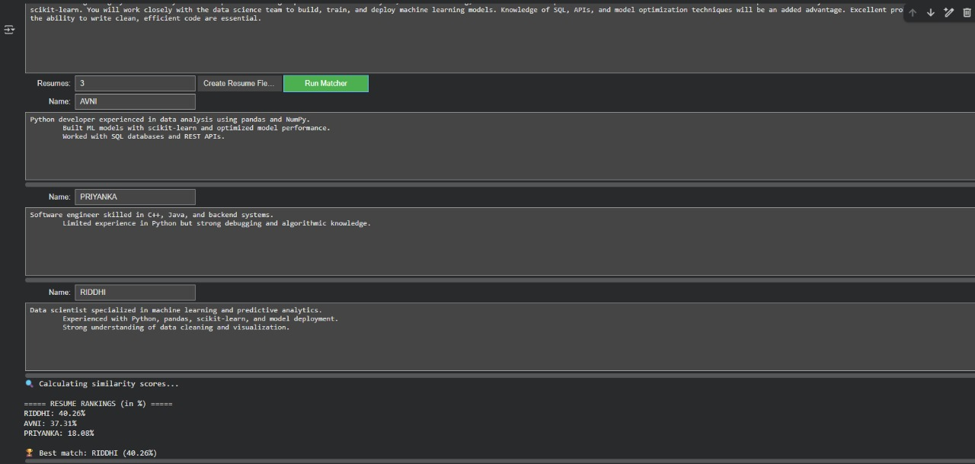
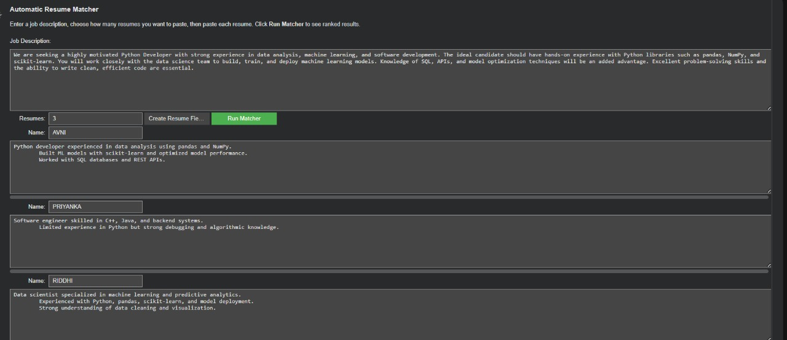
Input:
- Job Description: Python Developer with data analysis, machine learning, and SQL skills.
- Resumes: AVNI, PRIYANKA, RIDDHI

Output:
After reading the job description, the system performed a comparison against multiple resumes. The results table presented a ranking of candidates based on the similarity score calculated for each candidate. For example:
===== RESUME RANKINGS (in %) =====
RIDDHI: 40.26%
AVNI: 37.31%
PRIYANKA: 18.08%
Best match: RIDDHI (40.26%)
The resume for RIDDHI is noted as the best fit because the resume had the most frequent keywords in common with the description, such as Python, Machine Learning, and Data Analysis.
Interpretation:
- The resume of RIDDHI best matches the job description due to strong overlap in machine learning, data science, and Python terms.
- AVNI shows relevant Python and data skills but slightly lower ML coverage.
- PRIYANKA has strong general programming skills but less domain relevance.

- Conclusion and Future Scope:
The project illustrates the potential of classical string-matching algorithms in automating the resume screening process. Fuzzy Longest Common Subsequence (LCS), Knuth-Morris-Pratt (KMP), and Edit Distance algorithms yield both lexical and semantic accuracy in ranking candidates.
Future Scope:
- Link to a portal with web or GUI based recruiter upload function.
- Test with TF-IDF, Word2Vec, or BERT embeddings for deeper semantic understanding. Implement section based weighting (skills, education, experiences).
- Improve algorithm run-time for processing large datasets.

