**Descriptive Statistics & Probability: Set-1**

1)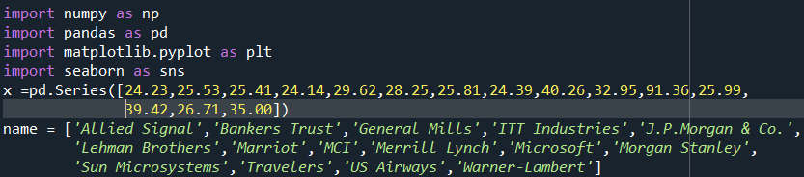



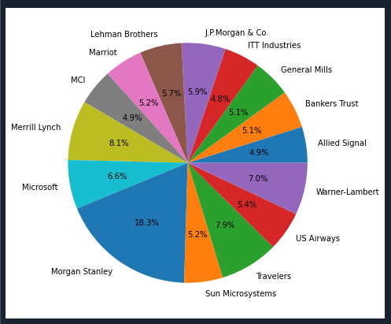



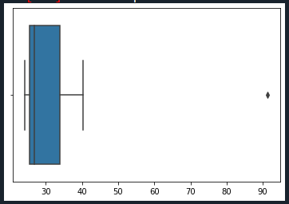

Mean:

Variance:

Standard Deviation:

2)

i) approximately - Q1 = 5

- Q2 = 10

- Q3 = 12

Inter Quartile Range (IQR) = Q3 – Q1

IQR = 12 – 5 = 7

ii) Here the Boxplot shows as Right Skewed and it is called as “Positively Skewed”.

iii)

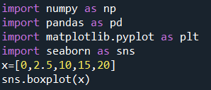

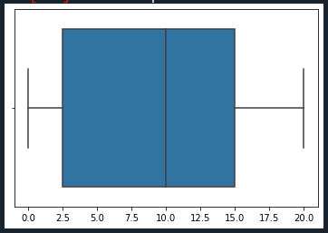

Here from the above boxplot we took 25 as 2.5 from the data point and the new Boxplot affected as “Positively Skewed”.

3)

i) Here the mode of the dataset lies in between of “5 – 10” and approximately between “4 – 8”.

ii) It is a “Right Skewed”. Mean>Median>Mode

iii) They both are right skewed and both have outliers the median can be easily visualized in boxplot where as in histogram mode is more visible.

4) If 1 in 200 long-distance telephone calls are getting misdirected.

Probability of call misdirecting = 1/200

Probability of call not misdirecting =1-1/200

The probability for at least on in five attempted telephone calls reaches the wrong number

Number of calls = 5n = 5p = 1/200q = 199/200

P(x) = at least one in five attempted telephone reaches the wrong number P(x)=ncxpxqn-x

P(x) = (ncx) (p^x) (q^n-x) #nCr = n! /r! *(n-r)!

P(1) = (5c1) (1/200)^1 (199/200)^5-1

P(1) = 0.0245037

5)

i)The most likely monetary outcome of the Business venture is 2000$, as for 2000$ the probability is 0.03 this is maximum as compared to others.

ii)Yes, the probability that the venture will make more than 0 or a profit

p(x<0)+p(x>1000)+p(x>2000)+p(x=3000) = 0.2+0.2+0.3+0.1 = 0.8

this states that there is a good 80% chances for his venture to be making of profit.

iii) The long-term average is Expected value = Sum(X*P(X)) =800$ which means on an average the returns will be + 800$.

iv) The good measure of the risk involved in a venture of this kind depends on the variability in the distribution. Higher variance means more chance of risk var(X) = E(X^2) - (E(X))^2

=2800000 - 800^2 = 2160000.