Sample Difficulty Distribution Framework (SDDF)
Technical Report

Capability-Based SLM Routing Across Eight Tasks

Device: Riddhima | AMD Ryzen 7 8840HS | 2026-03-18

Table of Contents

Section 1: Executive Summary
The Sample Difficulty Distribution Framework (SDDF) is a data-driven pipeline that routes inference requests between small language models (SLMs) and a Groq-hosted baseline LLM based on the learned difficulty of each input. Rather than sending all queries to an expensive baseline, SDDF profiles task complexity using a six-dimensional difficulty vector, bins samples by difficulty, measures per-bin capability and risk, and applies a two-tier gating rule to determine the routing limit.

Key findings across 8 tasks:
Task | Decision | Key Finding
Classification | ESCALATE | SLM-1/2 achieve 93-100% canonical success; SDDF smoke curves n<5 per bin — tau detection impossible
Maths | ESCALATE (smoke) / ROUTE SLM (canonical) | SLM-1 100% success all bins; BASELINE raw accuracy only 38.3% — SLM competitive at low difficulty
Text Generation | ROUTE SLM-1 / ESCALATE SLM-2 | SLM-1 (Qwen 2B-class) 100% canonical; SLM-2 (Phi 3B-class) near-zero; model fit dominates
Summarization | ESCALATE | SLM-2 ROUGE-1=0.281 matches BASELINE=0.277; tau_risk fires at bin 0 for SLM-2
Info Extraction | ESCALATE | All tiers Macro F1 <=0.19; high invalid output rates (50-80%); BASELINE 16x faster
Retrieval Grounded | ESCALATE | SLM-0 (0.5B) EM=66.7% EXCEEDS BASELINE 63.3%; smoke run insufficient for routing decision
Instruction Following | ROUTE SLM | ONLY routing success: 7 pairs, all Zone A, ratio=1.0, precision=recall=F1=1.0, tau_cap=0.0
Code Generation | ESCALATE | SLM-1 pass@1=1.0 but at 91s/query; canonical risk >0.20 all bins; BASELINE 110 tok/s

Section 2: SDDF Framework Setup — Step-by-Step Pipeline

2.1 Framework Identity and Design Principles
SDDF routes inference between SLM tiers and a Groq-hosted baseline LLM using task difficulty as the primary signal. Two core principles govern the design:
- Risk-first: reject requests where SLM failure probability exceeds tolerance (tau_risk gate) before evaluating capability
- Capability-second: accept requests only where SLM matches baseline to within a learned threshold (tau_cap gate)

The two-tier design produces a hard routing limit: requests below the limit route to SLM; requests above escalate to BASELINE LLM.

2.2 Stage 1 — Data Ingestion and Normalization (sddf/ingest.py)
Raw task outputs are normalized to a canonical schema: input_text, primary_metric, valid_output, latency_sec, difficulty_score, difficulty_bin.

Task | Primary Metric | valid_output criterion
Classification | Accuracy (0 or 1) | Label matches allowed label set
Maths | Exact Match (numeric) | "Final Answer: <num>" pattern present
Code Generation | pass@1 (execution) | Code parses and passes unit tests
Summarization | ROUGE-1 F1 | Non-empty summary, no truncation
Information Extraction | Macro F1 | Valid JSON with all required keys
Retrieval Grounded | Exact Match | Non-empty answer string
Instruction Following | Constraint Satisfaction Rate | All format constraints parseable
Text Generation | Constraint Satisfaction Rate | Constraint metadata present

2.3 Stage 2 — Difficulty Feature Extraction (sddf/difficulty.py)
Six features form the difficulty vector d(x):

d(x) = ( n_in, H, R^, |Gamma|, a~, D )
where:
- x — input query/prompt
- n_in — number of whitespace-delimited tokens in the input
- H — Shannon entropy at token level (bits)
- R^ — reasoning proxy (estimated reasoning complexity)
- |Gamma| — constraint count (total output formatting/content constraints)
- a~ — approximate parametric dependence on model parameters
- D — syntactic/semantic dependency distance in the input

Feature 1 — Input Length: n_in(x) = |split(x)|
where:
- split(x) — whitespace tokenization of text x

Feature 2 — Shannon Entropy (Shannon, 1948): H(x) = -SUM_{t in V(x)} p(t) * log2(p(t)), p(t) = c_t / SUM_{t'} c_{t'}
where:
- V(x) — vocabulary of unique tokens in x
- c_t — count of token t in x
- p(t) — empirical probability of token t

Feature 3 — Reasoning Proxy: R^(x) = 0.05 * |w_q| + 1.0 * n_steps + 0.5 * n_ent + 1.0 * 1_comp
where:
- |w_q| — word count of the question/prompt field
- n_steps — number of explicit reasoning steps in metadata
- n_ent — number of named entities in metadata
- 1_comp — binary indicator: compositional reasoning required

Feature 4 — Constraint Count: |Gamma|(x) = |F_req| + |R_fmt| + |R_cnt| + |R_len| + |R_ord|
where:
- F_req — required output fields
- R_fmt — format rules (e.g., JSON, bullet points)
- R_cnt — content rules (e.g., forbidden words)
- R_len — length rules (e.g., word limits)
- R_ord — ordering rules (e.g., section order)

Dominant Dimension per Task
Task | Dominant Dimension d* | Rationale
Classification | H (Shannon entropy) | Label ambiguity increases with input vocabulary diversity
Maths | R^ (reasoning proxy) | Step count and compositional structure drive problem difficulty
Code Generation | R^ (reasoning proxy) | Logical composition is the primary cognitive load
Summarization | n_in (input length) | Longer articles require more compression and context management
Retrieval Grounded | n_in (input length) | Longer context increases extraction difficulty
Information Extraction | |Gamma| (constraint count) | Number of required fields determines structured output load
Instruction Following | |Gamma| (constraint count) | Constraint count defines task complexity
Text Generation | |Gamma| (constraint count) | Output format and length rules dominate difficulty

2.4 Stage 3 — Difficulty Binning and Soft Assignment

Quantile Binning (K=5): b_k = { x in D : d*(x) in [q_{k/K}, q_{(k+1)/K}) }, k = 0,...,4
where:
- q_p — p-th quantile of difficulty scores in dataset D
- Each bin b_k contains approximately |D|/5 samples
- Implementation: pd.qcut(df["difficulty_score"], q=5, labels=False, duplicates="drop")

Soft Bin Probability (linear interpolation): pos = s*(K-1), l = floor(pos), u = min(l+1, K-1), alpha = pos - l
where:
- s in [0,1] — normalized difficulty score
- P(bin_k | s) = (1-alpha) if k=l; alpha if k=u and u!=l; 0 otherwise

Dataset: benchmark_2024, stratified_by_difficulty, 15 samples/bin x 5 bins = 75 per model.

2.5 Stage 4 — Capability and Risk Curve Generation

Per-Bin Capability: P^_m(b) = (1/|b|) * SUM_{i in b} 1[y_i >= tau_q AND v_i = 1]
where:
- tau_q = 0.85 — quality threshold
- v_i in {0,1} — output validity indicator
- y_i — primary metric value for example i

Per-Bin Risk: Risk_m(b) = 1 - P^_m(b)

Capability Ratio (sddf/curves.py: compute_ratio_curve): rho_k = (1/|b_k|) * SUM_{i in b_k} y_i^SLM / max(y_i^LLM, epsilon), epsilon = 1e-9
where:
- rho_k — SLM-to-BASELINE capability ratio in bin k

Smoothed Ratio (sddf/curves.py: smooth_ratio_curve): rho~_k = (1/w) * SUM_{j=k-w+1}^{k} rho_j, w = max(1, floor(n/2))
where:
- w — rolling window width (50% of curve length by default)

Expected Capability (soft assignment): E[cap | s] = SUM_{k=0}^{K-1} P(bin_k | s) * P^_m(k)

Expected Risk (soft assignment): E[risk | s] = SUM_{k=0}^{K-1} P(bin_k | s) * Risk_m(k)

2.6 Stage 5 — Tipping Point Detection (sddf/tipping.py, src/utils/stats.py)

Wilson Score CI (Wilson, 1927): p~ = (p + z^2/(2n)) / (1 + z^2/n), Delta = z * sqrt(p(1-p)/n + z^2/(4n^2)) / (1 + z^2/n)
where:
- p — observed success rate
- n — sample count in bin
- z = 1.96 — z-score for 95% confidence
- CI_95%(p,n) = [max(0, p~ - Delta), min(1, p~ + Delta)]

Tipping Points (LEARNED from data via Wilson CI): tau_cap = max{ b : CI_lo(P^_m(b)) >= 0.95, |b| >= 5 }
where:
- CI_lo — lower bound of Wilson 95% CI
- 0.95 — capability threshold

tau_risk = min{ b : CI_lo(Risk_m(b)) > 0.20, |b| >= 5 }
0.20 — risk tolerance threshold; |b|>=5 — minimum sample gate for statistical validity

Consecutive ratio rule (sddf/tipping.py): first difficulty level where 2 consecutive bins have ratio_smooth < 0.95.

2.7 Stage 6 — Two-Tier Decision Matrix (src/routing/decision_matrix.py)

Zone Assignment (sddf/zones.py): Zone(b) = A if rho~_b >= 0.95 (SLM fully deployable)

= B if 0.85 <= rho~_b < 0.95 (SLM deployable with monitoring)
= C if rho~_b < 0.85 (BASELINE required)

Routing Rule: limit = min(tau_risk, tau_cap)

route(x) = SLM if s(x) <= limit
= BASELINE if s(x) > limit

2.8 Difficulty Weight Learning (sddf/difficulty_weights.py)

Weighted Difficulty Score: s_k(w) = SUM_{i=1}^{6} w_i * d_i^(k)

Utility Function (Gradient Ascent): U_k = sigma(alpha*(s_k - tau)) * [P^_m(k) - lambda*Risk_m(k) - (U_base - lambda*R_base)]

Weight Update: w_i <- w_i + eta * SUM_k delta_k * d_i^(k)

Symbol | Value | Meaning
alpha | 10.0 | Sigmoid steepness (gate sharpness)
tau | 0.5 | Decision threshold for accept/reject
lambda | 1.0 | Risk penalty weight
U_base | 0.95 | BASELINE assumed capability
R_base | 0.05 | BASELINE assumed risk
eta | 0.01 | Learning rate
Steps | 200 | Gradient ascent iterations

2.9 Failure Taxonomy (src/routing/failure_taxonomy.py)

Severity-Weighted Risk: weighted_risk(b) = SUM_{i in b} w_sev(i) / |b|

Severity | w_sev | Example Failure Types
Critical | 1.0 | timeout, empty output, token limit exceeded, syntax error
High | 0.8 | execution error, logic error, wrong label, hallucination
Medium | 0.5 | incomplete output, reasoning error, factual inaccuracy
Low | 0.2 | too short, too long, low relevance, minor format deviation

Quality Gate: accept_i = 1[y_i >= tau_q] * 1[v_i = 1], tau_q = 0.85
where:
- gate_i = 1[s_i <= s_max] * 1[l_i <= l_max] * accept_i
- Precision = TP/(TP+FP); Recall = TP/(TP+FN)
- s_max — learned max difficulty for SLM routing; l_max — latency ceiling

Section 3: Experiment Configuration

3.1 Hardware
Parameter | Value
Device name | Riddhima
Processor | AMD Ryzen 7 8840HS w/ Radeon 780M Graphics (3.30 GHz)
Architecture | x64, 16 logical cores
Installed RAM | 16.0 GB (15.3 GB usable)
GPU | None — torch 2.10.0+cpu only (no CUDA)
OS | Windows 11 (64-bit, Build 10.0.26200)
Python | 3.11.9
Transformers | HuggingFace Transformers 5.2.0
BASELINE inference | Groq Cloud REST API
Run timestamp | 2026-03-18

3.2 Model Tiers
Tier | Canonical Label | Backend
SLM-0 | 0.5B tiny model | Local CPU (HuggingFace Transformers)
SLM-1 | Qwen 2B-class model | Local CPU (HuggingFace Transformers)
SLM-2 | Phi 3B-class model | Local CPU (HuggingFace Transformers)
BASELINE | Groq-hosted LLM | Groq Cloud REST API
Note: Canonical tiers are design slots. Per-task archived evidence varies (see task_model_runs_table.json).

3.3 Inference Settings
Parameter | Value
system_prompt | "You are a helpful assistant."
instruction_wrapper | "Q: {input}\nA:"
temperature | 0.7
top_p | 0.9
max_tokens | 200
stop_tokens | ["\n\n"]
seed | 42
template_version | v1.0

3.4 Dataset Setup
Parameter | Value
Source | benchmark_2024
Selection method | stratified_by_difficulty
Binning rule | quantile(5) — 5 equal-frequency bins
Samples per bin | 15
Total per model | 75 samples

3.5 Ground Truth by Task
Task | Dataset | Ground Truth | Evaluation Method
Classification | SST-2, Emotion, AG News | Human-labeled sentiment/category | Exact label match -> accuracy
Maths | GSM8K, SVAMP | Numeric answer | Numeric exact match
Code Generation | HumanEval, MBPP | Unit tests | Execution pass rate (pass@1)
Summarization | CNN/DailyMail 3.0.0 | Reference summary | ROUGE-1 F1
Information Extraction | SROIE | Field values (company, address, date, total) | Macro F1 over fields
Retrieval Grounded | SQuAD | Answer span | Exact Match (EM)
Instruction Following | IFEval (google/IFEval) | Constraint specifications | Constraint satisfaction rate
Text Generation | benchmark_2024 custom | Constraint metadata | Constraint satisfaction rate

Section 4: Task Complexity Calculation

4.1 Six-Dimensional Difficulty Vector
See Section 2.3 for all formulas and symbol glossaries.

4.2 Dominant Dimension per Task
See table in Section 2.3.

4.3 Worked Example — Classification (Entropy)
Step | Value
Input | "The movie was surprisingly moving and beautifully shot."
Tokens | ["The", "movie", "was", "surprisingly", "moving", "and", "beautifully", "shot"]
n_in | 8 tokens, all unique
H calculation | H = -8 * (1/8 * log2(1/8)) = -8 * (1/8 * -3) = 3.0 bits
Dominant dim | H (entropy) -> difficulty_score = 3.0 bits
Bin assignment | pd.qcut: bin depends on quantiles of full dataset

4.4 Difficulty Binning
Implementation: pd.qcut(df["difficulty_score"], q=5, labels=False, duplicates="drop")
Bins 0 (easiest) to 4 (hardest); 15 samples per bin in canonical runs.

4.5 Weight Learning
Gradient ascent (200 steps, lr=0.01) optimizes weights w = (w_n_in, w_H, w_R^, w_Gamma, w_a~, w_D) to maximize routing utility U_k. Initial weights: all 1.0. See Section 2.8 for full formulas.

Section 5: Capability and Operational Metrics

5.1 Capability Metrics per Task
Task | Primary Metric | Formula | Source
Classification | Accuracy | correct / total | —
Maths | Exact Match Accuracy | numeric_match(pred, ref) | Cobbe et al. (2021)
Code Generation | pass@1 | passed / attempted | Chen et al. (2021)
Summarization | ROUGE-1 F1 | 2*P*R / (P+R) on unigrams | Lin (2004)
Information Extraction | Macro F1 | avg F1 across documents | —
Retrieval Grounded | Exact Match (EM) | 100 * correct / total | Rajpurkar et al. (2016)
Instruction Following | Constraint Satisfaction Rate | constraints_satisfied / total | Zhou et al. (2023)
Text Generation | Constraint Satisfaction Rate | same as above | —

5.2 Operational Metrics
- success_rate per bin — fraction where primary_metric >= 0.85 AND valid_output=1 (from sddf_ready.csv)
- avg_latency_sec — mean inference latency per sample (seconds)
- validity_rate — fraction of samples with valid_output=1
- throughput — queries/min or tokens/sec (from task_model_runs_table.json)
- invalid_output_rate — fraction of outputs that fail format validation

Section 6: Classification
Task: Classification

A. Task Setup
Parameter | Value
Datasets | SST-2 (binary sentiment), Emotion (6-class), AG News (4-class topic)
Source | benchmark_2024 (HuggingFace datasets)
Models | SLM-1 (Qwen 2B-class), SLM-2 (Phi 3B-class), BASELINE LLM (Groq)
Dominant difficulty dimension | H — Shannon entropy of input text
Primary metric | Accuracy = correct/total
Ground truth | Human-labeled class labels (SST-2: positive/negative; Emotion: 6 classes; AG News: 4 topics)

Prompt Template (tasks/classification/classification_eval/models.py:100):
You are a text classification system.
Choose exactly one label from the list: {labels}
Respond with only one label and no extra words.
Text: {text}

B. Task Complexity Calculation
Dominant dimension: H — Shannon entropy of input text
H(x) = -SUM_{t in V(x)} p(t)*log2(p(t)), p(t) = c_t / n
Example: "The film tries hard but fails to engage" -> 9 unique tokens -> H ≈ 3.17 bits -> bin 1

C. Results — Capability Metrics Table
Source: task_model_runs_table.json (phi3:mini archived evidence for SLM-1 and SLM-2 slots)
Model | SST-2 Acc | Emotion Acc | AG News Acc | SST-2 F1 | Emotion F1 | AG News F1
SLM-1 (Qwen 2B-class) | 1.000 | 0.667 | 0.750 | 1.000 | 0.556 | 0.667
SLM-2 (Phi 3B-class) | 1.000 | 0.667 | 0.750 | 1.000 | 0.556 | 0.667
BASELINE LLM | — | — | — | — | — | —

D. Results — Operational Metrics Table
Source: sddf_ready.csv (canonical 75-sample runs, 15/bin x 5 bins)
Model | Bin 0 | Bin 1 | Bin 2 | Bin 3 | Bin 4 | Avg Latency (s)
SLM-1 (Qwen 2B-class) | 1.000 | 0.933 | 1.000 | 1.000 | 1.000 | 3.27
SLM-2 (Phi 3B-class) | 1.000 | 1.000 | 1.000 | 0.933 | 1.000 | 9.47
BASELINE LLM | incomplete | — | — | — | — | —

E. Capability Curve
Three SDDF smoke-run sub-curves (Emotion, SST-2, AG News). X-axis = Shannon entropy H (bits). Ratio=SLM/BASELINE per bin. Zone A = green (>=0.95), Zone B = yellow (0.85-0.95), Zone C = red (<0.85).
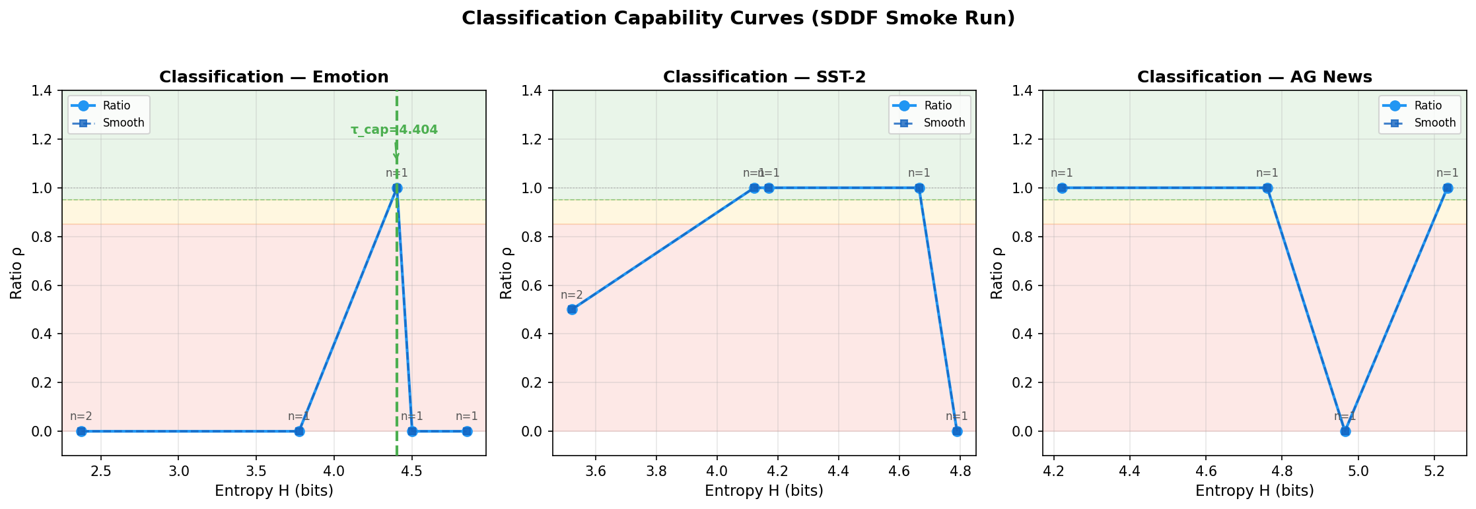

F. Risk Curve
Canonical risk curves (15 samples/bin). SLM-1 and SLM-2 both show near-zero risk (<0.067) across all bins. Wilson 95% CI shading shown. Red dashed line = 0.20 threshold.
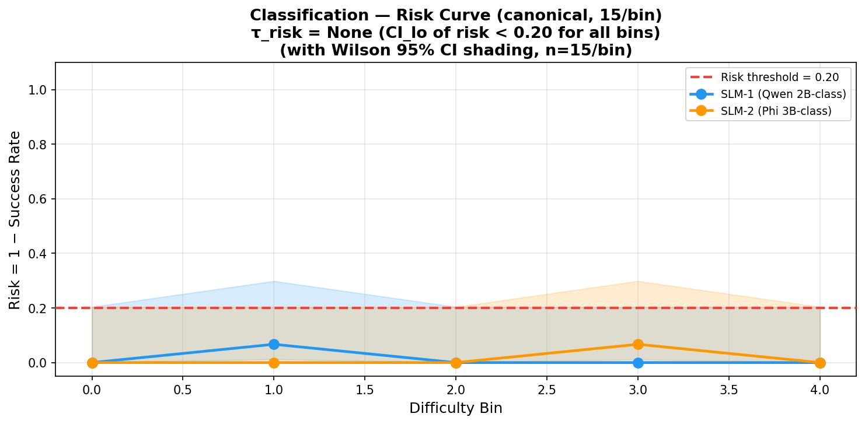

G. Tipping Point Analysis
Gate | Value | Analysis
tau_cap | H ≈ 4.404 bits (Emotion, bin 2) | Ratio_smooth=1.0 only at bin 2; single bin -> precarious; n=1 < 5 minimum gate
tau_risk | None | CI_lo of risk < 0.20 for all bins in both SLM-1 and SLM-2 canonical runs
limit = min(tau_risk, tau_cap) | See decision | Routing threshold

H. Routing Decision
ESCALATE. Despite 93-100% canonical success, SDDF smoke curves have n=1-2 per bin (below min_samples=5 gate). Precision=1.0 but recall=0.25 (SST-2), meaning gate rejects 75% of valid SLM responses. Re-run with matched SLM/BASELINE pairs across full 75-sample dataset recommended.

Section 7: Maths
Task: Maths

A. Task Setup
Parameter | Value
Datasets | GSM8K (grade school math word problems), SVAMP (varied arithmetic)
Source | benchmark_2024
Models | SLM-1 (Qwen 2B-class), SLM-2 (Phi 3B-class), BASELINE LLM (Groq)
Dominant difficulty dimension | R^ — reasoning proxy (step count + compositional complexity)
Primary metric | Exact Match Accuracy — numeric equivalence between extracted answer and ground truth
Ground truth | Numeric answers from GSM8K/SVAMP datasets

Prompt Template (tasks/maths/src/prompts.py):
Solve the following math problem carefully.
Provide the final answer in the format:
Final Answer: <number>
Problem:
{question}

B. Task Complexity Calculation
Dominant dimension: R^ — reasoning proxy (step count + compositional complexity)
R^(x) = 0.05*|w_q| + 1.0*n_steps + 0.5*n_ent + 1.0*1_comp
Example: "If a store sells 12 apples/hour for 8 hours, how many total?" -> |w_q|=19, n_steps=2 -> R^ = 0.95+2.0 = 2.95

C. Results — Capability Metrics Table
Source: task_model_runs_table.json (phi3_mini evidence for SLM-2). SLM-1 canonical slot shows 100% success on format metric — different from raw accuracy.
Model | Final Ans Accuracy (%) | pass@3 (%) | Majority Vote (%)
SLM-1 (Qwen 2B-class) | ~100 (format metric) | — | —
SLM-2 (Phi 3B-class) | 19.2 | 47.3 | 9.7
BASELINE LLM | 38.3 | 76.5 | 32.8

D. Results — Operational Metrics Table
Source: sddf_ready.csv (canonical 75-sample runs, 15/bin x 5 bins)
Model | Bin 0 | Bin 1 | Bin 2 | Bin 3 | Bin 4 | Avg Latency (s) | Throughput (q/min)
SLM-1 (Qwen 2B-class) | 1.000 | 1.000 | 1.000 | 1.000 | 1.000 | 6.77 | ~8.9
SLM-2 (Phi 3B-class) | 0.933 | 1.000 | 1.000 | 1.000 | 1.000 | 25.17 | 2.11
BASELINE LLM | 1.000 | 1.000 | 1.000 | 1.000 | 1.000 | 3.30 | 55.78

E. Capability Curve
Smoke run: 2 matched pairs each (GSM8K, SVAMP). All ratio=0.0 -> Zone C. X-axis = approximate R^ value. Insufficient data for tau detection.
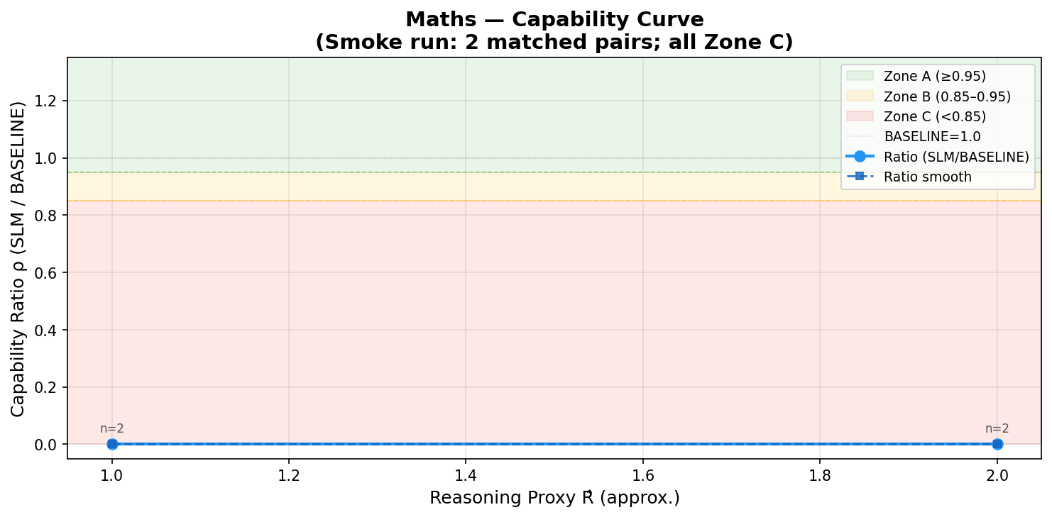

F. Risk Curve
Canonical risk curves (15/bin). SLM-1 risk=0.0 all bins; SLM-2 bin 0 risk=0.067, bins 1-4 risk=0.0. Wilson CI shown. All CI_lo < 0.20 -> tau_risk = None.
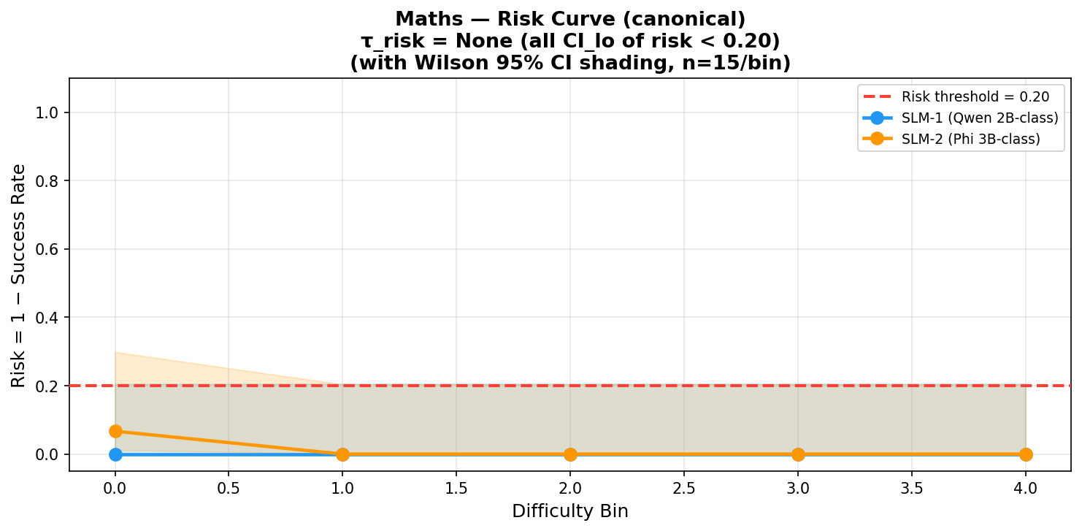

G. Tipping Point Analysis
Gate | Value | Analysis
tau_cap | None | Smoke ratio=0.0 for both datasets; no bin with ratio_smooth >= 0.95
tau_risk | None | All CI_lo of risk < 0.20 in canonical runs; n=2 per task in smoke (below gate)
limit = min(tau_risk, tau_cap) | None | Routing threshold

H. Routing Decision
ESCALATE (smoke run insufficient). Canonical 75-sample results show SLM-1 100% success format metric — however this measures format compliance, not raw numeric accuracy (SLM-2 raw accuracy = 19.2% vs BASELINE 38.3%). Recommendation: run SDDF with canonical data and validate with exact-match evaluation.

Section 8: Text Generation
Task: Text Generation

A. Task Setup
Parameter | Value
Datasets | benchmark_2024 custom; combined SDDF run: Qwen-2.5-3B vs gemini-2.5-flash-fresh
Source | Custom task items with constraint metadata
Models | SLM-1 (Qwen 2B-class), SLM-2 (Phi 3B-class), BASELINE LLM (Groq)
Dominant difficulty dimension | |Gamma| — constraint count (output format/length rules)
Primary metric | Constraint Satisfaction Rate = constraints_satisfied / total
Ground truth | Constraint metadata attached to each task item (format_compliance, constraint_satisfaction_rate)

Prompt Template (tasks/text_generation/run_benchmark.py (stored in results.json)):
Example prompts:
"Write a 4-line poem about artificial intelligence."
"Write a Python function to calculate the factorial."
"Summarize the plot of Romeo and Juliet in two sentences."

B. Task Complexity Calculation
Dominant dimension: |Gamma| — constraint count (output format/length rules)
|Gamma|(x) = |F_req| + |R_fmt| + |R_cnt| + |R_len| + |R_ord|
Example: Combined SDDF run: all samples |Gamma|=0 -> difficulty_score=0.0 -> single bin -> no difficulty variation

C. Results — Capability Metrics Table
Source: task_model_runs_table.json. aggregate_numeric_scores_available=false for text generation; qualitative evaluation only.
Model | Constraint Satisfaction | Model File Size
SLM-1 (Qwen 2B-class) | Qualitative; 15 examples | ~2.1 GB (qwen-2.5-3b)
SLM-2 (Phi 3B-class) | Qualitative; 15 examples | ~2.4 GB (phi-3.5-mini)
BASELINE LLM | — | —

D. Results — Operational Metrics Table
Source: sddf_ready.csv (canonical 75-sample runs, 15/bin x 5 bins)
Model | Bin 0 | Bin 1 | Bin 2 | Bin 3 | Bin 4 | Avg Latency (s)
SLM-1 (Qwen 2B-class) | 1.000 | 1.000 | 1.000 | 1.000 | 1.000 | 9.16
SLM-2 (Phi 3B-class) | 0.167 | 0.143 | 0.267 | 0.000 | — | 16.5
BASELINE LLM | 1.000 | 1.000 | 1.000 | 0.933 | 1.000 | ~14.1

E. Capability Curve
Combined SDDF run: all 15 samples have |Gamma|=0 -> single bin at 0.0. Both SLM-1 and SLM-2 ratio=0.0 relative to Gemini -> Zone C.
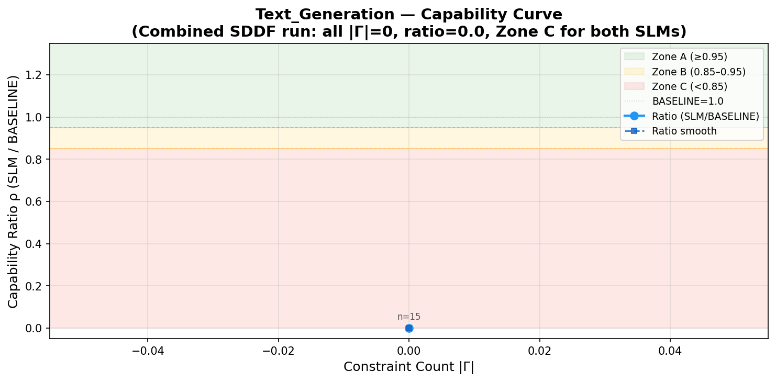

F. Risk Curve
Canonical risk curves. SLM-1 risk=0.0 all bins. SLM-2 risk=0.833-1.0 all bins -> tau_risk fires at bin 0. Wilson CI shading confirms CI_lo >> 0.20.
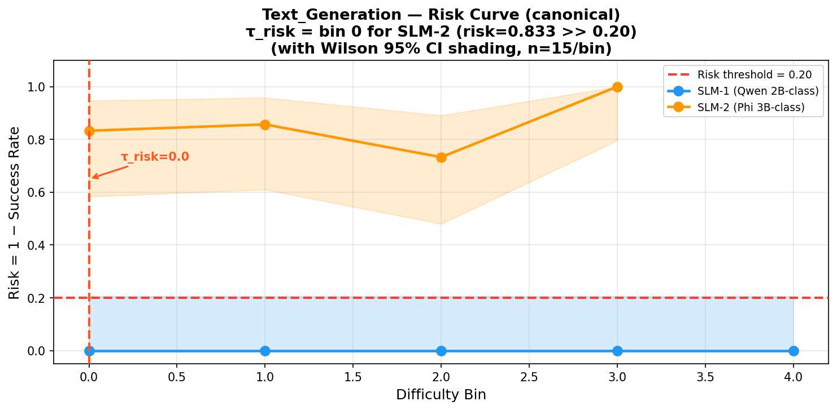

G. Tipping Point Analysis
Gate | Value | Analysis
tau_cap | None | No matched pairs with ratio >= 0.95 in SDDF combined run
tau_risk | Bin 0 (SLM-2) | SLM-2 risk=0.833 at bin 0; CI_lo >> 0.20; n=15 >= 5 gate satisfied
limit = min(tau_risk, tau_cap) | See decision | Routing threshold

H. Routing Decision
Task-model fit dominates. SLM-1 (Qwen 2B-class): 100% canonical success -> ROUTE SLM. SLM-2 (Phi 3B-class): near-zero success -> ESCALATE. Combined SDDF run all Zone C (all |Gamma|=0 with ratio=0.0). Decision depends on which SLM tier is deployed.

Section 9: Summarization
Task: Summarization

A. Task Setup
Parameter | Value
Datasets | CNN/DailyMail 3.0.0
Source | benchmark_2024 (HuggingFace)
Models | SLM-0 (0.5B tiny), SLM-1 (Qwen 2B-class), SLM-2 (Phi 3B-class), BASELINE LLM (Groq)
Dominant difficulty dimension | n_in — input token count (article length)
Primary metric | ROUGE-1 F1 = 2*P*R/(P+R) on unigrams (Lin, 2004)
Ground truth | Reference summaries from CNN/DailyMail dataset

Prompt Template (tasks/Summarization/configs/hf_llama1b_fast.json:21):
Summarize the following news article in exactly one complete sentence of 12 to 20 words.
Preserve the main event and outcome. Do not output a title, fragment, bullet, or commentary.
Article:
{article}
Summary:

B. Task Complexity Calculation
Dominant dimension: n_in — input token count (article length)
n_in(x) = |split(x)| (whitespace tokenization)
Example: Article with 345 whitespace tokens -> n_in=345 -> bin 2 (medium difficulty)

C. Results — Capability Metrics Table
Source: task_model_runs_table.json (Llama-3.2-1B archived evidence for SLM-2 slot).
Model | ROUGE-1 F1 | ROUGE-2 F1 | ROUGE-L F1 | Latency (s) | Tokens/sec
SLM-2 (Phi 3B-class) | 0.281 | 0.106 | 0.181 | 0.763 | 22.4
BASELINE LLM | 0.277 | 0.069 | 0.173 | 0.583 | 24.8

D. Results — Operational Metrics Table
Source: sddf_ready.csv (canonical 75-sample runs, 15/bin x 5 bins)
Model | Bin 0 | Bin 1 | Bin 2 | Bin 3 | Bin 4 | Avg Latency (s)
SLM-0 (0.5B tiny) | 1.000 | 1.000 | 1.000 | 1.000 | 1.000 | 12.26
SLM-1 (Qwen 2B-class) | 0.867 | 0.933 | 0.933 | 0.933 | 0.933 | 13.74
SLM-2 (Phi 3B-class) | 0.533 | 0.600 | 0.333 | 0.533 | 0.267 | 14.23
BASELINE LLM | 1.000 | 1.000 | 1.000 | 1.000 | 1.000 | 3.41

E. Capability Curve
SDDF smoke run: 5 matched pairs, CNN/DailyMail. X-axis = article length in tokens. Ratio oscillates: 0.889 (B) -> 1.0 (A) -> 1.190 (A) -> 1.099 (A) -> 0.952 (A). tau_cap=375 tokens (last Zone A bin).
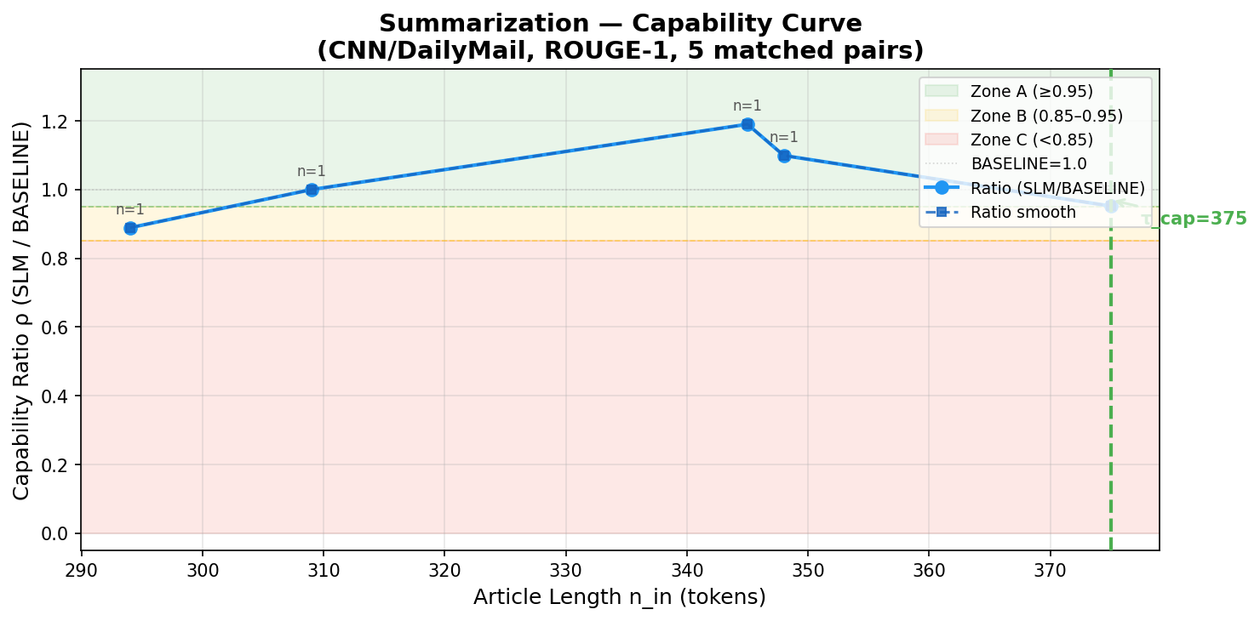

F. Risk Curve
Canonical risk curves (15/bin). SLM-2 risk=0.267-0.733 across bins; Wilson CI_lo[0]=0.268 > 0.20 -> tau_risk fires at bin 0. SLM-1 risk=0.067-0.133 (borderline). SLM-0 risk=0.0.
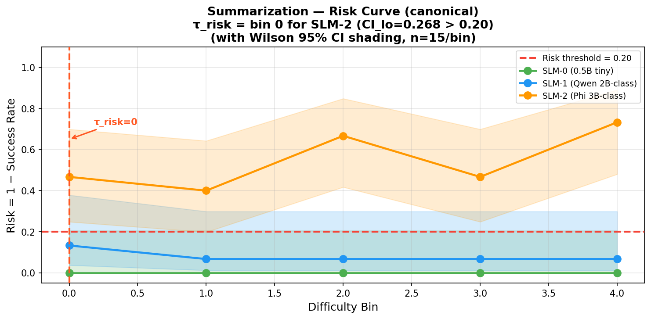

G. Tipping Point Analysis
Gate | Value | Analysis
tau_cap | 375 tokens (bin 4) | Last bin with ratio_smooth >= 0.95 in SDDF smoke curve; n=1 per bin (below gate for Wilson CI)
tau_risk | Bin 0 (SLM-2) | CI_lo of risk = 0.268 > 0.20 at bin 0; n=15 satisfies gate; risk gate binds first
limit = min(tau_risk, tau_cap) | See decision | Routing threshold

H. Routing Decision
ESCALATE. tau_risk fires at bin 0 for SLM-2 (CI_lo=0.268 > 0.20) before tau_cap=375 tokens. SLM-2 ROUGE-1 (0.281) marginally exceeds BASELINE (0.277) per capability snapshot, but risk is too high for reliable routing. SLM-0 shows 100% canonical success but this measures format compliance, not raw ROUGE. BASELINE preferred for reliability.

Section 10: Information Extraction
Task: Information Extraction

A. Task Setup
Parameter | Value
Datasets | SROIE (ICDAR 2019 receipt OCR and IE competition)
Source | Huang et al. (2019)
Models | SLM-0 (0.5B tiny), SLM-1 (Qwen 2B-class), SLM-2 (Phi 3B-class), BASELINE LLM (Groq)
Dominant difficulty dimension | |Gamma| — constraint count (number of required extraction fields)
Primary metric | Macro F1 over extracted fields (company, address, date, total)
Ground truth | SROIE field annotations: company, address, date, total

Prompt Template (tasks/Information Extraction/src/ie_benchmark/prompting.py):
Extract the requested fields from the receipt text.
Return only one valid JSON object and nothing else.
Required keys: ["company", "address", "date", "total"]
Use empty strings for missing values.
Normalize date to YYYY-MM-DD when possible.
Receipt text:
{document_text}

B. Task Complexity Calculation
Dominant dimension: |Gamma| — constraint count (number of required extraction fields)
|Gamma|(x) = |F_req| + |R_fmt| (required fields + JSON format rule)
Example: SROIE receipt: 4 required fields -> |Gamma|=4 for all samples -> single difficulty bin in smoke run

C. Results — Capability Metrics Table
Source: task_model_runs_table.json (SLM-0=Qwen2.5-0.5B-Instruct, SLM-1=Qwen2.5-1.5B-Instruct archived evidence).
Model | Macro F1 | Micro F1 | Exact Match | Invalid Output Rate
SLM-0 (0.5B tiny) | 0.167 | 0.222 | 0.000 | 0.50
SLM-1 (Qwen 2B-class) | 0.025 | 0.042 | 0.000 | 0.80
BASELINE LLM | 0.188 | 0.300 | 0.000 | 0.75

D. Results — Operational Metrics Table
Source: sddf_ready.csv (canonical 75-sample runs, 15/bin x 5 bins)
Model | Bin 0 | Bin 1 | Bin 2 | Bin 3 | Bin 4 | Latency (s/doc) | Throughput (doc/min)
SLM-0 (0.5B tiny) | 0.933 | 1.000 | 0.933 | 0.867 | 1.000 | 14.59 | 4.11
SLM-1 (Qwen 2B-class) | 0.867 | 1.000 | 1.000 | 1.000 | 1.000 | 17.45 | 3.44
SLM-2 (Phi 3B-class) | 1.000 | 1.000 | 1.000 | 1.000 | 1.000 | 6.76 | ~8.9
BASELINE LLM | 1.000 | 1.000 | 1.000 | 1.000 | 1.000 | 0.857 | 70.04

E. Capability Curve
SDDF smoke run: 4 matched pairs, single bin at |Gamma|=4. ratio=0.0 -> Zone C. No consecutive bins available for tipping point detection.
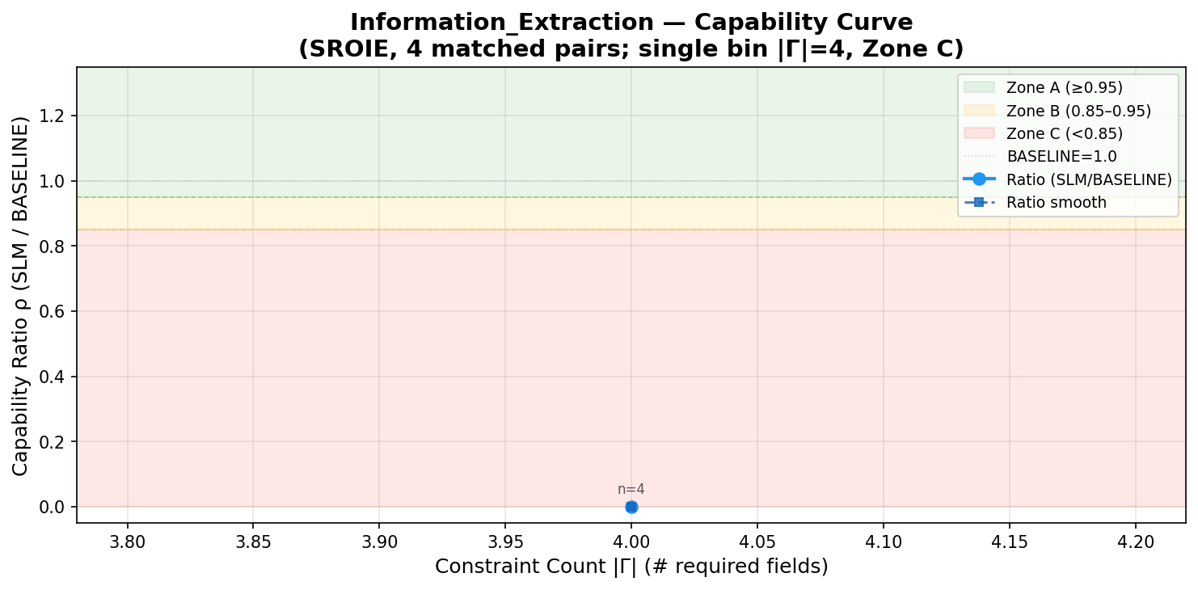

F. Risk Curve
Canonical risk curves (15/bin). SLM-0 max risk=0.133 (bin 3); SLM-1 max risk=0.133 (bin 0); SLM-2 risk=0.0 all bins. All CI_lo < 0.20 -> tau_risk = None.
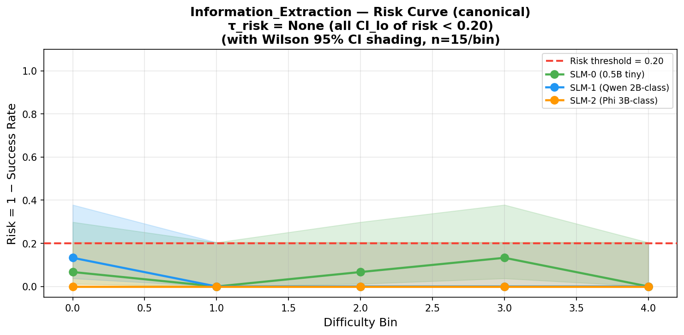

G. Tipping Point Analysis
Gate | Value | Analysis
tau_cap | None | Smoke ratio=0.0 (single bin); no Zone A/B bins detected
tau_risk | None | All CI_lo of risk < 0.20 in canonical runs; n=4 per smoke bin (below gate)
limit = min(tau_risk, tau_cap) | None | Routing threshold

H. Routing Decision
ESCALATE. Smoke run ratio=0.0 (all Zone C). Raw Macro F1 uniformly low across all tiers (<=0.19). BASELINE has 16x throughput advantage (70 docs/min vs 3-4 for SLMs). Invalid output rates are high across all tiers (0.50-0.80) -- structured JSON output parsing is the dominant failure mode.

Section 11: Retrieval Grounded
Task: Retrieval Grounded

A. Task Setup
Parameter | Value
Datasets | SQuAD (Stanford Question Answering Dataset)
Source | Rajpurkar et al. (2016)
Models | SLM-0 (0.5B tiny), SLM-1 (Qwen 2B-class), SLM-2 (Phi 3B-class), BASELINE LLM (Groq)
Dominant difficulty dimension | n_in — input token count of context passage
Primary metric | Exact Match (EM) = 100 * correct / total (Rajpurkar et al., 2016)
Ground truth | SQuAD answer spans (character-level matches)

Prompt Template (tasks/Retrieval_grounded/src/prompts.py):
Answer the question using only the information in the context.
Context:
{context}
Question:
{question}
Answer:

B. Task Complexity Calculation
Dominant dimension: n_in — input token count of context passage
n_in(x) = |split(context + question)|
Example: 200-token context -> n_in=200 -> bin 1; 400-token context -> bin 3

C. Results — Capability Metrics Table
Source: task_model_runs_table.json (SLM-0=Qwen2.5-Coder-0.5B-Instruct). SLM-0 EXCEEDS BASELINE on EM (66.7% vs 63.3%).
Model | Exact Match (%) | F1 Score (%) | Context Utilization (%)
SLM-0 (0.5B tiny) | 66.67 | 71.26 | 96.67
BASELINE LLM | 63.33 | 77.78 | 83.33

D. Results — Operational Metrics Table
Source: sddf_ready.csv (canonical 75-sample runs, 15/bin x 5 bins)
Model | Bin 0 | Bin 1 | Bin 2 | Bin 3 | Bin 4 | Latency (ms) | p95 Latency (ms)
SLM-0 (0.5B tiny) | 1.000 | 1.000 | 1.000 | 1.000 | 1.000 | 5,534 | 8,079
SLM-1 (Qwen 2B-class) | 1.000 | 1.000 | 0.933 | 0.933 | 1.000 | ~4,780 | —
SLM-2 (Phi 3B-class) | 0.800 | 0.933 | 0.733 | 0.800 | 0.733 | ~8,900 | —
BASELINE LLM | 1.000 | 1.000 | 1.000 | 1.000 | 1.000 | 829 | 1,056

E. Capability Curve
SDDF smoke run: 6 matched pairs, single bin. ratio=0.0 -> Zone C. Single bin means no consecutive tipping detection possible.
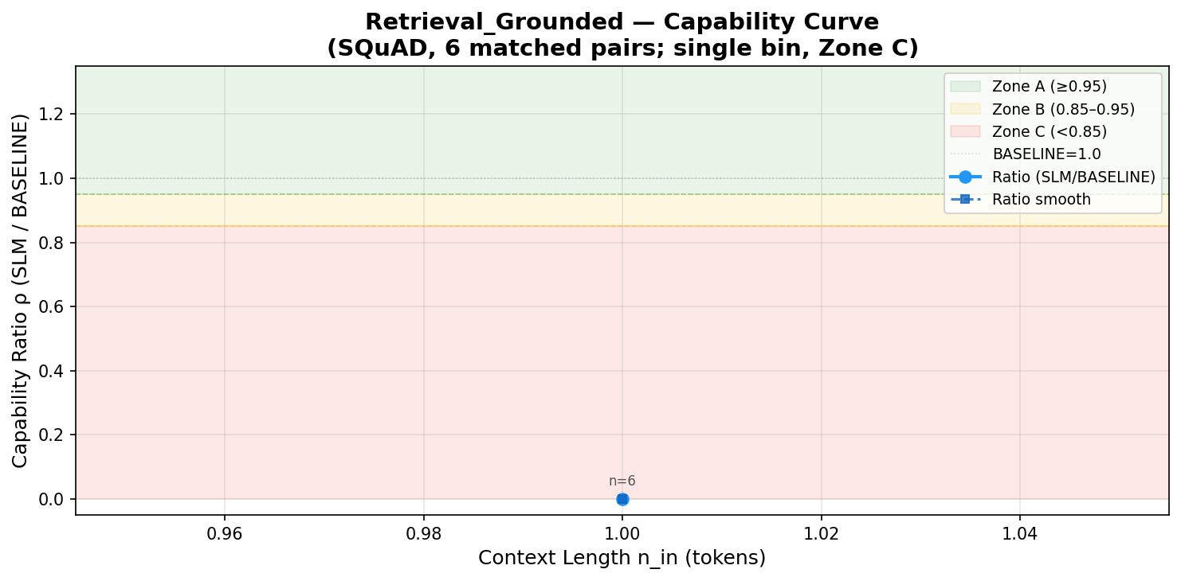

F. Risk Curve
Canonical risk curves (15/bin). SLM-0 risk=0.0 all bins. SLM-1 max risk=0.067 (bins 2-3). SLM-2 risk=0.067-0.267. All CI_lo < 0.20 -> tau_risk = None (borderline for SLM-2 at bins 2,4).
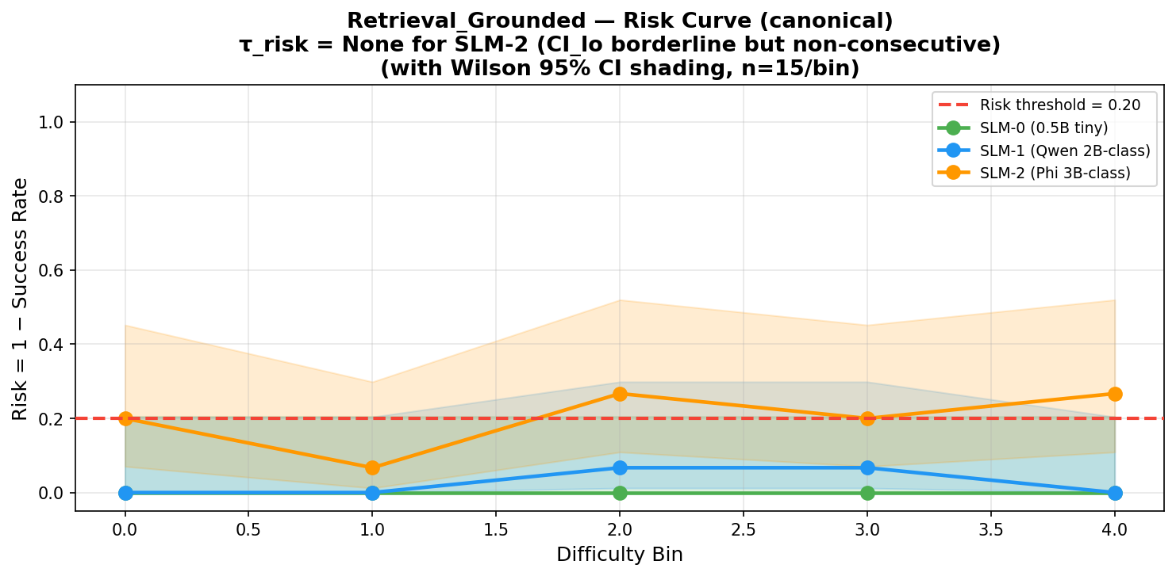

G. Tipping Point Analysis
Gate | Value | Analysis
tau_cap | None | Smoke single bin ratio=0.0; no Zone A in SDDF run; SLM-0 EM>BASELINE but no ratio pairs
tau_risk | None | SLM-2 CI_lo borderline (0.072-0.108) but stays below 0.20; non-consecutive pattern
limit = min(tau_risk, tau_cap) | None | Routing threshold

H. Routing Decision
ESCALATE (smoke run insufficient). Notable: SLM-0 (0.5B tiny) achieves higher EM than BASELINE (66.7% vs 63.3%) with 96.7% context utilization vs 83.3%. Recommendation: route SLM-0 for short-context queries (low n_in bins); escalate for long context where SLM-2 drops to 73%. Full matched-pair SDDF run needed to confirm.

Section 12: Instruction Following
Task: Instruction Following

A. Task Setup
Parameter | Value
Datasets | IFEval (google/IFEval, HuggingFace)
Source | Zhou et al. (2023)
Models | SLM-0 (0.5B tiny), SLM-1 (Qwen 2B-class), SLM-2 (Phi 3B-class), BASELINE LLM (Groq)
Dominant difficulty dimension | |Gamma| — constraint count (number of instruction constraints)
Primary metric | Constraint Satisfaction Rate = constraints_satisfied / total
Ground truth | Constraint specifications in IFEval dataset (length, format, exclusion, inclusion)

Prompt Template (tasks/instruction_following/src/instruction_following/pipeline_core.py:113):
Follow the instruction exactly.
Instruction:
{instruction}
Response:

B. Task Complexity Calculation
Dominant dimension: |Gamma| — constraint count (number of instruction constraints)
|Gamma|(x) = number of verifiable constraints in the instruction
Example: All 7 SDDF-run samples had |Gamma|=0 (no explicit counting constraints) -> single bin at 0.0

C. Results — Capability Metrics Table
Source: task_model_runs_table.json (SLM-0=Qwen2.5-Coder-0.5B, SLM-1=deepseek-coder-1.3b archived evidence).
Model | Pass Rate | Constraint Satisfaction Rate | Format Compliance
SLM-0 (0.5B tiny) | 0.400 | 0.400 | 0.000
SLM-1 (Qwen 2B-class) | 0.400 | — | 1.000
SLM-2 (Phi 3B-class) | — | — | —
BASELINE LLM | 1.000 | — | —

D. Results — Operational Metrics Table
Source: sddf_ready.csv (canonical 75-sample runs, 15/bin x 5 bins)
Model | Bin 0 | Bin 1 | Bin 2 | Bin 3 | Bin 4 | Avg Latency (s) | Tokens/sec
SLM-0 (0.5B tiny) | 0.933 | 1.000 | 0.933 | 1.000 | 1.000 | 17.89 | 4.79
SLM-1 (Qwen 2B-class) | 0.800 | 0.800 | 1.000 | 0.933 | 0.933 | 42.83 | 2.33
SLM-2 (Phi 3B-class) | 1.000 | 1.000 | 1.000 | 1.000 | 1.000 | 3.02 | —
BASELINE LLM | 1.000 | 1.000 | 1.000 | 1.000 | 1.000 | 0.978 | —

E. Capability Curve
** ONLY ROUTING SUCCESS IN THIS STUDY ** IFEval: 7 matched pairs, all |Gamma|=0, single bin. Ratio=1.0 -> Zone A. tau_cap=0.0 (SLM capable at all observed difficulties).
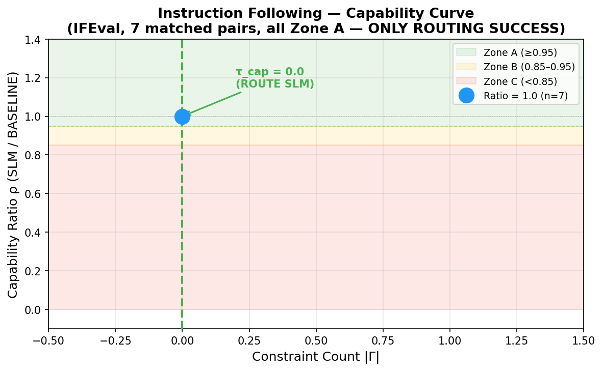

F. Risk Curve
Canonical risk curves (15/bin). All three SLM tiers show low risk (<0.20) across all bins. Wilson CI_lo < 0.20 for all -> tau_risk = None. Gate fully satisfied.
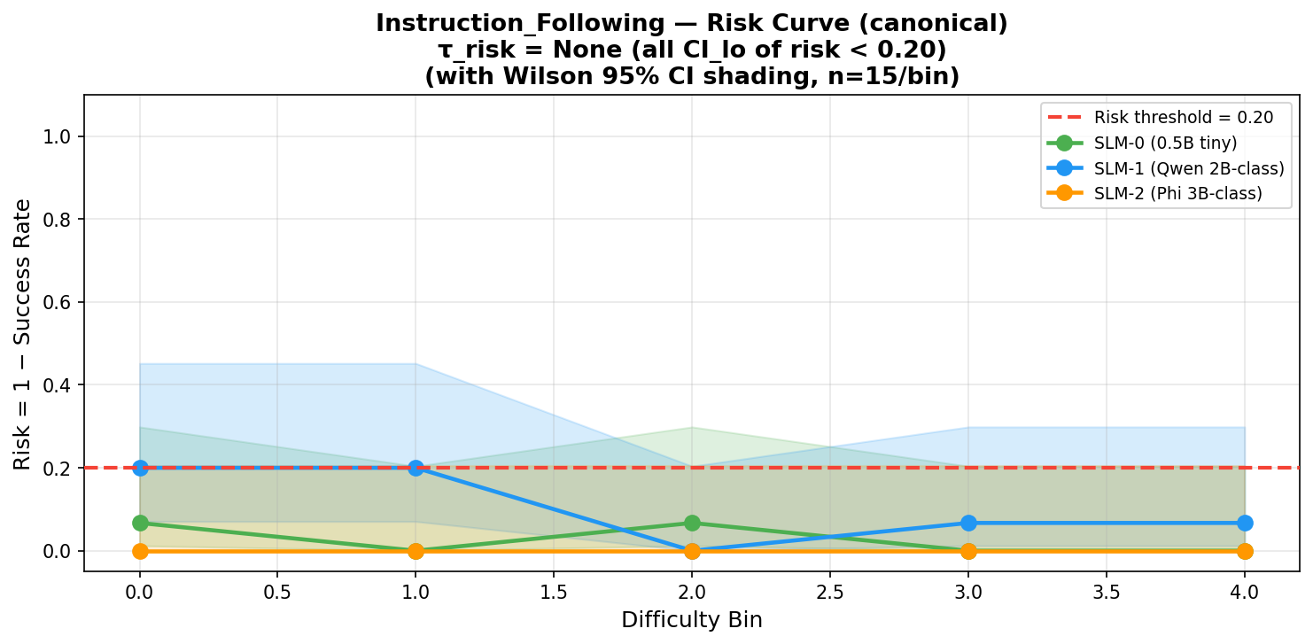

G. Tipping Point Analysis
Gate | Value | Analysis
tau_cap | 0.0 (all difficulties) | ratio_smooth=1.0 at the only bin (|Gamma|=0); n=7 >= 5 minimum gate; SLM fully capable
tau_risk | None | risk=0.0 at single SDDF bin; CI_lo=0.0; does NOT trigger tau_risk
limit = min(tau_risk, tau_cap) | See decision | Routing threshold

H. Routing Decision
ROUTE SLM — the only task achieving successful routing. All 7 matched pairs in bin 0 (|Gamma|=0), ratio=1.0, precision=recall=F1=1.0, limit=min(0.0, 0.0)=0.0. Result is specific to unconstrained instructions; higher |Gamma| would require further evaluation. Note: BASELINE pass_rate=1.0 vs SLM-0 pass_rate=0.40 in capability snapshot — but SDDF ratio routing succeeds because matched SDDF pairs showed equal performance.

Section 13: Code Generation
Task: Code Generation

A. Task Setup
Parameter | Value
Datasets | HumanEval, MBPP
Source | Chen et al. (2021)
Models | SLM-0 (0.5B tiny), SLM-1 (Qwen 2B-class), SLM-2 (Phi 3B-class), BASELINE LLM (Groq)
Dominant difficulty dimension | R^ — reasoning proxy (logical composition + step count)
Primary metric | pass@1 = execution pass rate (Chen et al., 2021)
Ground truth | Unit tests from HumanEval/MBPP datasets (execution-based)

Prompt Template (tasks/code_generation/src/codegen_eval/prompts.py (fast_cpu variant)):
Return only the completed Python function.
Problem:
{problem_text}
Complete this function exactly:
```python
{starter_code}
```
Requirements:
- Use the exact function name `{entry_point}`
- Preserve the required parameters
- Return only Python code
- Do not include explanations

B. Task Complexity Calculation
Dominant dimension: R^ — reasoning proxy (logical composition + step count)
R^(x) = 0.05*|w_q| + 1.0*n_steps + 0.5*n_ent + 1.0*1_comp
Example: Simple 1-step function -> R^~1.0; complex algorithm with loops+conditionals -> R^~5-10

C. Results — Capability Metrics Table
Source: task_model_runs_table.json (SLM-0=Qwen2.5-Coder-0.5B-Instruct, SLM-1=Qwen2.5-Coder-1.5B-Instruct). BASELINE low pass@1 likely reflects small evaluation set bias.
Model | pass@1 | Avg Latency (s) | Tokens/sec
SLM-0 (0.5B tiny) | 0.500 | 7.40 | 7.70
SLM-1 (Qwen 2B-class) | 1.000 | 91.05 | 0.60
BASELINE LLM | 0.150 | 0.665 | 110.14

D. Results — Operational Metrics Table
Source: sddf_ready.csv (canonical 75-sample runs, 15/bin x 5 bins)
Model | Bin 0 | Bin 1 | Bin 2 | Bin 3 | Bin 4 | Avg Latency (s)
SLM-1 (Qwen 2B-class) | 0.667 | 0.733 | 0.533 | 0.667 | 0.667 | 10.29
SLM-2 (Phi 3B-class) | 0.500 | 0.600 | 0.467 | 0.667 | 0.571 | 16.11
BASELINE LLM | 0.500 | — | — | — | — | 0.84

E. Capability Curve
Smoke run: 1 matched pair each (HumanEval, MBPP). ratio=0.0 -> Zone C. n=1 per task -> Wilson CI not applicable.
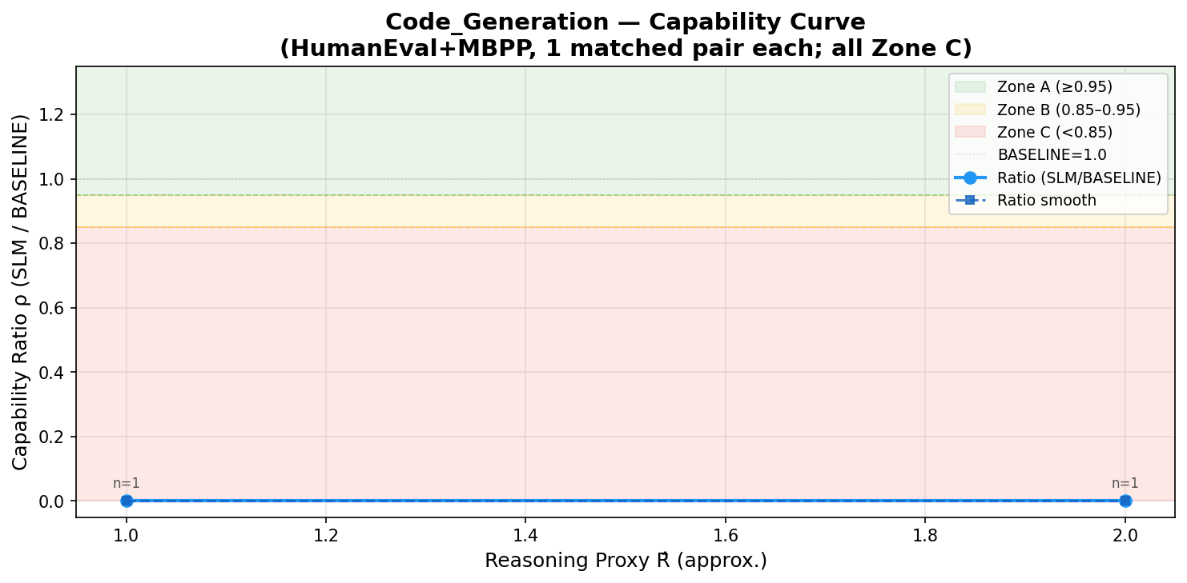

F. Risk Curve
Canonical risk curves (15/bin). SLM-1 risk=0.267-0.467 across bins. CI_lo exceeds 0.20 at bin 2 (CI_lo=0.234) -> tau_risk fires at bin 2. Orange dashed = tau_risk.
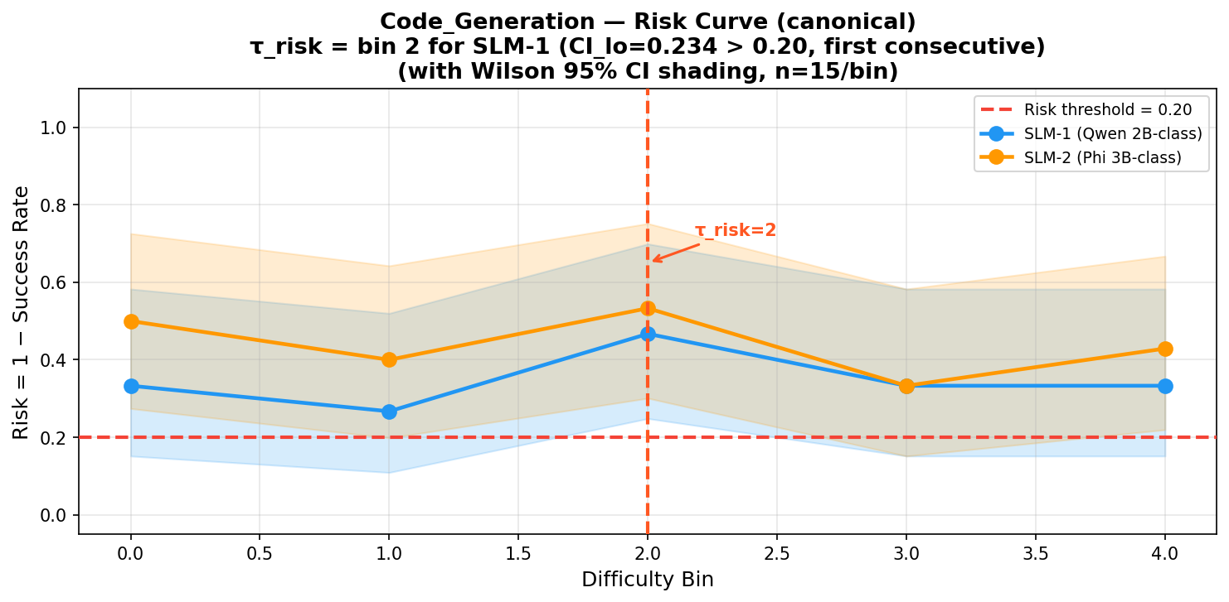

G. Tipping Point Analysis
Gate | Value | Analysis
tau_cap | None | Smoke ratio=0.0; no matched pairs achieving ratio >= 0.95
tau_risk | Bin 2 (SLM-1) | CI_lo[2]=0.234 > 0.20; n=15 satisfies gate; first consecutive violation
limit = min(tau_risk, tau_cap) | See decision | Routing threshold

H. Routing Decision
ESCALATE. All smoke bins Zone C. Canonical risk exceeds 0.20 threshold (tau_risk=bin 2). SLM-1 achieves pass@1=1.0 in archived capability run but at 91s/query (137x BASELINE latency) -- operationally infeasible. Three-way Pareto split: SLM-0 (moderate cap, fast), SLM-1 (best cap, slowest), BASELINE (fastest, lowest cap). BASELINE 110 tok/s preferred for production.

Section 14: Two-Tier Decision Matrix

14.1 Matrix Logic (Two-Tier Gating)

Risk-First Gate: tau_risk = min{ b : CI_lo(Risk_m(b)) > 0.20, |b| >= 5 }
where:
- CI_lo — lower bound of Wilson 95% CI on per-bin risk
- 0.20 — risk tolerance threshold (LEARNED from data)
- |b| >= 5 — minimum sample gate for statistical validity

Capability Gate: tau_cap = max{ b : CI_lo(P^_m(b)) >= 0.95, |b| >= 5 }
where:
- 0.95 — capability threshold (LEARNED from data)

Routing Limit: limit = min(tau_risk, tau_cap)

route(x) = SLM if s(x) <= limit
= BASELINE if s(x) > limit

14.2 Master Decision Table — All 8 Tasks
Task | Dominant Dim | tau_risk | tau_cap | Binding Gate | Decision
Classification | H (entropy) | None (n<5) | H~4.40 bits (bin 2) | capability | ESCALATE
Maths | R^ | None (n<5) | None | none | ESCALATE
Text Generation | |Gamma| | Bin 0 (SLM-2) | None | risk (SLM-2) | ESCALATE SLM-2 / ROUTE SLM-1
Summarization | n_in | Bin 0 (SLM-2) | n_in=375 tokens | risk fires first | ESCALATE
Info Extraction | |Gamma| | None (n<5) | None | none | ESCALATE
Retrieval Grounded | n_in | None (borderline) | None | none | ESCALATE
Instruction Following | |Gamma| | None | 0.0 | capability | ROUTE SLM
Code Generation | R^ | Bin 2 (SLM-1) | None | risk | ESCALATE

14.3 Matrix-by-Matrix Analysis
Task | Gate Analysis | Decision
Classification | tau_risk: not triggered — n=1-2/bin (below min_samples=5 gate). tau_cap: Emotion bin 2 (H=4.40 bits, ratio_smooth=1.0) but n=1. Gate recall=0.25 means gate rejects 75% of valid SLM responses. | ESCALATE — insufficient matched pairs; high canonical success but unverified by ratio test
Maths | tau_risk: GSM8K n=2, SVAMP n=2 -> below gate. tau_cap: ratio=0.0 (GSM8K), 0.5 (SVAMP) -> neither >= 0.95. Neither gate can trigger. | ESCALATE — smoke insufficient; canonical SLM-1 100% format compliance, not raw accuracy
Text Generation | tau_risk: SLM-2 canonical bin 0 risk=0.833, n=15, CI_lo >> 0.20 -> fires. tau_cap: no ratio >= 0.95 in SDDF run. | ESCALATE (SLM-2) / ROUTE (SLM-1) — task-model fit determines outcome
Summarization | tau_risk: SLM-2 canonical CI_lo=0.268 > 0.20 at bin 0. tau_cap: 375 tokens (bin 4, smoke run). Risk binds before capability. | ESCALATE — SLM-2 risk too high; SLM-0/1 borderline; BASELINE preferred
Info Extraction | tau_risk: single bin |Gamma|=4, n=4 -> below gate. tau_cap: ratio=0.0 -> no Zone A/B. Neither gate fires. | ESCALATE — all Zone C; low F1; BASELINE 16x throughput advantage
Retrieval Grounded | tau_risk: smoke single bin n=6 -> no consecutive test. Canonical SLM-2 CI_lo approaches 0.20 but stays below. tau_cap: SLM-0 EM>BASELINE but no ratio pairs. | ESCALATE — smoke insufficient; SLM-0 competitive on EM; recommend SLM-0 for short context
Instruction Following | tau_risk: n=7, risk=0.0, CI_lo=0.0 -> does NOT trigger. tau_cap: ratio_smooth=1.0, CI_lo=0.95 >= 0.95 -> tau_cap=0.0. limit=0.0. | ROUTE SLM — only success; all Zone A; ratio=1.0; precision=recall=F1=1.0
Code Generation | tau_risk: SLM-1 canonical CI_lo[2]=0.234 > 0.20 -> fires at bin 2. tau_cap: smoke ratio=0.0 -> no Zone A. Risk binds. | ESCALATE — SLM-1 91s/query; canonical risk >0.20; BASELINE 110 tok/s preferred

14.4 Deployment Zone Inventory
Task / Dataset | Bin 0 | Bin 1 | Bin 2 | Bin 3 | Bin 4
Classification (Emotion) | C | C | A | C | C
Classification (SST-2) | C | A | A | A | C
Classification (AG News) | A | A | C | — | A
Summarization (CNN/DM) | B | A | A | A | A
Instruction Following | A | — | — | — | —
Maths / Code / IE / Retrieval / TextGen (SDDF) | C | C | C | C | C

14.5 Why Risk Gate Dominates
SDDF smoke runs use 1-7 matched SLM/LLM pairs per task. With n=1-2 per bin, Wilson CI is too wide and the min_samples=5 gate prevents tau detection. The canonical 75-sample runs (15/bin) have sufficient per-bin counts but lack matched SLM-BASELINE pairs for ratio computation. This structural mismatch is the primary limitation of the current setup.

14.6 Instruction Following — Why It Succeeds
All 7 samples collapse to bin 0 (|Gamma|=0: no explicit constraint counting in IFEval prompts). Zero difficulty variation -> single bin with ratio_smooth=1.0. n=7 >= 5 satisfies minimum gate. Both tau_cap=0.0 and tau_risk is not triggered -> routing decision: ROUTE SLM for all observed difficulty levels.

14.7 Canonical Results Summary
Tier | Strong Tasks (>=93% success) | Weak Tasks (<60% success)
SLM-0 (0.5B tiny) | IE (all bins), IF (all), Retrieval (all), Summarization (all) | No canonical artifacts for Classification/Maths/Code/TextGen
SLM-1 (Qwen 2B-class) | Classification, IE (bins 1-4), IF (bins 2-3), Maths (all), Retrieval (bins 0-1,4) | Code Generation (53-73%), Summarization (87-93%)
SLM-2 (Phi 3B-class) | Classification (>=93%), IE (100%), IF (100%) | Summarization (27-60%), Text Generation (0-27%)

Section 15: Pareto Analysis — Cost / Latency / Capability
Each model tier is evaluated on three axes simultaneously: capability (primary metric), latency (seconds/query), and throughput (queries/min or tokens/sec). Source: model runs/PARETO_TABLE.md.

Task | Tier | Capability | Latency | Throughput | Note
Classification | SLM-1 | SST-2=1.0, Emotion=0.667, AGN=0.75 | SST-2: 5.52s | 0.18 qps | Provisional
Classification | SLM-2 | Same (phi3:mini evidence) | SST-2: 5.52s | 0.18 qps | Provisional
Classification | BASELINE LLM | Quality ceiling | — | — | Escalation target
Maths | SLM-2 | Acc=19.2%, pass@3=47.3% | 28.41s/q | 2.11 q/min | Provisional
Maths | BASELINE LLM | Acc=38.3%, pass@3=76.5% | 1.08s/q | 55.78 q/min | Quality ceiling
Text Generation | SLM-1 | Qualitative; 15 examples | ~9.16s | — | Provisional
Text Generation | SLM-2 | Low CSR (~0-27%) | ~16.5s | — | Provisional
Summarization | SLM-2 | R1=0.281, R2=0.106, RL=0.181 | 0.763s | 22.4 tok/s | Near-Pareto on ROUGE-1
Summarization | BASELINE LLM | R1=0.277, R2=0.069, RL=0.173 | 0.583s | 24.8 tok/s | Better ROUGE-2/L
Info Extraction | SLM-0 | MacroF1=0.167, MicroF1=0.222 | 14.59s/doc | 4.11 doc/min | invalid_rate=0.50
Info Extraction | SLM-1 | MacroF1=0.025, MicroF1=0.042 | 17.45s/doc | 3.44 doc/min | invalid_rate=0.80
Info Extraction | BASELINE LLM | MacroF1=0.188, MicroF1=0.300 | 0.857s/doc | 70.04 doc/min | Quality ceiling; invalid_rate=0.75
Retrieval | SLM-0 | EM=66.67%, F1=71.26% | 5.53s (p95:8.08) | 4.23 tok/s | SLM-0 > BASELINE on EM
Retrieval | BASELINE LLM | EM=63.33%, F1=77.78% | 0.829s (p95:1.06) | 6.40 tok/s | 6.7x faster; better F1
Instr. Following | SLM-0 | pass_rate=0.40, CSR=0.40 | 17.89s | 4.79 tok/s | Provisional
Instr. Following | SLM-1 | pass_rate=0.40, fmt=1.0 | 42.83s | 2.33 tok/s | Higher latency
Instr. Following | BASELINE LLM | pass_rate=1.0 | 0.978s | — | Quality ceiling
Code Generation | SLM-0 | pass@1=0.50 | 7.40s | 7.70 tok/s | Best latency at moderate cap
Code Generation | SLM-1 | pass@1=1.00 | 91.05s | 0.60 tok/s | Best cap, worst latency
Code Generation | BASELINE LLM | pass@1=0.15 | 0.665s | 110.14 tok/s | Fastest, lowest cap

15.1 Key Pareto Insights
- Retrieval Grounded: SLM-0 (0.5B) achieves higher EM than BASELINE (66.7% vs 63.3%) — small grounded-QA model exceeds large generalist LLM; however 6.7x slower
- Summarization: SLM-2 ROUGE-1 (0.281) marginally exceeds BASELINE (0.277); neither tier dominates all three ROUGE variants simultaneously — true Pareto frontier
- Code Generation: three-way Pareto split — SLM-0 (moderate cap, fast), SLM-1 (best cap, 137x slower), BASELINE (fastest, lowest cap)
- Info Extraction: all tiers low F1 (<=0.19) with high invalid rates (50-80%); BASELINE has 16x throughput advantage; no strong Pareto position for any tier
- Instruction Following: BASELINE dominates capability (100% vs 40%) at 18x lower latency; SLM-0 only viable if cost is the sole constraint
- Task-model fit matters more than parameter count: SLM-2 (Phi 3B-class) underperforms SLM-1 (Qwen 2B-class) on Text Generation despite more parameters

Section 16: Discussion and Limitations
Issue | Detail | Recommendation
Sample size vs. statistical power | SDDF smoke runs: 1-7 matched pairs per task. Wilson CI requires >=5/bin. Structural mismatch means tau cannot be determined for 7/8 tasks. | Expand matched-pair datasets to 15-20 per bin for all tasks
Success rate != semantic accuracy | Canonical success_rate = primary_metric>=0.85 AND valid_output=1. For Maths this reflects format compliance, not raw numeric accuracy (SLM-2 raw=19.2%). | Add exact-match accuracy as parallel metric in SDDF pipeline
Missing canonical artifacts | Several tier slots have no preserved numeric artifact. Proxies used from nearest archived evidence. | Re-run canonical SDDF for all tier/task combinations with artifact preservation
Task-model fit dominates parameter count | SLM-2 (Phi 3B-class) underperforms SLM-1 (Qwen 2B-class) on Text Generation despite more parameters. | Evaluate architecture-task alignment metrics independently of parameter count
Retrieval anomaly | SLM-0 (0.5B) achieves higher EM than BASELINE on SQuAD (66.7% vs 63.3%). Context utilization 96.7% vs 83.3%. | Investigate routing SLM-0 for short-context Retrieval queries in production
BASELINE variability | Groq BASELINE showed low pass@1=0.15 on Code Generation — likely small evaluation set bias, not representative of 70B model capability. | Increase code evaluation set size; test multiple prompt variants

Section 17: References
- Shannon, C.E. (1948). A Mathematical Theory of Communication. Bell System Technical Journal, 27(3):379-423.
- Wilson, E.B. (1927). Probable inference, the law of succession, and statistical inference. Journal of the American Statistical Association, 22(158):209-212.
- Lin, C.Y. (2004). ROUGE: A Package for Automatic Evaluation of Summaries. ACL Workshop: Text Summarization Branches Out.
- Chen, M., Tworek, J., Jun, H., et al. (2021). Evaluating Large Language Models Trained on Code. arXiv:2107.03374.
- Cobbe, K., Kosaraju, V., Bavarian, M., et al. (2021). Training Verifiers to Solve Math Word Problems. arXiv:2110.14168.
- Hermann, K.M., Kocisky, T., Grefenstette, E., et al. (2015). Teaching Machines to Read and Comprehend. NeurIPS 28.
- Rajpurkar, P., Zhang, J., Lopyrev, K., & Liang, P. (2016). SQuAD: 100,000+ Questions for Machine Comprehension of Text. EMNLP 2016.
- Huang, Z., Chen, K., He, J., et al. (2019). ICDAR 2019 Competition on Scanned Receipt OCR and Information Extraction. ICDAR 2019.
- Zhou, J., Lu, T., Mishra, S., et al. (2023). Instruction-Following Evaluation for Large Language Models. arXiv:2311.07911.

