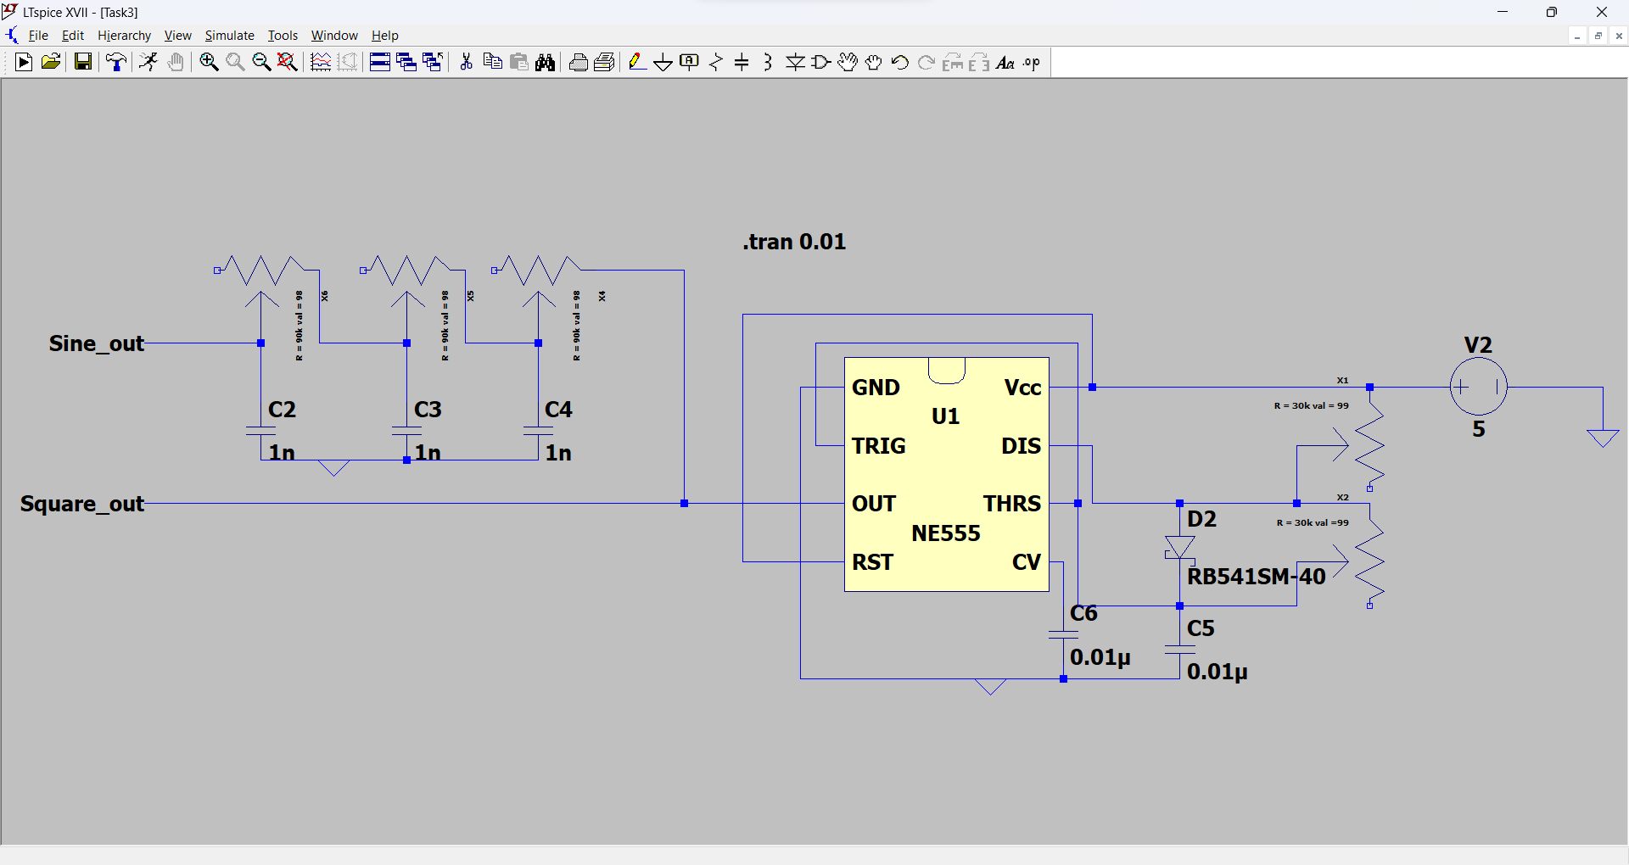 A Signal Generator with a 555 Timer

A diode is used to decrease the charging time by bypassing Rb. I’ve used a low Vf Schottky diode so that the charging voltage don’t differ much due to Vf.

Max Ra and Rb is 30k each.

So the lowest frequency can be made is f=1.44/(Ra+Rb)C=1.8k

To filter it with 3 RF filters to create sine wave maximum R should be 1/RC=1.8k\*2pi => R=88.42k (90k approx.)

Some of the waveforms are shown below.

1. Frequency = 1/380us = 2631.6Hz

Duty cycle = 51.8%

Sine = 1Vpp (Approx.)

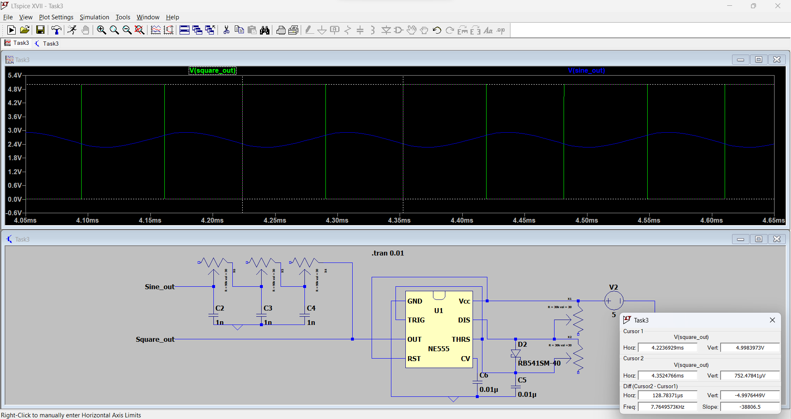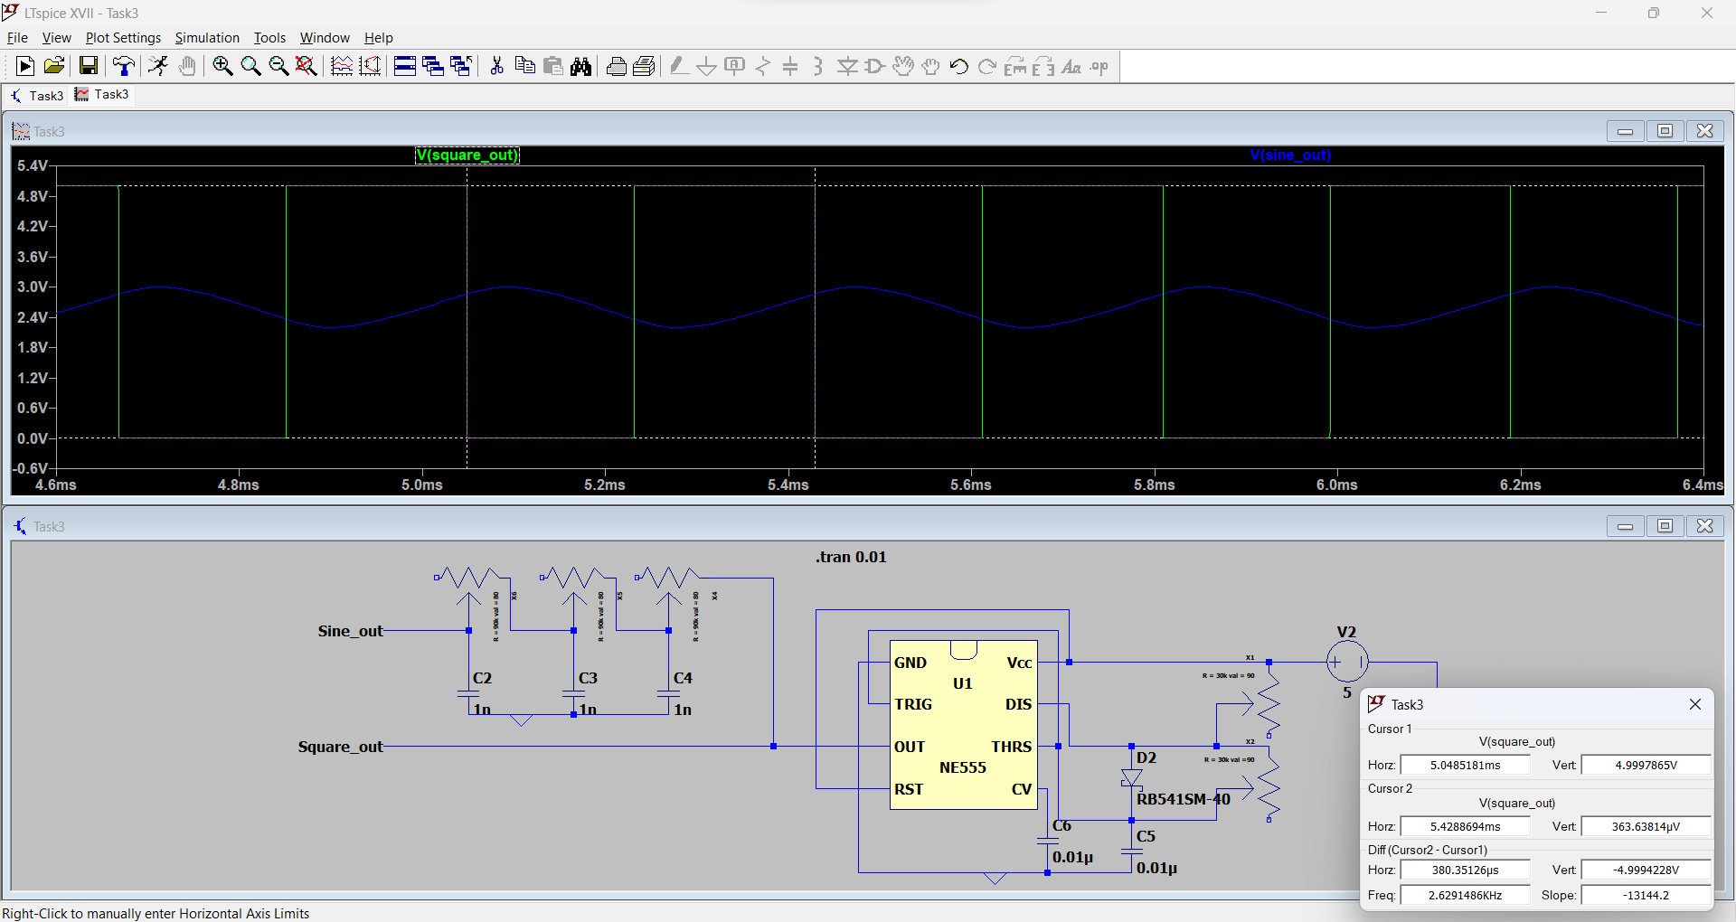2.

Frequency = 1/129us = 7752Hz

Duty cycle = 51.7%

Sine = 1Vpp (Approx.)

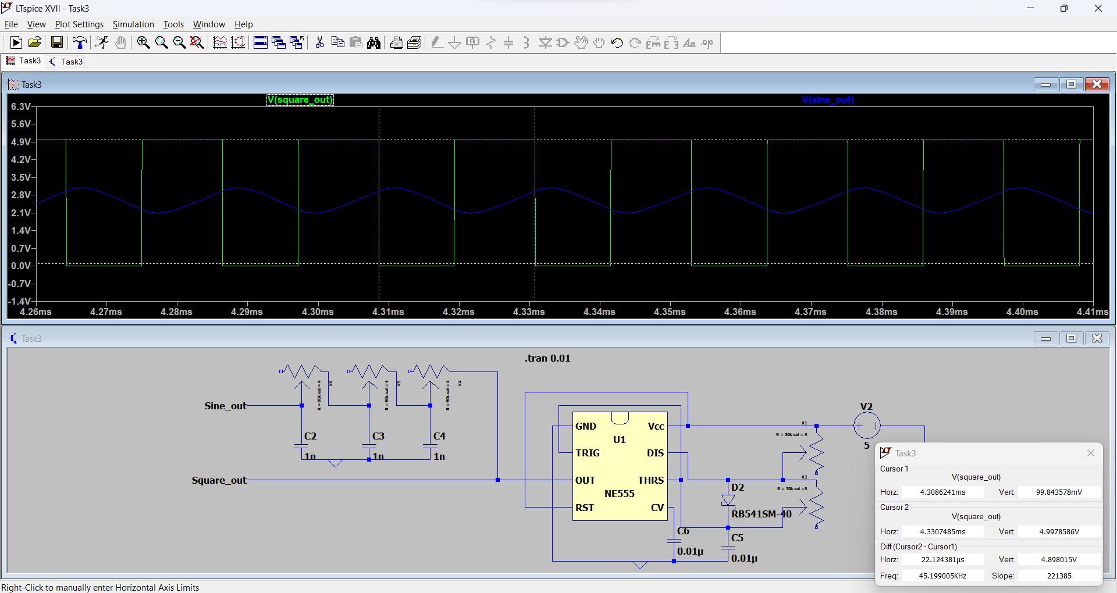3.

Frequency = 1/22us = 45.45kHz

Duty cycle = 51.4%

Sine = 1Vpp (Approx.)

The duty cycle can be adjusted more by decreasing the Ra slightly.

At high frequency due to the loading effect on the output due to the low resistance value of the RC filter the pulse rise time is a bit more but that is insignificant. Let me slow it for a higher frequency.

1. Frequency = 1/9.2us = 108.7Hz

Duty cycle = 51.4%

Sine = 1Vpp (Approx.)

