Task 2 — Parameter Exploration
Student Name: Riddhi Yeola
Objective:
To observe how altering local interaction rules (Neighbor Radius, Alignment Strength, and Separation Strength) affects the emergent global behavior of an autonomous agent flock.

1. Observation A: Stable Flocking
Under these baseline parameters, the agents exhibit classic, stable emergent behavior. The three rules balance perfectly: cohesion pulls the agents into unified groups, separation prevents them from colliding and creating a dense singularity, and alignment ensures they travel in a shared direction. There is no central controller dictating the path; instead, the fluid, bird-like flocking emerges entirely from these balanced local interactions.

Parameter | Value
Neighbor Radius (Perception) | 50
Alignment Strength | 1.0
Separation Strength | 1.5
Cohesion Strength | 1.0
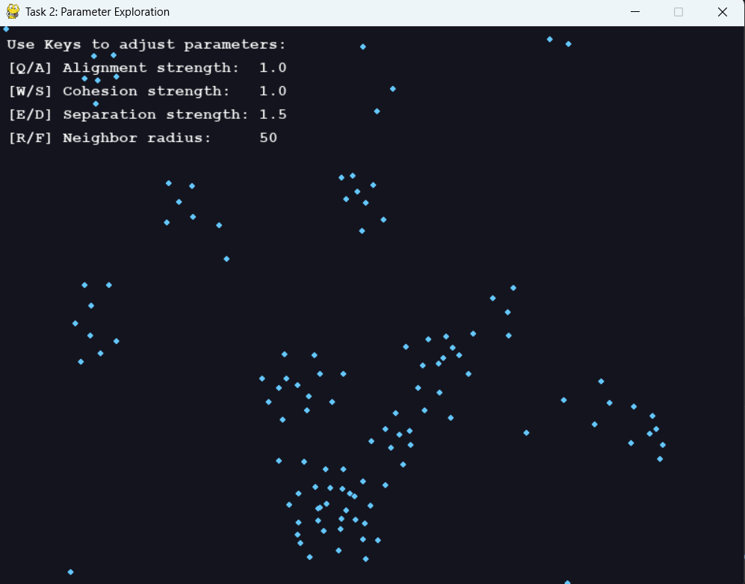

2. Observation B: Fragmentation
By drastically reducing the neighbor radius and alignment strength while maximizing the separation force, the stable flock shatters. The agents become "short-sighted," only able to perceive neighbors in their immediate vicinity. Because the separation force is overwhelmingly strong, their primary localized goal shifts from traveling together to aggressively avoiding collisions. The global pattern fragments completely into isolated individuals and tiny, chaotic clusters that scatter in random directions, unable to maintain a unified heading.

Parameter | Value
Neighbor Radius (Perception) | 15
Alignment Strength | 0.1
Separation Strength | 3.0
Cohesion Strength | 0.5
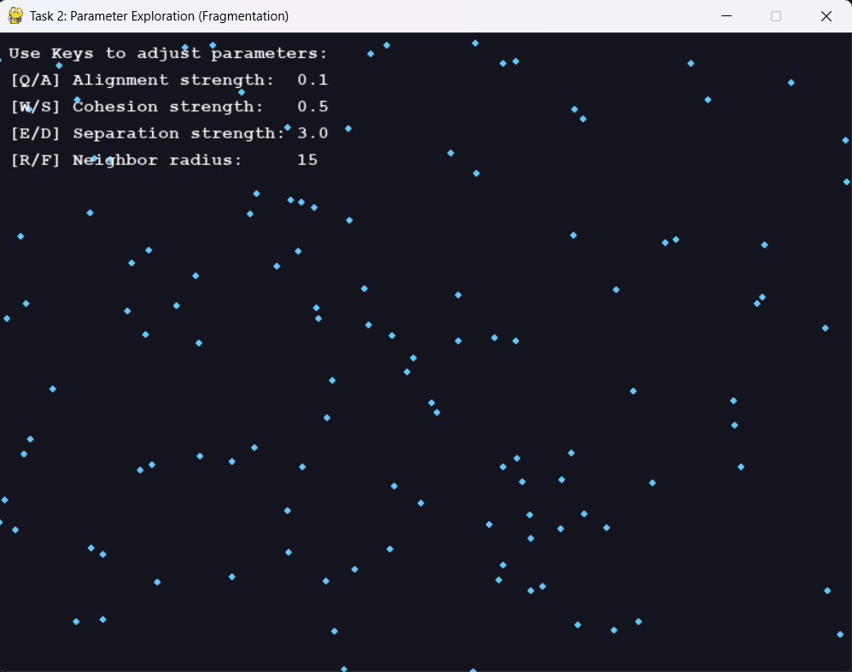

3. Observation C: Oscillation (Swarming)
To induce oscillation, alignment was completely disabled, while cohesion and separation were set to heavily competing values. A large neighbor radius causes agents to constantly detect a vast portion of the overall population. High cohesion pulls them violently toward the center of the mass, but the equally high separation force immediately repels them outward once they get too close. Without alignment to provide a shared forward momentum, the group becomes trapped in a continuous, vibrating cycle. They snap together and push apart repeatedly, resulting in an agitated, oscillating swarm rather than a traveling flock.

Parameter | Value
Neighbor Radius (Perception) | 100
Alignment Strength | 0.0
Separation Strength | 2.5
Cohesion Strength | 2.5
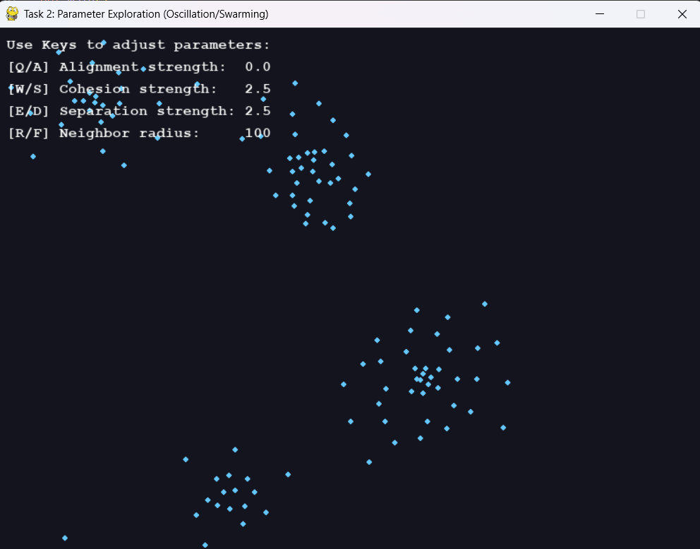

Conclusion
These experiments demonstrate that complex global behaviors—whether unified, fragmented, or oscillating—are highly sensitive to the parameters of local interactions. Coordinated behavior does not require a leader; it emerges dynamically from the rules the individual agents follow.

