1.PHP EXPRESSIONS:
Program
<!DOCTYPE html>
<html>
<head>
<title>PHP Expressions</title>
</head>
<body>
<h2>PHP Expressions Demonstration</h2>
<?php
$num1=15;
$num2=7;
$name="Riden";
echo"<h3>Basic Expressions</h3>";
echo"Number1:".$num1."<br>";
echo"Number2:".$num2."<br>";
echo"Name:".$name."<br><br>";

echo"<h3>Arithmetic Expressions</h3>";
echo"Addition:".($num1+$num2)."<br>";
echo"Subtraction:".($num1-$num2)."<br>";
echo"Multiplication:".($num1*$num2)."<br>";
echo"Division:".($num1/$num2)."<br>";
echo"Modulus:".($num1%$num2)."<br><br>";

echo"<h3>String Expressions:</h3>";
$greeting="Hello,".$name."!";
echo"Length of greeting:".strlen($greeting)."<br><br>";
echo"<h3>Boolean Expressions:</h3>";
echo"Is num1 greater than num2?".($num1>$num2?"Yes":"No")."<br><br>";
echo"Are both numbers positive?".(($num1>0)&&($num2>0)?"Yes":"No")."<br>";
?>
</body>
</html>

OUTPUT:
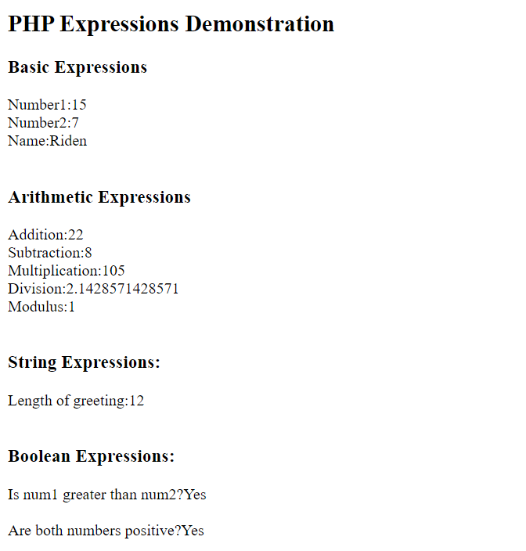

2.OPERATORS IN PHP:
Program
<!DOCTYPE html>
<html>
<head>
<title>PHP Operators</title>
</head>
<body>
<h2>PHP OPERATORS DEMONSTRATION</h2>

<?php
$a = 10;
$b = 5;
$c = 3;

echo "<h3>Arithmetic Operators</h3>";
echo "a = $a, b = $b, c = $c <br><br>";
echo "a + b = " . ($a + $b) . "<br>";
echo "a - b = " . ($a - $b) . "<br>";
echo "a * b = " . ($a * $b) . "<br>";
echo "a / b = " . ($a / $b) . "<br>";
echo "a % c = " . ($a % $c) . "<br>";

echo "<h3>Assignment Operators</h3>";
$x = $a;
echo "x = a : $x<br>";
$x += $b;
echo "x += b : $x<br>";
$x -= $c;
echo "x -= c : $x<br>";
$x *= 2;
echo "x *= 2 : $x<br><br>";

echo "<h3>Comparison Operators</h3>";
echo "a == b : " . ($a == $b ? "True" : "False") . "<br>";
echo "a < b : " . ($a < $b ? "True" : "False") . "<br>";
echo "a > b : " . ($a > $b ? "True" : "False") . "<br>";

echo "<h3>Increment/Decrement Operator</h3>";
$counter = 5;
echo "Original Counter: $counter<br>";
echo "Pre-Increment: " . (++$counter) . "<br>";
echo "Post-Increment: " . ($counter++) . "<br>";
echo "After Post-Increment: $counter<br>";
echo "Pre-Decrement: " . (--$counter) . "<br>";
echo "Post-Decrement: " . ($counter--) . "<br>";
echo "After Post-Decrement: $counter<br>";
?>

</body>
</html>

OUTPUT:
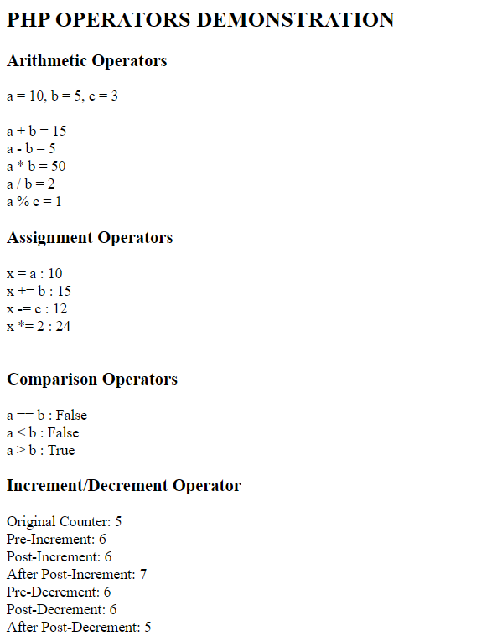

3.CONDITIONAL STATEMENTS AND LOOPING
Program
<!DOCTYPE html>
<html>
<head>
<title>Conditionals and Loops</title>
</head>
<body>
<h2>Conditionals Statements and Looping</h2>
<?php
$marks=75;
if($marks>=90)
{
echo"Grade:A+(Marks:$marks)<br>";
}
else if($marks>=80)
{
echo"Grade:A(Marks:$marks)<br>";
}
else if($marks>=70)
{
echo"Grade:B+(Marks:$marks)<br>";
}
else if($marks>=60)
{
echo"Grade:B(Marks:$marks)<br>";
}
else if($marks>=50)
{
echo"Grade:C(Marks:$marks)<br>";
}
else
{
echo"Fail<br>";
}
echo"<h3>Switch Statements</h3>";
$day="Monday";
switch($day)
{
case"Monday":
echo"Start of work week!<br>";
break;
case"Saturday":
echo"Weekend<br>";
break;
default:
echo"Regular<br>";
}
echo"<h3>For Loop:</h3>";
echo"<h3>Multiplication table of 5:<br>";
for($i=1;$i<=10;$i++)
{
echo"5*$i=".(5*$i)."<br>";
}
echo"<h3>While Loop:</h3>";
$count=1;
echo"Counting from 1 to 5:<br>";
while($count<=5)
{
echo"count:$count<br>";
$count++;
}
echo"<h3>Do-While Loop:</h3>";
$num=10;
echo"Counting down:<br>";
do{
echo"Number:$num<br>";
$num--;
}while($num>0);

echo"<h3>For Each-Loop:</h3>";
$fruits=array("Apple","Orange","Banana","Cherry","Graphes");
echo"List of fruits:<br>";
foreach($fruits as $index=>$fruit)
{
echo($index+1).".$fruit<br>";
}
?>
</body>
</html>

OUTPUT:
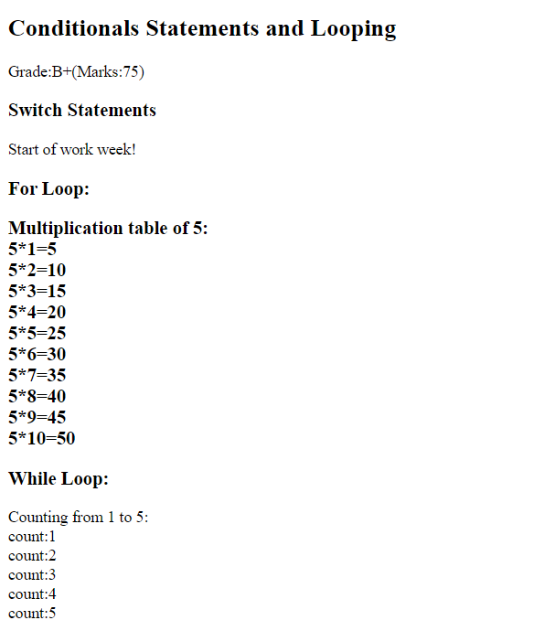
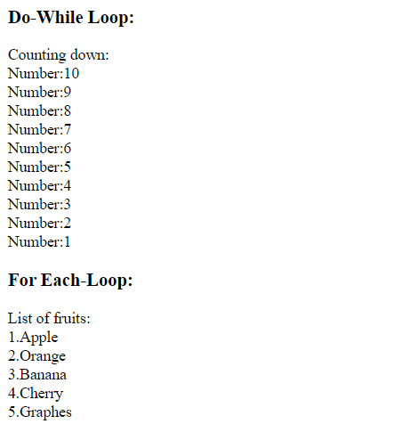

5.ARRAYS IN PHP
Program
<!DOCTYPE html>
<html>
<head>
<title>PHP Arrays</title>
</head>
<body>

<h2>Arrays in PHP</h2>
<?php
echo "<h3>Indexed Arrays</h3>";
$colors = array("Red", "Green", "Blue", "Yellow", "Purple");
echo "Colors array: ";
print_r($colors);
echo "<br>Third color: " . $colors[2] . "<br>";
echo "<h3>Associative Arrays</h3>";
$student = array(
"name" => "John Doe",
"age" => 20,
"grade" => "A",
"city" => "New York"
);
echo "Student information:<br>";
foreach ($student as $key => $value) {
echo ucfirst($key) . ": " . $value . "<br>";
}
echo "<h3>Multidimensional Array</h3>";
$employees = array(
array("Alice", "Manager", 75000),
array("Bob", "Developer", 65000),
array("Charlie", "Designer", 60000),
array("Diana", "Tester", 55000)
);
echo "Employee Details:<br>";
echo "<table border='1' cellpadding='5'>";
echo "<tr><th>Name</th><th>Position</th><th>Salary</th></tr>";
foreach ($employees as $employee) {
echo "<tr>";
echo "<td>{$employee[0]}</td>";
echo "<td>{$employee[1]}</td>";
echo "<td>{$employee[2]}</td>";
echo "</tr>";
}
echo "</table>";
echo "<h3>Array Functions</h3>";
$numbers = array(45, 23, 78, 12, 56, 89, 34);
echo "Original array: ";
print_r($numbers);
echo "<br>";
$reversed = array_reverse($numbers);
echo "Reversed array: ";
print_r($reversed);
echo "<br>";
echo "Array length: " . count($numbers) . "<br>";
$search = 56;
if (in_array($search, $numbers)) {
echo "$search found in array<br>";
}
$array1 = array("a", "b", "c");
$array2 = array("d", "e", "f");
$merged = array_merge($array1, $array2);
echo "Merged array: ";
print_r($merged);
echo "<br>";?>
</body>
</html>

OUTPUT:
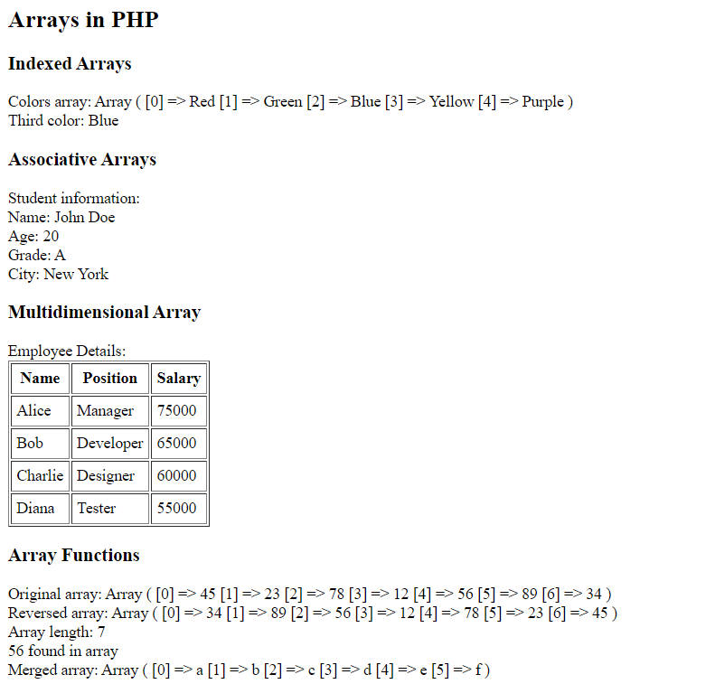
6.FILE HANDLING
<!DOCTYPE html>
<html>
<head>
<title>File Handling</title>
</head>
<body>
<h2>File Handling in PHP</h2>
<?php
$filename = "sample.txt";
$content = "This is a sample file created using PHP file handling.\n";
$content .= "Line 2: Learning file operations in PHP.\n";
$content .= "Line 3: File handling is essential for web applications.\n";

echo "<h3>Writing to a File:</h3>";
if (file_put_contents($filename, $content) !== false) {
echo "File '$filename' created successfully!<br>";
} else {
echo "Error creating file!<br>";
}
echo "<h3>Reading from a File:</h3>";
if (file_exists($filename)) {
$file_content = file_get_contents($filename);
echo "File content:<br>";
echo "<pre>" . htmlspecialchars($file_content) . "</pre>";
} else {
echo "File not found!<br>";
}
echo "<h3>Reading Line by Line:</h3>";
if (file_exists($filename)) {
$file = fopen($filename, "r");
echo "File content (line by line):<br>";
$line_number = 1;
while (!feof($file)) {
$line = fgets($file);
if ($line !== false) {
echo "Line $line_number: " . trim($line) . "<br>";
$line_number++;
}
}
fclose($file);
}
echo "<h3>Appending to a File:</h3>";
$append_content = "Line 4: This line was appended later.\n";
if (file_put_contents($filename, $append_content, FILE_APPEND) !== false) {
echo "Content appended successfully!<br>";
$updated_content = file_get_contents($filename);
echo "Updated file content:<br>";
echo "<pre>" . htmlspecialchars($updated_content) . "</pre>";
}
echo "<h3>File Information:</h3>";
if (file_exists($filename)) {
echo "File name: " . basename($filename) . "<br>";
echo "File size: " . filesize($filename) . " bytes<br>";
echo "File type: " . filetype($filename) . "<br>";
echo "Last modified: " . date("F d Y H:i:s", filemtime($filename)) . "<br>";
}
echo "<h3>Directory Operations:</h3>";
$files = scandir(".");
echo "Files in current directory:<br>";
foreach ($files as $file) {
if ($file != "." && $file != "..") {
echo "- $file<br>";
}
}
?>
</body>
</html>

OUTPUT:
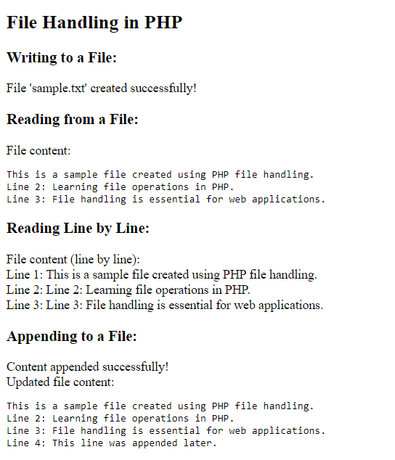
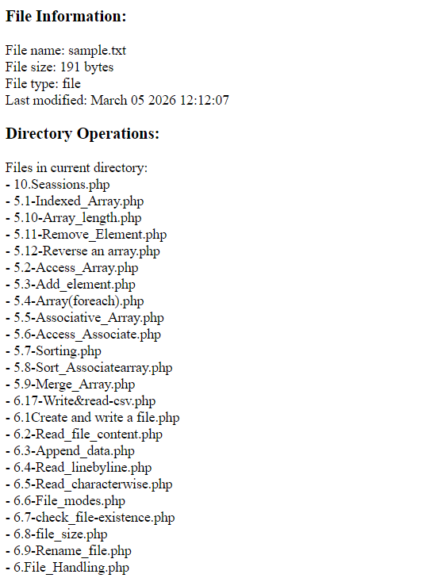

7.CREATE FORMS USING WEB CONTROLS
<!DOCTYPE html>
<html>
<head>
<title>PHP Forms</title>
<style>
.form-container {
max-width: 500px;
margin: 20px auto;
padding: 20px;
border: 1px solid #ccc;
border-radius: 5px;
}
.form-group {
margin-bottom: 15px;
}
label {
display: block;
margin-bottom: 5px;
font-weight: bold;
}
input, select, textarea {
width: 100%;
padding: 8px;
border: 1px solid #ddd;
border-radius: 4px;
}
button {
background-color: #4CAF50;
color: white;
padding: 10px 20px;
border: none;
border-radius: 4px;
cursor: pointer;
}
button:hover {
background-color: #45a049;
}
</style>
</head>
<body>
<div class="form-container">
<h2>Student Registration Form</h2>

<form method="POST" action="">
<div class="form-group">
<label for="name">Full Name:</label>
<input type="text" id="name" name="name" required>
</div>
<div class="form-group">
<label for="email">Email:</label>
<input type="email" id="email" name="email" required>
</div>
<div class="form-group">
<label for="password">Password:</label>
<input type="password" id="password" name="password" required>
</div>

<div class="form-group">
<label>Gender:</label>
<input type="radio" id="male" name="gender" value="Male" required>
<label for="male" style="display: inline;">Male</label>
<input type="radio" id="female" name="gender" value="Female">
<label for="female" style="display: inline;">Female</label>
<input type="radio" id="other" name="gender" value="Other">
<label for="other" style="display: inline;">Other</label>
</div>
<div class="form-group">
<label for="course">Course:</label>
<select id="course" name="course" required>
<option value="">Select Course</option>
<option value="Computer Science">Computer Science</option>
<option value="Electrical Engineering">Electrical Engineering</option>
<option value="Mechanical Engineering">Mechanical Engineering</option>
<option value="Civil Engineering">Civil Engineering</option>
</select>
</div>
<div class="form-group">
<label>Interests:</label>
<input type="checkbox" id="programming" name="interests[]" value="Programming">
<label for="programming" style="display: inline;">Programming</label><br>
<input type="checkbox" id="sports" name="interests[]" value="Sports">
<label for="sports" style="display: inline;">Sports</label><br>

<input type="checkbox" id="music" name="interests[]" value="Music">
<label for="music" style="display: inline;">Music</label><br>

<input type="checkbox" id="reading" name="interests[]" value="Reading">
<label for="reading" style="display: inline;">Reading</label>
</div>
<div class="form-group">
<label for="address">Address:</label>
<textarea id="address" name="address" rows="3"></textarea>
</div>
<div class="form-group">
<label for="birthdate">Date of Birth:</label>
<input type="date" id="birthdate" name="birthdate">
</div>
<button type="submit" name="submit">Register</button>
<button type="reset">Reset</button>
</form>
<?php
if (isset($_POST['submit'])) {
echo "<h3>Form Submitted Successfully!</h3>";
echo "<h4>Submitted Data:</h4>";
echo "<p><strong>Name:</strong> " . htmlspecialchars($_POST['name']) . "</p>";
echo "<p><strong>Email:</strong> " . htmlspecialchars($_POST['email']) . "</p>";
echo "<p><strong>Gender:</strong> " . htmlspecialchars($_POST['gender']) . "</p>";
echo "<p><strong>Course:</strong> " . htmlspecialchars($_POST['course']) . "</p>";

if (isset($_POST['interests'])) {
echo "<p><strong>Interests:</strong> " . implode(", ", $_POST['interests']) . "</p>";
} else {
echo "<p><strong>Interests:</strong> None selected</p>";
}
echo "<p><strong>Address:</strong> " . nl2br(htmlspecialchars($_POST['address'])) . "</p>";
echo "<p><strong>Date of Birth:</strong> " . htmlspecialchars($_POST['birthdate']) . "</p>";
}
?>
</div>
</body>
</html>

OUTPUT:
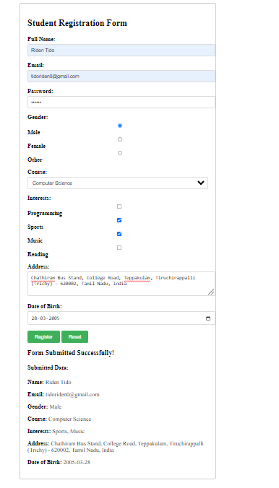

8.RETRIEVING SUBMITTING DATA
<!DOCTYPE html>
<html>
<head>
<title>Data Retrieval and Submission</title>
<style>
.container { max-width: 800px; margin: 20px auto; padding: 20px; }
.method-section { margin: 20px 0; padding: 15px; border: 1px solid #ddd; }
.get-form { background-color: #e7f3ff; }
.post-form { background-color: #f0ffe7; }
.file-form { background-color: #fff7e6; }
</style>
</head>
<body>
<div class="container">
<h2>Data Retrieval and Submission Methods</h2>
<div class="method-section get-form">
<h3>GET Method Example</h3>
<form method="GET" action="">
<input type="hidden" name="page" value="data_demo">
<label>Search Term: </label>
<input type="text" name="search" value="<?php echo isset($_GET['search']) ? htmlspecialchars($_GET['search']) : ''; ?>">
<button type="submit">Search</button>
</form>
<?php
if (isset($_GET['search']) && !empty($_GET['search'])) {
echo "<h4>GET Data Received:</h4>";
echo "<p>You searched for: <strong>" . htmlspecialchars($_GET['search']) . "</strong></p>";
echo "<p>Current URL: " . htmlspecialchars($_SERVER['REQUEST_URI']) . "</p>";
}
?>
</div>
<div class="method-section post-form">
<h3>POST Method Example</h3>
<form method="POST" action="">
<div>
<label>Username: </label>
<input type="text" name="username" required>
</div>
<div>
<label>Message: </label>
<textarea name="message" rows="3" required></textarea>
</div>
<button type="submit" name="post_submit">Submit Message</button>
</form>
<?php
if (isset($_POST['post_submit'])) {
echo "<h4>POST Data Received:</h4>";
echo "<p><strong>Username:</strong> " . htmlspecialchars($_POST['username']) . "</p>";
echo "<p><strong>Message:</strong> " . nl2br(htmlspecialchars($_POST['message'])) . "</p>";
echo "<p>Note: POST data is not visible in URL</p>";
}
?>
</div>
<div class="method-section file-form">
<h3>File Upload Example</h3>
<form method="POST" action="" enctype="multipart/form-data">
<div>
<label>Select File to Upload: </label>
<input type="file" name="file_upload" accept=".jpg,.jpeg,.png,.pdf,.txt" required>
</div>
<button type="submit" name="upload_submit">Upload File</button>
</form>
<?php
if (isset($_POST['upload_submit'])) {
echo "<h4>File Upload Status:</h4>";
if (isset($_FILES['file_upload'])) {
$file = $_FILES['file_upload'];
$filename = $file['name'];
$filetmp = $file['tmp_name'];
$filesize = $file['size'];
$fileerror = $file['error'];
if ($fileerror === 0) {
if (!is_dir('uploads')) {
mkdir('uploads', 0777, true);
}
$filepath = 'uploads/' . time() . '_' . $filename;
if (move_uploaded_file($filetmp, $filepath)) {
echo "<p style='color: green;'>File uploaded successfully!</p>";
echo "<p><strong>File Name:</strong> $filename</p>";
echo "<p><strong>File Size:</strong> " . round($filesize / 1024, 2) . " KB</p>";
echo "<p><strong>File Type:</strong> " . $file['type'] . "</p>";
echo "<p><strong>Saved As:</strong> $filepath</p>";
} else {
echo "<p style='color: red;'>Error moving uploaded file!</p>";
}
} else {
echo "<p style='color: red;'>Error uploading file: Error code $fileerror</p>";
}
} else {
echo"<p style='color: red;'>No file selected!</p>";
}
}
?>
</div>
<div class="method-section">
<h3>Superglobal Variables</h3>
<h4>GET Data:</h4>
<pre><?php print_r($_GET); ?></pre>
<h4>POST Data:</h4>
<pre><?php print_r($_POST); ?></pre>
<h4>FILES Data:</h4>
<pre><?php print_r($_FILES); ?></pre>
<h4>SERVER Information:</h4>
<p><strong>PHP_SELF:</strong> <?php echo $_SERVER['PHP_SELF']; ?></p>
<p><strong>REQUEST_METHOD:</strong> <?php echo $_SERVER['REQUEST_METHOD']; ?></p>
<p><strong>REMOTE_ADDR:</strong> <?php echo $_SERVER['REMOTE_ADDR']; ?></p>
</div>
</div>
</body>
</html>

OUTPUT:
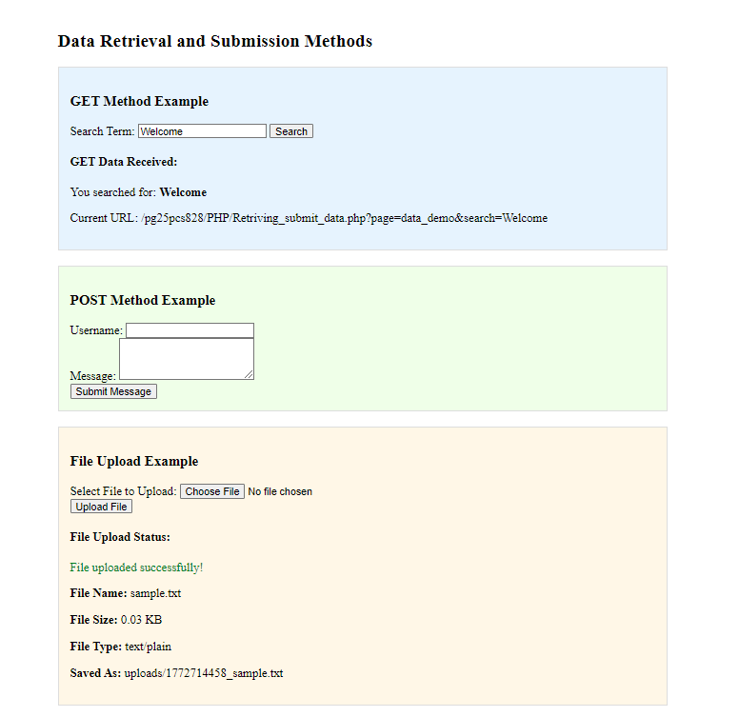

9.Cookies
<!DOCTYPE html>
<html>
<head>
<title>PHP Cookies</title>
<style>
.container{max-width:600px;margin:20px auto;padding:20px}
.section{margin:20px 0;padding:15px;border:1px solid #ddd}
</style>
</head>
<body>
<div class="container">
<h2>PHP Cookies Demonstration</h2>
<?php
if(isset($_POST['set_cookie'])){
$u=$_POST['username'];
$c=$_POST['color'];
$exp=time()+($_POST['expiry']*60);
setcookie("user",$u,$exp,"/");
setcookie("fav_color",$c,$exp,"/");
echo "<p style='color:green'>Cookies set successfully. Refresh page to see changes.</p>";
}
if(isset($_POST['modify_cookie'])){
$lang=$_POST['language'];
setcookie("fav_language",$lang,time()+3600,"/");
echo "<p style='color:green'>Language cookie updated</p>";
echo "<script>setTimeout(function(){location.reload();},1000);</script>";
}

if(isset($_POST['delete_cookies'])){
setcookie("user","",time()-3600,"/");
setcookie("fav_color","",time()-3600,"/");
setcookie("fav_language","",time()-3600,"/");
echo "<p style='color:green'>Cookies deleted</p>";
echo "<script>setTimeout(function(){location.reload();},1000);</script>";
}
?>
<div class="section">
<h3>Set Cookies</h3>
<form method="post">
Username:<input name="username"><br><br>
Favorite Color:<input name="color"><br><br>
Expiry(min):<input type="number" name="expiry" value="30"><br><br>
<button name="set_cookie">Set Cookie</button>
</form>
</div>
<div class="section">
<h3>Current Cookies</h3>
<?php
if(isset($_COOKIE['user']))
echo "<p><b>User:</b> ".htmlspecialchars($_COOKIE['user'])."</p>";
if(isset($_COOKIE['fav_color']))
echo "<p><b>Color:</b> ".htmlspecialchars($_COOKIE['fav_color'])."</p>";
if(isset($_COOKIE['fav_language']))
echo "<p><b>Language:</b> ".htmlspecialchars($_COOKIE['fav_language'])."</p>";
if(empty($_COOKIE)) echo "No cookies set";
?>
</div>
<div class="section">
<h3>Modify Cookie</h3>
<form method="post">
New Language:<input name="language">
<button name="modify_cookie">Update</button>
</form>
</div>
<div class="section">
<h3>Delete Cookies</h3>
<form method="post">
<button name="delete_cookies">Delete All Cookies</button>
</form>
</div>
<div class="section">
<h3>All Cookies</h3>
<pre><?php print_r($_COOKIE); ?></pre>
</div>
<div class="section">
<h3>Cookie Info</h3>
<?php
echo "Total Cookies: ".count($_COOKIE)."<br>";
if(isset($_COOKIE['user'])){
echo "<b>Welcome ".$_COOKIE['user']."</b><br>";
}
if(isset($_COOKIE['fav_color'])){
$col=$_COOKIE['fav_color'];
echo "Favorite Color: <span style='color:$col'>$col</span>";
}
?>
</div>
</div>
</body>
</html>

OUTPUT:
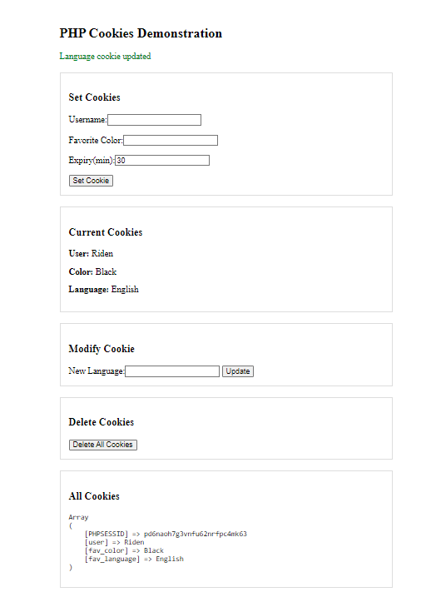
10.Session in PHP
Program
<!DOCTYPE html>
<html>
<head>
<title>PHP Sessions</title>
<style>
.container{max-width:600px;margin:20px auto;padding:20px}
.section{margin:20px 0;padding:15px;border:1px solid #ddd}
.login-form{background:#f0f8ff}
.session-info{background:#f0fff0}
</style>
</head>
<body>
<div class="container">
<h2>PHP Sessions Demonstration</h2>
<?php
session_start();
if(isset($_POST['login'])){
$u=$_POST['username'];$p=$_POST['password'];
if($u=='admin'&&$p=='password'){
$_SESSION['user']=$u;
$_SESSION['login_time']=date('Y-m-d H:i:s');
$_SESSION['page_views']=0;
echo "<p style='color:green'>Login successful! Welcome $u</p>";
}else echo "<p style='color:red'>Invalid username or password</p>";
}
if(isset($_POST['logout'])){
session_destroy();
echo "<p style='color:green'>Logged out</p>";
echo "<script>setTimeout(function(){location.reload();},1000);</script>";
}
if(isset($_SESSION['user'])){
$_SESSION['page_views']=isset($_SESSION['page_views'])?$_SESSION['page_views']+1:1;
}
?>
<div class="section login-form">
<h3>Session Login</h3>
<?php if(!isset($_SESSION['user'])){ ?>
<form method="post">
Username:<input type="text" name="username" value="admin"><br><br>
Password:<input type="password" name="password" value="password"><br><br>
<button name="login">Login</button>
</form>
<?php }else{ ?>
<p>Logged in as <b><?php echo $_SESSION['user']; ?></b></p>
<form method="post"><button name="logout">Logout</button></form>
<?php } ?>
</div>
<?php if(isset($_SESSION['user'])){ ?>
<div class="section">
<h3>Session Data</h3>
<form method="post">
Key:<input name="data_key">
Value:<input name="data_value">
<button name="add_data">Add</button>
</form>
<form method="post">
Remove Key:<input name="remove_key">
<button name="remove_data">Remove</button>
</form>
<?php
if(isset($_POST['add_data'])){
$k=$_POST['data_key'];$v=$_POST['data_value'];
$_SESSION[$k]=$v;
echo "<p style='color:green'>$k=$v added</p>";
}
if(isset($_POST['remove_data'])){
$k=$_POST['remove_key'];
if(isset($_SESSION[$k])){unset($_SESSION[$k]);echo "<p style='color:green'>$k removed</p>";}
else echo "<p style='color:red'>Key not found</p>";
}
?>
</div>
<?php } ?>
<div class="section session-info">
<h3>Session Info</h3>
<?php if(isset($_SESSION['user'])){ ?>
<table border="1" width="100%" cellpadding="6">
<tr><th>Key</th><th>Value</th></tr>
<?php foreach($_SESSION as $k=>$v){ ?>
<tr><td><?php echo htmlspecialchars($k); ?></td><td><?php echo htmlspecialchars($v); ?></td></tr>
<?php } ?>
</table>
<p><b>Login Time:</b> <?php echo $_SESSION['login_time']; ?></p>
<p><b>Page Views:</b> <?php echo $_SESSION['page_views']; ?></p>
<p><b>Session ID:</b> <?php echo session_id(); ?></p>
<?php }else echo "No active session"; ?>
</div>
</div>
</body>
</html>

Output:
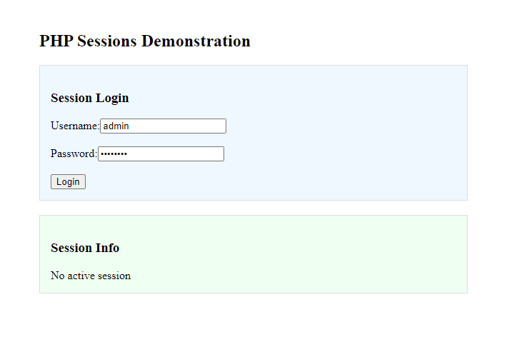

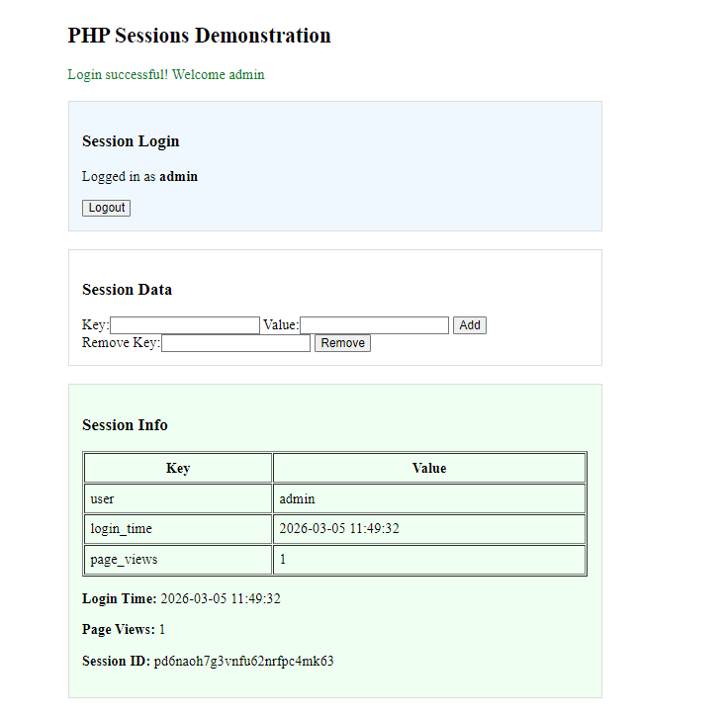

Lab 11: MySQL Basics and Transactions
Program
<!DOCTYPE html>
<html>
<head>
<title>MySQL Basics</title>
<style>
.container { max-width: 800px; margin: 20px auto; padding: 20px; }
.section { margin: 20px 0; padding: 15px; border: 1px solid #ddd; }
.success { color: green; }
.error { color: red; }
table { width: 100%; border-collapse: collapse; margin: 10px 0; }
th, td { border: 1px solid #ddd; padding: 8px; text-align: left; }
th { background-color: #f2f2f2; }
</style>
</head>
<body>
<div class="container">
<h2>MySQL Basics and Transactions</h2>
<?php
$servername = "localhost";
$username = "root";
$password = "";
$dbname = "php_lab";
try {
$conn = new PDO("mysql:host=$servername", $username, $password);
$conn->setAttribute(PDO::ATTR_ERRMODE, PDO::ERRMODE_EXCEPTION);
$conn->exec("CREATE DATABASE IF NOT EXISTS $dbname");
$conn->exec("USE $dbname");
echo "<p class='success'>Connected to MySQL server successfully!</p>";
} catch(PDOException $e) {
echo "<p class='error'>Connection failed: " . $e->getMessage() . "</p>";
die();
}
?>
<div class="section">
<h3>Create Students Table</h3>
<form method="POST">
<button type="submit" name="create_table">Create Students Table</button>
</form>
<?php
if (isset($_POST['create_table'])) {
try {
$sql = "CREATE TABLE IF NOT EXISTS students (
id INT(6) UNSIGNED AUTO_INCREMENT PRIMARY KEY,
name VARCHAR(50) NOT NULL,
email VARCHAR(50) NOT NULL,
age INT(3),
course VARCHAR(50),
created_at TIMESTAMP DEFAULT CURRENT_TIMESTAMP
)";
$conn->exec($sql);
echo "<p class='success'>Table 'students' created successfully!</p>";
} catch(PDOException $e) {
echo "<p class='error'>Error creating table: " . $e->getMessage() . "</p>";
}
}
?>
</div>
<div class="section">
<h3>Insert Student Data</h3>
<form method="POST">
<div>
<label>Name: </label>
<input type="text" name="name" required>
</div>
<div>
<label>Email: </label>
<input type="email" name="email" required>
</div>
<div>
<label>Age: </label>
<input type="number" name="age" required>
</div>
<div>
<label>Course: </label>
<input type="text" name="course" required>
</div>
<button type="submit" name="insert_data">Insert Student</button>
</form>
<?php
if (isset($_POST['insert_data'])) {
try {
$name = $_POST['name'];
$email = $_POST['email'];
$age = $_POST['age'];
$course = $_POST['course'];
$sql = "INSERT INTO students (name, email, age, course) VALUES (?, ?, ?, ?)";
$stmt = $conn->prepare($sql);
$stmt->execute([$name, $email, $age, $course]);
echo "<p class='success'>Student data inserted successfully!</p>";
} catch(PDOException $e) {
echo "<p class='error'>Error inserting data: " . $e->getMessage() . "</p>";
}
}
?>
</div>
<div class="section">
<h3>View Students Data</h3>
<form method="POST">
<button type="submit" name="view_data">View All Students</button>
</form>
<?php
if (isset($_POST['view_data'])) {
try {
$sql = "SELECT * FROM students";
$stmt = $conn->prepare($sql);
$stmt->execute();
$result = $stmt->fetchAll(PDO::FETCH_ASSOC);
if (count($result) > 0) {
echo "<table>";
echo "<tr><th>ID</th><th>Name</th><th>Email</th><th>Age</th><th>Course</th><th>Created At</th></tr>";
foreach ($result as $row) {
echo "<tr>";
echo "<td>" . $row['id'] . "</td>";
echo "<td>" . $row['name'] . "</td>";
echo "<td>" . $row['email'] . "</td>";
echo "<td>" . $row['age'] . "</td>";
echo "<td>" . $row['course'] . "</td>";
echo "<td>" . $row['created_at'] . "</td>";
echo "</tr>";
}
echo "</table>";
} else {
echo "<p>No students found in the database.</p>";
}
} catch(PDOException $e) {
echo "<p class='error'>Error retrieving data: " . $e->getMessage() . "</p>";
}
}
?>
</div>
<div class="section">
<h3>Transaction Demonstration</h3>
<form method="POST">
<button type="submit" name="transaction_demo">Run Transaction Demo</button>
</form>
<?php
if (isset($_POST['transaction_demo'])) {
try {
$conn->beginTransaction();
echo "<p>Starting transaction...</p>";
$conn->exec("INSERT INTO students (name, email, age, course) VALUES ('Transaction User 1', 'tx1@example.com', 22, 'Computer Science')");
echo "<p>Inserted first record</p>";
$conn->exec("INSERT INTO students (name, email, age, course) VALUES ('Transaction User 2', 'tx2@example.com', 23, 'Electrical Engineering')");
echo "<p>Inserted second record</p>";
$conn->commit();
echo "<p class='success'>Transaction committed successfully!</p>";
} catch(PDOException $e) {
$conn->rollBack();
echo "<p class='error'>Transaction failed: " . $e->getMessage() . "</p>";
echo "<p class='error'>Transaction rolled back!</p>";
}
}
?>
</div>
<div class="section">
<h3>Update and Delete Operations</h3>
<form method="POST">
<div>
<label>Student ID to Update: </label>
<input type="number" name="update_id" placeholder="Student ID">
<input type="text" name="new_course" placeholder="New Course">
<button type="submit" name="update_data">Update Course</button>
</div>
</form>
<form method="POST">
<div>
<label>Student ID to Delete: </label>
<input type="number" name="delete_id" placeholder="Student ID">
<button type="submit" name="delete_data">Delete Student</button>
</div>
</form>
<?php
if (isset($_POST['update_data'])) {
try {
$id = $_POST['update_id'];
$new_course = $_POST['new_course'];
$sql = "UPDATE students SET course = ? WHERE id = ?";
$stmt = $conn->prepare($sql);
$stmt->execute([$new_course, $id]);
echo "<p class='success'>Student record updated successfully!</p>";
} catch(PDOException $e) {
echo "<p class='error'>Error updating data: " . $e->getMessage() . "</p>";
}
}
if (isset($_POST['delete_data'])) {
try {
$id = $_POST['delete_id'];
$sql = "DELETE FROM students WHERE id = ?";
$stmt = $conn->prepare($sql);
$stmt->execute([$id]);
echo "<p class='success'>Student record deleted successfully!</p>";
} catch(PDOException $e) {
echo "<p class='error'>Error deleting data: " . $e->getMessage() . "</p>";
}
}
?>
</div>
<?php
$conn = null;
?>
</div>
</body>
</html>
Output

Lab 12: Querying MySQL Database
Program
<!DOCTYPE html>
<html>
<head>
<title>MySQL Querying</title>
<style>
.container { max-width: 1000px; margin: 20px auto; padding: 20px; }
.section { margin: 20px 0; padding: 15px; border: 1px solid #ddd; }
.query-section { background-color: #f9f9f9; }
table { width: 100%; border-collapse: collapse; margin: 10px 0; }
th, td { border: 1px solid #ddd; padding: 8px; text-align: left; }
th { background-color: #f2f2f2; }
.success { color: green; }
.error { color: red; }
</style>
</head>
<body>
<div class="container">
<h2>Querying MySQL Database</h2>
<?php
$servername = "localhost";
$username = "root";
$password = "";
$dbname = "php_lab_advanced";

try {
$conn = new PDO("mysql:host=$servername", $username, $password);
$conn->setAttribute(PDO::ATTR_ERRMODE, PDO::ERRMODE_EXCEPTION);
$conn->exec("CREATE DATABASE IF NOT EXISTS $dbname");
$conn->exec("USE $dbname");
echo "<p class='success'>Connected to database successfully!</p>";
} catch(PDOException $e) {
echo "<p class='error'>Connection failed: " . $e->getMessage() . "</p>";
die();
}
try {
$conn->exec("CREATE TABLE IF NOT EXISTS students (
student_id INT(6) UNSIGNED AUTO_INCREMENT PRIMARY KEY,
name VARCHAR(50) NOT NULL,
email VARCHAR(50) NOT NULL,
age INT(3),
department VARCHAR(50)
)");
$conn->exec("CREATE TABLE IF NOT EXISTS courses (
course_id INT(6) UNSIGNED AUTO_INCREMENT PRIMARY KEY,
course_name VARCHAR(50) NOT NULL,
credits INT(2),
instructor VARCHAR(50)
)")
$conn->exec("CREATE TABLE IF NOT EXISTS enrollments (
enrollment_id INT(6) UNSIGNED AUTO_INCREMENT PRIMARY KEY,
student_id INT(6) UNSIGNED,
course_id INT(6) UNSIGNED,
grade DECIMAL(3,2),
semester VARCHAR(20),
FOREIGN KEY (student_id) REFERENCES students(student_id),
FOREIGN KEY (course_id) REFERENCES courses(course_id)
)");
$conn->exec("INSERT IGNORE INTO students (student_id, name, email, age, department) VALUES
(1, 'Alice Johnson', 'alice@example.com', 20, 'Computer Science'),
(2, 'Bob Smith', 'bob@example.com', 22, 'Electrical Engineering'),
(3, 'Charlie Brown', 'charlie@example.com', 21, 'Computer Science'),
(4, 'Diana Miller', 'diana@example.com', 23, 'Mechanical Engineering'),
(5, 'Eva Davis', 'eva@example.com', 20, 'Computer Science')");
$conn->exec("INSERT IGNORE INTO courses (course_id, course_name, credits, instructor) VALUES
(1, 'Database Systems', 3, 'Dr. Smith'),
(2, 'Web Development', 4, 'Dr. Johnson'),
(3, 'Data Structures', 3, 'Dr. Williams'),
(4, 'Computer Networks', 3, 'Dr. Brown'),
(5, 'Software Engineering', 4, 'Dr. Davis')");
$conn->exec("INSERT IGNORE INTO enrollments (enrollment_id, student_id, course_id, grade, semester) VALUES
(1, 1, 1, 3.8, 'Fall 2024'),
(2, 1, 2, 3.5, 'Fall 2024'),
(3, 2, 1, 3.2, 'Fall 2024'),
(4, 2, 4, 3.9, 'Fall 2024'),
(5, 3, 2, 3.7, 'Fall 2024'),
(6, 3, 3, 3.4, 'Fall 2024'),
(7, 4, 5, 3.6, 'Fall 2024'),
(8, 5, 2, 3.9, 'Fall 2024'),
(9, 5, 3, 3.8, 'Fall 2024')");

} catch(PDOException $e) {
echo "<p class='error'>Error setting up database: " . $e->getMessage() . "</p>";
}
?>
<div class="section query-section">
<h3>Basic SELECT Queries</h3>
<h4>1. Select All Students</h4>
<?php
try {
$sql = "SELECT * FROM students";
$stmt = $conn->prepare($sql);
$stmt->execute();
$students = $stmt->fetchAll(PDO::FETCH_ASSOC);
echo "<table>";
echo "<tr><th>ID</th><th>Name</th><th>Email</th><th>Age</th><th>Department</th></tr>";
foreach ($students as $student) {
echo "<tr>";
echo "<td>" . $student['student_id'] . "</td>";
echo "<td>" . $student['name'] . "</td>";
echo "<td>" . $student['email'] . "</td>";
echo "<td>" . $student['age'] . "</td>";
echo "<td>" . $student['department'] . "</td>";
echo "</tr>";
}
echo "</table>";
} catch(PDOException $e) {
echo "<p class='error'>Error: " . $e->getMessage() . "</p>";
}
?>
<h4>2. Select with WHERE Clause</h4>
<?php
try {
$sql = "SELECT * FROM students WHERE department = 'Computer Science'";
$stmt = $conn->prepare($sql);
$stmt->execute();
$cs_students = $stmt->fetchAll(PDO::FETCH_ASSOC);
echo "<p><strong>Computer Science Students:</strong></p>";
echo "<table>";
echo "<tr><th>ID</th><th>Name</th><th>Email</th><th>Age</th></tr>";
foreach ($cs_students as $student) {
echo "<tr>";
echo "<td>" . $student['student_id'] . "</td>";
echo "<td>" . $student['name'] . "</td>";
echo "<td>" . $student['email'] . "</td>";
echo "<td>" . $student['age'] . "</td>";
echo "</tr>";
}
echo "</table>";
} catch(PDOException $e) {
echo "<p class='error'>Error: " . $e->getMessage() . "</p>";
}
?>
</div>
<div class="section query-section">
<h3>JOIN Queries</h3>
<h4>3. INNER JOIN - Student Enrollments</h4>
<?php
try {
$sql = "SELECT s.name, c.course_name, e.grade, e.semester
FROM enrollments e
INNER JOIN students s ON e.student_id = s.student_id
INNER JOIN courses c ON e.course_id = c.course_id
ORDER BY s.name";
$stmt = $conn->prepare($sql);
$stmt->execute();
$enrollments = $stmt->fetchAll(PDO::FETCH_ASSOC);
echo "<table>";
echo "<tr><th>Student Name</th><th>Course</th><th>Grade</th><th>Semester</th></tr>";
foreach ($enrollments as $enrollment) {
echo "<tr>";
echo "<td>" . $enrollment['name'] . "</td>";
echo "<td>" . $enrollment['course_name'] . "</td>";
echo "<td>" . $enrollment['grade'] . "</td>";
echo "<td>" . $enrollment['semester'] . "</td>";
echo "</tr>";
}
echo "</table>";
} catch(PDOException $e) {
echo "<p class='error'>Error: " . $e->getMessage() . "</p>";
}
?>

<h4>4. LEFT JOIN - All Students with Enrollments</h4>
<?php
try {
$sql = "SELECT s.name, s.department, c.course_name, e.grade
FROM students s
LEFT JOIN enrollments e ON s.student_id = e.student_id
LEFT JOIN courses c ON e.course_id = c.course_id
ORDER BY s.name";
$stmt = $conn->prepare($sql);
$stmt->execute();
$student_courses = $stmt->fetchAll(PDO::FETCH_ASSOC);
echo "<table>";
echo "<tr><th>Student Name</th><th>Department</th><th>Course</th><th>Grade</th></tr>";
foreach ($student_courses as $record) {
echo "<tr>";
echo "<td>" . $record['name'] . "</td>";
echo "<td>" . $record['department'] . "</td>";
echo "<td>" . ($record['course_name'] ?: 'Not enrolled') . "</td>";
echo "<td>" . ($record['grade'] ?: '-') . "</td>";
echo "</tr>";
}
echo "</table>";
} catch(PDOException $e) {
echo "<p class='error'>Error: " . $e->getMessage() . "</p>";
}
?>
</div>
<div class="section query-section">
<h3>Aggregation Queries</h3>
<h4>5. COUNT and GROUP BY</h4>
<?php
try {
$sql = "SELECT department, COUNT(*) as student_count
FROM students
GROUP BY department
ORDER BY student_count DESC";
$stmt = $conn->prepare($sql);
$stmt->execute();
$dept_counts = $stmt->fetchAll(PDO::FETCH_ASSOC);
echo "<table>";
echo "<tr><th>Department</th><th>Student Count</th></tr>";
foreach ($dept_counts as $dept) {
echo "<tr>";
echo "<td>" . $dept['department'] . "</td>";
echo "<td>" . $dept['student_count'] . "</td>";
echo "</tr>";
}
echo "</table>";
} catch(PDOException $e) {
echo "<p class='error'>Error: " . $e->getMessage() . "</p>";
}
?>
<h4>6. AVG, MAX, MIN - Grade Statistics</h4>
<?php
try {
$sql = "SELECT
c.course_name,
COUNT(e.enrollment_id) as enrollment_count,
AVG(e.grade) as average_grade,
MAX(e.grade) as highest_grade,
MIN(e.grade) as lowest_grade
FROM enrollments e
INNER JOIN courses c ON e.course_id = c.course_id
GROUP BY c.course_id, c.course_name
ORDER BY average_grade DESC";
$stmt = $conn->prepare($sql);
$stmt->execute();
$grade_stats = $stmt->fetchAll(PDO::FETCH_ASSOC);
echo "<table>";
echo "<tr><th>Course</th><th>Enrollments</th><th>Average Grade</th><th>Highest Grade</th><th>Lowest Grade</th></tr>";
foreach ($grade_stats as $stats) {
echo "<tr>";
echo "<td>" . $stats['course_name'] . "</td>";
echo "<td>" . $stats['enrollment_count'] . "</td>";
echo "<td>" . number_format($stats['average_grade'], 2) . "</td>";
echo "<td>" . $stats['highest_grade'] . "</td>";
echo "<td>" . $stats['lowest_grade'] . "</td>";
echo "</tr>";
}
echo "</table>";
} catch(PDOException $e) {
echo "<p class='error'>Error: " . $e->getMessage() . "</p>";
}
?>
</div>
<div class="section query-section">
<h3>Advanced Queries</h3>
<h4>7. Subquery - Students with Above Average Grades</h4>
<?php
try {
$sql = "SELECT s.name, c.course_name, e.grade
FROM enrollments e
INNER JOIN students s ON e.student_id = s.student_id
INNER JOIN courses c ON e.course_id = c.course_id
WHERE e.grade > (SELECT AVG(grade) FROM enrollments)
ORDER BY e.grade DESC";
$stmt = $conn->prepare($sql);
$stmt->execute();
$above_avg = $stmt->fetchAll(PDO::FETCH_ASSOC);
echo "<table>";
echo "<tr><th>Student Name</th><th>Course</th><th>Grade</th></tr>";
foreach ($above_avg as $record) {
echo "<tr>";
echo "<td>" . $record['name'] . "</td>";
echo "<td>" . $record['course_name'] . "</td>";
echo "<td>" . $record['grade'] . "</td>";
echo "</tr>";
}
echo "</table>";
} catch(PDOException $e) {
echo "<p class='error'>Error: " . $e->getMessage() . "</p>";
}
?>
<h4>8. HAVING Clause - Courses with High Average</h4>
<?php
try {
$sql = "SELECT c.course_name, AVG(e.grade) as avg_grade
FROM enrollments e
INNER JOIN courses c ON e.course_id = c.course_id
GROUP BY c.course_id, c.course_name
HAVING AVG(e.grade) > 3.5
ORDER BY avg_grade DESC";
$stmt = $conn->prepare($sql);
$stmt->execute();
$high_avg = $stmt->fetchAll(PDO::FETCH_ASSOC);
echo "<table>";
echo "<tr><th>Course</th><th>Average Grade</th></tr>";
foreach ($high_avg as $course) {
echo "<tr>";
echo "<td>" . $course['course_name'] . "</td>";
echo "<td>" . number_format($course['avg_grade'], 2) . "</td>";
echo "</tr>";
}
echo "</table>";
} catch(PDOException $e) {
echo "<p class='error'>Error: " . $e->getMessage() . "</p>";
}
?>
</div>
<div class="section">
<h3>Prepared Statements with User Input</h3>
<form method="POST">
<div>
<label>Search Student by Name: </label>
<input type="text" name="search_name" placeholder="Enter student name">
<button type="submit" name="search">Search</button>
</div>
</form>
<?php
if (isset($_POST['search'])) {
try {
$search_name = "%" . $_POST['search_name'] . "%";
$sql = "SELECT s.*, c.course_name, e.grade
FROM students s
LEFT JOIN enrollments e ON s.student_id = e.student_id
LEFT JOIN courses c ON e.course_id = c.course_id
WHERE s.name LIKE ?
ORDER BY s.name";
$stmt = $conn->prepare($sql);
$stmt->execute([$search_name]);
$search_results = $stmt->fetchAll(PDO::FETCH_ASSOC);
if (count($search_results) > 0) {
echo "<h4>Search Results:</h4>";
echo "<table>";
echo "<tr><th>Student ID</th><th>Name</th><th>Email</th><th>Department</th><th>Course</th><th>Grade</th></tr>";

$current_student = null;
foreach ($search_results as $result) {
echo "<tr>";
echo "<td>" . $result['student_id'] . "</td>";
echo "<td>" . $result['name'] . "</td>";
echo "<td>" . $result['email'] . "</td>";
echo "<td>" . $result['department'] . "</td>";
echo "<td>" . ($result['course_name'] ?: 'Not enrolled') . "</td>";
echo "<td>" . ($result['grade'] ?: '-') . "</td>";
echo "</tr>";
}
echo "</table>";
} else {
echo "<p>No students found matching your search.</p>";
}
} catch(PDOException $e) {
echo "<p class='error'>Search error: " . $e->getMessage() . "</p>";
}
}
?>
</div>
<?php
$conn = null;
?>
</div>
</body>
</html>
Output

