1.PHP EXPRESSIONS:
Program
<!DOCTYPE html>
<html>
<head>
<title>PHP Expressions</title>
</head>
<body>
<h2>PHP Expressions Demonstration</h2>
<?php
$num1=15;
$num2=7;
$name="Riden";
echo"<h3>Basic Expressions</h3>";
echo"Number1:".$num1."<br>";
echo"Number2:".$num2."<br>";
echo"Name:".$name."<br><br>";

echo"<h3>Arithmetic Expressions</h3>";
echo"Addition:".($num1+$num2)."<br>";
echo"Subtraction:".($num1-$num2)."<br>";
echo"Multiplication:".($num1*$num2)."<br>";
echo"Division:".($num1/$num2)."<br>";
echo"Modulus:".($num1%$num2)."<br><br>";

echo"<h3>String Expressions:</h3>";
$greeting="Hello,".$name."!";
echo"Length of greeting:".strlen($greeting)."<br><br>";
echo"<h3>Boolean Expressions:</h3>";
echo"Is num1 greater than num2?".($num1>$num2?"Yes":"No")."<br><br>";
echo"Are both numbers positive?".(($num1>0)&&($num2>0)?"Yes":"No")."<br>";
?>
</body>
</html>

OUTPUT:
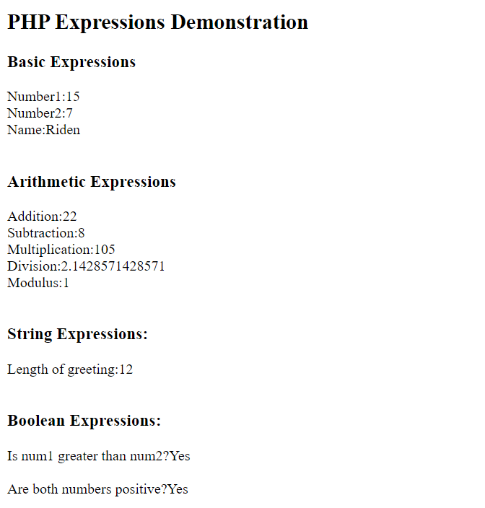

2.OPERATORS IN PHP:
Program
<!DOCTYPE html>
<html>
<head>
<title>PHP Operators</title>
</head>
<body>
<h2>PHP OPERATORS DEMONSTRATION</h2>

<?php
$a = 10;
$b = 5;
$c = 3;

echo "<h3>Arithmetic Operators</h3>";
echo "a = $a, b = $b, c = $c <br><br>";
echo "a + b = " . ($a + $b) . "<br>";
echo "a - b = " . ($a - $b) . "<br>";
echo "a * b = " . ($a * $b) . "<br>";
echo "a / b = " . ($a / $b) . "<br>";
echo "a % c = " . ($a % $c) . "<br>";

echo "<h3>Assignment Operators</h3>";
$x = $a;
echo "x = a : $x<br>";
$x += $b;
echo "x += b : $x<br>";
$x -= $c;
echo "x -= c : $x<br>";
$x *= 2;
echo "x *= 2 : $x<br><br>";

echo "<h3>Comparison Operators</h3>";
echo "a == b : " . ($a == $b ? "True" : "False") . "<br>";
echo "a < b : " . ($a < $b ? "True" : "False") . "<br>";
echo "a > b : " . ($a > $b ? "True" : "False") . "<br>";

echo "<h3>Increment/Decrement Operator</h3>";
$counter = 5;
echo "Original Counter: $counter<br>";
echo "Pre-Increment: " . (++$counter) . "<br>";
echo "Post-Increment: " . ($counter++) . "<br>";
echo "After Post-Increment: $counter<br>";
echo "Pre-Decrement: " . (--$counter) . "<br>";
echo "Post-Decrement: " . ($counter--) . "<br>";
echo "After Post-Decrement: $counter<br>";
?>

</body>
</html>

OUTPUT:
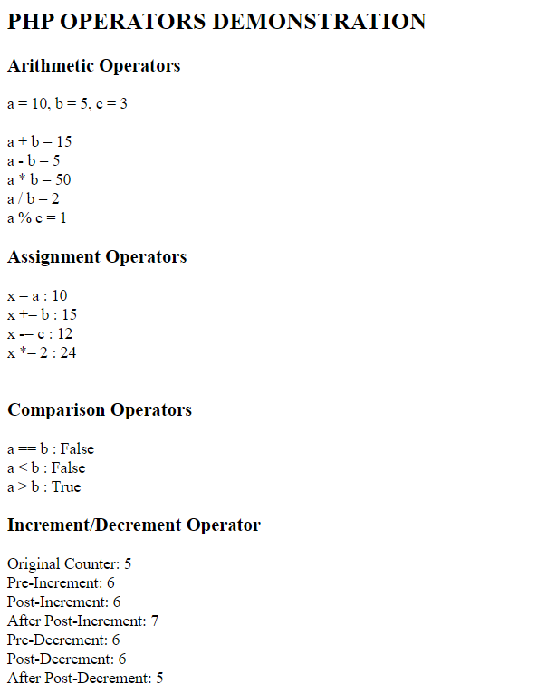

3.CONDITIONAL STATEMENTS AND LOOPING
Program
<!DOCTYPE html>
<html>
<head>
<title>Conditionals and Loops</title>
</head>
<body>
<h2>Conditionals Statements and Looping</h2>
<?php
$marks=75;
if($marks>=90)
{
echo"Grade:A+(Marks:$marks)<br>";
}
else if($marks>=80)
{
echo"Grade:A(Marks:$marks)<br>";
}
else if($marks>=70)
{
echo"Grade:B+(Marks:$marks)<br>";
}
else if($marks>=60)
{
echo"Grade:B(Marks:$marks)<br>";
}
else if($marks>=50)
{
echo"Grade:C(Marks:$marks)<br>";
}
else
{
echo"Fail<br>";
}
echo"<h3>Switch Statements</h3>";
$day="Monday";
switch($day)
{
case"Monday":
echo"Start of work week!<br>";
break;
case"Saturday":
echo"Weekend<br>";
break;
default:
echo"Regular<br>";
}
echo"<h3>For Loop:</h3>";
echo"<h3>Multiplication table of 5:<br>";
for($i=1;$i<=10;$i++)
{
echo"5*$i=".(5*$i)."<br>";
}
echo"<h3>While Loop:</h3>";
$count=1;
echo"Counting from 1 to 5:<br>";
while($count<=5)
{
echo"count:$count<br>";
$count++;
}
echo"<h3>Do-While Loop:</h3>";
$num=10;
echo"Counting down:<br>";
do{
echo"Number:$num<br>";
$num--;
}while($num>0);

echo"<h3>For Each-Loop:</h3>";
$fruits=array("Apple","Orange","Banana","Cherry","Graphes");
echo"List of fruits:<br>";
foreach($fruits as $index=>$fruit)
{
echo($index+1).".$fruit<br>";
}
?>
</body>
</html>

OUTPUT:
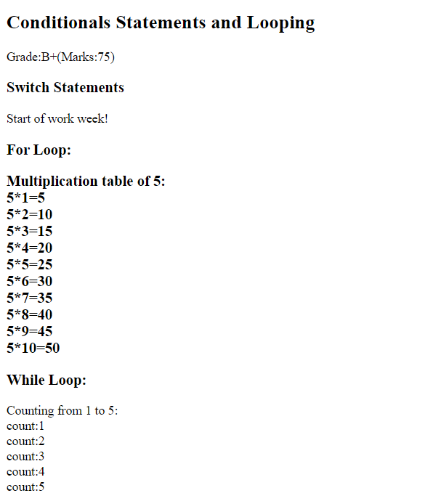
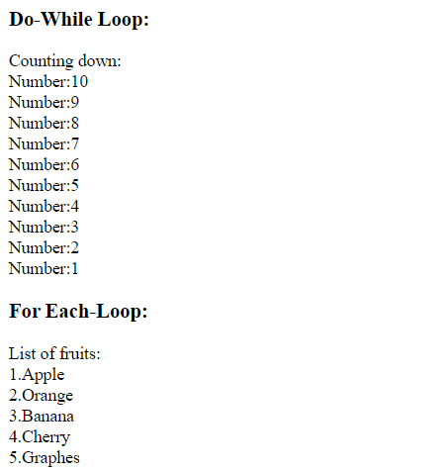

5.ARRAYS IN PHP
Program
<!DOCTYPE html>
<html>
<head>
<title>PHP Arrays</title>
</head>
<body>

<h2>Arrays in PHP</h2>
<?php
echo "<h3>Indexed Arrays</h3>";
$colors = array("Red", "Green", "Blue", "Yellow", "Purple");
echo "Colors array: ";
print_r($colors);
echo "<br>Third color: " . $colors[2] . "<br>";
echo "<h3>Associative Arrays</h3>";
$student = array(
"name" => "John Doe",
"age" => 20,
"grade" => "A",
"city" => "New York"
);
echo "Student information:<br>";
foreach ($student as $key => $value) {
echo ucfirst($key) . ": " . $value . "<br>";
}
echo "<h3>Multidimensional Array</h3>";
$employees = array(
array("Alice", "Manager", 75000),
array("Bob", "Developer", 65000),
array("Charlie", "Designer", 60000),
array("Diana", "Tester", 55000)
);
echo "Employee Details:<br>";
echo "<table border='1' cellpadding='5'>";
echo "<tr><th>Name</th><th>Position</th><th>Salary</th></tr>";
foreach ($employees as $employee) {
echo "<tr>";
echo "<td>{$employee[0]}</td>";
echo "<td>{$employee[1]}</td>";
echo "<td>{$employee[2]}</td>";
echo "</tr>";
}
echo "</table>";
echo "<h3>Array Functions</h3>";
$numbers = array(45, 23, 78, 12, 56, 89, 34);
echo "Original array: ";
print_r($numbers);
echo "<br>";
$reversed = array_reverse($numbers);
echo "Reversed array: ";
print_r($reversed);
echo "<br>";
echo "Array length: " . count($numbers) . "<br>";
$search = 56;
if (in_array($search, $numbers)) {
echo "$search found in array<br>";
}
$array1 = array("a", "b", "c");
$array2 = array("d", "e", "f");
$merged = array_merge($array1, $array2);
echo "Merged array: ";
print_r($merged);
echo "<br>";?>
</body>
</html>

OUTPUT:
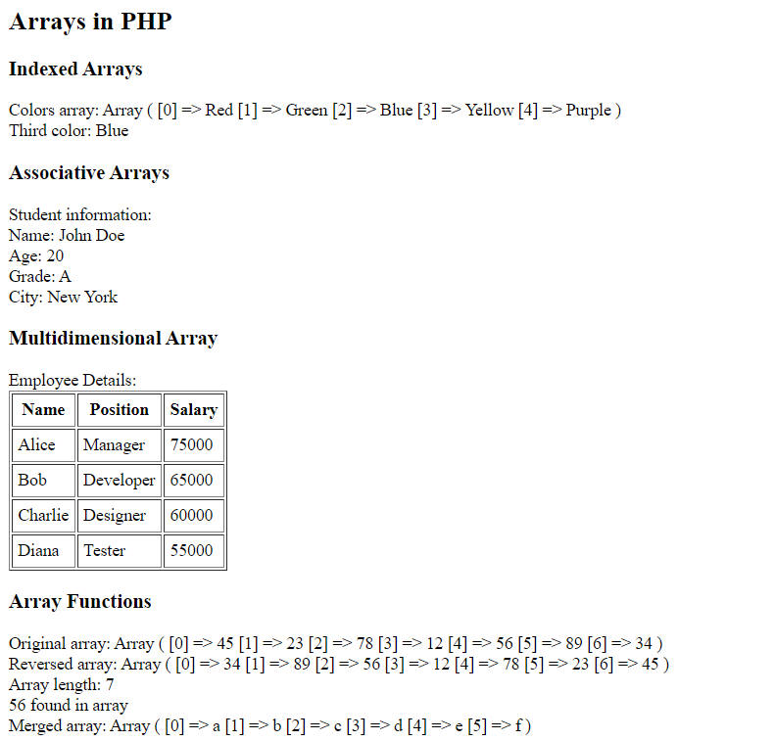
6.FILE HANDLING
<!DOCTYPE html>
<html>
<head>
<title>File Handling</title>
</head>
<body>
<h2>File Handling in PHP</h2>
<?php
$filename = "sample.txt";
$content = "This is a sample file created using PHP file handling.\n";
$content .= "Line 2: Learning file operations in PHP.\n";
$content .= "Line 3: File handling is essential for web applications.\n";

echo "<h3>Writing to a File:</h3>";
if (file_put_contents($filename, $content) !== false) {
echo "File '$filename' created successfully!<br>";
} else {
echo "Error creating file!<br>";
}
echo "<h3>Reading from a File:</h3>";
if (file_exists($filename)) {
$file_content = file_get_contents($filename);
echo "File content:<br>";
echo "<pre>" . htmlspecialchars($file_content) . "</pre>";
} else {
echo "File not found!<br>";
}
echo "<h3>Reading Line by Line:</h3>";
if (file_exists($filename)) {
$file = fopen($filename, "r");
echo "File content (line by line):<br>";
$line_number = 1;
while (!feof($file)) {
$line = fgets($file);
if ($line !== false) {
echo "Line $line_number: " . trim($line) . "<br>";
$line_number++;
}
}
fclose($file);
}
echo "<h3>Appending to a File:</h3>";
$append_content = "Line 4: This line was appended later.\n";
if (file_put_contents($filename, $append_content, FILE_APPEND) !== false) {
echo "Content appended successfully!<br>";
$updated_content = file_get_contents($filename);
echo "Updated file content:<br>";
echo "<pre>" . htmlspecialchars($updated_content) . "</pre>";
}
echo "<h3>File Information:</h3>";
if (file_exists($filename)) {
echo "File name: " . basename($filename) . "<br>";
echo "File size: " . filesize($filename) . " bytes<br>";
echo "File type: " . filetype($filename) . "<br>";
echo "Last modified: " . date("F d Y H:i:s", filemtime($filename)) . "<br>";
}
echo "<h3>Directory Operations:</h3>";
$files = scandir(".");
echo "Files in current directory:<br>";
foreach ($files as $file) {
if ($file != "." && $file != "..") {
echo "- $file<br>";
}
}
?>
</body>
</html>

OUTPUT:
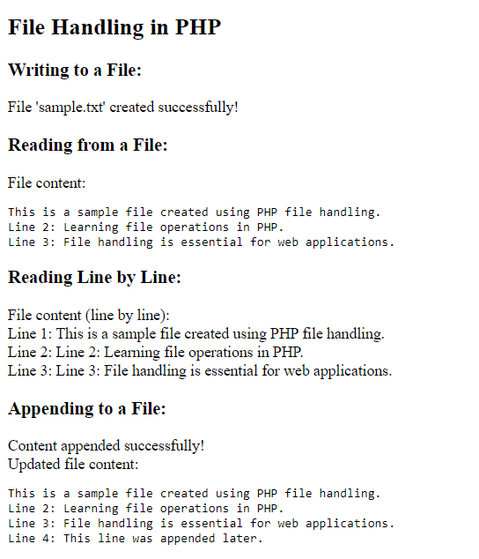
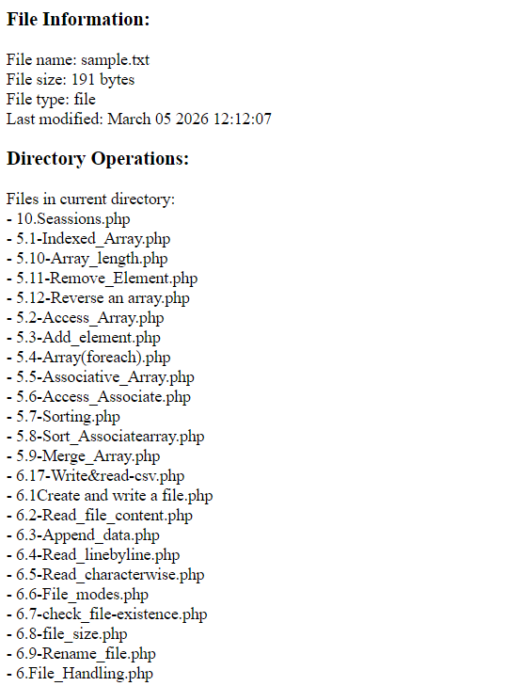

7.CREATE FORMS USING WEB CONTROLS
<!DOCTYPE html>
<html>
<head>
<title>PHP Forms</title>
<style>
.form-container {
max-width: 500px;
margin: 20px auto;
padding: 20px;
border: 1px solid #ccc;
border-radius: 5px;
}
.form-group {
margin-bottom: 15px;
}
label {
display: block;
margin-bottom: 5px;
font-weight: bold;
}
input, select, textarea {
width: 100%;
padding: 8px;
border: 1px solid #ddd;
border-radius: 4px;
}
button {
background-color: #4CAF50;
color: white;
padding: 10px 20px;
border: none;
border-radius: 4px;
cursor: pointer;
}
button:hover {
background-color: #45a049;
}
</style>
</head>
<body>
<div class="form-container">
<h2>Student Registration Form</h2>

<form method="POST" action="">
<div class="form-group">
<label for="name">Full Name:</label>
<input type="text" id="name" name="name" required>
</div>
<div class="form-group">
<label for="email">Email:</label>
<input type="email" id="email" name="email" required>
</div>
<div class="form-group">
<label for="password">Password:</label>
<input type="password" id="password" name="password" required>
</div>

<div class="form-group">
<label>Gender:</label>
<input type="radio" id="male" name="gender" value="Male" required>
<label for="male" style="display: inline;">Male</label>
<input type="radio" id="female" name="gender" value="Female">
<label for="female" style="display: inline;">Female</label>
<input type="radio" id="other" name="gender" value="Other">
<label for="other" style="display: inline;">Other</label>
</div>
<div class="form-group">
<label for="course">Course:</label>
<select id="course" name="course" required>
<option value="">Select Course</option>
<option value="Computer Science">Computer Science</option>
<option value="Electrical Engineering">Electrical Engineering</option>
<option value="Mechanical Engineering">Mechanical Engineering</option>
<option value="Civil Engineering">Civil Engineering</option>
</select>
</div>
<div class="form-group">
<label>Interests:</label>
<input type="checkbox" id="programming" name="interests[]" value="Programming">
<label for="programming" style="display: inline;">Programming</label><br>
<input type="checkbox" id="sports" name="interests[]" value="Sports">
<label for="sports" style="display: inline;">Sports</label><br>

<input type="checkbox" id="music" name="interests[]" value="Music">
<label for="music" style="display: inline;">Music</label><br>

<input type="checkbox" id="reading" name="interests[]" value="Reading">
<label for="reading" style="display: inline;">Reading</label>
</div>
<div class="form-group">
<label for="address">Address:</label>
<textarea id="address" name="address" rows="3"></textarea>
</div>
<div class="form-group">
<label for="birthdate">Date of Birth:</label>
<input type="date" id="birthdate" name="birthdate">
</div>
<button type="submit" name="submit">Register</button>
<button type="reset">Reset</button>
</form>
<?php
if (isset($_POST['submit'])) {
echo "<h3>Form Submitted Successfully!</h3>";
echo "<h4>Submitted Data:</h4>";
echo "<p><strong>Name:</strong> " . htmlspecialchars($_POST['name']) . "</p>";
echo "<p><strong>Email:</strong> " . htmlspecialchars($_POST['email']) . "</p>";
echo "<p><strong>Gender:</strong> " . htmlspecialchars($_POST['gender']) . "</p>";
echo "<p><strong>Course:</strong> " . htmlspecialchars($_POST['course']) . "</p>";

if (isset($_POST['interests'])) {
echo "<p><strong>Interests:</strong> " . implode(", ", $_POST['interests']) . "</p>";
} else {
echo "<p><strong>Interests:</strong> None selected</p>";
}
echo "<p><strong>Address:</strong> " . nl2br(htmlspecialchars($_POST['address'])) . "</p>";
echo "<p><strong>Date of Birth:</strong> " . htmlspecialchars($_POST['birthdate']) . "</p>";
}
?>
</div>
</body>
</html>

OUTPUT:
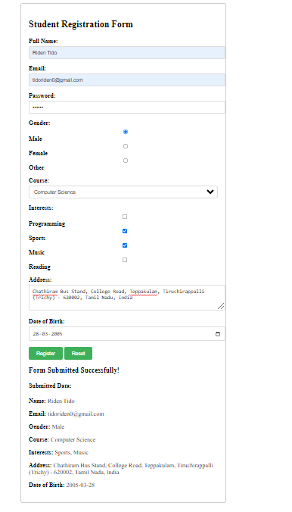

8.RETRIEVING SUBMITTING DATA
<!DOCTYPE html>
<html>
<head>
<title>Data Retrieval and Submission</title>
<style>
.container { max-width: 800px; margin: 20px auto; padding: 20px; }
.method-section { margin: 20px 0; padding: 15px; border: 1px solid #ddd; }
.get-form { background-color: #e7f3ff; }
.post-form { background-color: #f0ffe7; }
.file-form { background-color: #fff7e6; }
</style>
</head>
<body>
<div class="container">
<h2>Data Retrieval and Submission Methods</h2>
<div class="method-section get-form">
<h3>GET Method Example</h3>
<form method="GET" action="">
<input type="hidden" name="page" value="data_demo">
<label>Search Term: </label>
<input type="text" name="search" value="<?php echo isset($_GET['search']) ? htmlspecialchars($_GET['search']) : ''; ?>">
<button type="submit">Search</button>
</form>
<?php
if (isset($_GET['search']) && !empty($_GET['search'])) {
echo "<h4>GET Data Received:</h4>";
echo "<p>You searched for: <strong>" . htmlspecialchars($_GET['search']) . "</strong></p>";
echo "<p>Current URL: " . htmlspecialchars($_SERVER['REQUEST_URI']) . "</p>";
}
?>
</div>
<div class="method-section post-form">
<h3>POST Method Example</h3>
<form method="POST" action="">
<div>
<label>Username: </label>
<input type="text" name="username" required>
</div>
<div>
<label>Message: </label>
<textarea name="message" rows="3" required></textarea>
</div>
<button type="submit" name="post_submit">Submit Message</button>
</form>
<?php
if (isset($_POST['post_submit'])) {
echo "<h4>POST Data Received:</h4>";
echo "<p><strong>Username:</strong> " . htmlspecialchars($_POST['username']) . "</p>";
echo "<p><strong>Message:</strong> " . nl2br(htmlspecialchars($_POST['message'])) . "</p>";
echo "<p>Note: POST data is not visible in URL</p>";
}
?>
</div>
<div class="method-section file-form">
<h3>File Upload Example</h3>
<form method="POST" action="" enctype="multipart/form-data">
<div>
<label>Select File to Upload: </label>
<input type="file" name="file_upload" accept=".jpg,.jpeg,.png,.pdf,.txt" required>
</div>
<button type="submit" name="upload_submit">Upload File</button>
</form>
<?php
if (isset($_POST['upload_submit'])) {
echo "<h4>File Upload Status:</h4>";
if (isset($_FILES['file_upload'])) {
$file = $_FILES['file_upload'];
$filename = $file['name'];
$filetmp = $file['tmp_name'];
$filesize = $file['size'];
$fileerror = $file['error'];
if ($fileerror === 0) {
if (!is_dir('uploads')) {
mkdir('uploads', 0777, true);
}
$filepath = 'uploads/' . time() . '_' . $filename;
if (move_uploaded_file($filetmp, $filepath)) {
echo "<p style='color: green;'>File uploaded successfully!</p>";
echo "<p><strong>File Name:</strong> $filename</p>";
echo "<p><strong>File Size:</strong> " . round($filesize / 1024, 2) . " KB</p>";
echo "<p><strong>File Type:</strong> " . $file['type'] . "</p>";
echo "<p><strong>Saved As:</strong> $filepath</p>";
} else {
echo "<p style='color: red;'>Error moving uploaded file!</p>";
}
} else {
echo "<p style='color: red;'>Error uploading file: Error code $fileerror</p>";
}
} else {
echo"<p style='color: red;'>No file selected!</p>";
}
}
?>
</div>
<div class="method-section">
<h3>Superglobal Variables</h3>
<h4>GET Data:</h4>
<pre><?php print_r($_GET); ?></pre>
<h4>POST Data:</h4>
<pre><?php print_r($_POST); ?></pre>
<h4>FILES Data:</h4>
<pre><?php print_r($_FILES); ?></pre>
<h4>SERVER Information:</h4>
<p><strong>PHP_SELF:</strong> <?php echo $_SERVER['PHP_SELF']; ?></p>
<p><strong>REQUEST_METHOD:</strong> <?php echo $_SERVER['REQUEST_METHOD']; ?></p>
<p><strong>REMOTE_ADDR:</strong> <?php echo $_SERVER['REMOTE_ADDR']; ?></p>
</div>
</div>
</body>
</html>

OUTPUT:
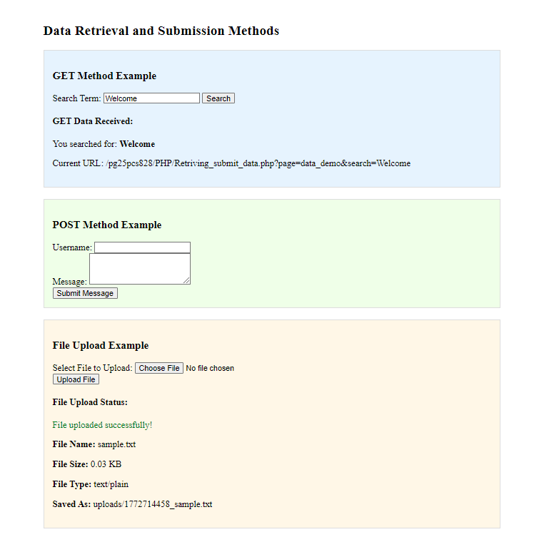

9.Cookies
<!DOCTYPE html>
<html>
<head>
<title>PHP Cookies</title>
<style>
.container{max-width:600px;margin:20px auto;padding:20px}
.section{margin:20px 0;padding:15px;border:1px solid #ddd}
</style>
</head>
<body>
<div class="container">
<h2>PHP Cookies Demonstration</h2>
<?php
if(isset($_POST['set_cookie'])){
$u=$_POST['username'];
$c=$_POST['color'];
$exp=time()+($_POST['expiry']*60);
setcookie("user",$u,$exp,"/");
setcookie("fav_color",$c,$exp,"/");
echo "<p style='color:green'>Cookies set successfully. Refresh page to see changes.</p>";
}
if(isset($_POST['modify_cookie'])){
$lang=$_POST['language'];
setcookie("fav_language",$lang,time()+3600,"/");
echo "<p style='color:green'>Language cookie updated</p>";
echo "<script>setTimeout(function(){location.reload();},1000);</script>";
}

if(isset($_POST['delete_cookies'])){
setcookie("user","",time()-3600,"/");
setcookie("fav_color","",time()-3600,"/");
setcookie("fav_language","",time()-3600,"/");
echo "<p style='color:green'>Cookies deleted</p>";
echo "<script>setTimeout(function(){location.reload();},1000);</script>";
}
?>
<div class="section">
<h3>Set Cookies</h3>
<form method="post">
Username:<input name="username"><br><br>
Favorite Color:<input name="color"><br><br>
Expiry(min):<input type="number" name="expiry" value="30"><br><br>
<button name="set_cookie">Set Cookie</button>
</form>
</div>
<div class="section">
<h3>Current Cookies</h3>
<?php
if(isset($_COOKIE['user']))
echo "<p><b>User:</b> ".htmlspecialchars($_COOKIE['user'])."</p>";
if(isset($_COOKIE['fav_color']))
echo "<p><b>Color:</b> ".htmlspecialchars($_COOKIE['fav_color'])."</p>";
if(isset($_COOKIE['fav_language']))
echo "<p><b>Language:</b> ".htmlspecialchars($_COOKIE['fav_language'])."</p>";
if(empty($_COOKIE)) echo "No cookies set";
?>
</div>
<div class="section">
<h3>Modify Cookie</h3>
<form method="post">
New Language:<input name="language">
<button name="modify_cookie">Update</button>
</form>
</div>
<div class="section">
<h3>Delete Cookies</h3>
<form method="post">
<button name="delete_cookies">Delete All Cookies</button>
</form>
</div>
<div class="section">
<h3>All Cookies</h3>
<pre><?php print_r($_COOKIE); ?></pre>
</div>
<div class="section">
<h3>Cookie Info</h3>
<?php
echo "Total Cookies: ".count($_COOKIE)."<br>";
if(isset($_COOKIE['user'])){
echo "<b>Welcome ".$_COOKIE['user']."</b><br>";
}
if(isset($_COOKIE['fav_color'])){
$col=$_COOKIE['fav_color'];
echo "Favorite Color: <span style='color:$col'>$col</span>";
}
?>
</div>
</div>
</body>
</html>

OUTPUT:
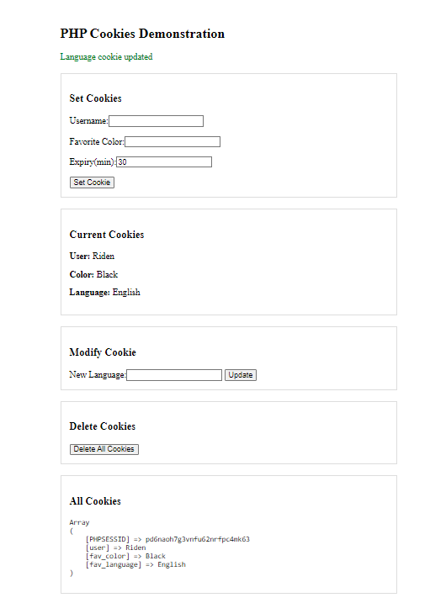
10.Session in PHP
Program
<!DOCTYPE html>
<html>
<head>
<title>PHP Sessions</title>
<style>
.container{max-width:600px;margin:20px auto;padding:20px}
.section{margin:20px 0;padding:15px;border:1px solid #ddd}
.login-form{background:#f0f8ff}
.session-info{background:#f0fff0}
</style>
</head>
<body>
<div class="container">
<h2>PHP Sessions Demonstration</h2>
<?php
session_start();
if(isset($_POST['login'])){
$u=$_POST['username'];$p=$_POST['password'];
if($u=='admin'&&$p=='password'){
$_SESSION['user']=$u;
$_SESSION['login_time']=date('Y-m-d H:i:s');
$_SESSION['page_views']=0;
echo "<p style='color:green'>Login successful! Welcome $u</p>";
}else echo "<p style='color:red'>Invalid username or password</p>";
}
if(isset($_POST['logout'])){
session_destroy();
echo "<p style='color:green'>Logged out</p>";
echo "<script>setTimeout(function(){location.reload();},1000);</script>";
}
if(isset($_SESSION['user'])){
$_SESSION['page_views']=isset($_SESSION['page_views'])?$_SESSION['page_views']+1:1;
}
?>
<div class="section login-form">
<h3>Session Login</h3>
<?php if(!isset($_SESSION['user'])){ ?>
<form method="post">
Username:<input type="text" name="username" value="admin"><br><br>
Password:<input type="password" name="password" value="password"><br><br>
<button name="login">Login</button>
</form>
<?php }else{ ?>
<p>Logged in as <b><?php echo $_SESSION['user']; ?></b></p>
<form method="post"><button name="logout">Logout</button></form>
<?php } ?>
</div>
<?php if(isset($_SESSION['user'])){ ?>
<div class="section">
<h3>Session Data</h3>
<form method="post">
Key:<input name="data_key">
Value:<input name="data_value">
<button name="add_data">Add</button>
</form>
<form method="post">
Remove Key:<input name="remove_key">
<button name="remove_data">Remove</button>
</form>
<?php
if(isset($_POST['add_data'])){
$k=$_POST['data_key'];$v=$_POST['data_value'];
$_SESSION[$k]=$v;
echo "<p style='color:green'>$k=$v added</p>";
}
if(isset($_POST['remove_data'])){
$k=$_POST['remove_key'];
if(isset($_SESSION[$k])){unset($_SESSION[$k]);echo "<p style='color:green'>$k removed</p>";}
else echo "<p style='color:red'>Key not found</p>";
}
?>
</div>
<?php } ?>
<div class="section session-info">
<h3>Session Info</h3>
<?php if(isset($_SESSION['user'])){ ?>
<table border="1" width="100%" cellpadding="6">
<tr><th>Key</th><th>Value</th></tr>
<?php foreach($_SESSION as $k=>$v){ ?>
<tr><td><?php echo htmlspecialchars($k); ?></td><td><?php echo htmlspecialchars($v); ?></td></tr>
<?php } ?>
</table>
<p><b>Login Time:</b> <?php echo $_SESSION['login_time']; ?></p>
<p><b>Page Views:</b> <?php echo $_SESSION['page_views']; ?></p>
<p><b>Session ID:</b> <?php echo session_id(); ?></p>
<?php }else echo "No active session"; ?>
</div>
</div>
</body>
</html>

Output:
