1.DATA PREPROCESSING
import pandas as pd
data = pd.read_csv("student.csv")
print("Dataset:")
print(data)
print("\nDataset Info:")
print(data.info())
from sklearn.impute import SimpleImputer
imputer = SimpleImputer(strategy="mean")
data[["StudyHours", "Marks"]] = imputer.fit_transform(data[["StudyHours", "Marks"]])
print("\nAfter handling missing values:")
print(data)

OUTPUT:
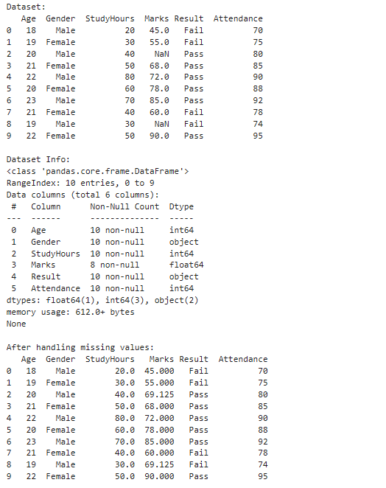

2.LINEAR REGRESSION-HOUSE PRICE PREDICTION (NO NEED TO CREATE CSV FILE)
import numpy as np
from sklearn.linear_model import LinearRegression
sqft = np.array([600, 900, 1200, 1500, 1800]).reshape(-1, 1)
price = np.array([120000, 170000, 220000, 270000, 320000])
model = LinearRegression() model.fit(sqft, price)
prediction = model.predict([[600]]) print("Slope (m):", model.coef_[0]) print("Intercept (c):", model.intercept_)
print("Predicted Price for 600 Sqft: ₹", int(prediction[0]))

OUTPUT:
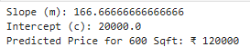

3.K-NEAREST NEIGHBORS CLASSIFICATION

from sklearn.neighbors import KNeighborsClassifier
X = [[35], [55], [75]]
y = [0, 1, 1]
model = KNeighborsClassifier(n_neighbors=1)
model.fit(X, y)
prediction = model.predict([[45]])
print("Prediction:", prediction[0])

OUTPUT:
4.IMPLEMENTATION OF SVM
from sklearn import datasets
from sklearn.model_selection import train_test_split
from sklearn.svm import SVC
from sklearn.metrics import accuracy_score, classification_report, confusion_matrix
iris = datasets.load_iris()
X = iris.data
y = iris.target
X_train, X_test, y_train, y_test = train_test_split(
X, y, test_size=0.2, random_state=42
)
svm_model = SVC(kernel='linear', C=1)
svm_model.fit(X_train, y_train)
y_pred = svm_model.predict(X_test)
accuracy = accuracy_score(y_test, y_pred)
print("Accuracy:", accuracy)
print("\nClassification Report:")
print(classification_report(y_test, y_pred))
print("Confusion Matrix:")
print(confusion_matrix(y_test, y_pred))

OUTPUT:
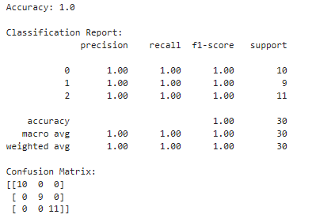
5.STATISTICAL OPERATIONS USING NUMPY
import numpy as np
data = np.array([10, 20, 30, 40, 50])
print("Data:", data)
print("Mean:", np.mean(data))
print("Median:", np.median(data))
print("Minimum value:", np.min(data))
print("Maximum value:", np.max(data))
print("Standard Deviation:", np.std(data))
print("Variance:", np.var(data))

OUTPUT:
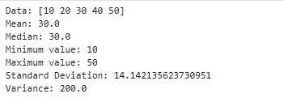

6.Filter method
import pandas as pd
from sklearn.feature_selection import SelectKBest, f_classif
data = pd.read_csv("heart.csv")
X = data.drop("target", axis=1)
y = data["target"]
selector = SelectKBest(score_func=f_classif, k=5)
X_new = selector.fit_transform(X, y)
selected_features = X.columns[selector.get_support()]
print("Top 5 selected features:", list(selected_features))
OUTPUT:

7.wrapper method (Recursive Feature Elimination (RFE))
import pandas as pd
from sklearn.linear_model import LogisticRegression
from sklearn.feature_selection import RFE
data = pd.read_csv("heart.csv")
X = data.drop("target", axis=1)
y = data["target"]
model = LogisticRegression(max_iter=1000)
rfe = RFE(model, n_features_to_select=5)
X_rfe = rfe.fit_transform(X, y)
selected_features = X.columns[rfe.support_]
print("Top 5 selected features (Wrapper Method):", list(selected_features))

OUTPUT:

8.Embedded method
import pandas as pd
from sklearn.linear_model import LogisticRegression
from sklearn.feature_selection import SelectFromModel
from sklearn.preprocessing import StandardScaler
import warnings
warnings.filterwarnings("ignore")
data = pd.read_csv("heart.csv")
X = data.drop(columns=["target"])
y = data["target"]
X_scaled = StandardScaler().fit_transform(X)
model = LogisticRegression(penalty="l1", solver="liblinear", max_iter=1000)
model.fit(X_scaled, y)
selector = SelectFromModel(model, prefit=True)
print("Selected Features:", list(X.columns[selector.get_support()]))
print("New Shape:", selector.transform(X_scaled).shape)

OUTPUT:

9.LDA(Linear Discriminant Analysis)
import pandas as pd
from sklearn.discriminant_analysis import LinearDiscriminantAnalysis as LDA
from sklearn.preprocessing import StandardScaler
data = pd.read_csv("heart.csv")
X = StandardScaler().fit_transform(data.drop("target", axis=1))
y = data["target"]
X_lda = LDA(n_components=1).fit_transform(X, y)
print(X_lda[:5])

OUTPUT:
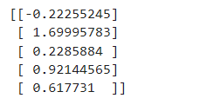

10.K-Fold Cross Validation
import pandas as pd
from sklearn.model_selection import cross_val_score
from sklearn.linear_model import LogisticRegression
data = pd.read_csv("heart.csv")
X = data.drop("target",axis=1)
y= data["target"]
scores = cross_val_score(LogisticRegression(max_iter=1000), X, y, cv=5)
print(scores, scores.mean())

OUTPUT:

11.PCA
import pandas as pd
from sklearn.preprocessing import StandardScaler
from sklearn.decomposition import PCA
import matplotlib.pyplot as plt
df = pd.read_csv("heart.csv")
X, y = df.drop("target", axis=1), df["target"]
X_scaled = StandardScaler().fit_transform(X)
X_pca = PCA().fit_transform(X_scaled)
plt.plot(PCA().fit(X_scaled).explained_variance_ratio_.cumsum(), marker='o', linestyle='--'); plt.show()
X2 = PCA(n_components=2).fit_transform(X_scaled)
plt.scatter(X2[:,0], X2[:,1], c=y, cmap='viridis', edgecolor='k'); plt.show()

OUTPUT:
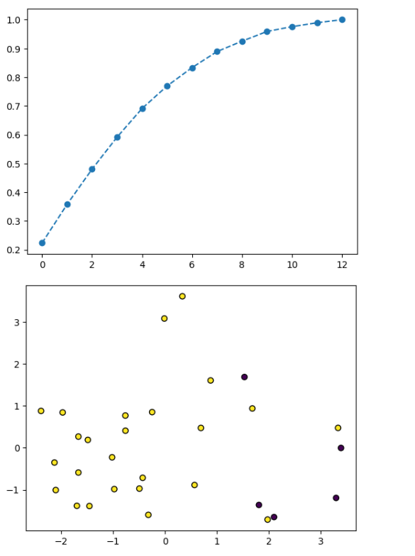

12.Random Forest
import pandas as pd
import numpy as np
from sklearn.preprocessing import LabelEncoder, StandardScaler
from sklearn.linear_model import Lasso
from sklearn.ensemble import RandomForestClassifier
from sklearn.feature_selection import SelectFromModel
data = pd.read_csv("student_performance_dataset.csv")
print("Dataset Preview:")
print(data.head())
X = data.drop("Final_Exam_Result", axis=1)
y = data["Final_Exam_Result"]
le = LabelEncoder()
y = le.fit_transform(y)
print("\nOriginal Feature Count:", X.shape[1])
scaler = StandardScaler()
X_scaled = scaler.fit_transform(X)
lasso = Lasso(alpha=0.1)
lasso.fit(X_scaled, y)
selected_lasso = X.columns[lasso.coef_ != 0]
print("\nSelected Features using Lasso:")
print(selected_lasso)
rf = RandomForestClassifier(n_estimators=100, random_state=42)
rf.fit(X, y)
importances = rf.feature_importances_
feature_importance_df = pd.DataFrame({
'Feature': X.columns,
'Importance': importances
}).sort_values(by='Importance', ascending=False)
print("\nFeature Importance (Random Forest):")
print(feature_importance_df)
threshold = np.mean(importances)
selected_rf = X.columns[importances > threshold]
print("\nSelected Features using Random Forest:")
print(selected_rf)

OUTPUT:
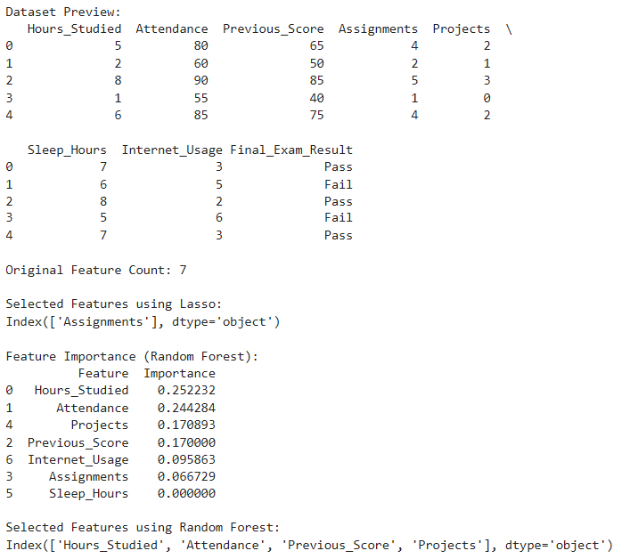

13.Bagging Classifier
import pandas as pd
from sklearn.model_selection import train_test_split
from sklearn.preprocessing import LabelEncoder
from sklearn.tree import DecisionTreeClassifier
from sklearn.ensemble import BaggingClassifier
from sklearn.metrics import accuracy_score
data = pd.read_csv("employee_attrition_dataset.csv")
print("Dataset Preview")
print(data.head())
X = data.drop("Attrition", axis=1)
y = data["Attrition"]
le = LabelEncoder()
y = le.fit_transform(y)
X_train, X_test, y_train, y_test = train_test_split(
X, y, test_size=0.3, random_state=42
)
base_model = DecisionTreeClassifier()
bagging_model = BaggingClassifier(
estimator=base_model,
n_estimators=10,
random_state=42
)
bagging_model.fit(X_train, y_train)
y_pred = bagging_model.predict(X_test)
accuracy = accuracy_score(y_test, y_pred)
print("Bagging Model Accuracy:", accuracy)
OUTPUT:
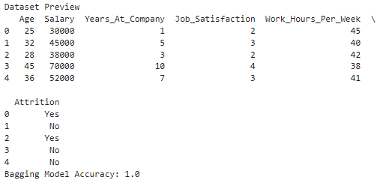

14.AdaBoost Classifier
import pandas as pd
from sklearn.model_selection import train_test_split
from sklearn.preprocessing import LabelEncoder
from sklearn.tree import DecisionTreeClassifier
from sklearn.ensemble import AdaBoostClassifier
from sklearn.metrics import accuracy_score
data = pd.read_csv("boosting_student_dataset.csv")
print("Dataset Preview")
print(data.head())
X = data.drop("Result", axis=1)
y = data["Result"]
le = LabelEncoder()
y = le.fit_transform(y)
X_train, X_test, y_train, y_test = train_test_split(
X, y, test_size=0.3, random_state=42
)
base_model = DecisionTreeClassifier(max_depth=1)
boost_model = AdaBoostClassifier(
estimator=base_model,
n_estimators=50,
learning_rate=1,
random_state=42 )
boost_model.fit(X_train, y_train)
y_pred = boost_model.predict(X_test)
accuracy = accuracy_score(y_test, y_pred)
print("Boosting Model Accuracy:", accuracy)

OUTPUT:
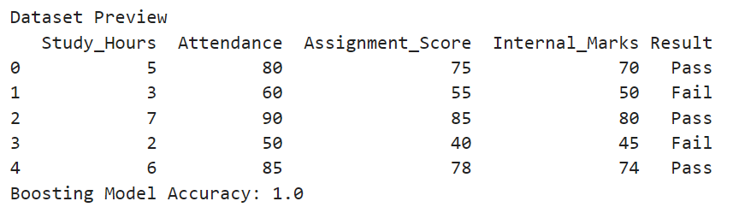

15. Gradient Boosting Classifier
import pandas as pd
from sklearn.model_selection import train_test_split
from sklearn.preprocessing import LabelEncoder
from sklearn.ensemble import GradientBoostingClassifier
from sklearn.metrics import accuracy_score
data = pd.read_csv("gradient_boosting_student_dataset.csv")
print("Dataset Preview")
print(data.head())
X = data.drop("Result", axis=1)
y = data["Result"]
le = LabelEncoder()
y = le.fit_transform(y)
X_train, X_test, y_train, y_test = train_test_split(
X, y, test_size=0.3, random_state=42
)
gb_model = GradientBoostingClassifier(
n_estimators=100,
learning_rate=0.1,
max_depth=3,
random_state=42
)
gb_model.fit(X_train, y_train)
y_pred = gb_model.predict(X_test)
accuracy = accuracy_score(y_test, y_pred)
print("Gradient Boosting Accuracy:", accuracy)

OUTPUT:
