1)Fee Structure Link not found.

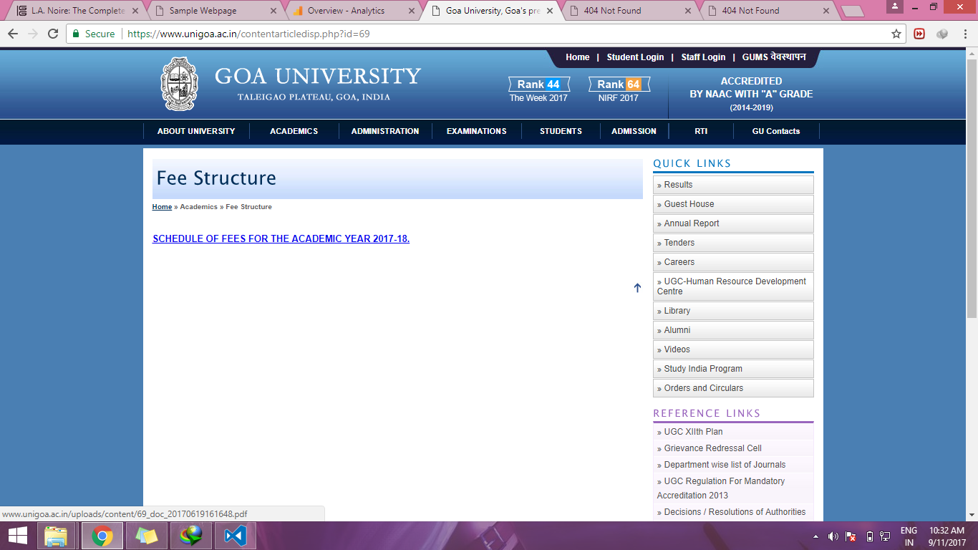

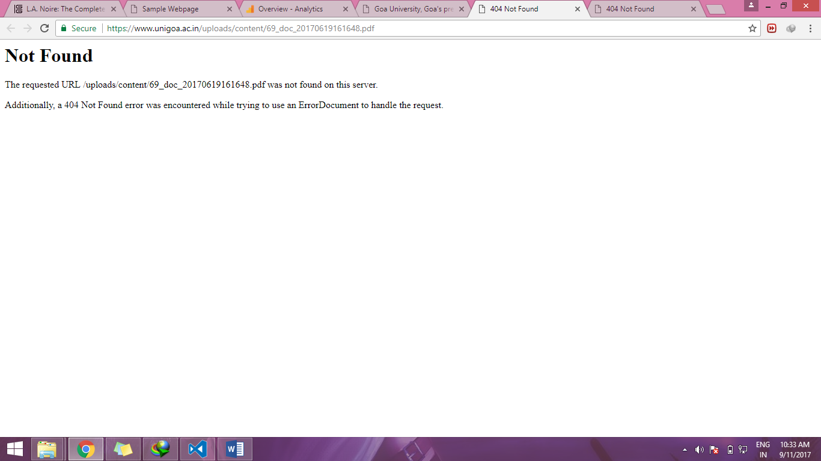

2) No videos in the videos section. At least provide with a message saying “No videos to display”

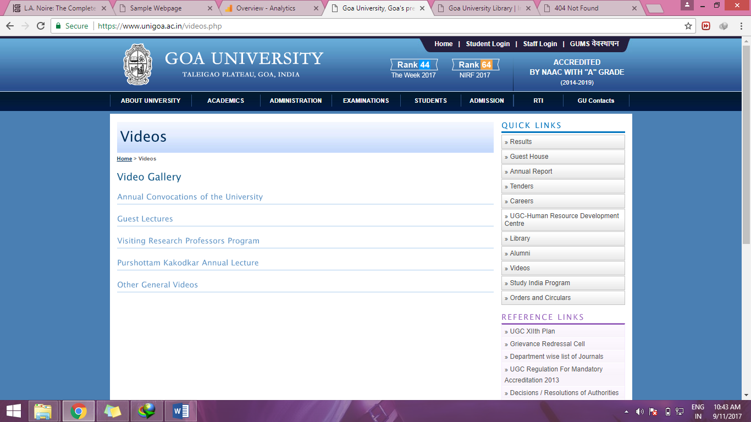

3)Anything typed in the textbox is accepted to be an email. No validations.

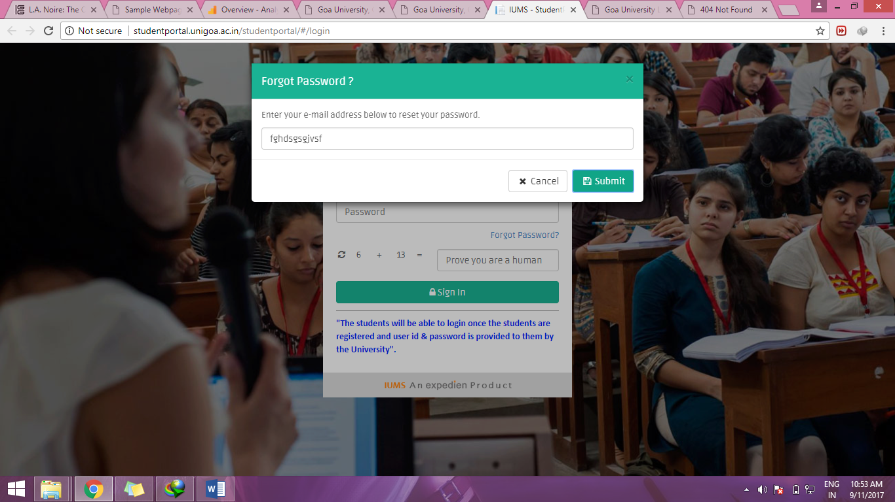

4)Forgot password link in staff login leads to the following page. If forgot password feature is not allowed, remove the link.

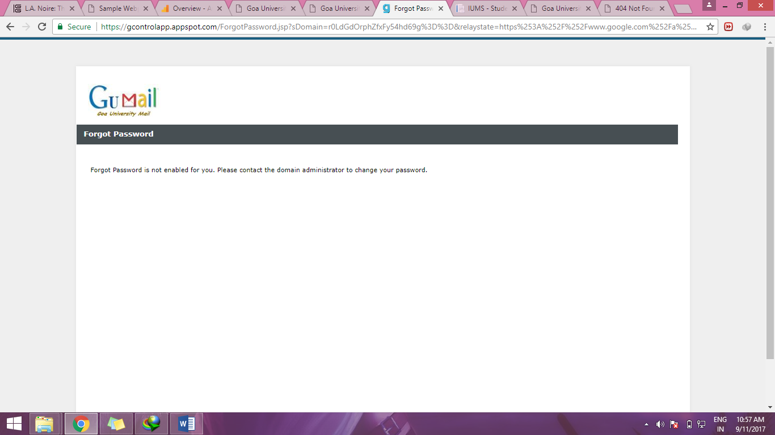

5) Font size small and content is not properly visible especially to people with weak eye sight.

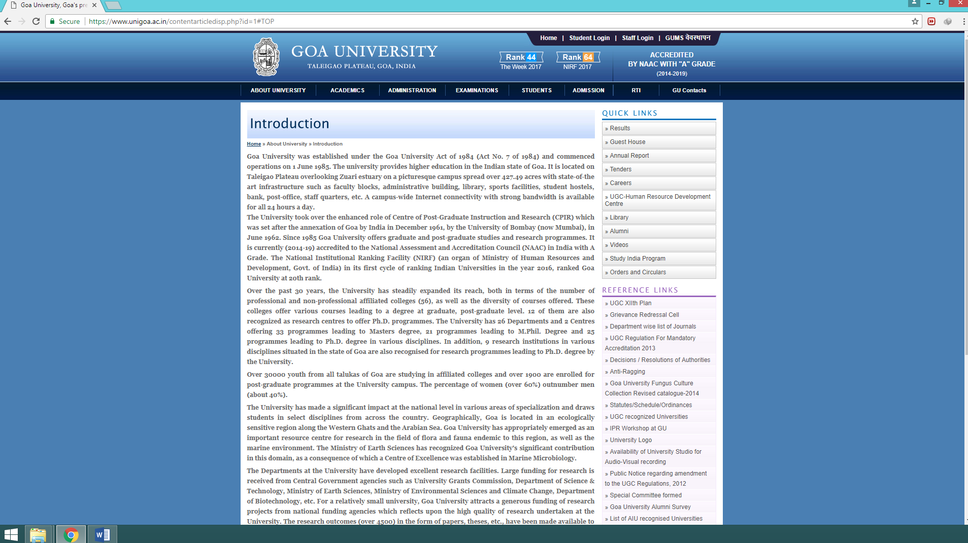

6)Inconsistent picture grid display

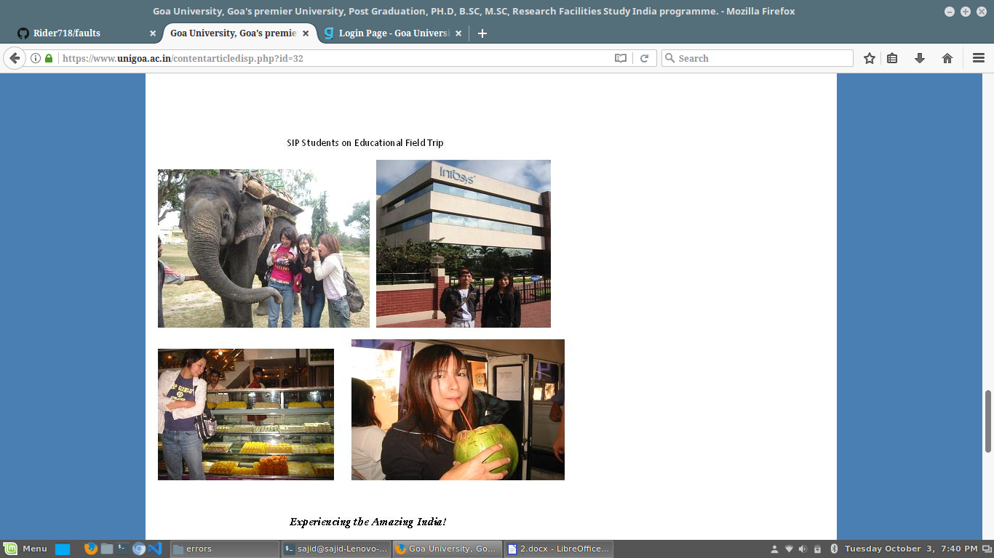

7)Inconsistent color scheme

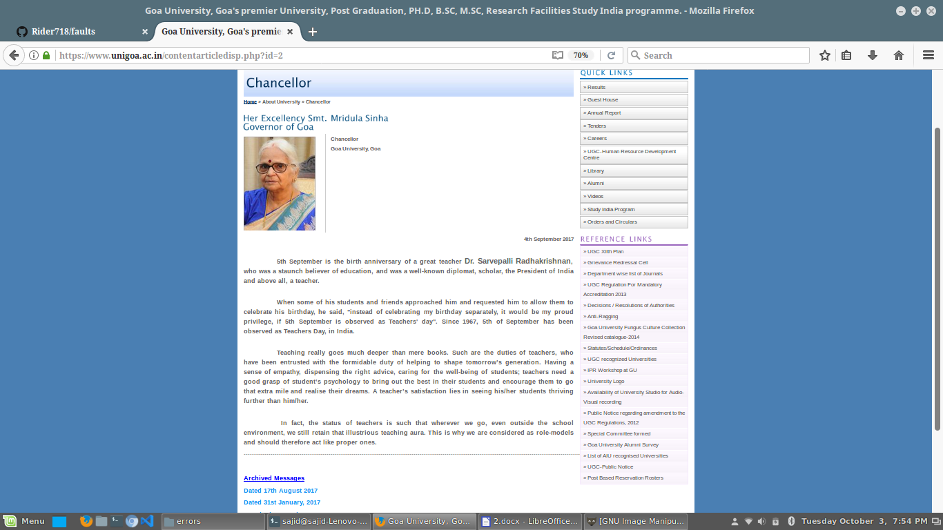

8)Excessive use of color. Compromises uniformity.

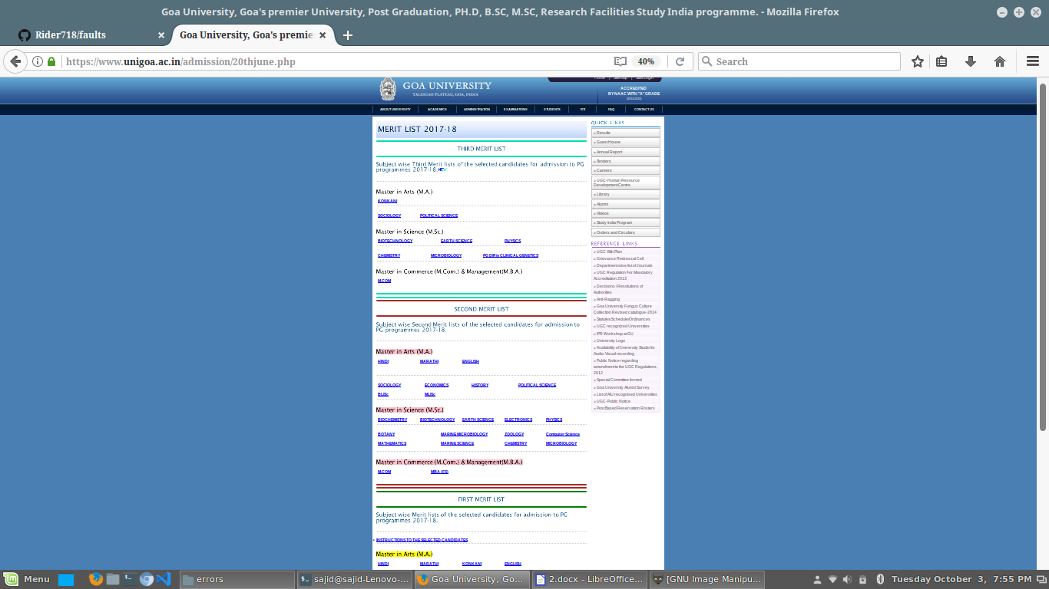

9)Change in the upper navigation links

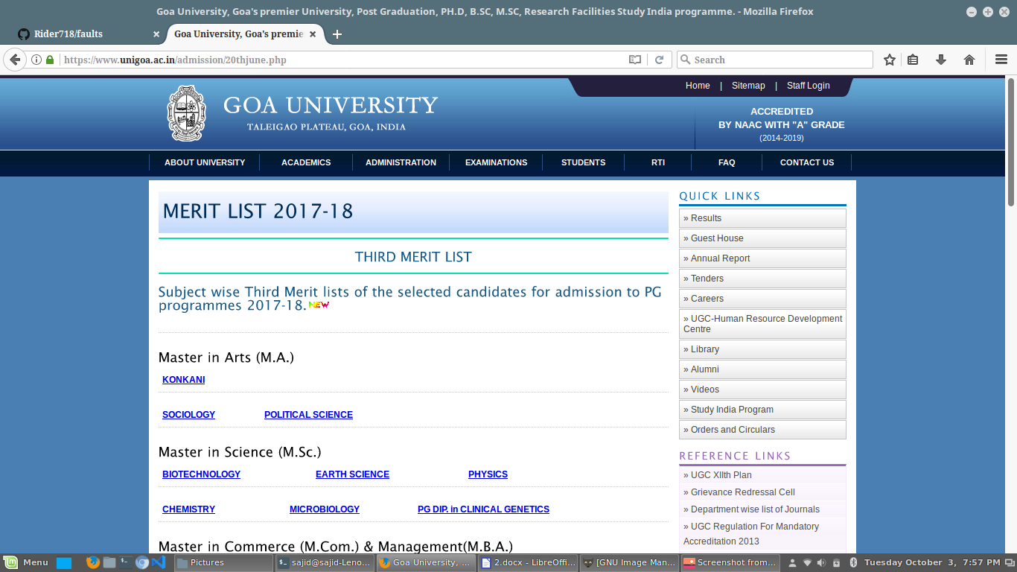

10)Most of the links on the website are pdfs. Not a good experience for the user.

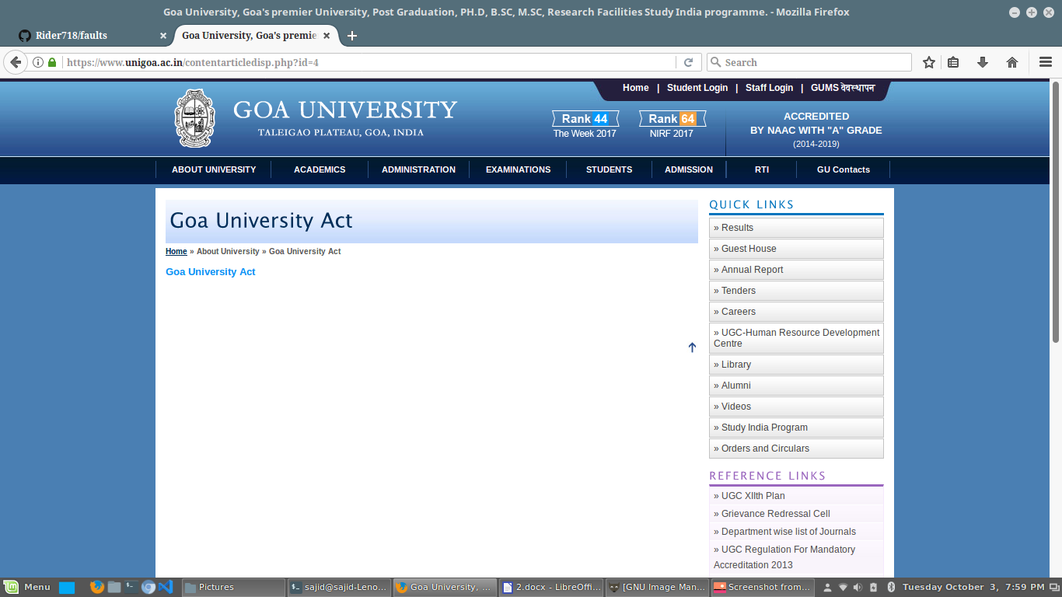

11)Website is not responsive

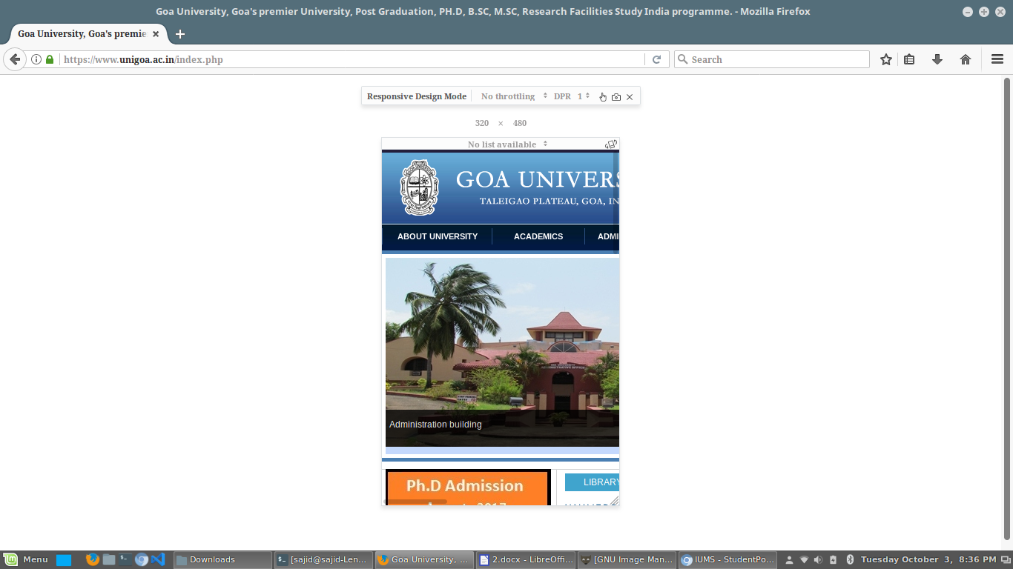

12)Non uniformity across different modules of the website like library, student login, staff login.

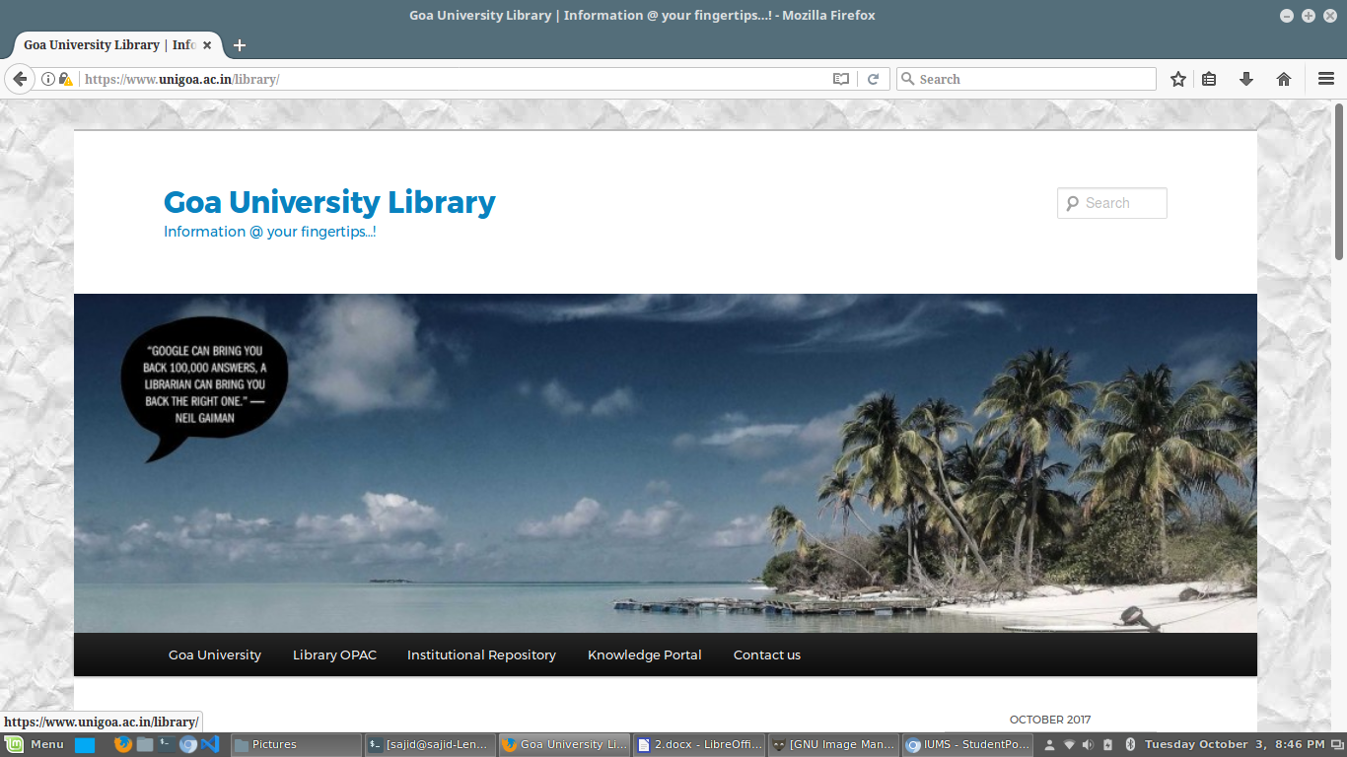

13)No favicon used

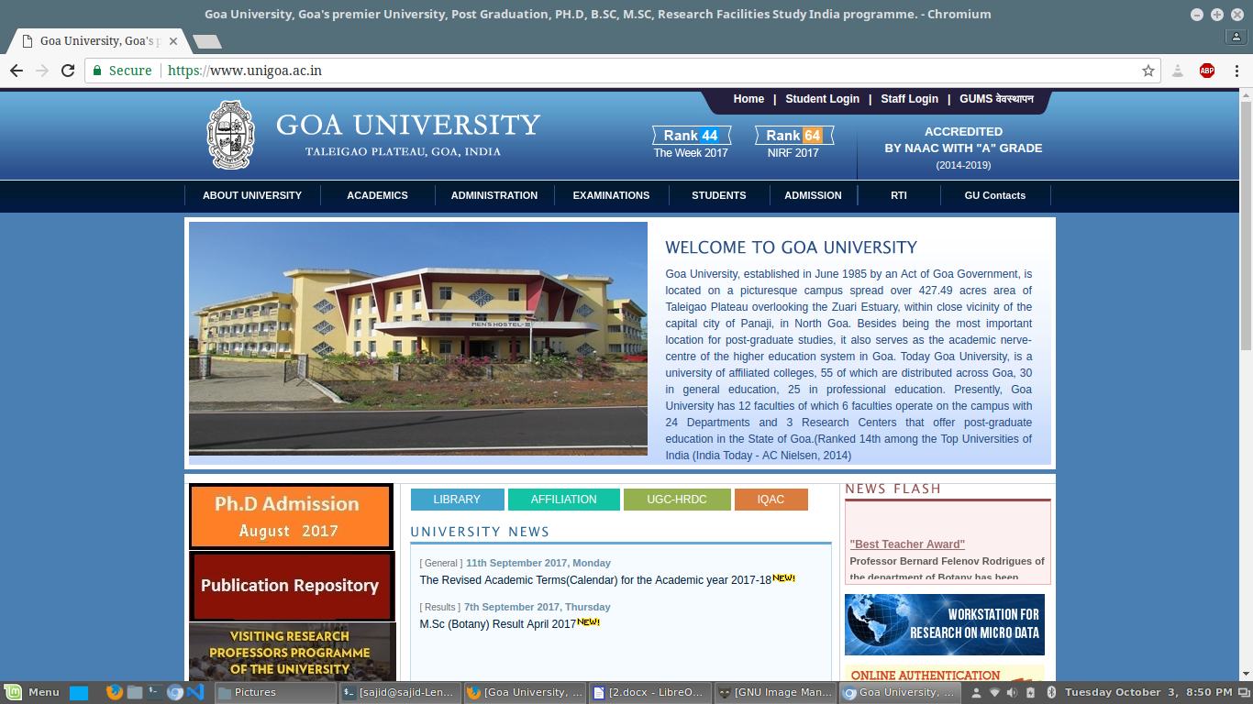

6)About university-> goa university act, gu it policyp, institutional view plan,status,ordiance

7) academics -> list of recognised guides of goa university empty

Acedemics -> fellowship/scholership scheme, fee structure

Acedemics -> faculty of university -> department of english : unessasry links are given

Publication: no uniformity is maintained

Department of french and francophone studies: thrust areas,infrastructure

Dean of faculty images are not uniform, fixed size, some information of deans are not updated

Academics -> faculties of the university and academics departments all subjects have save information stored. Redundancy

Academics-> affiliate institutions -> professional colleges city: bicholim, course group: bachelors degree in education ,course: -select- ERR………………..

B in science agriculture

Bsc bachelor in education

Masters in science hydrography

Master of science in nursing

Master of library and info sci

Two radio buttons city and course. Can’t understand why it’s there ?!

Informal way of displaying message “Sorry !!! No Affiliates Details Found ...”

Should also sort according to degree

Affiliate institution should be categorized properly and not in the drop down

Acedemics-> programs offered -> masters: in that bachelors option also can be given the the drop down, not organized properly

In Acedemics-> programs offered -> phd programmes, M phill : programme group is not reqired but still given

Academics -> center/programs /projects ->research development and resources mobilization cell

Visiting research professors programs: “Not Found

The requested URL /VRPP was not found on this server.

Additionally, a 404 Not Found error was encountered while trying to use an ErrorDocument to handle the request.”