**JTARPG World building**

* Keep it small
* A world divided in sections
* Some sections bigger and wealthier than others
* Each section has 1 wealthy city
* Further distance from the city, poorer area

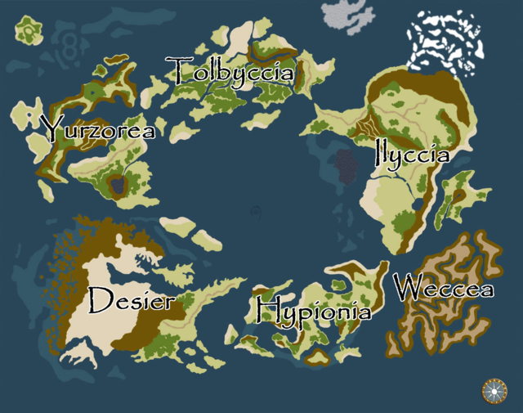

*Temporary example map*

* Demons roam the lands everywhere
* People don’t actually know where they come from (something for us to think about)
* Wealthier areas have more protection against demons
* Hunters roaming the lands killing demons
* Each section has their own known top class hunters (mercenaries that can be paid)
* Demons stay away from well protected areas or where a known top class hunter is near

*Claymore episode 1*

<https://www.youtube.com/watch?v=y5KDzc4Xw1A>

* Antagonist is human (A demon would be too predictable)
* We can use the definition of demon quite broadly as it’s an otherworldly being basically capable of anything
* Demons have their own hierarchy

*Shingeki no Bahamut, Demon Invasion*

<https://www.youtube.com/watch?v=LvMj-tux6wY>

*Berserk*

<https://www.youtube.com/watch?v=7gkuxh3SbdY>

* Demons are always in search for food (uncontrollable hunger)
* Unable to live in harmony with humans (food chain)
* Humans are used as cattle by demons

*The Promised Neverland*

<https://www.youtube.com/watch?v=EcMWYK33vHw>

* Demons with excessive power are sealed or left alone as long as they don’t cause any problems or when they aren’t known
* Wars have been fought previously

*Claymore, VS Awakend being left alone because of threat*

<https://www.youtube.com/watch?v=Hh5_b86_Pm4>

* Living and breathing world (Player actions can change what happens in certain areas, new dialogue or animations for villagers)

*Persona 5, Shibuya*

<https://www.youtube.com/watch?v=nftXCH9KllE>

Additional notes

-Demons eten ook elkaar op.

-Ridgie suggeert dat demons lijken op wat ze eten.

-Bijv Demons eten specifiek "kinderen", mannen of vrouwen en nemen die vorm aan.