Removal of Ambiguity (Converting an Ambiguous Grammar into Unambiguous Grammar)
Ambiguous grammar, in computer languages and compilers, refers to when certain elements from source code may be parsed according to more than one possible interpretation since there exist ambiguous or conflicting grammar production rules. This may lead to uncertainty about how the code will be processed and what will be executed.
Think of it this way: consider having a recipe that says something like "cook the pasta until done." If it is not defined what "done" is, one may end up overcooking or undercooking their pasta. Similarly, in programming, where the grammar is ambiguous, this may result in inconsistent interpretation, or incorrect interpretation, of code.
Ambiguity removal is aimed at clarity and precision in the grammar of a programming language so that each sentence written in such a language would have only one interpretation. If the forms within a program have unique meanings, then the compiler or interpreter can process it correctly and without any errors.

What is Ambiguity?
Ambiguity in grammar can be explained as a case when any one single string or expression can be interpreted in more than one way owing to different parse trees. This happens when, with the same input, a grammar gives rise to more than one valid derivation or more than one parse tree displaying different meanings or structures. In the context of programming languages, ambiguity is undesirable because it may cause a compiler or interpreter to give indeterminate results, and thus inconsistent, as to which of several possible interpretations was intended.
For example, take the math expression "3 + 4 * 5." Because the grammar itself does not define precedence, this can be understood either as "(3 + 4) * 5" or as "3 + (4 * 5)"-both versions bound by different results.
Indeed, ambiguity removal does require designing grammars that map every valid input string to a unique parse tree and hence predictable behavior, so as not to create confusion during language processing.

We are going to see the removal of ambiguity from grammar using suitable examples.

Ambiguous vs Unambiguous Grammar
The grammars which have more than one derivation tree or parse tree are ambiguous. This grammar is not parsed by any parsers.
Example:
1. Consider the production shown below:
S->aSbS | bSaS | ∈
Say, we want to generate the string "abab" from the above grammar. We can observe that the given string can be derived using two parse trees. So, the above grammar is ambiguous.
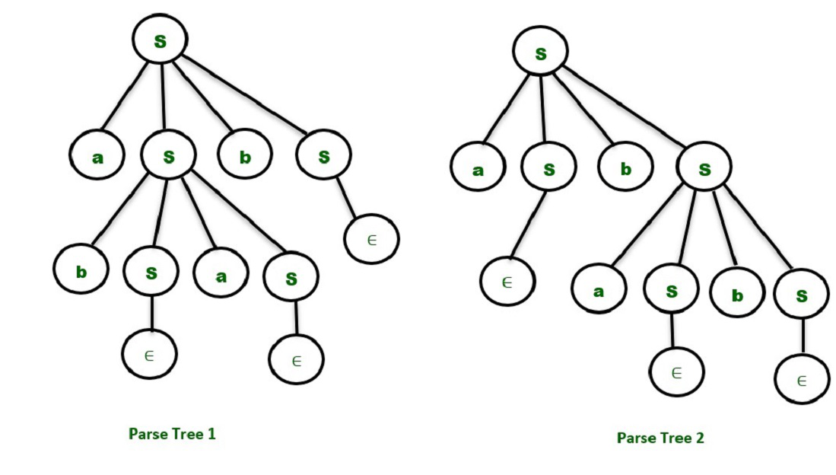
The grammars which have only one derivation tree or parse tree are called unambiguous grammars.
2. Consider the productions shown below:
S -> AB
A -> Aa | a
B -> b
For the string "aab" we have only one Parse Tree for the above grammar as shown below.
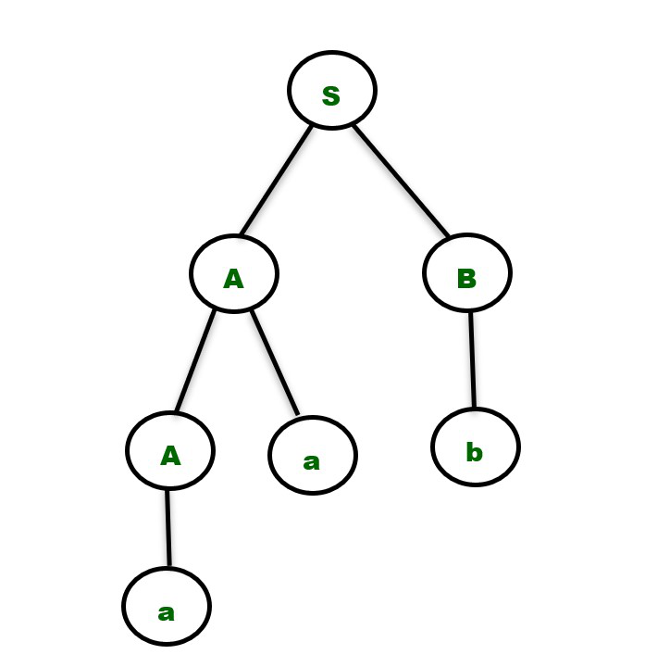
It is important to note that there are no direct algorithms to find whether grammar is ambiguous or not. We need to build the parse tree for a given input string that belongs to the language produced by the grammar and then decide whether the grammar is ambiguous or unambiguous based on the number of parse trees obtained as discussed above.
Note - The string has to be chosen carefully because there may be some strings available in the language produced by the unambiguous grammar which has only one parse tree.

Removal of Ambiguity
We can remove ambiguity solely on the basis of the following two properties -

1. Precedence
If different operators are used, we will consider the precedence of the operators. The three important characteristics are :
- The level at which the production is present denotes the priority of the operator used.
- The production at higher levels will have operators with less priority. In the parse tree, the nodes which are at top levels or close to the root node will contain the lower priority operators.
- The production at lower levels will have operators with higher priority. In the parse tree, the nodes which are at lower levels or close to the leaf nodes will contain the higher priority operators.

2. Associativity
If the same precedence operators are in production, then we will have to consider the associativity.
- If the associativity is left to right, then we have to prompt a left recursion in the production. The parse tree will also be left recursive and grow on the left side.
+, -, *, / are left associative operators.
- If the associativity is right to left, then we have to prompt the right recursion in the productions. The parse tree will also be right recursive and grow on the right side.
^ is a right associative operator.
Example 1 - Consider the ambiguous grammar
E -> E-E | id
The language in the grammar will contain { id, id-id, id-id-id, ….}
Say, we want to derive the string id-id-id. Let's consider a single value of id=3 to get more insights. The result should be :
3-3-3 =-3
Since the same priority operators, we need to consider associativity which is left to right.

Parse Tree
The parse tree which grows on the left side of the root will be the correct parse tree in order to make the grammar unambiguous.
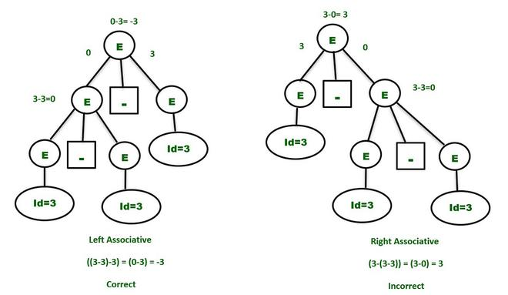
So, to make the above grammar unambiguous, simply make the grammar Left Recursive by replacing the left most non-terminal E in the right side of the production with another random variable, say P. The grammar becomes :
E -> E - P | P
P -> id
The above grammar is now unambiguous and will contain only one Parse Tree for the above expression as shown below -
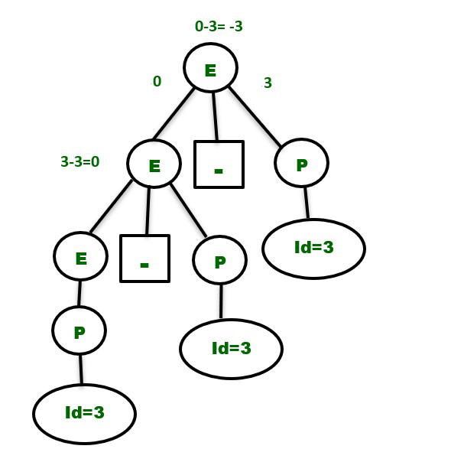
Similarly, the unambiguous grammar for the expression : 2^3^2 will be -
E -> P ^ E | P // Right Recursive as ^ is right associative.
P -> id
Example 2 - Consider the grammar shown below, which has two different operators :
E -> E + E | E * E | id
Clearly, the above grammar is ambiguous as we can draw two parse trees for the string "id+id*id" as shown below. Consider the expression :
3 + 2 * 5 // "*" has more priority than "+"
The correct answer is : (3+(2*5))=13
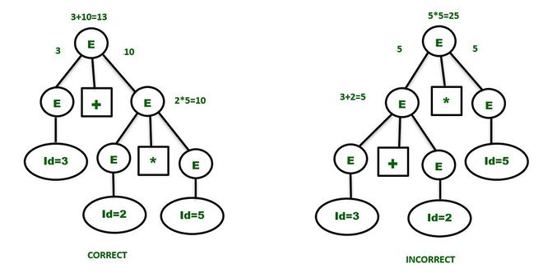
The "+" having the least priority has to be at the upper level and has to wait for the result produced by the "*" operator which is at the lower level. So, the first parse tree is the correct one and gives the same result as expected.
The unambiguous grammar will contain the productions having the highest priority operator ("*" in the example) at the lower level and vice versa. The associativity of both the operators are Left to Right. So, the unambiguous grammar has to be left recursive. The grammar will be :
E -> E + P // + is at higher level and left associative
E -> P
P -> P * Q // * is at lower level and left associative
P -> Q
Q -> id
(or)
E -> E + P | P
P -> P * Q | Q
Q -> id
E is used for doing addition operations and P is used to perform multiplication operations. They are independent and will maintain the precedence order in the parse tree. The parse tree for the string " id+id*id+id " will be -
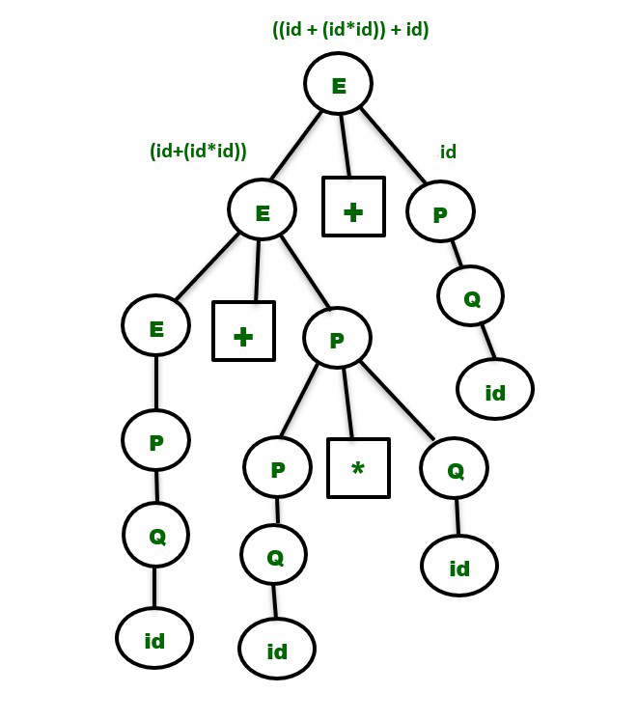
Note : It is very important to note that while converting an ambiguous grammar to an unambiguous grammar, we shouldn't change the original language provided by the ambiguous grammar. So, the non-terminals in the ambiguous grammar have to be replaced with other variables in such a way that we get the same language as it was derived before and also maintain the precedence and associativity rule simultaneously.
This is the reason we wrote the production E -> P and P -> Q and Q -> id after replacing them in the above example, because the language contains the strings { id, id+id } as well.
Similarly, the unambiguous grammar for an expression having the operators -,*,^ is :
E -> E - P | P // Minus operator is at higher level due to least priority and left associative.
P -> P * Q | Q // Multiplication operator has more priority than - and lesser than ^ and left associative.
Q -> R ^ Q | R // Exponent operator is at lower level due to highest priority and right associative.
R -> id
Also, there are some ambiguous grammars which can't be converted into unambiguous grammars.

Converting Context Free Grammar to Chomsky Normal Form
Converting a CFG to CNF is an important step in many parsing algorithms, like the CYK algorithm, and helps in understanding the structure of languages. A context free grammar (CFG) is in Chomsky Normal Form (CNF) if all production rules satisfy the following conditions:
- A non-terminal generating a terminal (e.g.; X→ x)
- A non-terminal generating two non-terminals (e.g.; X→YZ)
- Start symbol generating ε. (e.g.; S→ ε)
Consider the following grammars,
G1 = {S→a, S→AZ, A→a, Z→z}
G2 = {S→a, S→aZ, Z→a}
The grammar G1 is in CNF as production rules satisfy the rules specified for CNF. However, the grammar G2 is not in CNF as the production rule S→aZ contains terminal followed by non-terminal which does not satisfy the rules specified for CNF.

Key Properties of CNF
- A single CFG can be converted into different equivalent CNF forms.
- CNF produces the same language as the original CFG.
- CNF is widely used in parsing algorithms such as:
  - Cocke - Younger - Kasami (CYK) algorithm for membership checking.
  - Bottom-up parsers in compilers.
- For a string of length n, a CNF derivation requires at most 2n-1 derivation steps.
- Any CFG that does not generate ε has an equivalent CNF.

Steps to Convert CFG to CNF

Step 1: Eliminate the Start Symbol from RHS
If start symbol S is at the RHS of any production in the grammar, create a new production as: S0→S where S0 is the new start symbol.

Step 2: Remove Null, Unit, and Useless Productions
- Null (ε) Productions: If a rule contains ε, remove it by modifying other rules accordingly.
- Unit Productions: If a rule has a single non-terminal on the RHS (e.g.,
- A→B
- A→B), replace it with B’s productions.
- Useless Productions: Remove non-reachable or non-generating symbols from the grammar.

Step 3: Replace Terminals in Mixed Productions
Eliminate terminals from RHS if they exist with other terminals or non-terminals. e.g. , production rule X→ xY can be decomposed as: X→ZY, Z→x.

Step 4: Reduce Productions with More Than Two Non-Terminals
Eliminate RHS with more than two non-terminals. e.g,; production rule X→XYZ can be decomposed as: X→PZ, P→XY

Example: Converting a CFG to CNF
Let us take an example to convert CFG to CNF. Consider the given grammar G1:
S → ASB
A → aAS | a | ε
B → SbS | A | bb
Step 1.
As start symbol S appears on the RHS, we will create a new production rule S0→S. Therefore, the grammar will become:
S0→S
S → ASB
A → aAS | a | ε
B → SbS | A | bb
Step 2.
As grammar contains null production A→ ε, its removal from the grammar yields:
S0→S
S → ASB | SB
A → a | aAS | aS
B → SbS | A | ε | bb
Now, it creates null production B→ ε, its removal from the grammar yields:
S0→S
S → AS | S | ASB | SB
A → a | aAS | aS
B → SbS | A | bb
Now, it creates unit production B→A, its removal from the grammar yields:
S0→S
S → AS | ASB | SB | S
A → a | aAS | aS
B → SbS | bb | aAS | aS | a
Also, removal of unit production S0→S from grammar yields:
S0→ AS | ASB | SB | S
S → AS | ASB | SB | S
A → aAS | aS | a
B → SbS | bb | aAS | aS | a
Also, removal of unit production S→S and S0→S from grammar yields:
S0→ AS | ASB | SB
S → AS | ASB | SB
A → aAS | aS | a
B → SbS | bb | aAS | aS | a
Step 3.
In production rule A→aAS | aS and B→ SbS | aAS | aS, terminals a and b exist on RHS with non-terminates. Removing them from RHS:
S0→ AS | ASB | SB
S → AS | ASB | SB
A → XAS | XS |a
B → SYS | bb | XAS | XS |a
X →a
Y→b
Also, B→ bb can’t be part of CNF, removing it from grammar yields:
S0→ AS | ASB | SB
S → AS | ASB | SB
A → XAS | XS | a
B → SYS | YY | XAS | XS | a
X → a
Y → b
Step 4:
In production rule S0→ASB, S→ASB RHS has more than two symbols, removing it from grammar yields:
S0→ AS | PB | SB
S → AS | PB | SB
A → XAS | XS | a
B → SYS | YY | XAS | XS | a
X → a
Y → b
P → AS
Similarly, A→XAS has more than two symbols, removing it from grammar yields:
S0→ AS | PB | SB
S → AS | PB | SB
A → RS | XS | a
B → SYS | YY | RS | XS | a
X → a
Y → b
P → AS
R → XA
Similarly, B→SYS has more than two symbols, removing it from grammar yields:
S0→ AS | PB | SB
S → AS | PB | SB
A → RS | XS | a
B → TS | YY | RS | XS | a
X → a
Y → b
P → AS
R → XA
T → SY
So this is the required CNF for given grammar.

Converting Context Free Grammar to Greibach Normal Form
Context-free grammar (CFG) and Greibach Normal Form (GNF) are fundamental concepts in formal language theory, particularly in the field of compiler design and automata theory. This article delves into what CFG and GNF are, provides examples, and outlines the steps to convert a CFG into GNF.

What is Context Free Grammar?
Context-Free Grammar (CFG) is a set of recursive rewriting rules used to generate patterns of strings. A CFG consists of a set of production rules that describe all possible strings in a given formal language.

What is the Greibach Normal Form?
A CFG is in Greibach Normal Form (GNF) if all production rules satisfy one of the following conditions:
- A non-terminal generating a terminal (e.g., X→xX→x)
- A non-terminal generates a terminal followed by any number of non-terminals (e.g., X→xX1X2…XNX→xX1​X2​…XN​)
Consider the following grammar:
- G1={S→aA∣bB,B→bB∣b,A→aA∣a}G1={S→aA∣bB,B→bB∣b,A→aA∣a}
- G2={S→aA∣bB,B→bB∣ϵ,A→aA∣ϵ}G2={S→aA∣bB,B→bB∣ϵ,A→aA∣ϵ}
The grammar G1G1 is in CNF as production rules satisfy the rules specified for CNF, so it can be directly used to convert to GNF. According to the rules, G1G1 is also in GNF form. However, the grammar G2G2 is not in CNF as the production rules B→ϵB→ϵ and A→ϵA→ϵ do not satisfy the rules specified for CNF (only the start symbol can generate ϵϵ), so first remove the unit and null production and convert it into GNF.
A context-free grammar (CFG) is in Greibach Normal Form (GNF) if all production rules satisfy one of the following conditions:
- A non-terminal generating a terminal (e.g.; X->x)
- A non-terminal generates a terminal followed by any number of non-terminals (e.g.; X->xX1X2…XN)
Consider the following grammar:
G1 = {S->aA|bB, B->bB|b, A->aA|a}
G2 = {S->aA|bB, B->bB|ε, A->aA|ε}
The grammar G1 is in CNF as production rules satisfy the rules specified for CNF so it can be directly used to convert to GNF. According to the rules G1 is also in GNF form. However, the grammar G2 is not in CNF as the production rules B -> ε and A-> ε do not satisfy the rules specified for CNF (only start symbol can generate ε), so first remove the unit and null production and convert it into GNF.
Note:
- For a given grammar, there can be more than one GNF
- GNF produces the same language as generated by CFG

How to Convert CFG to GNF
Step 1. If the given grammar is not in CNF, convert it to CNF. You can refer following article to convert CFG to CNF: Converting Context Free Grammar to Chomsky Normal Form.
Step 2. Change the names of non terminal symbols to A1 till AN in same sequence.
Step 3. Check for every production rule if RHS has first symbol as non terminal say Aj for the production of Ai, it is mandatory that i should be less than j. Not great and not even equal.
If i> j then replace the production rule of Aj at its place in Ai.
If i=j, it is the left recursion. Create a new state Z which has the symbols of the left recursive production, once followed by Z and once without Z, and change that production rule by removing that particular production and adding all other production once followed by Z.
Step 4. Replace very first non terminal symbol in any production rule with its production until production rule satisfies the above conditions.
For converting a CNF to GNF always move left to right for renaming the variables.
Example: Suppose this the production and we need to convert it into GNF.
S → XA|BB
B → b|SB
X → b
A → a
For converting a CNF to GNF first rename the non terminal symbols to A1,A2 till AN in same sequence as they are used.
A1 = S
A2 = X
A3 = A
A4 = B
Therefore, now the new production rule is,
A1 → A2A3 | A4A4
A2 → b
A3 → a
A4 → b | A1A4
Now, check for every production Ai → Aj X, where X can be any number of terminal symbols. If i<j in the production then it is good to go to the next step but if i>=j then change the production by replacing it with that terminal symbol's production. if i=j then it is a left recursion and you need to remove left recursion.
Here for A4, 4 !< 1, so now replace it with A1's production rule.
1.
A1 → A2A3 | A4A4
A2 → b
A3 → a
A4 → b | A2A3A4 | A4A4A4
----------------------
2.
A1 → A2A3 | A4A4
A2 → b
A3 → a
A4 → b | bA3A4 | A4A4A4
Here A4A4A4 in production rule of A4 is the example of left recursion.
To replace the left most recursion take a new Non terminal symbol Z, which has the X part or the trailing part of the left most recursive production once followed by Z and once without Z. Here in A4A4A4, the part after the first A4 is A4A4, therefore
Z → A4A4 | A4A4Z
Now change the above production rule by putting Z after every previous production of that Ai, and remove the left recursive production.
A1 → A2A3 | A4A4
A2 → b
A3 → a
A4 → b | bA3A4 | bZ | bA3A4Z
Z → A4A4 | A4A4Z
The Last step is to replace the production to the form of either
Ai → x (any single terminal symbol)
OR
Ai → xX (any single terminal followed by any number of non terminals)
So here we need to replace A2 in production rule of A1 and so on.
A1 → bA3 | bA4 | bA3A4A4 | bZA4 | bA3A4ZA4
A2 → b
A3 → a
A4 → b | bA3A4 | bZ | bA3A4Z
Z → bA4 | bA3A4A4 | bZA4 | bA3A4ZA4 | bA4Z | bA3A4A4Z | bZA4Z | bA3A4ZA4Z
The respective grammar is non in GNF form.
Decision Properties
- Emptiness: We can decide if a CFL is empty (i.e., it has no strings).
- Finiteness: We can decide if a CFL has only a finite number of strings.
- Membership: We can decide if a string belongs to a CFL (using parsing techniques like CYK algorithm).
- Equivalence: Undecidable. We cannot always determine if two CFLs are exactly the same.
- Universality (L = Σ*) : Undecidable.
- Inclusion (L₁ ⊆ L₂) : Undecidable.

Introduction to Syntax Analysis in Compiler Design
Syntax Analysis, also called Parsing, is the second stage of a compiler and takes place after Lexical Analysis. In the first stage, the source code is broken into small pieces called tokens. Syntax analysis then checks how these tokens are arranged.
The main goal of syntax analysis is to make sure that the tokens are placed in a correct and meaningful order, according to the grammar rules of the programming language. If the structure is correct, the parser creates a Parse Tree or an Abstract Syntax Tree (AST), which shows the program’s structure in a clear, hierarchical way and helps the compiler understand the code better.

Role of Syntax Analysis
- Takes tokens produced by the lexical analyzer as input
- Verifies the grammatical structure of the program
- Detects syntax errors such as missing semicolons or unmatched parentheses
- Builds a parse tree or AST for further compiler phases

Concepts for Syntax Analysis in Compiler Design
1. Context-Free Grammars (CFG)
A Context-Free Grammar (CFG) defines the syntax rules of a programming language. It consists of production rules that describe how valid strings (token sequences) are formed.
CFGs are powerful enough to represent:
- Nested structures
- Balanced parentheses
- Block-structured programming constructs
Because of this, CFGs are widely used to specify the syntax of programming languages.
2. Derivations
A derivation is the step-by-step process of applying grammar rules to start from the start symbol and finally produce a valid string of tokens.
It helps the parser build a parse tree, which visually shows how the grammar rules are applied to form the structure of the program.
3. Concrete Syntax Tree (CST)
Represents the complete grammatical structure of the source code, including all grammar symbols and punctuation.
4. Abstract Syntax Tree (AST)
A simplified version of the CST that removes unnecessary details and keeps only the essential syntactic structure.
ASTs are preferred in later compiler phases because they are easier to analyze and optimize.
5. Ambiguity
A grammar is called ambiguous when the same input string can be parsed in more than one way, producing multiple parse trees.
This can confuse the compiler and lead to incorrect interpretation of the program, so programming languages are designed using unambiguous grammars.

Features of Syntax Analysis

Syntax Tree Construction
Syntax analysis creates a syntax tree, which is a hierarchical representation of the program. This tree shows how different parts of the code—such as statements, expressions, and operators—are related to each other.

Grammar-Based Validation
The parser uses context-free grammar (CFG) rules to check whether the program follows the correct syntax of the programming language. These grammar rules define how valid programs should be written.

Top-Down and Bottom-Up Parsing
Syntax analysis can be performed using two main parsing techniques:
- Top-Down Parsing: Builds the syntax tree starting from the root and moving toward the leaves.
- Bottom-Up Parsing: Builds the syntax tree starting from the leaves and moving upward to the root.

Error Detection
Syntax analysis detects syntax errors in the program, such as missing semicolons or incorrect statement structure. When an error is found, the parser reports it clearly so the programmer can fix it.
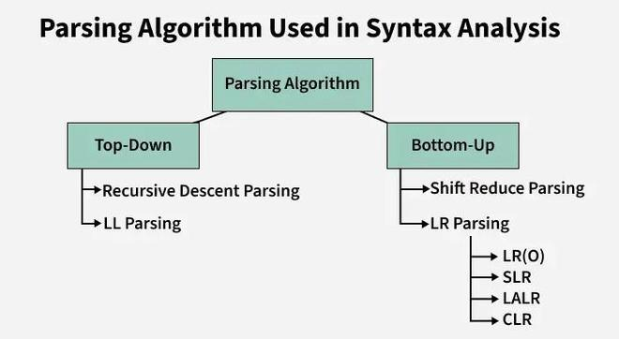Parsing Algos

Context-Free Grammar (CFG)
A Context-Free Grammar (CFG) provides a powerful way to define programming languages by handling structures that regular expressions cannot. Unlike regular expressions, CFGs can represent complex and nested patterns, such as:
- Properly balanced parentheses
- Functions with nested blocks
CFGs describe context-free languages, which are more expressive than regular languages. They use production rules to show how symbols can be replaced to form valid programs, making CFGs well-suited for defining the syntax of programming languages.

Parse Tree
A parse tree, also called a syntax tree, is a tree-shaped diagram that shows how a string is formed using the rules of a Context-Free Grammar (CFG). It visually explains how the parser starts from the grammar’s start symbol and applies production rules to generate the input string.
- The root of the tree represents the start symbol of the grammar.
- Internal nodes represent non-terminal symbols, which are expanded using grammar rules.
- Leaf nodes represent terminal symbols, which correspond to the actual tokens in the input.
Example: Suppose Production rules for the Grammar of a language are:
S -> cAd
A -> bc|a
And the input string is “cad”.
Now the parser attempts to construct a syntax tree from this grammar for the given input string. It uses the given production rules and applies those as needed to generate the string. To generate string “cad” it uses the rules as shown in the given diagram: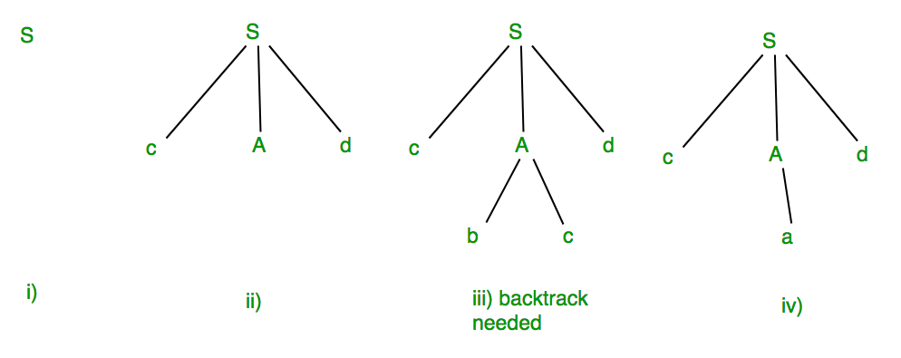
In step (iii) above, the production rule A->bc was not a suitable one to apply (because the string produced is “cbcd” not “cad”), here the parser needs to backtrack, and apply the next production rule available with A which is shown in step (iv), and the string “cad” is produced.
Thus, the given input can be produced by the given grammar, therefore the input is correct in syntax. But backtrack was needed to get the correct syntax tree, which is really a complex process to implement.

Steps in Syntax Analysis Phase
The Syntax Analysis phase, also known as Parsing, checks whether the structure of the source code follows the grammar rules of the programming language.

Parsing
- The parser takes the tokens produced by the lexical analyzer and checks them against the grammar rules. If the structure is valid, it constructs a parse tree or an Abstract Syntax Tree (AST) that represents the hierarchical structure of the program.

Error Handling
- If the source code contains syntax errors, the parser detects them and reports meaningful error messages, often indicating the location of the error so the programmer can correct it.

Symbol Table Interaction
- During parsing, information about identifiers such as their names and scopes is recorded and updated in the symbol table, which is later used by other compiler phases.

