Grammar in Theory of Computation
Grammar refers to a formal system that defines how strings in a language are constructed.
It plays a crucial role in determining the syntactic correctness of languages and forms the foundation for parsing and interpreting programming languages, natural languages, and other formal systems.
Or
Grammar is a formal system that defines a set of rules for generating valid strings within a language. It serves as a blueprint for constructing syntactically correct sentences or meaningful sequences in a formal language.

Representation of Grammar
A grammar G can be formally written as a 4-tuple (N, T, S, P) where −
- N or V_{N} is a set of variables or non-terminal symbols.
- T or ∑ is a set of Terminal symbols.
- S is a special variable called the Start symbol, S ∈ N
- P is Production rules for Terminals and Non-terminals. A production rule has the form α → β, where α and β are strings on V_{N} ∪ ∑ and least one symbol of α belongs to V_{N}.
The types of grammars:
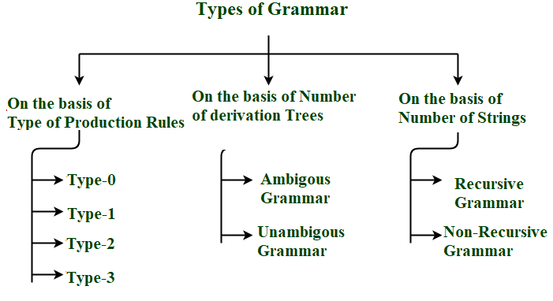

Types of Grammars
There are several types of Grammar. We classify them on the basis mentioned below.
- Type of Production Rules: The form and complexity of the production rules define the grammar type, such as context-free, context-sensitive, regular, or unrestricted grammars.
- Number of Derivation Trees: The number of ways a string can be derived from the grammar. Ambiguous grammars have multiple derivation trees for the same string.
- Number of Strings: The size and nature of the language generated by the grammar.

Basic Elements/components of Grammar
Grammar is composed of two basic elements
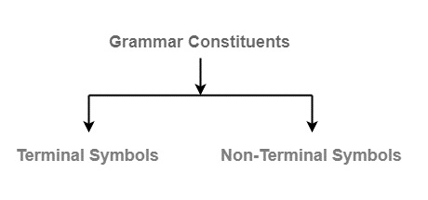
Terminal Symbols - Terminal symbols are the components of the sentences that are generated using grammar and are denoted using small case letters like a, b, c etc.
Non-Terminal Symbols - Non-Terminal Symbols take part in the generation of the sentence but are not the component of the sentence. These types of symbols are also called Auxiliary Symbols and Variables. They are represented using a capital letter like A, B, C, etc.

Example 1
Consider a grammar
G=(V,T,P,S)
Where,
- V = { S , A , B } Non-Terminal symbols
- T = { a , b } Terminal symbols
- P = { S → ABa , A → BB , B → ab , AA → b } Production rules
- S = { S } Start symbol

Example 2
Consider a grammar
G=(V,T,P,S)
Where,
- V = {S, A, B} non terminal symbols
- T = { 0,1} terminal symbols
- P = { S → A1B A → 0A| ε B → 0B| 1B| ε } Production rules
- S = {S} start symbol.

The process of string derivation using grammar rules:

Production Rules
A production or production rule in computer science is a rewrite rule specifying a symbol substitution that can be recursively performed to generate new symbol sequences. It is of the form α-> β where α is a Non-Terminal Symbol which can be replaced by β which is a string of Terminal Symbols or Non-Terminal Symbols.

Example 1
Consider Grammar G1 = <N, T, P, S>
T = {a,b} #Set of terminal symbols
1 2 3 4 5
P = { A -> Aa, A -> Ab, A -> a ,A -> b, A -> 𝜺} #Set of all production rules
S = {A} #Start Symbol
As the start symbol S is equivalent to A then we can produce Aa, Ab, a, b, 𝜺 strings. These strings can further produce strings where A can be replaced by the strings mentioned in the production rules. Hence this grammar can be used to produce strings of the form (a+b)*.
Derivation of Strings
A->a #using production rule 3
OR
A->Aa #using production rule 1
Aa->ba #using production rule 4
OR
A->Aa #using production rule 1
Aa->AAa #using production rule 1
AAa->bAa #using production rule 4
bAa->ba #using production rule 5

Example
Let us consider the grammar −
G2 = ({S, A}, {a, b}, S, {S → aAb, aA → aaAb, A → ε } )
Some of the strings that can be derived are −
S ⇒ aAb using production S → aAb
⇒ aaAbb using production aA → aAb
⇒ aaaAbbb using production aA → aaAb
⇒ aaabbb using production A → ε

Chomsky Classification of Grammars
According to Noam Chomosky, there are four types of grammars − Type 0, Type 1, Type 2, and Type 3. The following table shows how they differ from each other −
Grammar Type | Grammar Accepted | Language Accepted | Automaton
Type 0 | Unrestricted grammar | Recursively enumerable language | Turing Machine
Type 1 | Context-sensitive grammar | Context-sensitive language | Linear-bounded automaton
Type 2 | Context-free grammar | Context-free language | Pushdown automaton
Type 3 | Regular grammar | Regular language | Finite state automaton
Take a look at the following illustration. It shows the scope of each type of grammar −
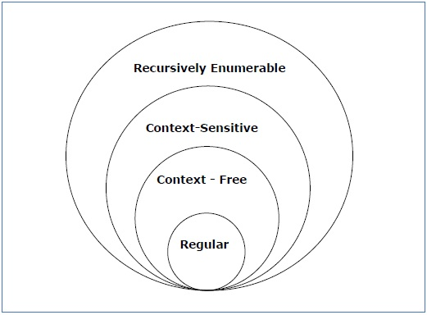

Type - 3 Grammar
Type-3 grammars generate regular languages. Type-3 grammars must have a single non-terminal on the left-hand side and a right-hand side consisting of a single terminal or single terminal followed by a single non-terminal.
The productions must be in the form X → a or X → aY
where X, Y ∈ N (Non terminal)
and a ∈ T (Terminal)
The rule S → ε is allowed if S does not appear on the right side of any rule.

Example
X → ε
X → a | aY
Y → b

Advertisement

Type - 2 Grammar
Type-2 grammars generate context-free languages.
The productions must be in the form A →
where A ∈ N (Non terminal)
and ∈ (T ∪ N)* (String of terminals and non-terminals).
These languages generated by these grammars are be recognized by a non-deterministic pushdown automaton.

Example
S → X a
X → a
X → aX
X → abc
X → ε

Type - 1 Grammar
Type-1 grammars generate context-sensitive languages. The productions must be in the form
α A β → α β
where A ∈ N (Non-terminal)
and α, β, ∈ (T ∪ N)* (Strings of terminals and non-terminals)
The strings α and β may be empty, but must be non-empty.
The rule S → ε is allowed if S does not appear on the right side of any rule. The languages generated by these grammars are recognized by a linear bounded automaton.

Example
AB → AbBc
A → bcA
B → b

Type - 0 Grammar
Type-0 grammars generate recursively enumerable languages. The productions have no restrictions. They are any phase structure grammar including all formal grammars.
They generate the languages that are recognized by a Turing machine.
The productions can be in the form of α → β where α is a string of terminals and nonterminals with at least one non-terminal and α cannot be null. β is a string of terminals and non-terminals.

Example
S → ACaB
Bc → acB
CB → DB
aD → Db

Equivalent Grammars
Two grammars are said to be equivalent if they generate the same language. For instance, if Grammar 1 and Grammar 2 both generate strings of the form (𝑎+𝑏)∗, they are considered equivalent.

Construction of a Grammar Generating a Language
Well consider some languages and convert it into a grammar G which produces those languages.

Example
Problem − Suppose, L (G) = {a^{m} b^{n} | m ≥ 0 and n > 0}. We have to find out the grammar G which produces L(G).
Solution
Since L(G) = {a^{m} b^{n} | m ≥ 0 and n > 0}
the set of strings accepted can be rewritten as −
L(G) = {b, ab,bb, aab, abb, .}
Here, the start symbol has to take at least one b preceded by any number of a including null.
To accept the string set {b, ab, bb, aab, abb, .}, we have taken the productions −
S → aS , S → B, B → b and B → bB
S → B → b (Accepted)
S → B → bB → bb (Accepted)
S → aS → aB → ab (Accepted)
S → aS → aaS → aaB → aab(Accepted)
S → aS → aB → abB → abb (Accepted)
Thus, we can prove every single string in L(G) is accepted by the language generated by the production set.
Hence the grammar −
G: ({S, A, B}, {a, b}, S, { S → aS | B , B → b | bB })

Context-Free Grammar Introduction
Definition − A context-free grammar (CFG) consisting of a finite set of grammar rules is a quadruple (N, T, P, S) where
- N is a set of non-terminal symbols.
- T is a set of terminals where N ∩ T = NULL.
- P is a set of rules, P: N → (N ∪ T)*, i.e., the left-hand side of the production rule P does have any right context or left context.
- S is the start symbol.
Example
- The grammar ({A}, {a, b, c}, P, A), P : A → aA, A → abc.
- The grammar ({S, a, b}, {a, b}, P, S), P: S → aSa, S → bSb, S → ε
- The grammar ({S, F}, {0, 1}, P, S), P: S → 00S | 11F, F → 00F | ε

Generation of Derivation Tree
A derivation tree or parse tree is an ordered rooted tree that graphically represents the semantic information a string derived from a context-free grammar.

Representation Technique
- Root vertex − Must be labeled by the start symbol.
- Vertex − Labeled by a non-terminal symbol.
- Leaves − Labeled by a terminal symbol or ε.
If S → x₁x₂ x_{n} is a production rule in a CFG, then the parse tree / derivation tree will be as follows −
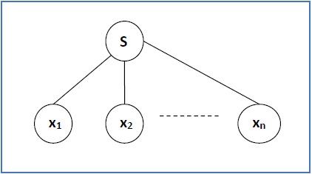
There are two different approaches to draw a derivation tree −
Top-down Approach −
- Starts with the starting symbol S
- Goes down to tree leaves using productions
Bottom-up Approach −
- Starts from tree leaves
- Proceeds upward to the root which is the starting symbol S

Derivation Tree
The derivation or the yield of a parse tree is the final string obtained by concatenating the labels of the leaves of the tree from left to right, ignoring the Nulls. However, if all the leaves are Null, derivation is Null.
Or

What are Derivation Tree?
A Derivation Tree, also known as a Parse Tree, is a visual representation of the process by which a context-free grammar generates a particular string. It provides a hierarchical breakdown of the string. This illustrates the sequence of production rules applied to derive the string from the grammar's start symbol.

Key Elements of a Derivation Tree
Before learning how to construct a derivation tree, let's understand their essential components:
- Root Vertex − The root vertex represents the starting point of the derivation process and is always labeled with the grammar's start symbol.
- Vertices (Internal Nodes) − These nodes represent the non-terminal symbols of the grammar, serving as intermediate stages in the derivation.
- Leaves − These nodes represent the terminal symbols of the grammar, forming the final string derived from the grammar. They can also be labeled with the empty symbol, ε, if the grammar allows for empty productions.

Example of Context-Free Grammar
Let's consider the following context-free grammar G −
G=(V,T,P,S)
Where,
- V = {S, A, B} (Variables or Non-terminal symbols)
- T = {0, 1} (Terminal symbols)
- P = {S → 0B, A → 1AA | ε, B → 0AA} (Production Rules)
- S = S (Start Symbol)
This grammar defines a language where strings begin with a '0', then followed by a combination of '0's and '1's.

Derivation Tree Construction
To illustrate the formation of a derivation tree, let us examine the derivation of the string "001" from the grammar G:

Root Vertex
We begin by placing the start symbol 'S' as the root vertex of the tree.

Applying Production Rules
Looking at the production rules, we see that 'S' can be replaced by "0B".


Continuing the Derivation
The rightmost vertex is 'B', and the production rule for 'B' is "0AA". Applying this rule, we obtain −


Reaching Terminal Symbols
Now, we have two 'A' variables. Since the production rule for 'A' allows for the empty string 'ε', we can replace the right most 'A's with 'ε', and left A to 1AA.
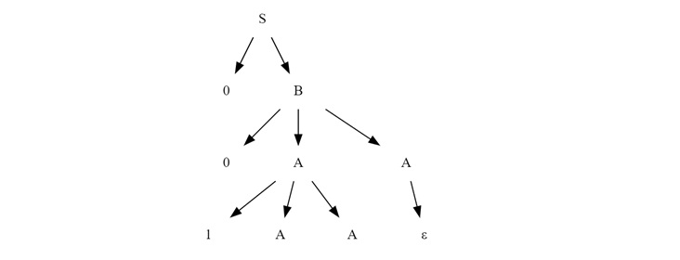
Now from the final non-terminals A to ε to get final tree.
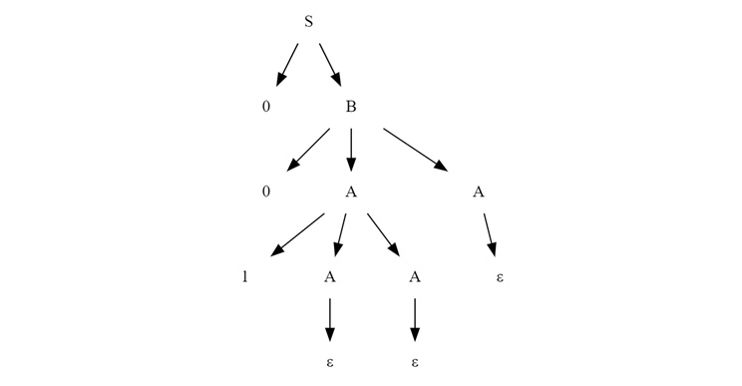
This final structure represents the derivation tree for the string "001" from grammar G.

Left Derivation Tree and Right Derivation Tree
There are two primary methods for constructing derivation trees: The left derivation and right derivation. These methods dictate the order in which production rules are applied to non-terminal symbols within the sentential form.
- Left Derivation Tree − A Left Derivation Tree is generated by consistently applying production rules to the leftmost variable in each step of the derivation. This method uses expanding the non-terminal symbols on the left side of the sentential form.
- Right Derivation Tree − A Right Derivation Tree is obtained by applying production rules to the rightmost variable in each step. This method uses expanding non-terminal symbols on the right side of the sentential form.

Example of Left and Right Derivation Trees
Let's consider a new grammar and generate both left and right derivation trees to understand the difference in their construction.
Grammar −
S→aAS|aSS|ε
A→SbA|ba
String to derive: "aabbaa"

Left Derivation Tree
For the left derivation tree, we start from S.
- Applying Leftmost Derivation − We apply the production rule 'S → aSS' to the leftmost 'S'.

- Expanding Leftmost Variable − We expand the leftmost 'S' using the rule 'S → aAS'.

- Continuing Leftmost Derivation − We continue expanding the leftmost 'A' using the rule 'A → ba'.

- Completing the Derivation − We expand the next leftmost S to aSS, and from there remaining S to 'S → ε'.
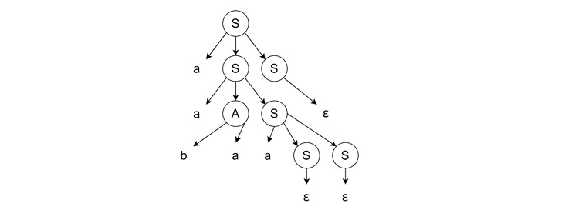

Right Derivation Tree
Like left most derivation, we start from the start symbol 'S'.
- Applying Rightmost Derivation − We apply the production rule 'S → aSS' to the rightmost 'S'.
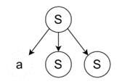
- Expanding Rightmost Variable − We expand the rightmost 'S' using the rule 'S → aAS'.

- Continuing Rightmost Derivation − We expand the rightmost 'S' using the rule 'S → aSS'.
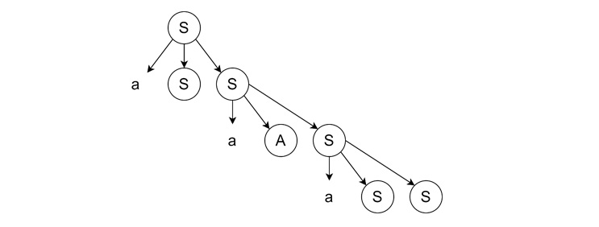
- Completing the Derivation − We expand the remaining 'A' and 'S' from the right to left, the last two S will produce ε. Then A will bring ‘ba’ and the leftmost S will bring ε again.
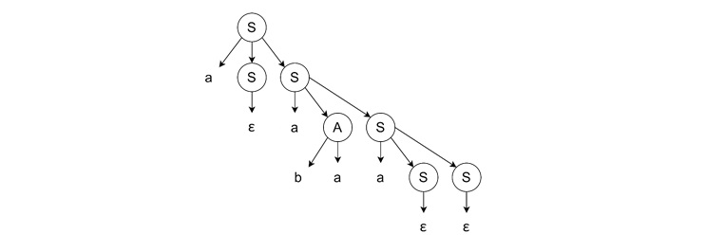

Example
Let a CFG {N,T,P,S} be
N = {S}, T = {a, b}, Starting symbol = S, P = S → SS | aSb | ε
One derivation from the above CFG is abaabb
S → SS → aSbS → abS → abaSb → abaaSbb → abaabb
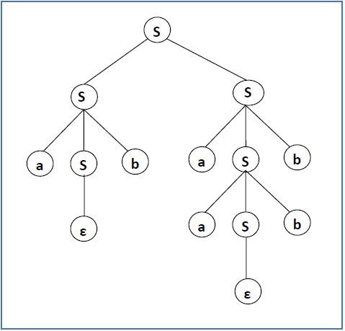

Sentential Form and Partial Derivation Tree
A partial derivation tree is a sub-tree of a derivation tree/parse tree such that either all of its children are in the sub-tree or none of them are in the sub-tree.
Example
If in any CFG the productions are −
S → AB, A → aaA | ε, B → Bb| ε
the partial derivation tree can be the following −
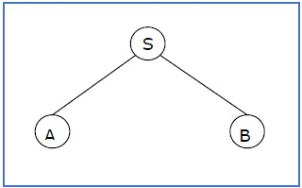
If a partial derivation tree contains the root S, it is called a sentential form. The above sub-tree is also in sentential form.

Leftmost and Rightmost Derivation of a String
- Leftmost derivation − A leftmost derivation is obtained by applying production to the leftmost variable in each step.
- Rightmost derivation − A rightmost derivation is obtained by applying production to the rightmost variable in each step.
Example
Let any set of production rules in a CFG be
X → X+X | X*X |X| a
over an alphabet {a}.
The leftmost derivation for the string "a+a*a" may be −
X → X+X → a+X → a + X*X → a+a*X → a+a*a
The stepwise derivation of the above string is shown as below −
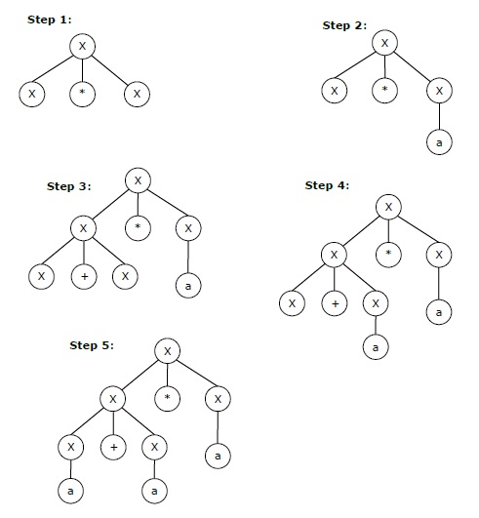
The rightmost derivation for the above string "a+a*a" may be −
X → X*X → X*a → X+X*a → X+a*a → a+a*a
The stepwise derivation of the above string is shown as below −
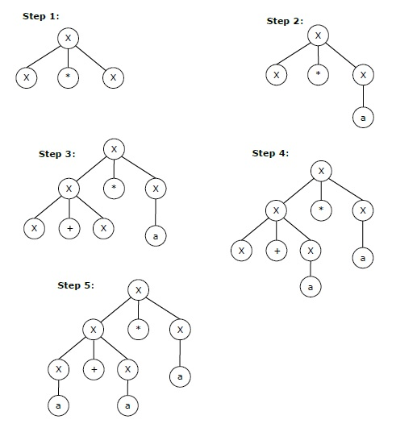

Left and Right Recursive Grammars
In a context-free grammar G, if there is a production in the form X → Xa where X is a non-terminal and a is a string of terminals, it is called a left recursive production. The grammar having a left recursive production is called a left recursive grammar.
And if in a context-free grammar G, if there is a production is in the form X → aX where X is a non-terminal and a is a string of terminals, it is called a right recursive production. The grammar having a right recursive production is called a right recursive grammar.

Non-CFG Example
Productions such as:
a->bSa, or
a->ba is not a CFG as on the left-hand side there is a terminal which does not follow the CFGs rule.
But we can construct it by :
Lets consider the string "aba" and and try to derive the given grammar from the productions given. We start with symbol S, apply production rule S->bSa and then (S->a) to get the string "aba".
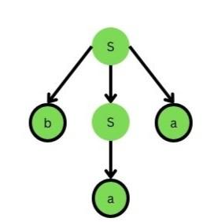Parse tree of string "aba"
In the computer science field, context-free grammars are frequently used, especially in the areas of formal language theory, compiler development, and natural language processing. It is also used for explaining the syntax of programming languages and other formal languages.

Limitations of Context-Free Grammar
- Cannot Handle Everything :
  - CFGs are good for defining basic rules of a language, but they can’t handle everything.
  - Some rules in English or programming languages are too complex for CFG.
- Can Be Confusing (Ambiguity)
  - Sometimes, CFG can allow more than one meaning for the same sentence or code.
  - This is called ambiguity, and it makes it hard for the computer to understand the correct meaning.
- Can’t Check Meaning
  - CFGs only look at the structure, not the meaning.
  - They can’t check if the types match, if variables are used properly, or if functions are called correctly.

Example of Parse Tree Construction
Let us consider an example of a parse tree construction using a simple grammar −
Given grammar
G
−
E→E+E|E×E|(E)||−E|id
Deriving the String "-(id + id)"
To determine whether the string "-(id + id)" is a valid sentence in this grammar, we can construct a parse tree as follows −
- Start with
- E
- .
- Apply the production
- E→−EE
- to get the intermediate string "\mathrm{- E}".
- Apply
- E→(E)
- to derive "
- −(E)
- ".
- Apply
- E→E+E
- to derive "
- −(E+E)
- ".
- Finally, apply
- E→id
- to get the final string "
- −(id+id)
- ".
Here is the corresponding parse tree −
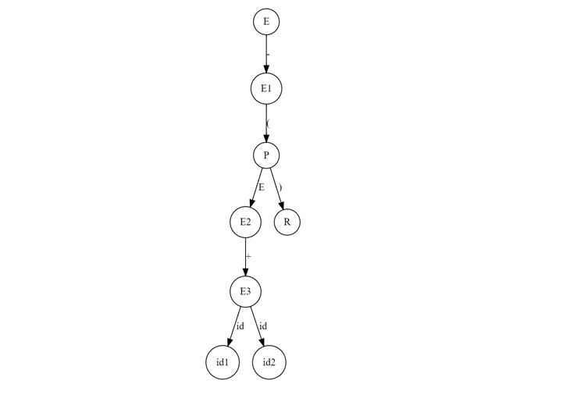
This representation shows the hierarchical structure of the derivation, with the root representing the start symbol and the leaves representing the terminal symbols of the string.

Another Example of Parse Tree
Consider a different grammar for a second example −
Given grammar
G
S→SS|aSb|ε
To derive the string "aabb", we proceed as follows −
- Start with
- S
- .
- Apply
- S→aSb
- to get "
- aSb
- ".
- Apply
- S→asb
- again within the non-terminal
- S
- to derive "
- aaSbb
- ".
- Finally, apply
- S→ε
- to replace the last
- S
- , resulting in "
- aabb
- ".
The corresponding parse tree can be represented like below −
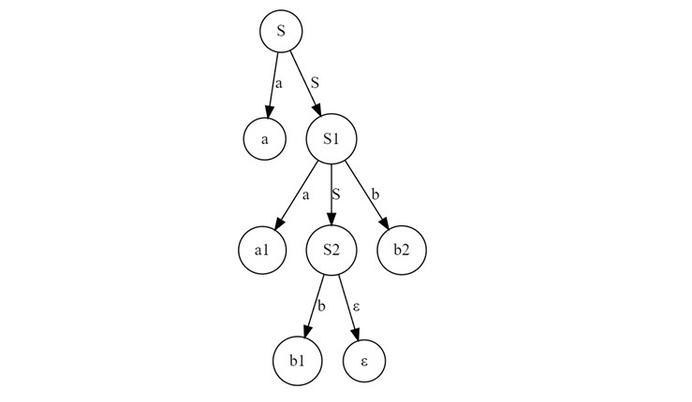

Ambiguity in Parse Trees
A grammar is said to be ambiguous if there exists at least one string that can be derived in more than one way. So there are multiple distinct parse trees. Ambiguity poses challenges when parsing as it can lead to multiple interpretations of the same string.
For instance, consider the following grammar −
S→S+S|S×S|id
The string "id + id × id" can have two different parse trees depending on the order of operations −

First Parse Tree
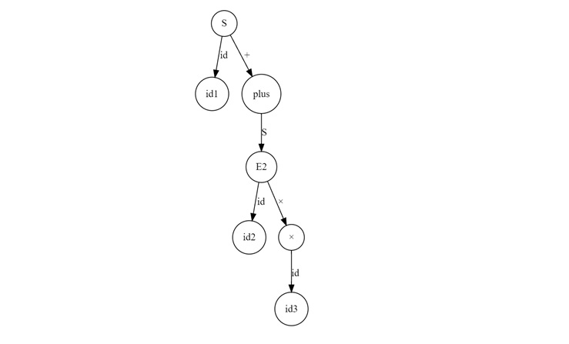

Second Parse Tree
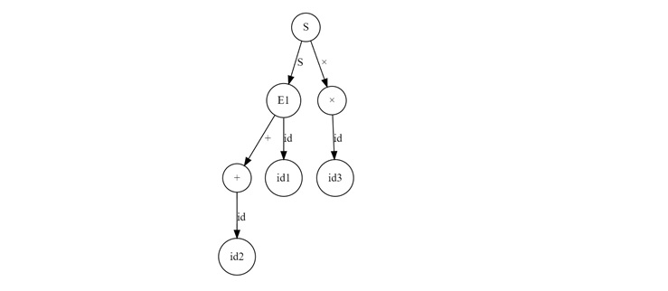

Ambiguity in Context-Free Grammars
If a context free grammar G has more than one derivation tree for some string w ∈ L(G), it is called an ambiguous grammar. There exist multiple right-most or left-most derivations for some string generated from that grammar.
- If the grammar is not ambiguous then we call it unambiguous grammar.
- If the grammar has ambiguity then it is good for compiler construction.
- No method can automatically detect and remove the ambiguity, but we can remove the ambiguity by re-writing the whole grammar without ambiguity.

Example 1
Check whether the grammar G with production rules −
X → X+X | X*X |X| a
is ambiguous or not.

Solution
Lets find out the derivation tree for the string "a+a*a". It has two leftmost derivations.
Derivation 1 − X → X+X → a +X → a+ X*X → a+a*X → a+a*a
Parse tree 1 −
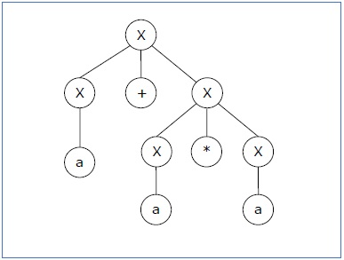
Derivation 2 − X → X*X → X+X*X → a+ X*X → a+a*X → a+a*a
Parse tree 2 −
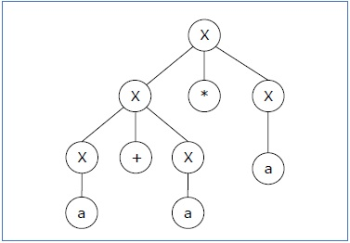
Since there are two parse trees for a single string "a+a*a", the grammar G is ambiguous.

Example 2
Let us consider a grammar with production rules, as shown below −
E=I
E=E+E
E=E×E
E=(E)
E=ϵ|0|1|2|3…9
Let's consider a string "3*2+5"
If the above grammar generates two parse trees by using Left most derivation (LMD) then, we can say that the given grammar is ambiguous grammar.
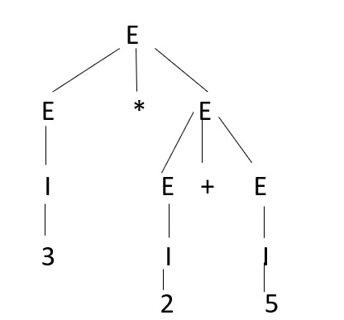
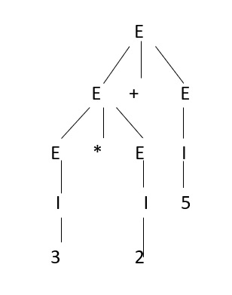
Since there are two parse trees for a single string, then we can say the given grammar is ambiguous grammar.

Example 3
Consider another example,
Check whether the grammar is ambiguous or not.
A→AA
A→(A)
A→a
For the string "a(a)(a)a" the above grammar can generate two parse trees, as given below −
