# CST8248 – Emerging Technologies

# **Assignment 1 – Project Initialization and Planning and Communication**

Team : TechHeads

Group Members :

|  |  |  |  |  |
| --- | --- | --- | --- | --- |
| **#** | **Name** | **College-id** | **Student-number** | **Course-Section** |
| 1. | Ridham Gondaliya | Gond0019@algonquinlive.com | 040974805 | CST8248-021 |
| 2. | Nikhil Khanna | Khan0411@algonquinlive.com | 040951233 | CST8248-022 |
| 3. | Stella Odagwe | odag0001@algonquinlive.com | 0409 | CST8245-015 |

* Project Timeline
  + Brainstorming phase :

The project is mainly focused in the component of the cloud and web-based services related to the real working infrastructure. We need to learn and deploy the right tools and services to make all these objectives to work well as suggested. So, in this brainstorming phase of the project, all the required material and resources need to be gathered and discussed with the team members.

* + Research time and dates (not all research must be done at the outset):

The research time for the project will be determined throughout the project work. Some of the research and discussion will be done together if any service-related problem happens in the configuration.

* + Project start date and end date :

Week 3 is the starting date of the project discussion, so we will start our project after week 4 and the due date of the project will be week 12.

* + Detailed tasks breakdown (which project elements will be deployed by which team member) :

Tasks in the project distributed to each members in the team by the interest and the knowledge.

1. Create and maintain active directory for the employer’s domain : Nikhil, Ridham
2. Connect to the WAC to the domain using the domain credential : Stella
3. Configuring iSCSI Target and maintaining iSCSI : Ridham
4. Managing the backup and disaster recovery with the Veeam server : Nikhil
5. File server configuration : Stella

* + Test phase (not all testing needs to be completed at the end, it may need to be an iterative process)

In the test phase, the work will be conducted together to see and conclude that system is working properly with all the services running on the given platforms.

* + Documentation – How will documentation be tracked.

This project will be done in the task management tool called Github.

All the project work will be documented separately in this tool and will be gathered after the project is done.

* Assign team members to each of the tasks above. (Member roles can be altered if need be. This information will be used to track member participation)

This information is given in the provide Gantt chart. Team members are assigned to each task by their overall knowledge about the service and their interest.

* Provide a Gantt chart

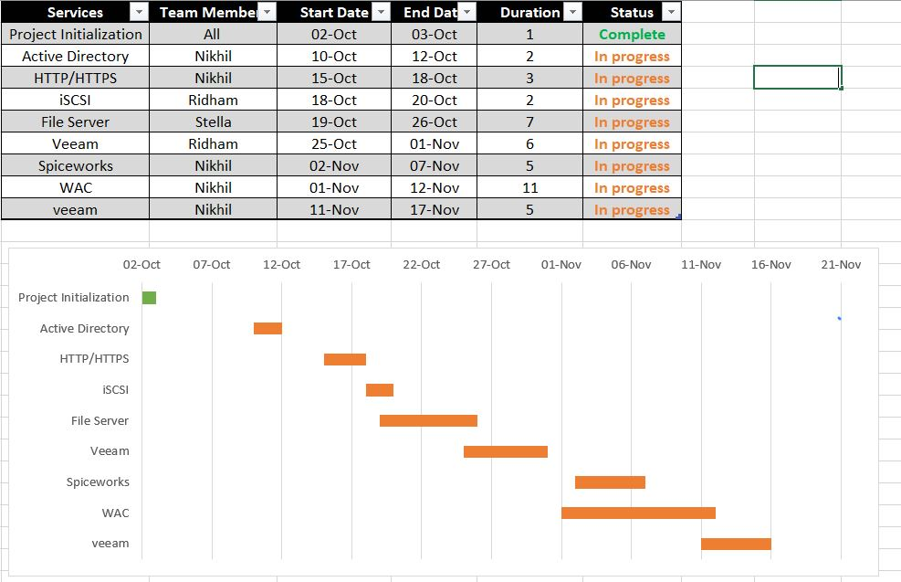

* Provide a communications plan
  + Where will meetings occur?

Our meeting will occur mainly in Zoom as well as on the MS Teams

* + When will meetings occur?

So, for the meeting we all have decided a fixed day which is Tuesday at 10:00AM-

2:00PM

* + Who will record the meeting minutes?

The group leader will record the meeting minutes which is Ridham Gondaliya

* + Where will meeting minutes be stored and viewed?

The meeting minutes will be recorded in the report which we have to submit to you.