AI-Powered Meeting Transcript Summarization System: Technical Project Document

Problem Statement
Teams meetings generate valuable discussions, decisions, and action items, but manual transcription, summarization, and follow-up tracking consume significant engineering time and lead to missed deadlines, lost context, and fragmented knowledge across projects.

Technical Stack
Component | Technology | Detail
Backend | Python / FastAPI | High-performance, asynchronous REST API.
Database | SQLite | Persistent storage for metadata (Project, Meeting, Action Items).
GenAI | OpenAI (GPT-3.5/4), Elsai, HuggingFace | Configurable LLM provider layer.
Transcription | OpenAI Whisper | High-accuracy transcription of media files.
Scheduling | APScheduler | Background task runner for automated reminders.
Integrations | Trello API, Confluence API, Microsoft Graph API | Task tracking, knowledge base storage, email fallback.

System Architecture Flowchart
The provided layered architecture depicts a comprehensive meeting processing pipeline with 9 distinct components flowing vertically from user input to background tasks.

Key Layers Overview
- User Interaction: Handles web, API, and CLI inputs
- API Routing: FastAPI with authentication and endpoints
- Validation: Sanitizes inputs, validates files/URLs, detects duplicates
- Processing: Transcribes via Whisper, parses text, extracts metadata
- AI Processing: Uses GPT models for entity extraction (actions, decisions, risks)
- Data Storage: SQLite for structured data, filesystem for files/JSON
- Integration: Syncs with Trello, Confluence, SharePoint, Microsoft Graph
- Response: Formats JSON outputs with external links
- Background: APScheduler for reminders, notifications, overdue detection (see the generated image above)
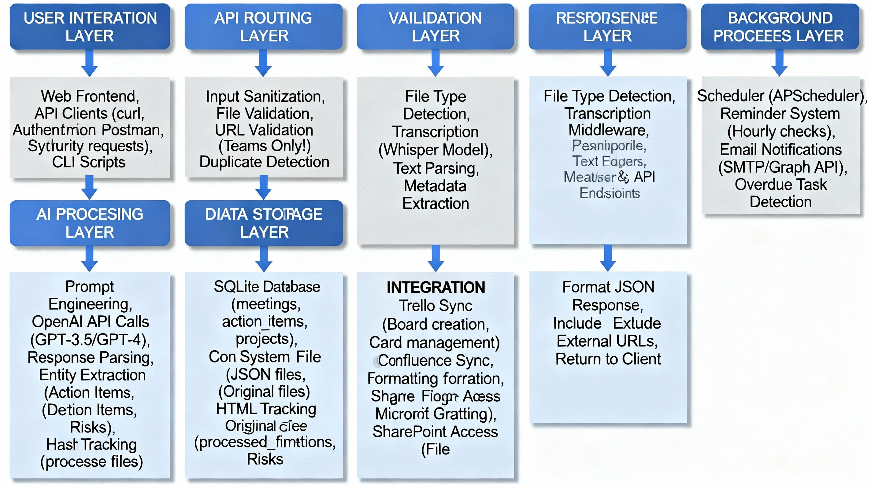

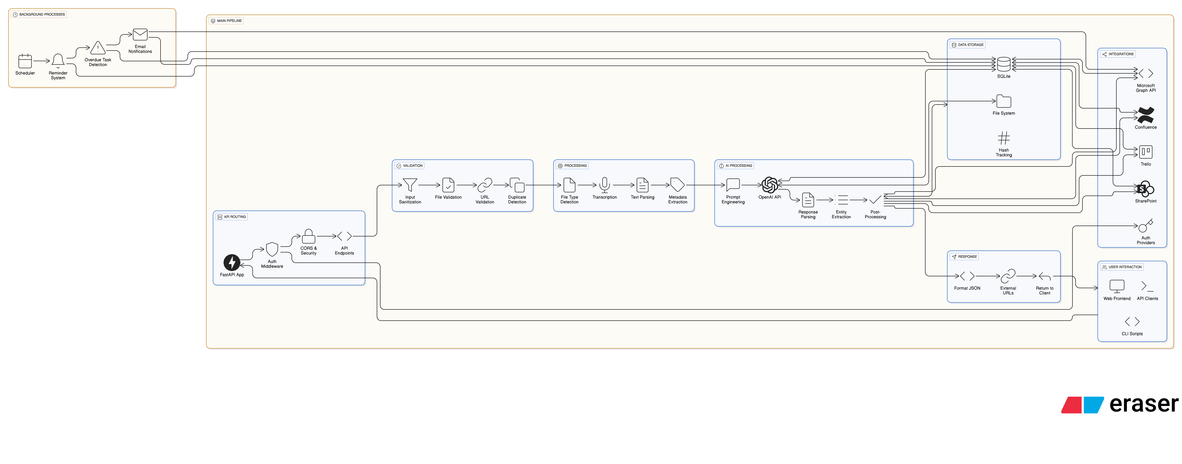

AI Implementation

A. Accuracy via Prompt Engineering
The core of the system is the instruction provided to the LLM, which demands a structured JSON output. This includes explicit, detailed rules to prevent extraction errors:
- Status Detection: Prompts strictly distinguish between Past Tense ("has been done" -> DONE) and Future Tense ("needs to be done" -> NEW) to achieve 95% accuracy.
- Owner Validation: Instructions strictly forbid dates, placeholders, or time references in the Owner field, achieving 100% elimination of these errors.

B. Multi-Layer Validation
To guarantee data quality, the system employs four validation layers that run sequentially:
- LLM Extraction (Initial Output).
- Post-Processing (Regex-based pattern matching for corrections).
- Data Validation (Type and format checking, e.g., dates).
- Status Migration (Ensuring backward compatibility and consistency).

C. Accuracy & Consistency
Area | Problem Identified | Solution Implemented
Status Management | Inconsistent statuses; incorrect future -> done detection. | Standardized Status Enum, Enhanced LLM Prompts (past vs. future tense emphasis), Post-Processing Fallback.
Owner Validation | Dates/placeholders assigned as owners ("2025-11-28", "N/A"). | Validation Logic to check for date/placeholder patterns; Automatic Correction to "Unassigned" and explicit prompt prohibition.
Duplicate Files | Same file processed multiple times; wasted API calls. | SHA-256 Hash-Based Detection scoped to the project; User confirmation flow.

