**Date:04/05/2021**

1. **How to compile a java file?**

* Save program with .java extension.
* Open a command prompt window and go to the directory where java program is saved.
* Type 'javac FirstProgram.java' and press enter to compile your code. If there are no errors in code, the command prompt will take you to the next line.
* The file is compiled and we can see FirstProgram.class file generated in the same folder.

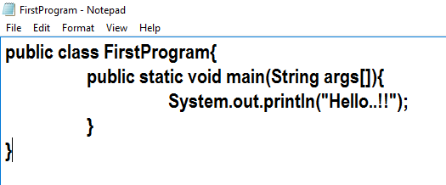

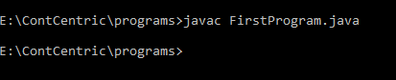

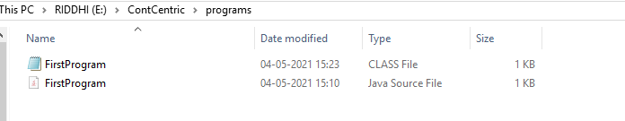

1. **How to run a class file?**

* First compile the java program.
* Then type ‘java FirstProgram’ and press enter to compile your code.
* Output is displayed on screen.



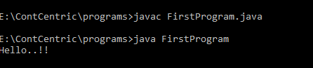

1. **How to debug a java file?**

* A Java program can be debugged simply by right clicking on the Java editor class file from Package explorer. Select **Debug As → Java Application**.

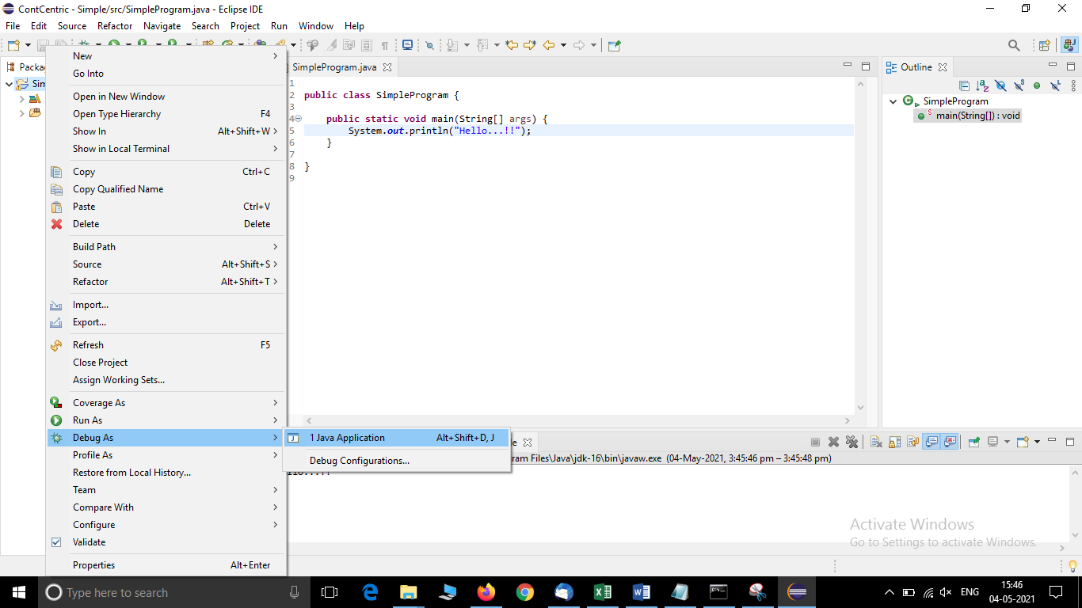

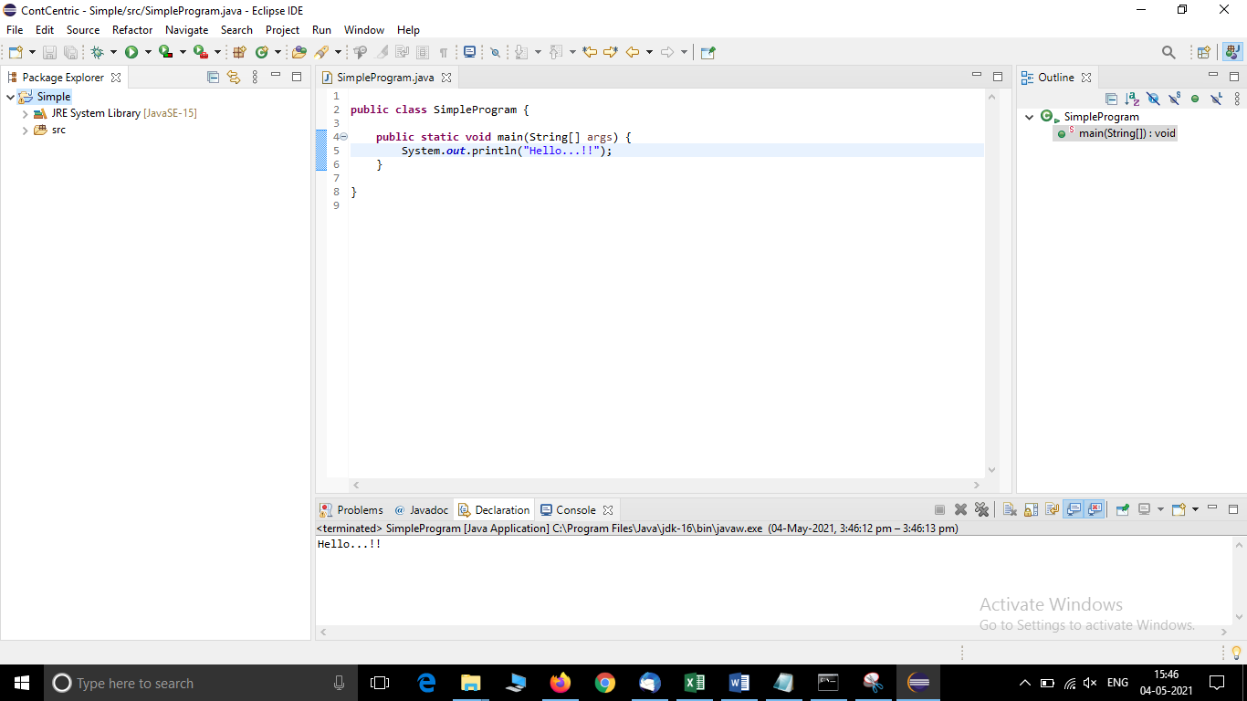

1. **How to set classpath?**

* Select Start
* Go to the Control Panel
* Select System and Security
* Select Advanced System settings
* Click on Environment Variables

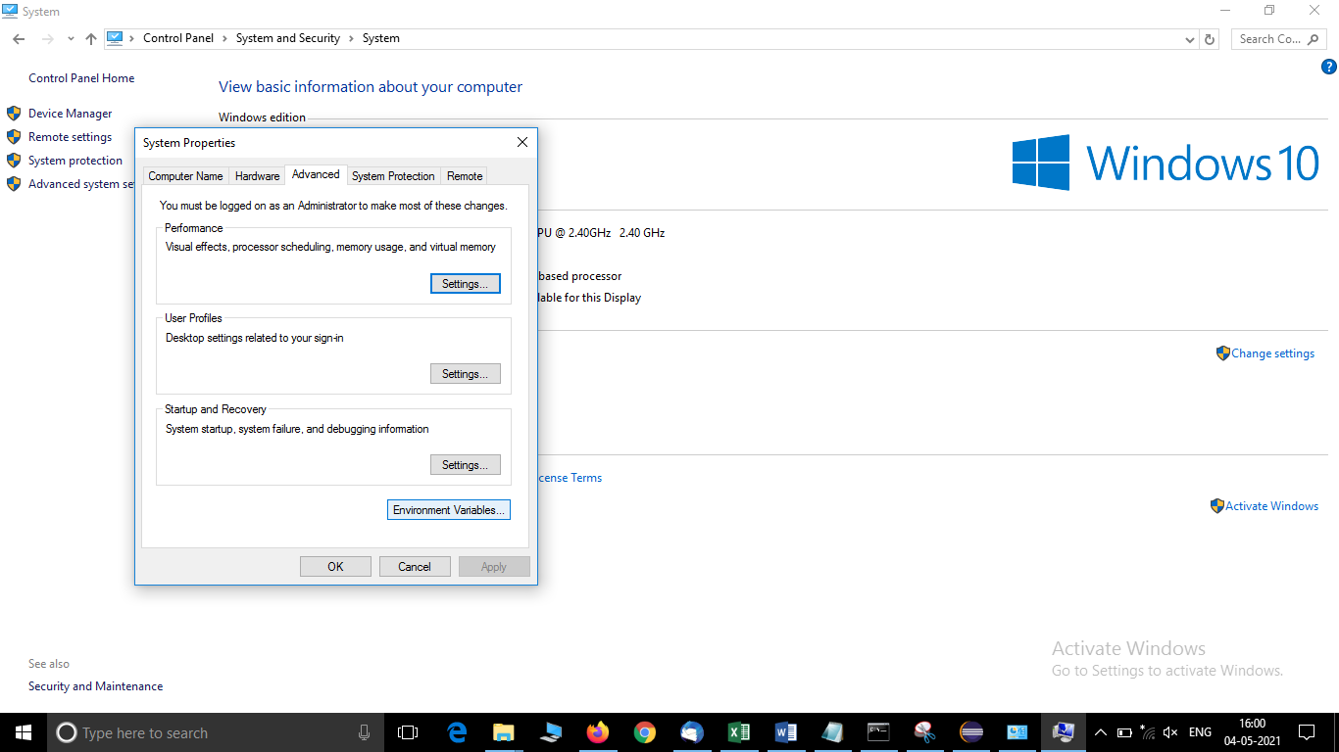

* Click on New under System Variables

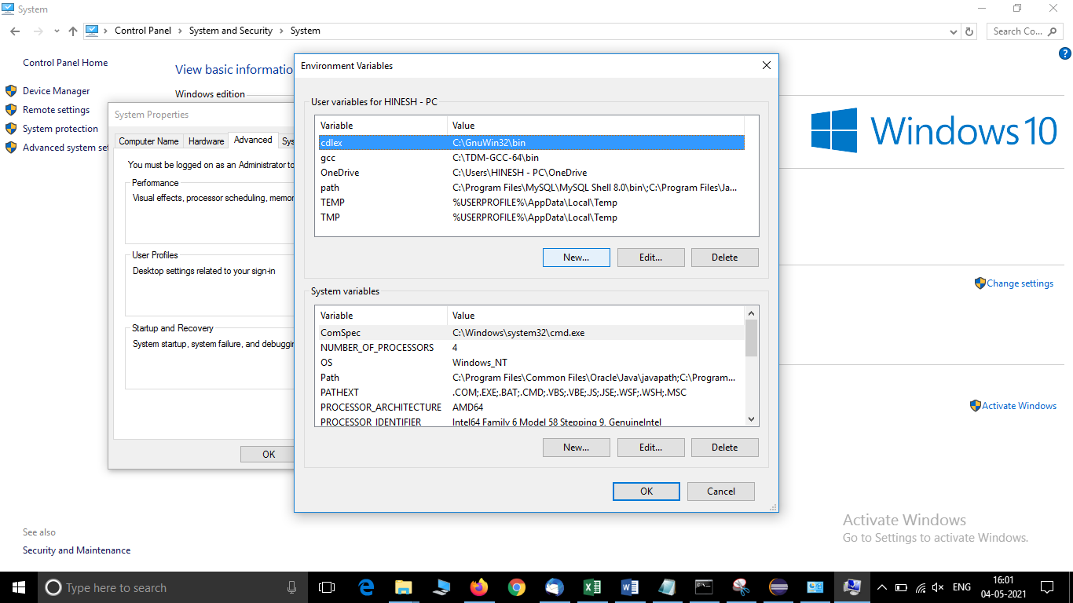

* Add **CLASSPATH** as variable name and path of files as a variable value.

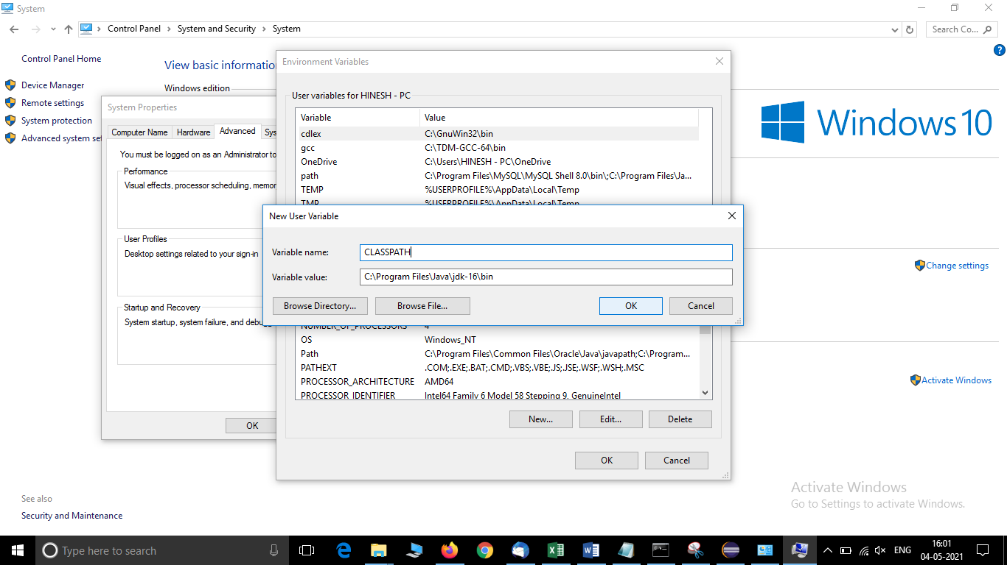

* Select OK.

1. **How to view current classpath?**

* To **check** our **CLASSPATH** on Windows we can open a command prompt and type echo %**CLASSPATH**%

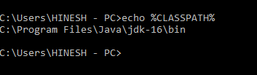

1. **How to set destination of the class file?**

* Following example demonstrates how to set destination of the class file that will be created after compiling a java file using -d option with javac command.

javac FirstProgram.java -d c:\myclasses

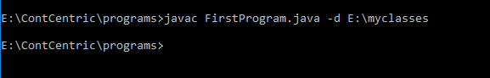

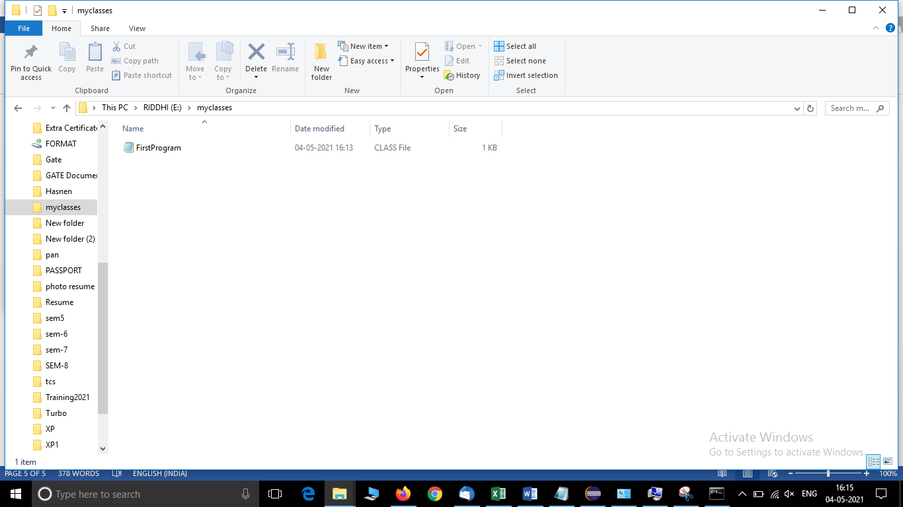

1. **How to run a compiled class file?**

* Open Command Prompt and type 'java classname’
* Press Enter.

Ex: If classname if FirstProgram.class then type ‘java FirstProgram’ (Here FirstProgram is already compiled)



1. **How to check version of java running on your system?**

* Open Command Prompt and type ‘java –version’ then press Enter.

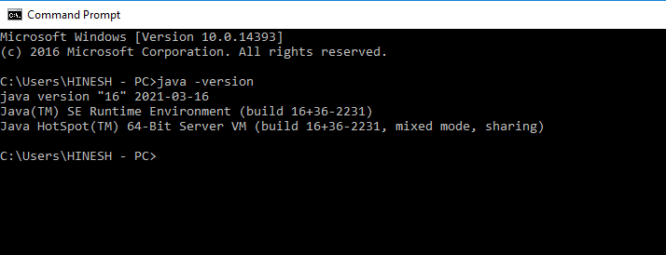

1. **How to set classpath when class files are in .jar file?**

c:> java -classpath C:\java\myclasses.jar utility.testapp.main

1. **Program to find out the range(min and max) of the given data types.**

**public** **class** FindMinMax {

**public** **static** **void** main(String[] args) {

System.***out***.println("Byte\n" + "Min Value:" + Byte.***MIN_VALUE*** + "\nMax Value:" + Byte.***MAX_VALUE***);

System.***out***.println("\nShort\n" + "Min Value:" + Short.***MIN_VALUE*** + "\nMax Value:" + Short.***MAX_VALUE***);

System.***out***.println("\nInteger\n" + "Min Value:" + Integer.***MIN_VALUE*** + "\nMax Value:" + Integer.***MAX_VALUE***);

System.***out***.println("\nLong\n" + "Min Value:" + Long.***MIN_VALUE*** + "\nMax Value:" + Long.***MAX_VALUE***);

System.***out***.println("\nFloat\n" + "Min Value:" + Float.***MIN_VALUE*** + "\nMax Value:" + Float.***MAX_VALUE***);

System.***out***.println("\nDouble\n" + "Min Value:" + Double.***MIN_VALUE*** + "\nMax Value:" + Double.***MAX_VALUE***);

}

}

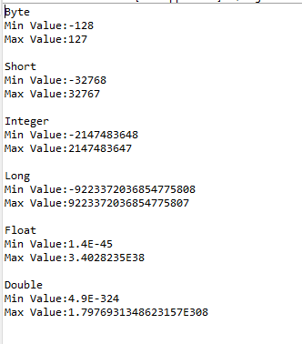

1. **Program to find the default value of the given data types.**

**public** **class** DefaultValue {

**static** **boolean** *b*;

**static** **char** *c*;

**static** **byte** *bt*;

**static** **short** *s*;

**static** **int** *i*;

**static** **long** *l*;

**static** **float** *f*;

**static** **double** *d*;

**public** **static** **void** main(String[] args) {

System.***out***.println("Default value of Boolean: " + *b*);

System.***out***.println("Default value of Character: " + *c*);

System.***out***.println("Default value of Byte: " + *bt*);

System.***out***.println("Default value of Short: " + *s*);

System.***out***.println("Default value of Integer: " + *i*);

System.***out***.println("Default value of Long: " + *l*);

System.***out***.println("Default value of Float: " + *f*);

System.***out***.println("Default value of Double: " + *d*);

}

}

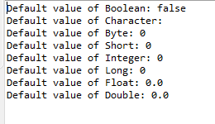

1. **Program to convert the given decimal number into integer**

**import** java.util.Scanner;

**public** **class** DecimalToInteger {

**public** **static** **void** main(String[] args) {

**double** dvalue;

**int** ivalue;

System.***out***.print("Enter Decimal Value:");

Scanner sc=**new** Scanner(System.***in***);

dvalue=sc.nextDouble();

ivalue=(**int**)dvalue;

System.***out***.println(ivalue);

}

}

