**FEATURE ENGINEERING/PREPROCESSING**

**CSE 303: Machine Learning**

Submitted by

Name: Guntur Ridhi

Roll No: AP22110011467

Section: CSE M

Lab Date: 27/08/2024

Submission Date: 02/09/2024

**Department Computer Science and Engineering**

**School of Engineering and Sciences**

**SRM University–AP**

**Amaravati, Andhra Pradesh – 522 240, India**

1. **Question**

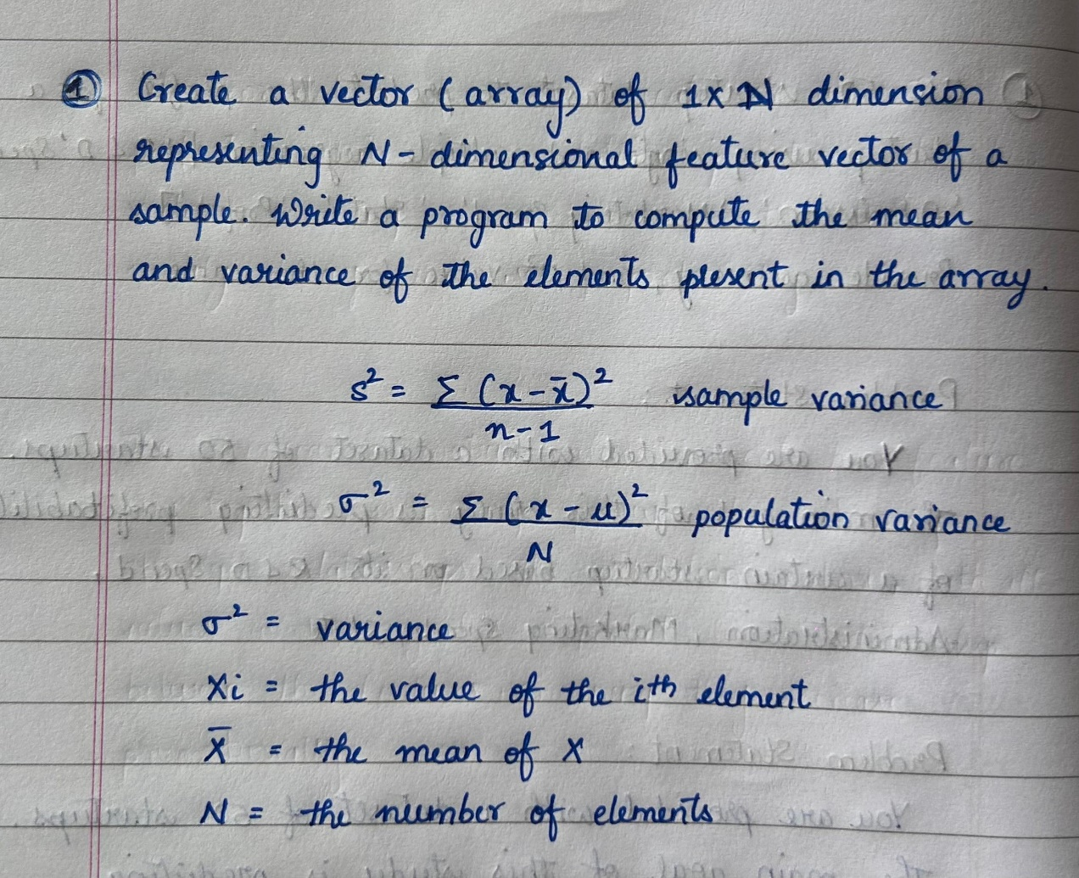

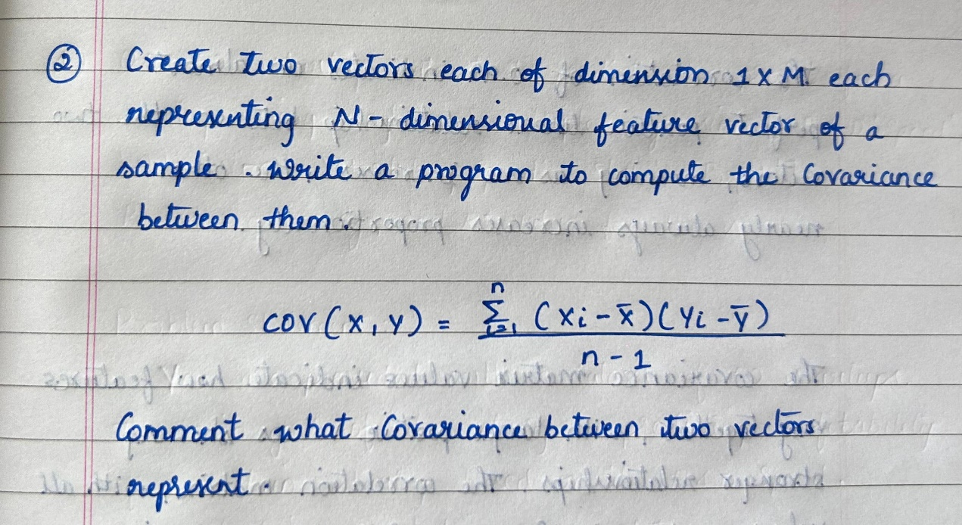

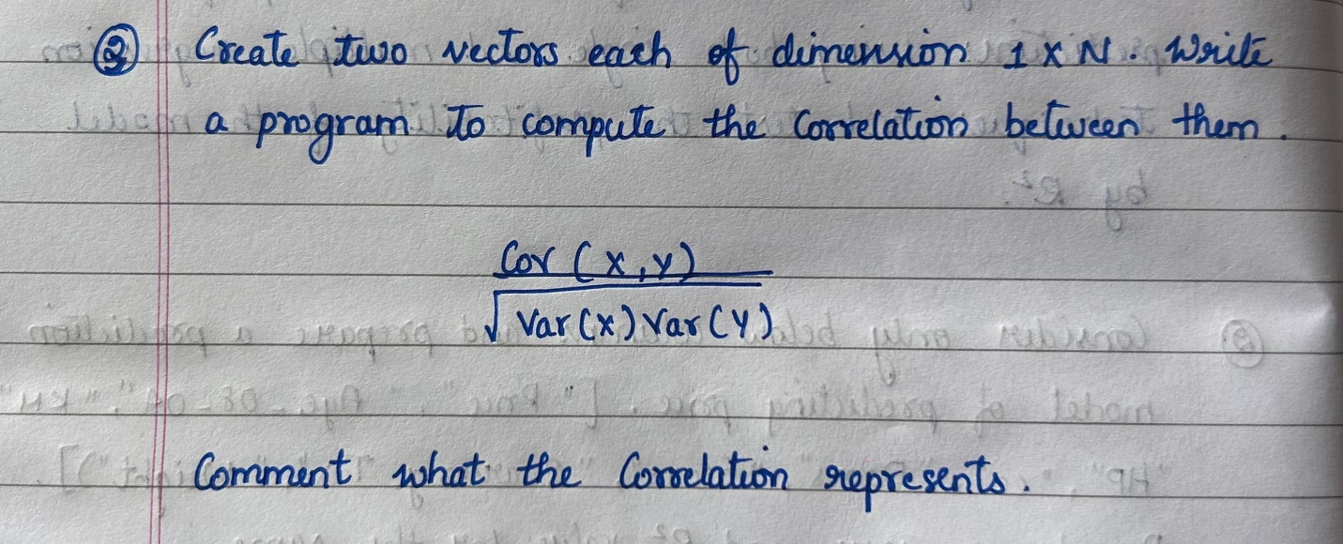

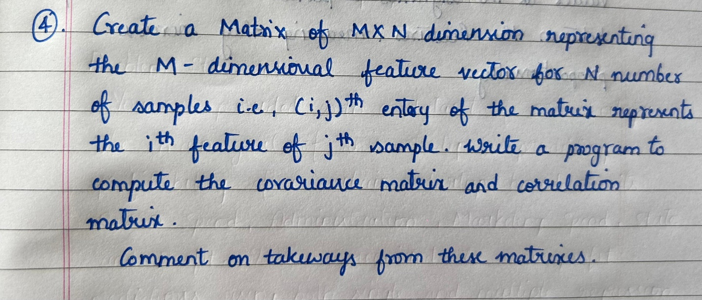

1. **Algorithm Description**

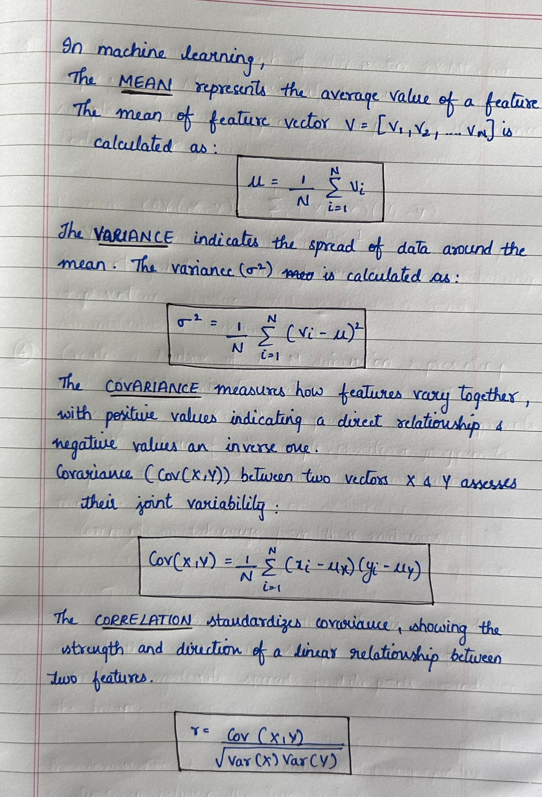

1. **Solution**

**QUESTION-1:**

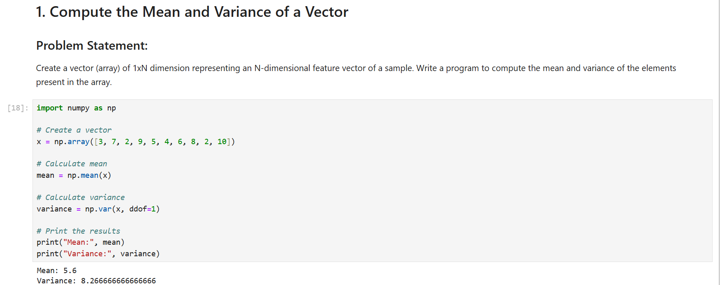

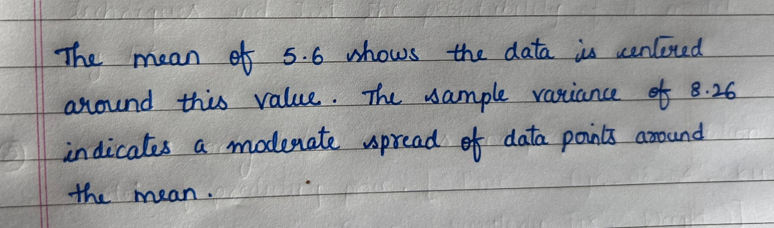

**QUESTION-2:**

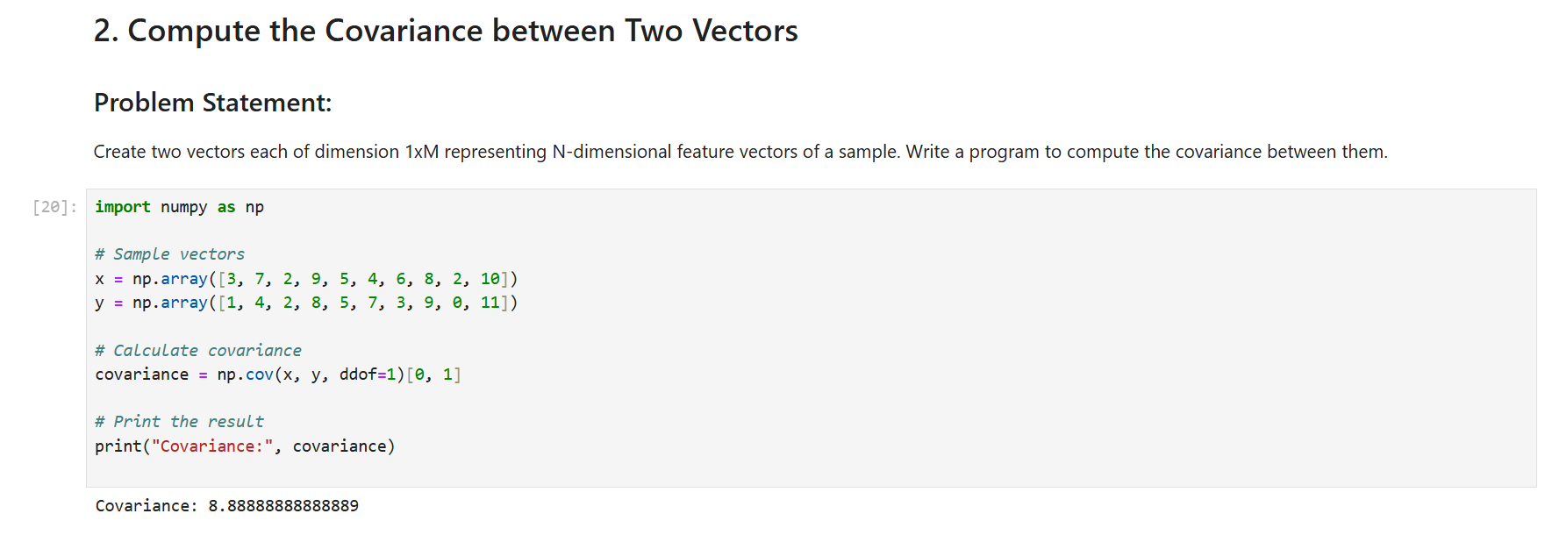

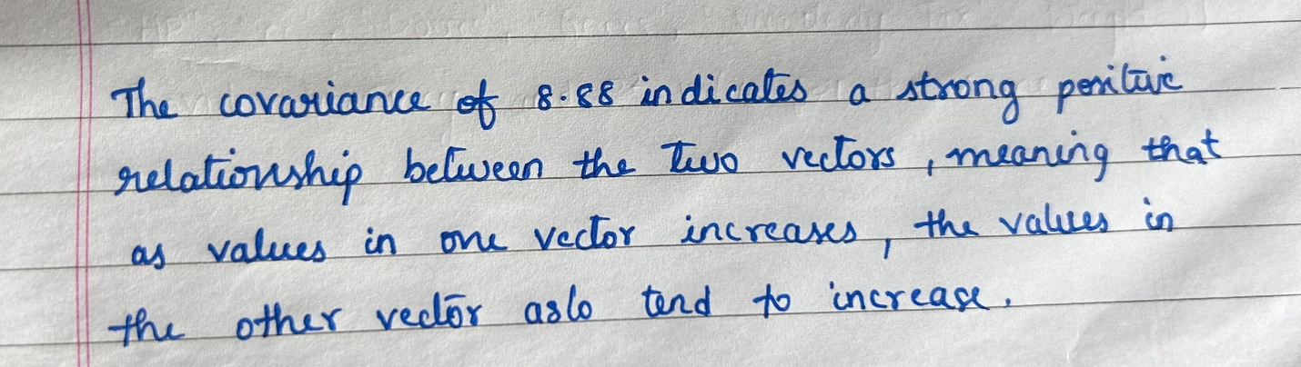

**QUESTION-3:**

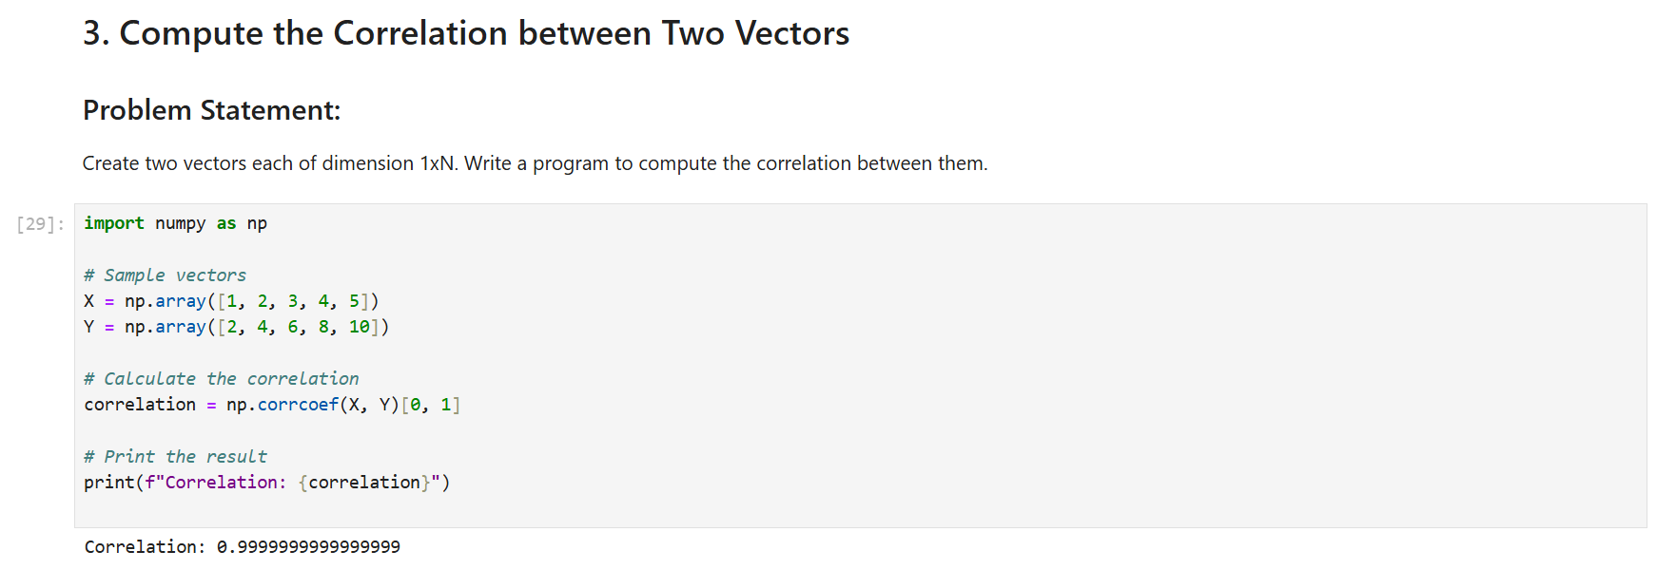

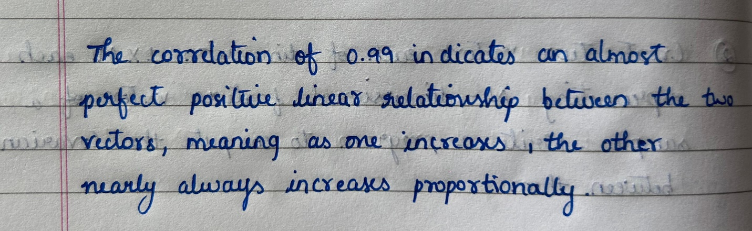

**QUESTION-4:**

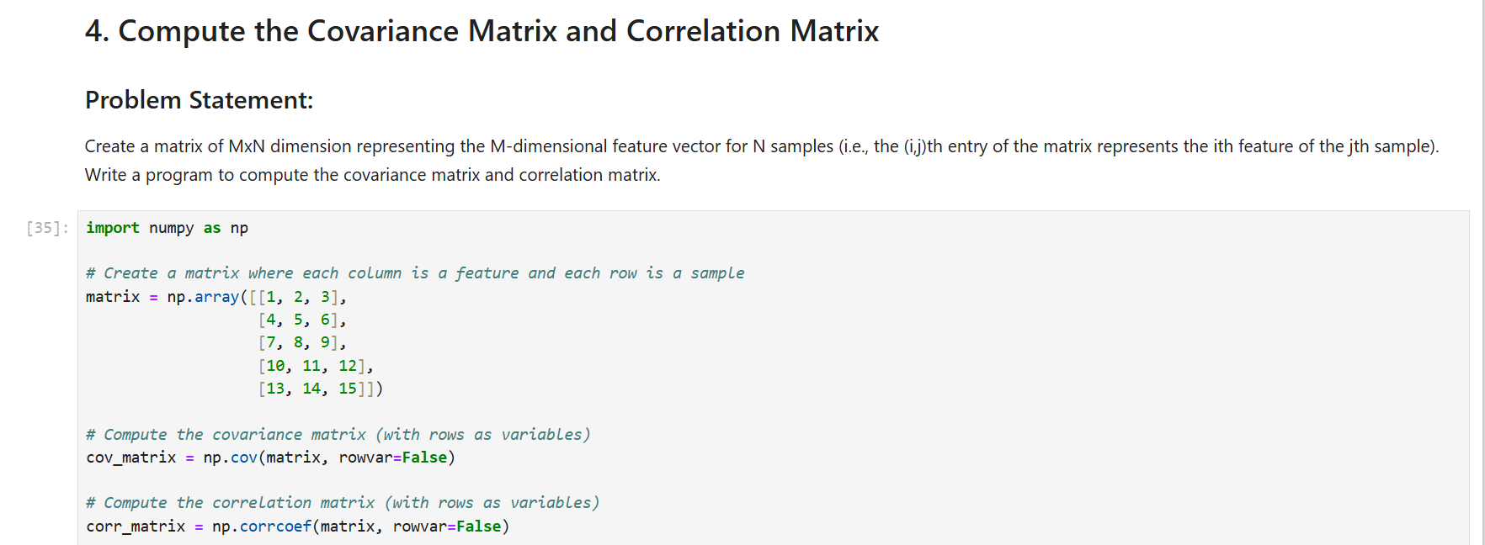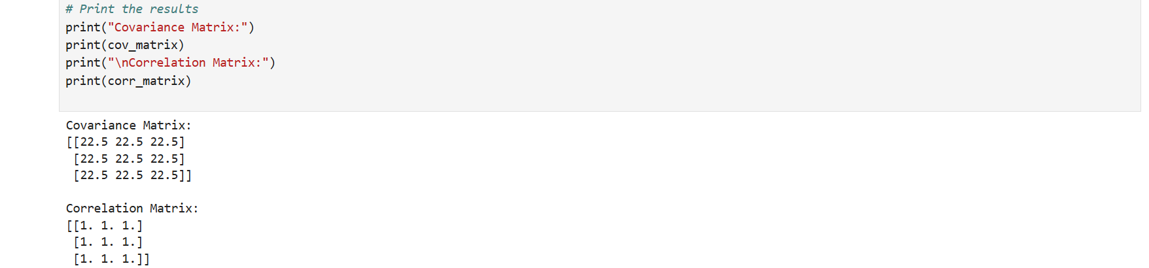

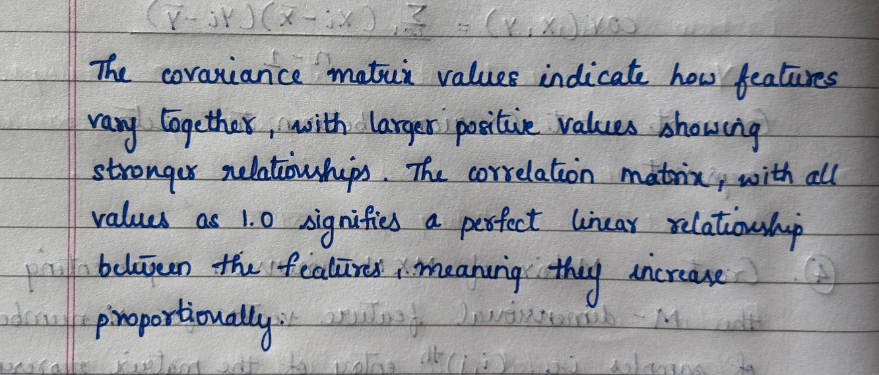

1. **Code Repository:**